Market Entry Analysis Private Label Packaged Food (Ireland)
Prepared by: Priya Kumari
Role: Business Analyst
Date: 04/01/2026

1. Business Question
Should the FMCG company enter the Irish private label packaged food market and if yes, at what price point to ensure at least 30% gross margin while remaining competitive?
Explanation of terms:
- Private-label packaged food: Products sold under retailer brand but manufactured by a third party. Example: Tesco Finest biscuits.
- Gross margin: Profitability per unit after subtracting cost of goods sold.
- Competitive: Price relative to existing products in the market to attract customers.

2. Success Criteria
The project will be considered successful if:
- Gross margin ≥ 30%
  - Meaning: After covering production, packaging, and distribution costs, the company retains at least 30% of revenue to cover overhead and profit.
  - Reason: Below 30% the product may not be sustainable due to cost inflation, discounts or operational risks.
- Pricing within ±10% of key competitors
  - Meaning: Price must be comparable to existing private-label products.
  - Reason: If the price is too high, customers will switch and if too low, perceived quality may be poor and margins are threatened.
- Positive contribution margin within first year
  - Meaning: The product should start generating profit after variable costs in the first year of sales.
  - Reason: Ensures investment is recovered early and the business is financially viable.

Empirical Data Anchoring
"Demand assumptions are anchored in CSO Census 2022 population distribution data and CSO Household Budget Survey expenditure patterns. The 30% gross margin benchmark is validated against Eurostat Structural Business Statistics for EU food manufacturing (NACE C10) and supported by Eurostat HICP food inflation trends for Ireland. Logistics cost risk parameters are calibrated against Eurostat road freight transport statistics and World Bank Logistics Performance Index data, which confirm Ireland's above-average distribution cost structure."

3. Key Assumptions (5Cs Framework)

Company
- FMCG company has existing manufacturing capabilities in packaged foods and can scale production without major new investment.
- Established European supply chain enables timely delivery to Ireland.
- Sufficient financial resources to invest in market entry, production and initial promotion.
- Previous experience in launching products and managing margins.

Cost
- Cost includes raw materials, packaging, logistics and distribution per unit.
- Fixed costs include initial supplier contracts, quality testing and regulatory compliance.
- Gross margin target ≥30% ensures profitability after all variable and fixed costs.

Competition
- Market has other private-label products and national brands.
- Price competition exists but differentiation is limited.
- Competitor price data is available and guides pricing assumptions.

Consumer
- End consumers are price-sensitive but quality-aware.
- Private-label buyers prefer cheaper alternatives with similar quality to national brands.
- Urban areas have higher demand due to higher footfall and repeat purchase.

Channel
- Distribution primarily through retailer-owned logistics networks.
- Urban regions are more efficient for distribution; rural regions may have higher costs.
- Online channels exist but are secondary; focus is retail stores.

4. Project Hypotheses
- Demand is highest in urban regions of Ireland.
- Competitive pricing allows achieving at least 30% gross margin.
- Distribution and logistics costs are the key risk to profitability.

5. Scope

In Scope
- Market sizing for private label packaged food in Ireland
- Cost analysis and gross margin calculation
- Competitive pricing benchmarking
- Distribution channel and logistics cost analysis

Out of Scope
- Manufacturing plant setup
- Marketing campaigns or brand-building strategy
- International expansion
- Detailed consumer psychology studies
Now, “What data do we need to test these assumptions and success criteria?”

6. Key Business Metrics Required
Based on the hypotheses, the following metrics are required:

6.1 Cost Metrics
Used to evaluate profitability
- Raw material cost per unit
- Packaging cost per unit
- Logistics cost per unit
- Fixed cost allocation per unit

6.2 Pricing Metrics
Used to evaluate market positioning
- Competitor price
- Target selling price

6.3 Profitability Metrics
Used to test financial feasibility
- Total cost per unit
- Gross margin per unit

6.4 Demand Metrics
Used to validate volume assumptions
- Monthly demand by region (Urban vs Rural)

7. Data Table Design (Logical Model)
In consulting and industry projects, raw data is structured into logical tables before analysis. The following tables were designed.

7.1 Products Table
Purpose: Identify each product uniquely
Columns:
- Product_ID (Primary Key)
- Product_Name
- Category

7.2 Costs Table
Purpose: Capture per-unit cost structure
Columns:
- Product_ID (Foreign Key)
- Raw_Material_Cost
- Packaging_Cost
- Logistics_Cost
- Fixed_Costs

7.3 Pricing Table
Purpose: Compare planned pricing against competition
Columns:
- Product_ID (Foreign Key)
- Competitor_Price
- Target_Price

7.4 Demand Table
Purpose: Estimate demand across regions
Columns:
- Product_ID (Foreign Key)
- Region (Urban / Rural)
- Monthly_Demand

8. Data Relationships
The following relationships were defined to enable analysis:
- Products → Costs (One-to-One)
- Products → Pricing (One-to-One)
- Products → Demand (One-to-Many)
These relationships allow integrated analysis across cost, pricing and demand.

9. Definition of Calculated Metrics
To ensure clarity, key calculations are defined before implementation.

9.1 Total Cost per Unit
Total Cost = Raw Material + Packaging + Logistics + Fixed Cost (allocated)

9.2 Gross Margin
Gross Margin (%) = (Target Price − Total Cost) / Target Price
Reason: Gross margin measures core operational profitability before overheads, marketing, and taxes. It is a standard metric used in FMCG decision-making.

9.3 Revenue
Revenue = Target Price × Monthly Demand

Data Source Assumptions
Since this is a strategic case study and not a live company dataset, the following assumptions were made:
- Costs are estimated based on industry averages
- Competitor prices are approximated from publicly available retail pricing
- Demand is estimated using market entry benchmarks
Justification: Consulting projects often start with assumptions when real data is unavailable. These assumptions are later validated or revised.

10. Tool Usage

SQL
Used for:
- Creating structured tables
- Storing and managing data
- Preparing analysis-ready datasets

Power BI

Used for:
- Creating Dashboards
- Understanding insights

11. Data Analysis & Hypothesis Testing

Hypothesis 1 (H1)

Urban regions in Ireland exhibit higher demand compared to non-urban regions

1. Hypothesis Statement
Urban regions in Ireland are expected to generate higher demand for private-label packaged food products due to higher population density, greater retail penetration and higher frequency of grocery purchases.

2. Business Rationale
- Urban consumers have:
  - Better access to supermarkets
  - Higher exposure to private-label products
  - Higher convenience-driven consumption
- FMCG companies often prioritise urban markets during early market entry phases.

3. Methodology
- Monthly demand data was analysed by region.
- Products were mapped to demand volumes in Urban and Non-Urban regions.
- Aggregate demand was compared across regions.
Metric used:
Total Monthly Demand by Region

4. Findings
Analysis shows that urban regions contribute higher monthly demand compared to non-urban regions across the analysed product set.
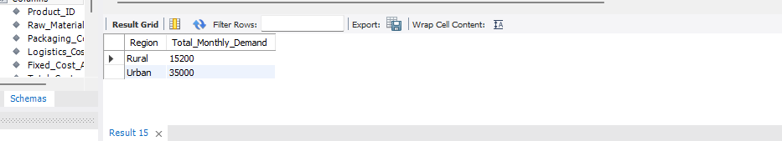

5. Conclusion
The hypothesis is supported.
Urban regions show stronger demand and represent the most attractive initial focus for market entry.

6. Business Implication
- Initial launch and promotions should prioritise urban markets.
- Non-urban markets can be targeted in later expansion phases.

Hypothesis 2 (H2)

Competitive pricing allows achieving a gross margin of at least 30%

1. Hypothesis Statement
By pricing competitively against existing market players, the company can achieve a minimum gross margin of 30% across its product portfolio.

2. Business Rationale
- Private-label products typically compete on price while maintaining reasonable margins.
- A 30% gross margin is commonly used as a minimum profitability benchmark in FMCG to cover operating expenses and support sustainable growth.

3. Methodology
- Gross margin was calculated at the product level using the formula:
Gross Margin (%) = (Selling Price − Cost Price) / Selling Price × 100
- Each product’s gross margin was evaluated against the 30% benchmark.

4. Findings
- Out of five products analysed, three products (60%) achieved a gross margin greater than 30%.
- Two products failed to meet the margin threshold despite competitive pricing.
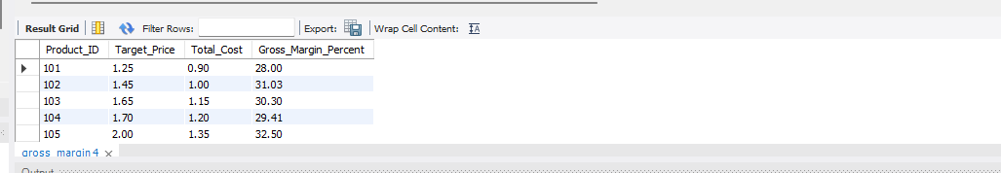

5. Conclusion
The hypothesis is partially supported.
Competitive pricing enables achieving the target gross margin for a majority of products, but margin performance is inconsistent across the portfolio.

6. Business Implication
- Competitive pricing alone is insufficient to guarantee profitability.
- Further investigation into cost drivers is required for underperforming products.

Hypothesis 3 (H3)

Distribution and logistics costs are a key risk to profitability

1. Hypothesis Statement
Distribution and logistics costs significantly reduce product profitability and are a major risk to achieving the target gross margin.

2. Business Rationale
- FMCG products are sensitive to supply chain efficiency.
- Logistics costs directly erode gross margin on a per-unit basis.
- Inefficient distribution can undermine otherwise viable pricing strategies.

3. Methodology
Logistics impact was calculated as a percentage of selling price to quantify margin erosion:
Logistics Cost Impact (%) = (Logistics Cost ÷ Selling Price) × 100
Net profit margin was then calculated as:
Net Margin (%) = (Selling Price − Cost Price − Logistics Cost) ÷ Selling Price × 100

4. Findings
- All analysed products incur logistics costs exceeding 8% of selling price.
- Logistics costs reduce achievable margins by more than 8 percentage points per product.
- Products failing to meet the 30% gross margin target show higher logistics impact.

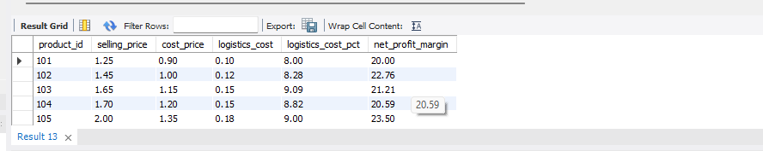

5. Conclusion
The hypothesis is strongly supported.
Distribution and logistics costs represent a systemic profitability risk, affecting 100% of the product portfolio.

6. Business Implication
- Cost optimisation efforts should prioritise:
  - Distribution efficiency
  - Warehouse optimisation
  - Route planning and scale efficiencies
- Without addressing logistics costs, achieving consistent margin targets will remain challenging.
12. Insights, Implications, Recommendations
1. Executive Summary
The analysis evaluated the feasibility of entering Ireland’s private-label packaged food market under a 30% gross margin target. Findings indicate strong urban demand, partial margin feasibility across products and logistics costs as a material profitability risk. Market entry is feasible with selective product focus and cost optimization initiatives.
2. Key Insights
2.1 Insight 1(Demand)
- Urban regions show significantly higher demand
- Indicates higher price tolerance and volume scalability
Demand concentration in urban regions supports an initial urban-focused market entry strategy to maximize early revenue realization.
2.2 Insight 2(Pricing & Margin)
- Only 3 out of 5 products achieved ≥30% gross margin
- Full portfolio launch fails margin criteria
Margin analysis reveals that portfolio-wide pricing is not viable under current cost structures. Selective product launch is required.
2.3 Insight 3(Logistics Risk)
- Logistics cost >8% of selling price across all products
- Direct erosion of margins
Logistics represents a structural cost risk and is the primary driver of margin dilution across the portfolio.

3. Business Implications
Findings | Implications
Urban demand | Focus initial launch in Dublin & Cork
Only 3 products profitable | Limit SKU count initially
High logistics cost | Supply chain redesign needed

4. Recommendations

4.1 Recommendation 1(Phased Market Entry)
Launch only the 3 profitable SKUs in urban regions to achieve target margin thresholds.

4.2 Recommendation 2(Pricing Recommendation)
The product should be launched at the higher of:
- The minimum price required to achieve ≥30% gross margin.
- The pricing should be within 10% range of major competitors.
Revisit pricing strategy for non-profitable products through pack-size optimization or ingredient reformulation.

4.3 Recommendation 3(Logistics Cost Optimization)
Explore regional warehouses, 3PL renegotiation, or distributor-led fulfilment to reduce logistics costs below 6%.
5. Risk & Mitigation
Risk | Reason | Mitigation
High logistics cost share | Logistics cost impact >8% for all products | Optimize routes, renegotiate contracts, or redesign last mile model
Margin pressure on select SKUs | Only 3 of 5 products ≥30% gross margin | Focus on high-margin SKUs; reprice or exit low-margin ones
Scalability risk | Low-margin SKUs reduce profit as volumes increase | Fix margin structure before scale-up

