**Lab Assignment – 1**

1. Create ASP.NET page to accept a name from the user and display welcome message.

**Assignment1.aspx Code:**

<%@ Page Language="C#" AutoEventWireup="true" CodeBehind="Assignment1.aspx.cs" Inherits="sem6new.Assignment1" %>

<!DOCTYPE html>

<html xmlns="http://www.w3.org/1999/xhtml">

<head runat="server">

<title></title>

</head>

<body>

<form id="form1" runat="server">

<div>

<asp:Label ID="Label1" runat="server" Text="Name"></asp:Label>

&nbsp;&nbsp;

<asp:TextBox ID="TextBox1" runat="server" OnTextChanged="TextBox1_TextChanged"></asp:TextBox>

</div>

<p>

<asp:Button ID="Button1" runat="server" OnClick="Button1_Click" Text="Click me" />

&nbsp;&nbsp;&nbsp;&nbsp;&nbsp;&nbsp;&nbsp;&nbsp;&nbsp;&nbsp;&nbsp;&nbsp;&nbsp;&nbsp;&nbsp;

<asp:Label ID="Label2" runat="server" Text="Label"></asp:Label>

</p>

</form>

</body>

</html>

**Assignment1.aspx.cs Code**

using System;

using System.Collections.Generic;

using System.Linq;

using System.Web;

using System.Web.UI;

using System.Web.UI.WebControls;

namespace sem6new

{

public partial class Assignment1 : System.Web.UI.Page

{

protected void Page_Load(object sender, EventArgs e)

{

}

protected void TextBox1_TextChanged(object sender, EventArgs e)

{

}

protected void Button1_Click(object sender, EventArgs e)

{

Label2.Text=TextBox1.Text;

}

}

}

**Output Screenshot:**

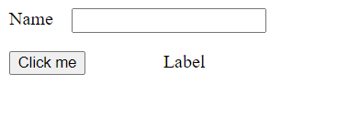

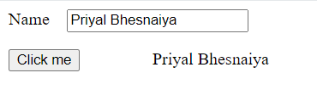

**2.** Create ASP.NET page to accept a name from the user and display welcome message.

**Assignment1_2.aspx Code**

<%@ Page Language="C#" AutoEventWireup="true" CodeBehind="Assignment1_2.aspx.cs" Inherits="sem6new.Assignment1_2" %>

<!DOCTYPE html>

<html xmlns="http://www.w3.org/1999/xhtml">

<head runat="server">

<title></title>

</head>

<body>

<form id="form1" runat="server">

<div>

<asp:Label ID="Label1" runat="server" Text="F"></asp:Label>

&nbsp;&nbsp;&nbsp;

<asp:TextBox ID="TextBox1" runat="server"></asp:TextBox>

<br />

<br />

<asp:Button ID="Button1" runat="server" OnClick="Button1_Click" style="width: 23px" Text="c" />

</div>

<p>

&nbsp;</p>

<asp:Label ID="Label2" runat="server" Text="Label"></asp:Label>

</form>

</body>

</html>

**Assignment1_2.aspx.cs Code**

using System;

using System.Collections.Generic;

using System.Linq;

using System.Web;

using System.Web.UI;

using System.Web.UI.WebControls;

namespace sem6new

{

public partial class Assignment1_2 : System.Web.UI.Page

{

protected void Page_Load(object sender, EventArgs e)

{

}

protected void Button1_Click(object sender, EventArgs e)

{

double fahrenheit = Convert.ToDouble(TextBox1.Text);

double celsius = (fahrenheit - 32) * 5 / 9;

Label2.Text = "Celsius: " + celsius;

}

}

}

**Output Screenshot:**

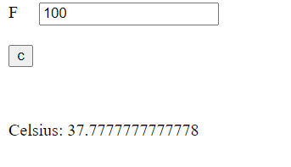

3. Create ASP.NET page to accept a name from the user and display welcome message.

**Assignment1_3.aspx Code**

<%@ Page Language="C#" AutoEventWireup="true" CodeBehind="Assignment1_3.aspx.cs" Inherits="sem6new.Assignment1_3" %>

<!DOCTYPE html>

<html xmlns="http://www.w3.org/1999/xhtml">

<head runat="server">

<title></title>

</head>

<body>

<form id="form1" runat="server">

<div>

<asp:Label ID="Label1" runat="server" Text="Num1"></asp:Label>

&nbsp;&nbsp;&nbsp;

<asp:TextBox ID="TextBox1" runat="server"></asp:TextBox>

<br />

<br />

<asp:Label ID="Label2" runat="server" Text="Num2"></asp:Label>

&nbsp;&nbsp;&nbsp;&nbsp;

<asp:TextBox ID="TextBox2" runat="server"></asp:TextBox>

<br />

<br />

<br />

<asp:Button ID="Button1" runat="server" OnClick="Button1_Click" Text="+" />

&nbsp;<asp:Button ID="Button2" runat="server" OnClick="Button2_Click" Text="-" />

&nbsp;<asp:Button ID="Button3" runat="server" OnClick="Button3_Click" Text="*" />

&nbsp;<asp:Button ID="Button4" runat="server" OnClick="Button4_Click" Text="/" />

&nbsp;&nbsp;&nbsp;&nbsp;&nbsp;&nbsp;&nbsp;&nbsp;&nbsp;&nbsp;&nbsp;&nbsp;&nbsp;&nbsp;&nbsp;

<asp:Label ID="Label3" runat="server" Text="Label"></asp:Label>

</div>

</form>

</body>

</html>

**Assignment1_3.aspx.cs Code**

using System;

using System.Collections.Generic;

using System.Linq;

using System.Web;

using System.Web.UI;

using System.Web.UI.WebControls;

namespace sem6new

{

public partial class Assignment1_3 : System.Web.UI.Page

{

protected void Page_Load(object sender, EventArgs e)

{

}

protected void Button1_Click(object sender, EventArgs e)

{

int num1 = Convert.ToInt32(TextBox1.Text);

int num2 = Convert.ToInt32(TextBox2.Text);

int sum = num1 + num2;

Label3.Text = sum.ToString();

}

protected void Button2_Click(object sender, EventArgs e)

{

int num1 = Convert.ToInt32(TextBox1.Text);

int num2 = Convert.ToInt32(TextBox2.Text);

int sum = num1 - num2;

Label3.Text = sum.ToString();

}

protected void Button3_Click(object sender, EventArgs e)

{

int num1 = Convert.ToInt32(TextBox1.Text);

int num2 = Convert.ToInt32(TextBox2.Text);

int sum = num1 * num2;

Label3.Text = sum.ToString();

}

protected void Button4_Click(object sender, EventArgs e)

{

int num1 = Convert.ToInt32(TextBox1.Text);

int num2 = Convert.ToInt32(TextBox2.Text);

int sum = num1 / num2;

Label3.Text = sum.ToString();

}

}

}

**Output Screenshot:**

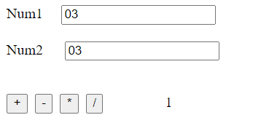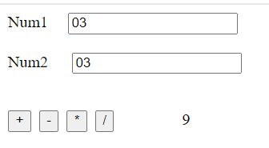

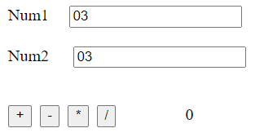

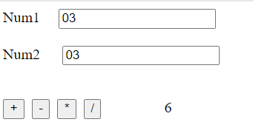

1. Create ASP.NET page to accept a name from the user and display welcome message.

**AutoPostBack.aspx Code**

<%@ Page Language="C#" AutoEventWireup="true" CodeBehind="AutoPostBack.aspx.cs" Inherits="sem6new.AutoPostBack" %>

<!DOCTYPE html>

<html xmlns="http://www.w3.org/1999/xhtml">

<head runat="server">

<link href="https://cdn.jsdelivr.net/npm/bootstrap@5.3.3/dist/css/bootstrap.min.css" rel="stylesheet" integrity="sha384-QWTKZyjpPEjISv5WaRU9OFeRpok6YctnYmDr5pNlyT2bRjXh0JMhjY6hW+ALEwIH" crossorigin="anonymous">

<title></title>

</head>

<body>

<form id="form1" runat="server">

<nav class="navbar navbar-expand-lg navbar-light bg-light">

<div class="container-fluid">

<a class="navbar-brand" href="#">Navbar</a>

<button class="navbar-toggler" type="button" data-bs-toggle="collapse" data-bs-target="#navbarSupportedContent" aria-controls="navbarSupportedContent" aria-expanded="false" aria-label="Toggle navigation">

<span class="navbar-toggler-icon"></span>

</button>

<div class="collapse navbar-collapse" id="navbarSupportedContent">

<ul class="navbar-nav me-auto mb-2 mb-lg-0">

<li class="nav-item">

<a class="nav-link active" aria-current="page" href="#">Home</a>

</li>

<li class="nav-item">

<a class="nav-link" href="#">Link</a>

</li>

<li class="nav-item dropdown">

<a class="nav-link dropdown-toggle" href="#" id="navbarDropdown" role="button" data-bs-toggle="dropdown" aria-expanded="false">

Dropdown

</a>

<ul class="dropdown-menu" aria-labelledby="navbarDropdown">

<li><a class="dropdown-item" href="#">Action</a></li>

<li><a class="dropdown-item" href="#">Another action</a></li>

<li><hr class="dropdown-divider"></li>

<li><a class="dropdown-item" href="#">Something else here</a></li>

</ul>

</li>

<li class="nav-item">

<a class="nav-link disabled" href="#" tabindex="-1" aria-disabled="true">Disabled</a>

</li>

</ul>

</nav>

<input class="form-control me-2" type="search" placeholder="Search" aria-label="Search">

<button class="btn btn-outline-success" type="submit">Search</button>

</div>

</div>

</nav>

<div>

</div>

<asp:ListBox ID="ListBox1" runat="server" AutoPostBack="True" OnSelectedIndexChanged="ListBox1_SelectedIndexChanged">

<asp:ListItem>MORBI</asp:ListItem>

<asp:ListItem>rAJKOT</asp:ListItem>

<asp:ListItem>AHMEDABAD</asp:ListItem>

<asp:ListItem>JUNAGADH</asp:ListItem>

<asp:ListItem Value="KANPUR">KANPUR</asp:ListItem>

</asp:ListBox>

<p>

<asp:Label ID="Label1" runat="server" Text="Label"></asp:Label>

</p>

<p>

&nbsp;</p>

<p>

&nbsp;</p>

<asp:Calendar ID="Calendar1" runat="server" OnSelectionChanged="Calendar1_SelectionChanged"></asp:Calendar>

<p>

&nbsp;</p>

<asp:Label ID="Label2" runat="server" Text="Label"></asp:Label>

</form>

</body>

</html>

**AutoPostBack.aspx.cs Code**

using System;

using System.Collections.Generic;

using System.Linq;

using System.Web;

using System.Web.UI;

using System.Web.UI.WebControls;

namespace sem6new

{

public partial class AutoPostBack : System.Web.UI.Page

{

protected void Page_Load(object sender, EventArgs e)

{

}

protected void ListBox1_SelectedIndexChanged(object sender, EventArgs e)

{

Label1.Text = "YOUR CITY IS :" + ListBox1.SelectedValue.ToString();

}

protected void Calendar1_SelectionChanged(object sender, EventArgs e)

{

Label2.Text = "Date is " + Calendar1.SelectedDate.ToString();

}

}

}

**Output Screenshot:**

