HDFC Dashboard Page

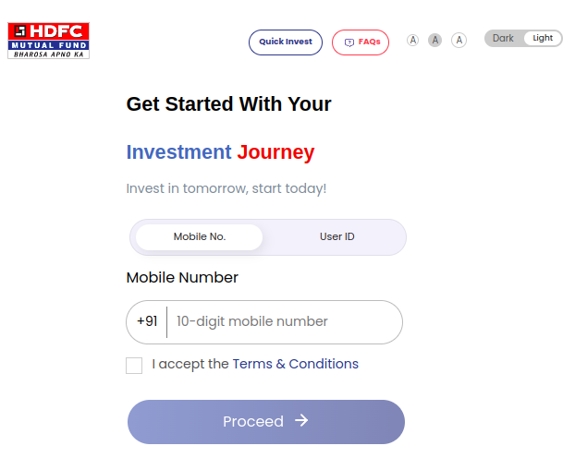
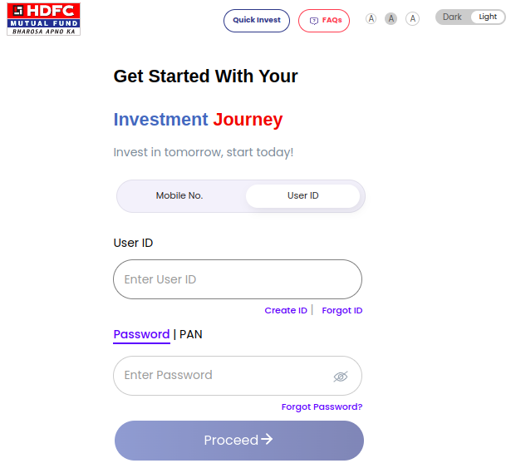

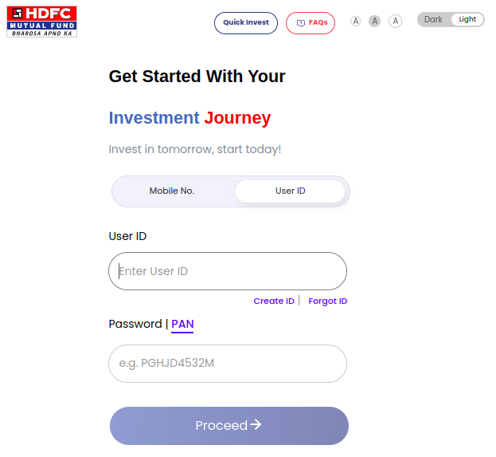

Investor Journey After Successfully done registration

1.Open official website of HDFC Amc (hdfcfund.com)
2. Click On Login button (Investor)
3. You can Login with Mobile number, User ID with Password and User ID with PAN
4. After Click On Proceed Button it will redirect to OTP Page

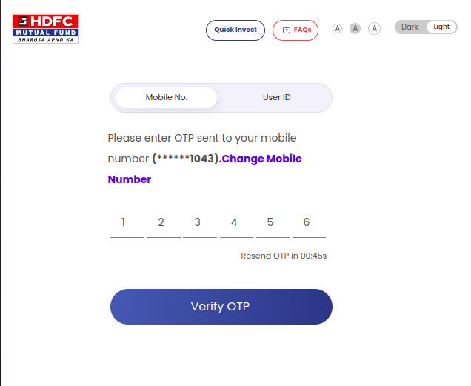

1. OTP is recieved on register mobile number and Email ID
- Validation – If You enter wrong OTP More than 3 times, 4 th & 5 th time it will ask CAPTCHA then Mobile number is blocked for 1 hr

2. Click on Verify OTP button (Visible After enter six digit OTP)
3. It Will redirect to Enter PAN and DOB page

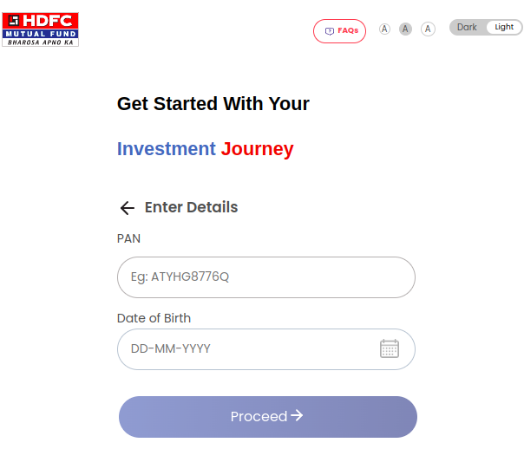

1. Enter Valid PAN
2. Enter valid DOB
3.Click On Proceed button (Visible After Enter Valid PAN and DOB)
4. After click on proceed it will redirect to dashboard page

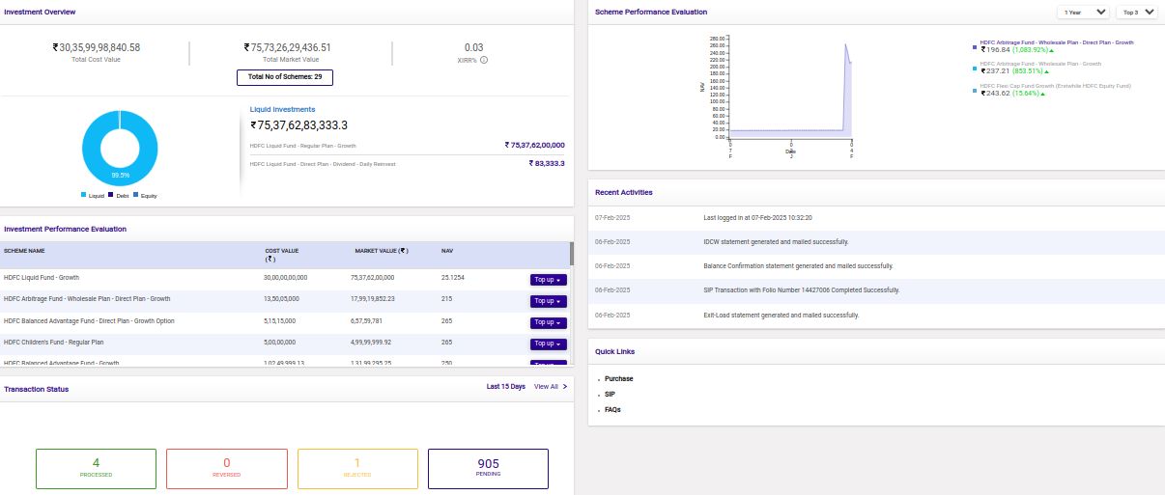
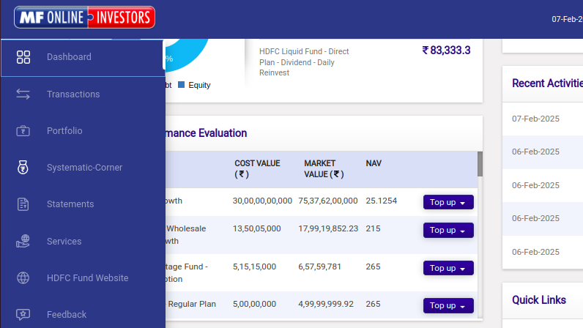
1.

