HDFC New Investor Journey After ekyc

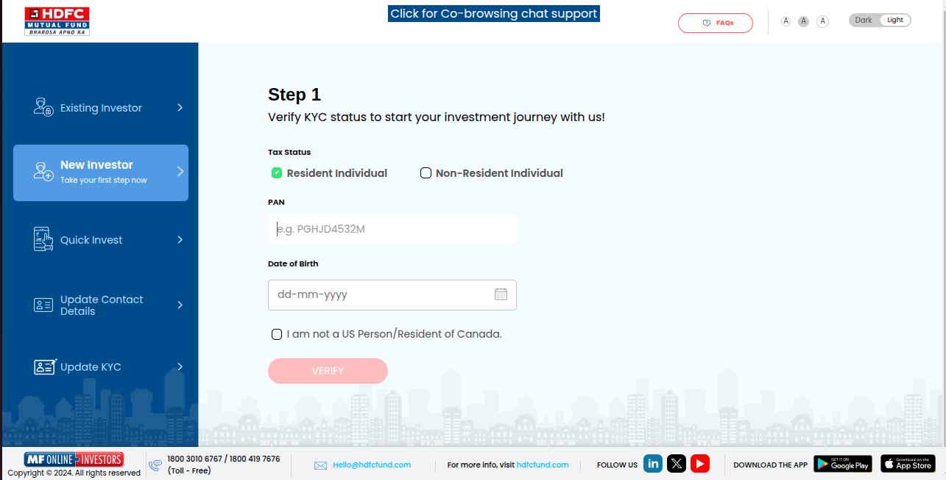

Steps -

1.Open Official Werbsite of HDFC Mutual Fund , hdfcfund.com
2.Click On new Investor
3.Step-1 page Will Open
4.We can invest throgh Resident person and Non resident person.
5.Select Tax Status ‘Resident Individual’
6.Enter Valid Pan Number (If My pan Card is Not verified So it will redirect to CAMS Portal)
Validation - Please enter valid PAN
7.Enter Valid Date OF Birth
8.Selct Checkbox (I am not a US Person/Resident of Canada)
9.After Enterning All the Details and Select Checkbox ‘Verify’ Button Will Enable
10.Click On Verify button then redirect to OTP Page
11.Enter OTP Recieved ON Mobile Number And Email ID.
12. After Submit OTP It Will Redirect to Investment Detail Page

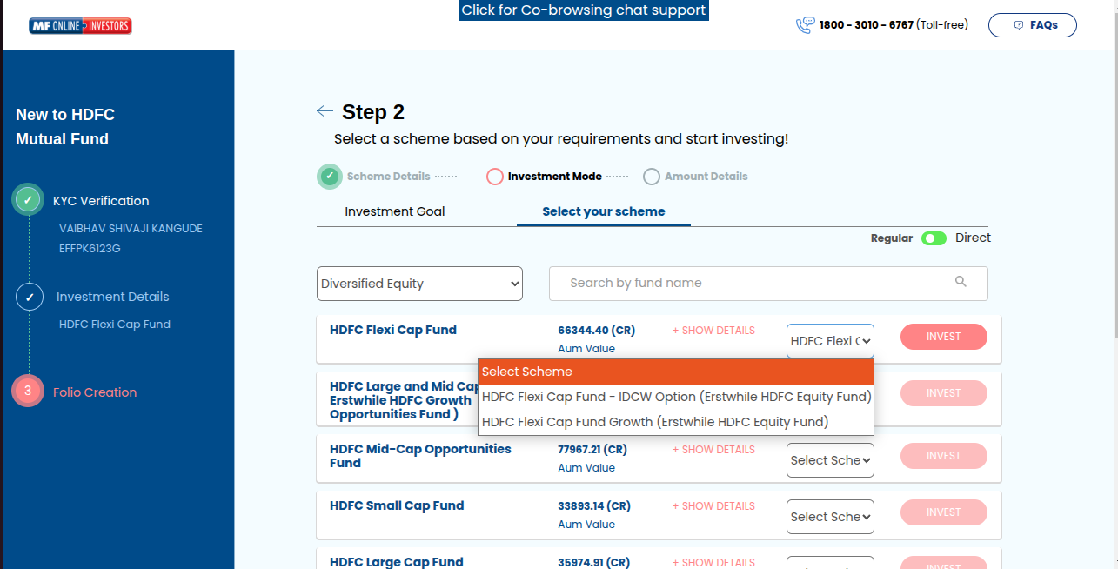
For Direct Plan

1. Select Plan i.e Direct or Regular
2. Invest Button Will Enable After Selecting scheme
3. Click On Invest Button
4. After that It will redirect to investment details page

After Selecting Direct Plan
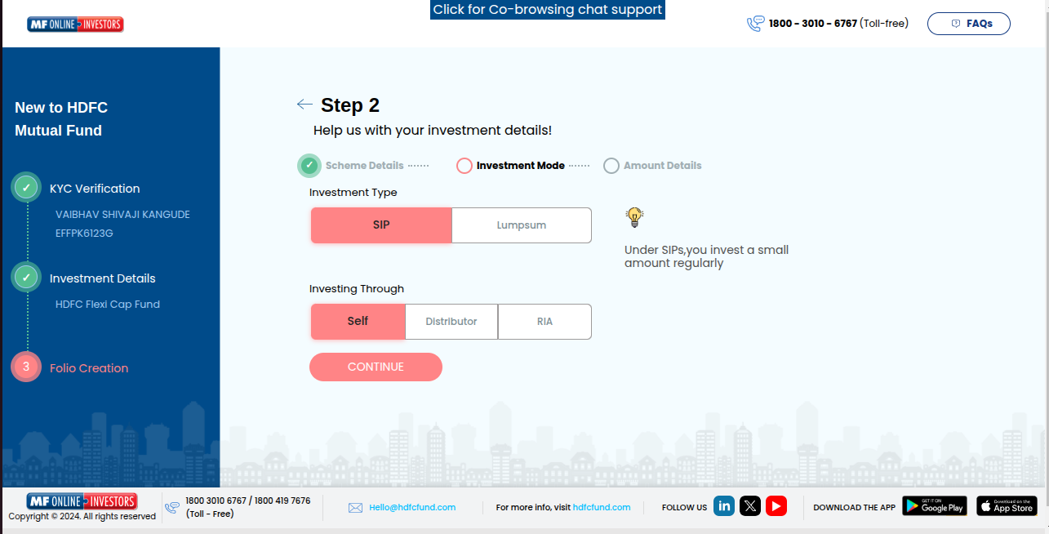
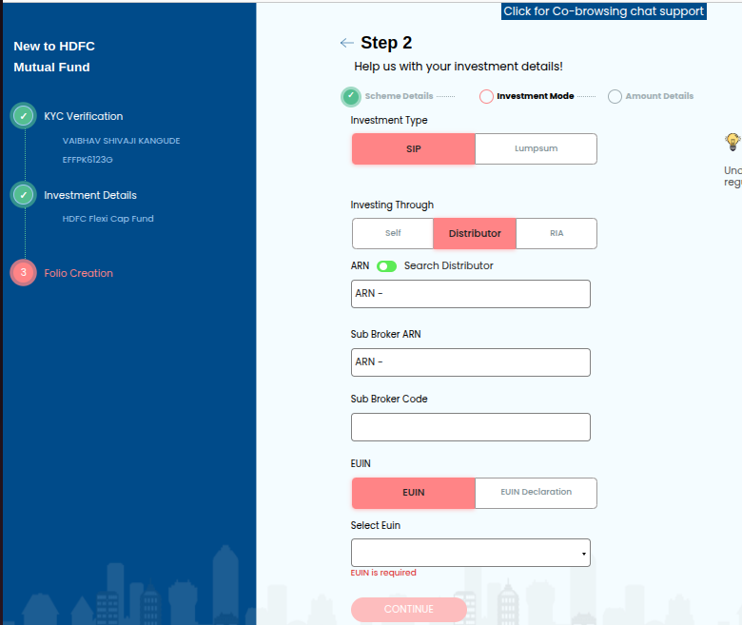
After Selecting Regular Plan

For Direct -

1. Select Investment type i.e SIP And Lumpsum
2. Investing Through Self And RIA only because we select Direct plan so distrubutor option will disable.
3. If you try to select distributor it will show below error message(‘For Direct Scheme Distributor Is Not Allowed’)
4. If You Invest throug RIA Then RIA Code enter
5. Click On Continue Button then It will Redirect to Step-2 Investment Mode Page

For Regular -
1.Investing Through Distributor only because we select Regular plan so Self and RIA option will disable.
- If try to click on Self or RIA It Will Show Error Message “For Regular Scheme Self And RIA Is Not Allowed”
1.Select Investment type i.e SIP And Lumpsum
2.Enetr ARN Manually or Search Distributor
3.If you enter wrong ARN it will show error Message (“Broker Code Is Not Valid”)
- If You Enter Valid ARN it Will Show Distributor Name(“Distributor Name : HDFC Bank Limited”)
-You can Search Distributor only through name
6.Enter Sub broker ARN
-If you enter wrong Sub ARN it will show error Message (“Broker Code Is Not Valid”)
- If You Enter Valid ARN it Will Show Distributor Name(“Sub Broker Name : HDFC Bank Limited”)
7.Enter Sub broker code(Not Mandatory)
- If You not enter subbroker ARN then Sub broker code field disable
8.Select EUIN(Employee Unique Identification Number) Options
a) If Click on EUIN Option then “Select EUIN Field ” open so Enter EUIN Number
b) If You dont have EUIN Number Then Select EUIN Declation Option
- Select Checkbox Of below Declartion
- I/We hereby confirm that the EUIN box has been intentionally left blank by me/us as this transaction is executed without any interaction or advice by the employee/relationship manager/sales person of the above distributor/sub broker or notwithstanding the advice of in-appropriateness, if any, provided by the employee/relationship manager/sales person of the distributor/sub broker.
9.Click on “Continue” Button
- Button Enable After Filling All Manadatory Fields And selecting Checkbox.

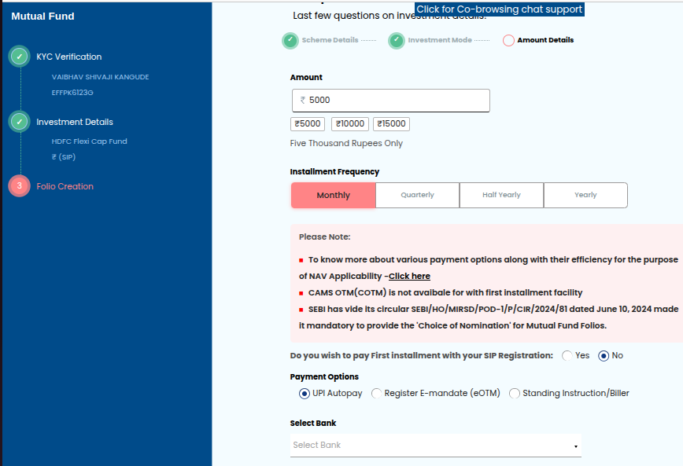
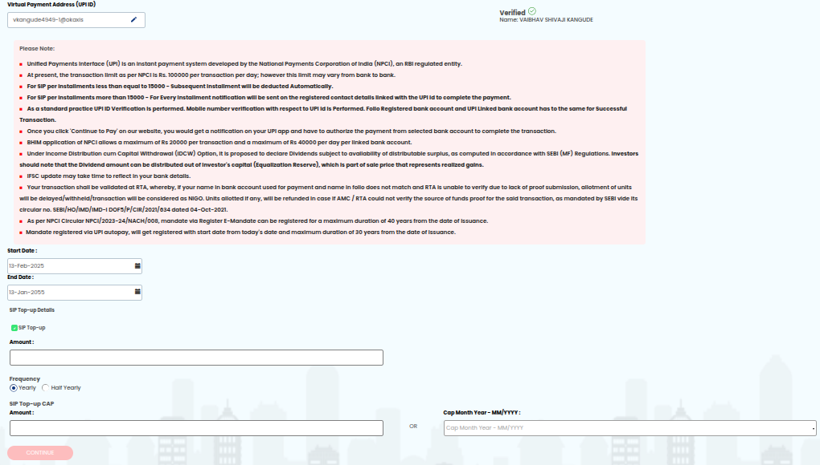

For UPI Transaction

1.In HDFC AMC There are 3 payment options UPI Auto pay,Registar E mandate,Standing Instruction/Biller.
- Based On Payment options Amount will diffrent for Quaterly,half yearly And Yearly
- I am Selcting UPI auto pay options
2.Select Instalment Frequency Monthly then enter amount
- (By default amount should be 5000)
- Min Amount 100 and As per SEBI For UPI transaction Max amount is 1 lakh
3. Select Bank
4. After Selecting Bank It will ask For UPI ID Verification(Through NPCI) so Enter UPI ID and click on verify button
5. Maximum Duration Of UPI is 30 years From the start date Of SIP
6. You can top up SIP Also, select “SIP Top-UP ” Option
7. Select Fequency (Yearly,Half Yearly)
8. Enter Top up amount (Min 100 rs Amount can top Up )
9.Enter SIP Top up cap amount Enter (top up upto whenever this amount will not fill)
- Min SIP Top Up Cap Amount will be more(i.e extra Rs 100) e.g top up amount 500 so SIP top up cap should be 600
10.Click on Continue Button, Enable After Fill all details
11. It will redirect to Folio Creation page

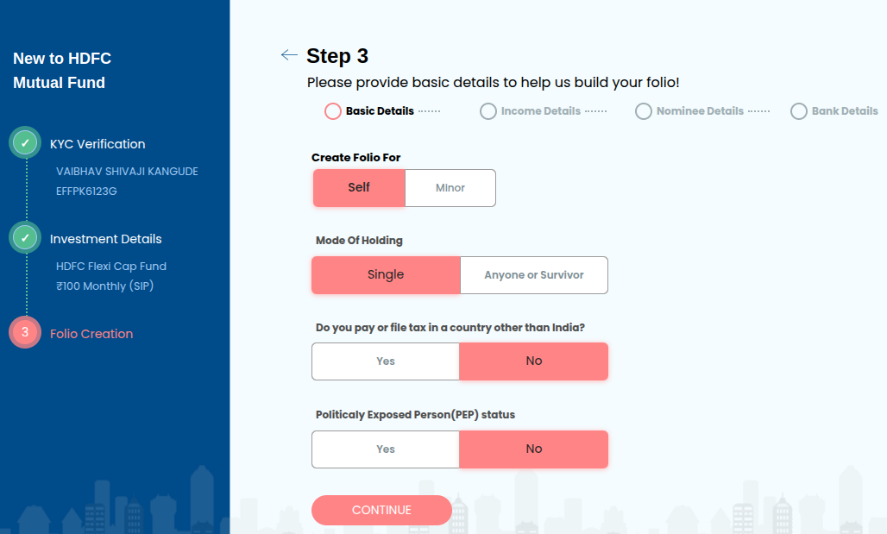
Basic Details Page -

1.In folio creation page you have to enter First Basic Details
2. Create Folio For Self (For Individual Person and Minor is For Below 18 age)
3. Mode Of Holding is Single Bydefault selected becuase i am creating folio for Self
4.Select if you are tax payer outside of india then select Yes,No options
5.If You are Political Exposed Person So select Yes,No Options
6. Click On Continue Button
7.It will Redirect to Income Details page

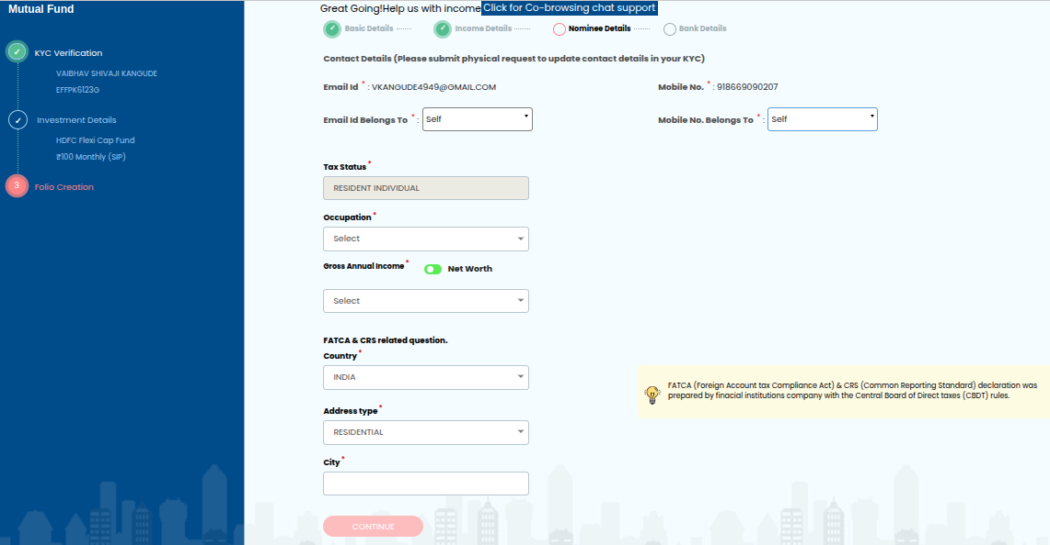

1. In income Details page first you have to select email id belongs to and mobile number belongs to (In both Options – Self,spouse,dependent children,dependent parent,guardian)
2. Tax status will auto fetch (Resident Individuals) On previous details
3. Select Occupation (Agriculturiest, Private sector,public sector.retiered ,service,student, buisiness,housewife,forex delear)
4.Select Gross anual Income(Below 1 lakh,1 to 5 lakh.... etc)
- If you click on toogle button then it will show to enter net worth(Not Older Than 1 year)
- So we Select date and enter gross anual income Manually
5. FATCA & CRS Related Questions
- Select Country
- Address Type
- City
- Then Click On Continue Button (Enable After Fill All Mandatory Details)
6. It Will redirect to Nominee Details Page

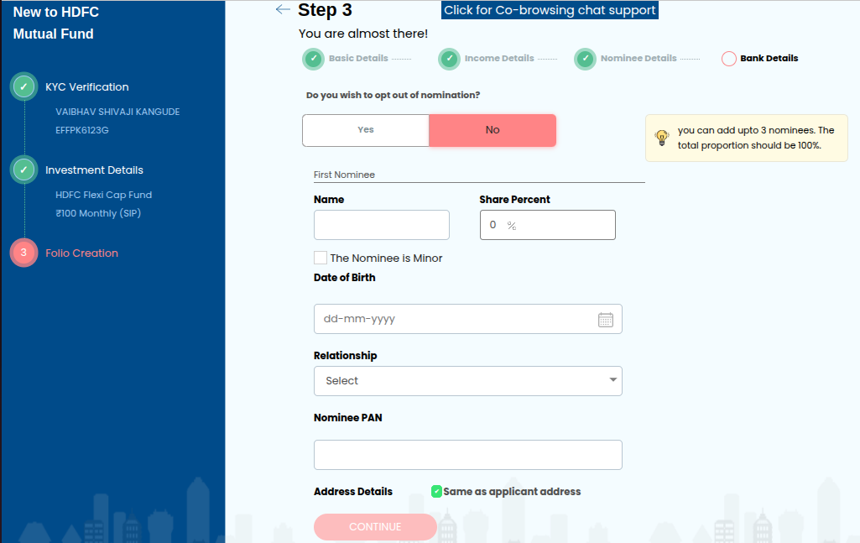
Nominee Details
A) If You want to add Nominee

1.Select Do you wish to opt out of nomination?(Yes/NO)
- If You select yes then Nominee Details Field Show
2. Enter First Name Of Nominee (You Can Add upto max 3 Nominees and total Proportion Should be 100 %)
- After 1 March 2025 as Per SEBI Rule You can add max 10 Nominees but poportion should be 100%
- Validation- Total Proportion OF nominee Should be 100
3. Enter Share of Percent (You Can Delete Nominee Also)
4. Enter DOB
5. Enter RelationShip (Father,Mother,Daughter,Spouse)
6.Enter Nominee PAN
7.Enter Adress Details(If Nominee Adress is same then select check box- Same As Applicant address)
8.If Nominee is Minor (Below 18 Age) then you have to click on checkbox
- Enter DOB OF Minor Nominee
- Enter Relationship (Son,Daughter)
- Enter Nominee Pan (Here Minor Nominee PAN is Not Mandatory But Guardian PAN is Mandatory)
- Enter Guardian Name
- Enter Guardian Relationship
- Enter Gaurdian PAN
- Enter Address details
9.Click On Continue Button
10.It will Redirect to Bank Details Page
B) If You dont Want to add Nominee then select No, then declation page will show then select check box and click on continue button and it will redirect to bank details page.
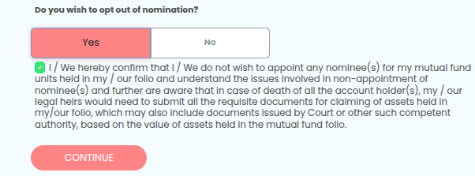

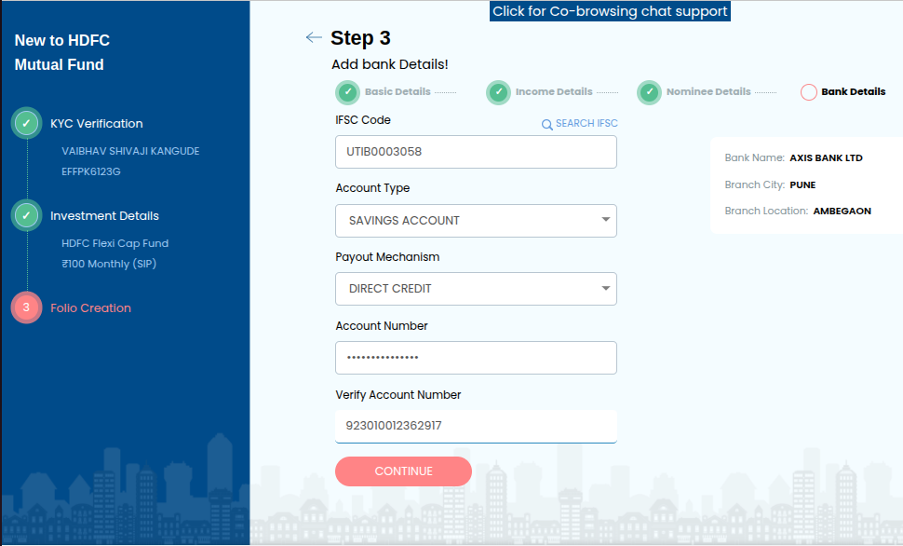
1.Enter IFSC Code by using Manually After Click on search option
2 .After Clicking on search button it will redirect to search IFSC page Open
- You can search by using IFSC and Bank Name And City Also

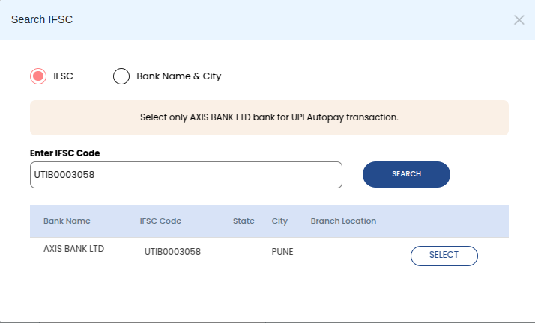
3.Enter Account type (Saving,Current, Post Office Saving Account,Saving Cum Current Account)
4.Enter Payout Mechanism(Cheque,Direct Credit)
- When You withdrawal Amount HDFC direct credit the amount to your bank or shared a cheque to your Bank for same
5.Enter Account Number
6.Verify Account Number
7. If you try to Add bank account more than 3 times this below error show
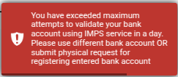

8.Click On Continue Button
9.It Will Redirect to Review

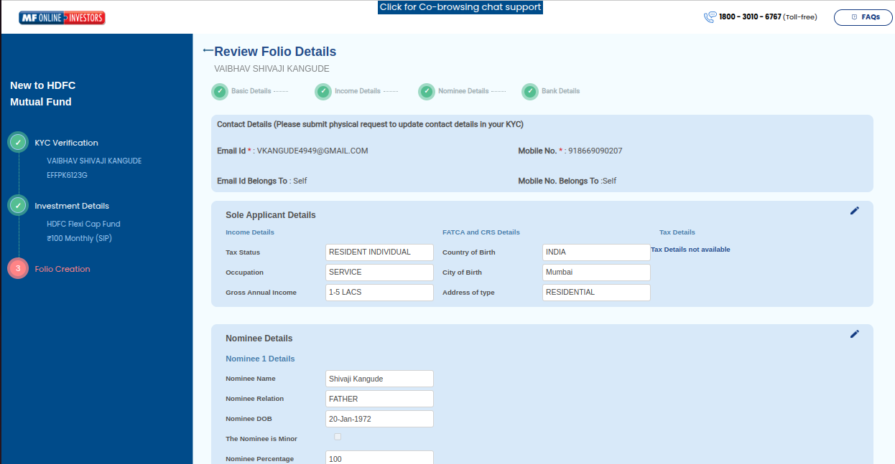
Review Folio Details Page
1. In this Page Your All Details Will Show You Can edit the details also
2. Click On Submit Button
3. System Show Popup Message (Mention that successfully created,folio number)

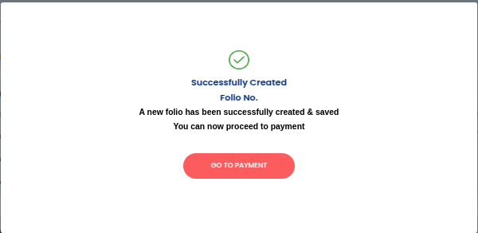
4. Click On GO TO PAYMENT Button
5. Redirect To the payment page.

