1. Write a C program to store marks for n number of student in an array and print their marks.
#include <stdio.h>
int main() {
int n, i;
printf("Enter the number of students: ");
scanf("%d", &n);
int marks[n];
printf("Enter marks for each student:\n");
for (i = 0; i < n; i++) {
printf("Student %d: ", i + 1);
scanf("%d", &marks[i]);
}
printf("\nMarks entered are:\n");
for (i = 0; i < n; i++) {
printf("Student %d: %d\n", i + 1, marks[i]);
}
return 0;
}

NAME:PRIYAM CHAKRABORTY SEC:1B ROLL:09

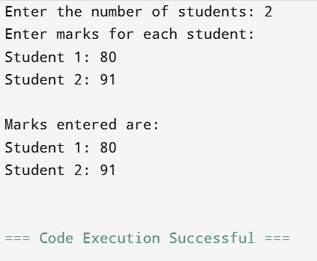

2. Write a C program which stores the marks of subject Mathematics and English of n number of students in an array and then prints their individual total marks.
#include<stdio.h>
int main() {
int n, i;
printf("Enter the number of students: ");
scanf("%d", &n);
int marks[n][2];
printf("Enter marks for each student for Mathematics and English:\n");
for (i = 0; i < n; i++) {
printf("Student %d:\n", i + 1);
printf(" Mathematics: ");
scanf("%d", &marks[i][0]);
printf(" English: ");
scanf("%d", &marks[i][1]);
}
printf("\nIndividual total marks are:\n");
for (i = 0; i < n; i++) {
int totalMarks = marks[i][0] + marks[i][1];
printf("Student %d: %d\n", i + 1, totalMarks);
}
return 0;
}
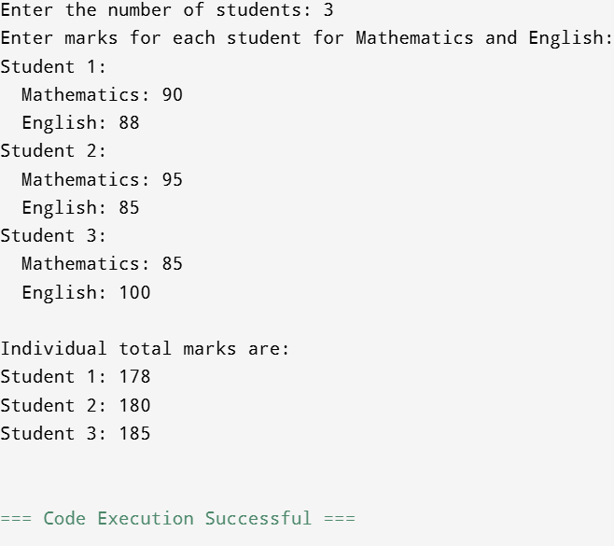
NAME:PRIYAM CHAKRABORTY SEC:1B ROLL:09

3. Write a C program to insert an element in an array in a particular position.
#include <stdio.h>
int main() {
int size, i, pos, element;
printf("Enter the size of the array: ");
scanf("%d", &size);
int arr[100];
printf("Enter %d elements:\n", size);
for (i = 0; i < size; i++) {
scanf("%d", &arr[i]);
}
printf("Enter the element to insert: ");
scanf("%d", &element);
printf("Enter the position (1 to %d) to insert the element: ", size + 1);
scanf("%d", &pos);
if (pos > 0 && pos <= size + 1) {
for (i = size; i >= pos - 1; i--) {
arr[i + 1] = arr[i];
}
arr[pos - 1] = element;
size++;
printf("The new array is: ");
for (i = 0; i < size; i++) {
printf("%d ", arr[i]);
}
printf("\n");
} else {
printf("Invalid position!\n");
}
return 0;
}

NAME:PRIYAM CHAKRABORTY SEC:1B ROLL:09
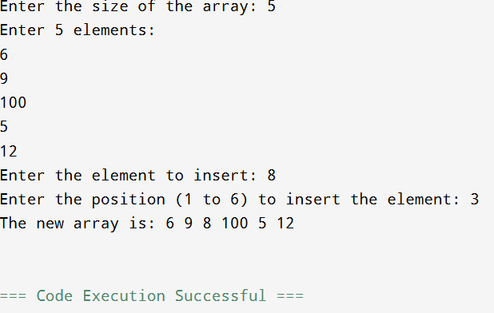

4. Write a C program to delete an element from a particular position of an array.
#include <stdio.h>
int main() {
int size, i, pos;
printf("Enter the size of the array: ");
scanf("%d", &size);
int arr[100];
printf("Enter %d elements:\n", size);
for (i = 0; i < size; i++) {
scanf("%d", &arr[i]);
}
printf("Enter the position (1 to %d) of the element to delete: ", size);
scanf("%d", &pos);
if (pos > 0 && pos <= size) {
for (i = pos - 1; i < size - 1; i++) {
arr[i] = arr[i + 1];
}
size--;
printf("The new array is: ");
for (i = 0; i < size; i++) {
printf("%d ", arr[i]);
}
printf("\n");
} else {
printf("Invalid position!\n");
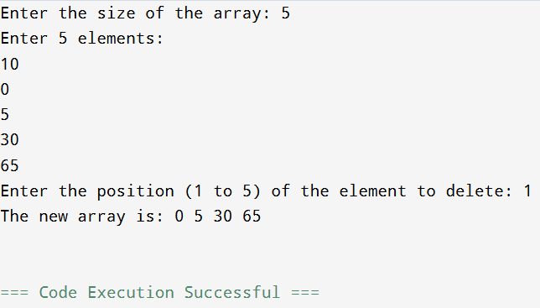
}
return 0;
}
NAME:PRIYAM CHAKRABORTY
SEC:1B ROLL:09
5. Write a C program to convert a decimal number taken as input from user to corresponding binary number and store the result in an array.
#include <stdio.h>
int main() {
int decimal_num, binary_num[32], i = 0;
printf("Enter a decimal number: ");
scanf("%d", &decimal_num);
if (decimal_num == 0) {
printf("Binary number: 0\n");
} else {
while (decimal_num > 0) {
binary_num[i] = decimal_num % 2;
decimal_num = decimal_num / 2;
i++;
}
printf("Binary number: ");
for (int j = i - 1; j >= 0; j--) {
printf("%d", binary_num[j]);
}
printf("\n");
}
return 0;
}

NAME:PRIYAM CHAKRABORTY SEC:1B ROLL:09

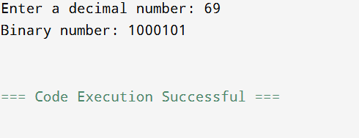

6. Write a C program to input a binary number in an array and convert into corresponding decimal number.
#include <stdio.h>
#include <string.h>
#include <math.h>
int main() {
char binary_str[32];
int len, decimal_num = 0, power = 0, i;
printf("Enter a binary number: ");
scanf("%s", binary_str);
len = strlen(binary_str);
for (i = len - 1; i >= 0; i--) {
if (binary_str[i] == '1') {
decimal_num += pow(2, power);
}
power++;
}
printf("The decimal equivalent is: %d\n", decimal_num);
return 0;
}

NAME:PRIYAM CHAKRABORTY SEC:1B ROLL:09

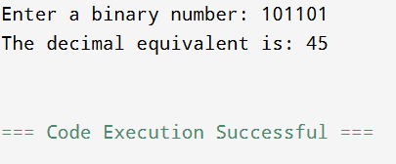

7. Write a C program to find the smallest and the largest elements in an array.

#include <stdio.h>
int main() {
int size, i;
printf("Enter the size of the array: ");
scanf("%d", &size);
int arr[size];
printf("Enter %d elements:\n", size);
for (i = 0; i < size; i++) {
scanf("%d", &arr[i]);
}
int smallest = arr[0];
int largest = arr[0];
for (i = 1; i < size; i++) {
if (arr[i] < smallest) {
smallest = arr[i];
}
if (arr[i] > largest) {
largest = arr[i];
}
} printf("The smallest element is: %d\n", smallest);
printf("The largest element is: %d\n", largest);
return 0;
}
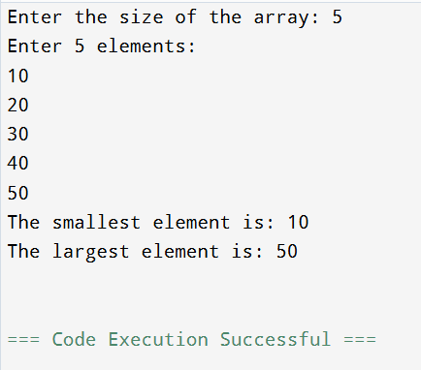

NAME:PRIYAM CHAKRABORTY SEC:1B ROLL:09

8. Write a C program for deleting duplicate elements in an array.
#include <stdio.h>
int main() {
int n;
printf("Enter the size of the array: ");
scanf("%d", &n);
int arr[n];
printf("Enter the elements of the array:\n");
for (int i = 0; i < n; i++) {
scanf("%d", &arr[i]);
}
for (int i = 0; i < n; i++) {
for (int j = i + 1; j < n; j++) {
if (arr[i] == arr[j]) {
for (int k = j; k < n - 1; k++) {
arr[k] = arr[k + 1];
}
n--;
j--;
}
}
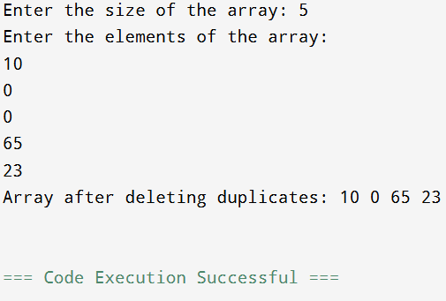
}
printf("Array after deleting duplicates: ");
for (int i = 0; i < n; i++) {
printf("%d ", arr[i]);
}
printf("\n");
return 0;
}
NAME:PRIYAM CHAKRABORTY SEC:1B ROLL:09
9. Write a C program to search for a particular element in an array.
#include <stdio.h>
int main() {
int size, i, search_element, found_index = -1;
printf("Enter the size of the array: ");
scanf("%d", &size);
int arr[size];
printf("Enter %d elements:\n", size);
for (i = 0; i < size; i++) {
scanf("%d", &arr[i]);
}
printf("Enter the element to search for: ");
scanf("%d", &search_element);
for (i = 0; i < size; i++) {
if (arr[i] == search_element) {
found_index = i;
break;
}
}
if (found_index != -1) {
printf("Element found at index: %d\n", found_index);
} else {
printf("Element not found in the array.\n");
}
return 0;
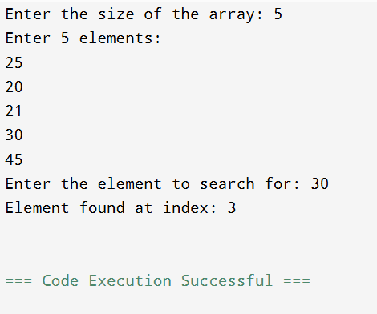
}

NAME:PRIYAM CHAKRABORTY SEC:1B ROLL:09

10. Write a C program to sort n elements (ascending order).
#include <stdio.h>
int main() {
int n, i, j, temp;
printf("Enter the number of elements: ");
scanf("%d", &n);
int arr[n];
printf("Enter %d elements:\n", n);
for (i = 0; i < n; i++) {
scanf("%d", &arr[i]);
}
for (i = 0; i < n - 1; i++) {
for (j = 0; j < n - i - 1; j++) {
if (arr[j] > arr[j + 1]) {
temp = arr[j];
arr[j] = arr[j + 1];
arr[j + 1] = temp;
}
}
}
printf("Sorted array in ascending order: ");
for (i = 0; i < n; i++) {
printf("%d ", arr[i]);
}
printf("\n");
return 0;
}
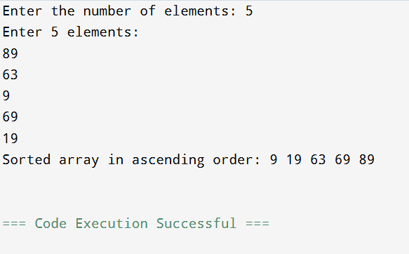

NAME:PRIYAM CHAKRABORTY SEC:1B ROLL:09
11. Write a C program to find second highest number from the array without using sorting.
#include <stdio.h>
int main() {
int n, i;
printf("Enter the number of elements: ");
scanf("%d", &n);
if (n < 2) {
printf("Array must have at least two elements.\n");
return 1;
}
int arr[n];
printf("Enter %d elements:\n", n);
for (i = 0; i < n; i++) {
scanf("%d", &arr[i]);
}
int first_highest = arr[0];
int second_highest = arr[0];
for (i = 1; i < n; i++) {
if (arr[i] > first_highest) {
second_highest = first_highest;
first_highest = arr[i];
} else if (arr[i] > second_highest && arr[i] < first_highest) {
second_highest = arr[i];
}
}
if (first_highest == second_highest) {
printf("There is no second highest element as all elements are the same.\n");
} else {
printf("The second highest number is: %d\n", second_highest);
}
return 0;
}

NAME:PRIYAM CHAKRABORTY SEC:1B ROLL:09

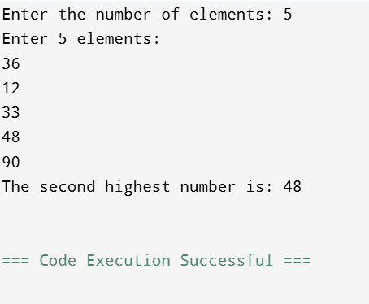

12. Write a C program to perform addition and subtraction between two matrices.
#include <stdio.h>
int main() {
int rows, cols, i, j;
printf("Enter the number of rows: ");
scanf("%d", &rows);
printf("Enter the number of columns: ");
scanf("%d", &cols);
int matrix1[rows][cols], matrix2[rows][cols], sum_matrix[rows][cols], diff_matrix[rows][cols];
printf("Enter elements of the first matrix:\n");
for (i = 0; i < rows; i++) {
for (j = 0; j < cols; j++) {
scanf("%d", &matrix1[i][j]);
}
}
printf("Enter elements of the second matrix:\n");
for (i = 0; i < rows; i++) {
for (j = 0; j < cols; j++) {
scanf("%d", &matrix2[i][j]);
}
}
for (i = 0; i < rows; i++) {
for (j = 0; j < cols; j++) {
sum_matrix[i][j] = matrix1[i][j] + matrix2[i][j];
diff_matrix[i][j] = matrix1[i][j] - matrix2[i][j];
}
}
printf("\nSum of the matrices:\n");
for (i = 0; i < rows; i++) {
for (j = 0; j < cols; j++) {
printf("%d\t", sum_matrix[i][j]);
}
printf("\n");
}
printf("\nDifference of the matrices:\n");
for (i = 0; i < rows; i++) {
for (j = 0; j < cols; j++) {
printf("%d\t", diff_matrix[i][j]);
}
printf("\n");
}
return 0;
}
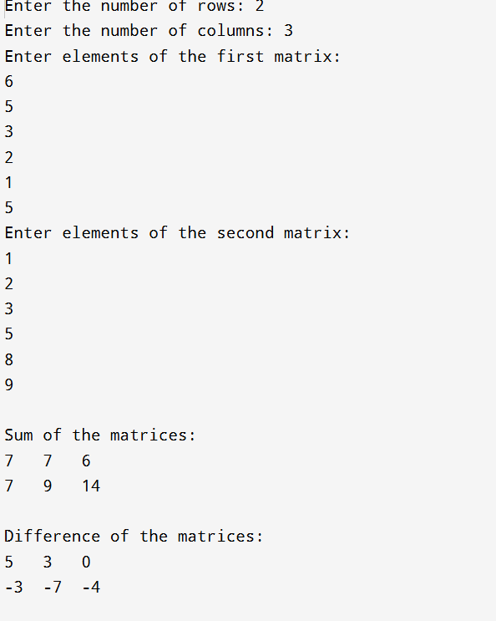
NAME:PRIYAM CHAKRABORTY SEC:1B ROLL:09

13. Write a C program to transpose a matrix.
#include <stdio.h>
int main() {
int rows, cols, i, j;
printf("Enter the number of rows: ");
scanf("%d", &rows);
printf("Enter the number of columns: ");
scanf("%d", &cols);
int matrix[rows][cols], transpose[cols][rows];
printf("Enter elements of the matrix:\n");
for (i = 0; i < rows; i++) {
for (j = 0; j < cols; j++) {
scanf("%d", &matrix[i][j]);
}
}
for (i = 0; i < rows; i++) {
for (j = 0; j < cols; j++) {
transpose[j][i] = matrix[i][j];
}
}
printf("\nOriginal Matrix:\n");
for (i = 0; i < rows; i++) {
for (j = 0; j < cols; j++) {
printf("%d\t", matrix[i][j]);
}
printf("\n");
}
printf("\nTransposed Matrix:\n");
for (i = 0; i < cols; i++) {
for (j = 0; j < rows; j++) {
printf("%d\t", transpose[i][j]);
}
printf("\n");
}
return 0;
}

NAME:PRIYAM CHAKRABORTY SEC:1B ROLL:09
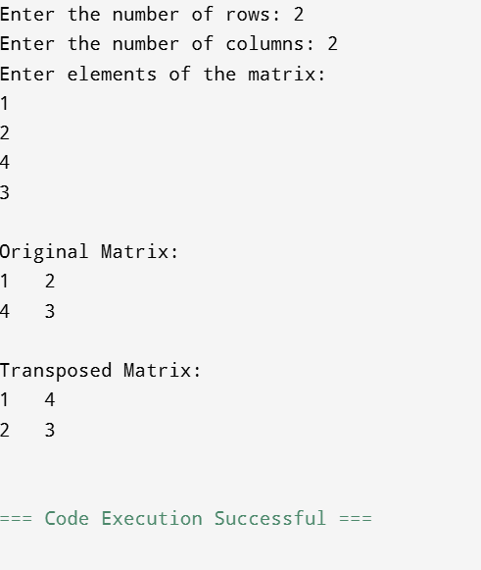

14. Write a C program to add the elements of each row and each column of a matrix.
#include <stdio.h>
int main() {
int rows, cols, i, j, row_sum, col_sum;
printf("Enter the number of rows: ");
scanf("%d", &rows);
printf("Enter the number of columns: ");
scanf("%d", &cols);
int matrix[rows][cols];
printf("Enter elements of the matrix:\n");
for (i = 0; i < rows; i++) {
for (j = 0; j < cols; j++) {
scanf("%d", &matrix[i][j]);
}
}
printf("\nRow Sums:\n");
for (i = 0; i < rows; i++) {
row_sum = 0;
for (j = 0; j < cols; j++) {
row_sum += matrix[i][j];
}
printf("Sum of Row %d: %d\n", i + 1, row_sum);
}

printf("\nColumn Sums:\n");
for (j = 0; j < cols; j++) {
col_sum = 0;
for (i = 0; i < rows; i++) {
col_sum += matrix[i][j];
}
printf("Sum of Column %d: %d\n", j + 1, col_sum);
}
return 0;
}

NAME:PRIYAM CHAKRABORTY SEC:1B ROLL:09

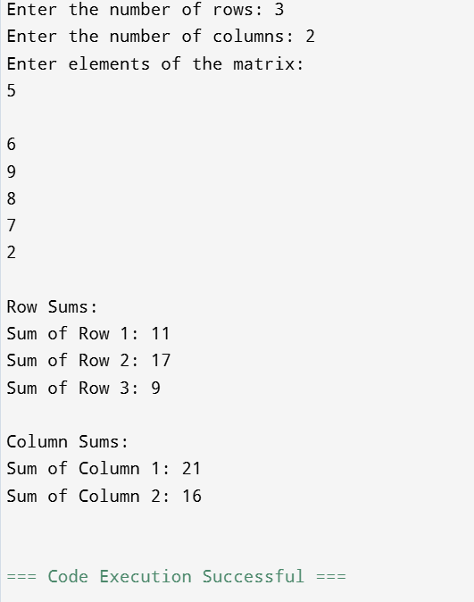

15. Write a C program to perform the multiplication of two matrices.
#include <stdio.h>
int main() {
int r1, c1, r2, c2, i, j, k;
printf("Enter rows and columns for first matrix: ");
scanf("%d %d", &r1, &c1);
printf("Enter rows and columns for second matrix: ");
scanf("%d %d", &r2, &c2);
if (c1 != r2) {
printf("Matrices cannot be multiplied.\n");
return 1;
}
int matrix1[r1][c1], matrix2[r2][c2], result[r1][c2];
printf("\nEnter elements of first matrix:\n");
for (i = 0; i < r1; ++i) {
for (j = 0; j < c1; ++j) {
scanf("%d", &matrix1[i][j]);
}
}
printf("\nEnter elements of second matrix:\n");
for (i = 0; i < r2; ++i) {
for (j = 0; j < c2; ++j) {
scanf("%d", &matrix2[i][j]);
}
}
for (i = 0; i < r1; ++i) {
for (j = 0; j < c2; ++j) {
result[i][j] = 0;
for (k = 0; k < c1; ++k) {
result[i][j] += matrix1[i][k] * matrix2[k][j];
}
}
}
printf("\nResultant matrix:\n");
for (i = 0; i < r1; ++i) {
for (j = 0; j < c2; ++j) {
printf("%d\t", result[i][j]);
}
printf("\n");
}
return 0;
}

NAME:PRIYAM CHAKRABORTY SEC:1B ROLL:09

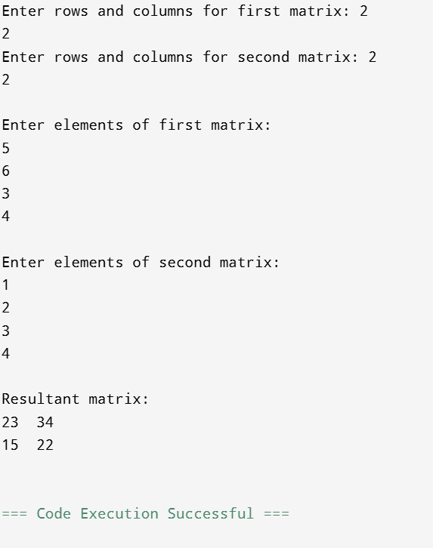

1

16. Write a C program to check whether a matrix is identity matrix or not.
#include <stdio.h>
int main() {
int rows, cols, i, j, is_identity = 1;
printf("Enter the number of rows: ");
scanf("%d", &rows);
printf("Enter the number of columns: ");
scanf("%d", &cols);
if (rows != cols) {
printf("The matrix is not a square matrix, so it cannot be an identity matrix.\n");
return 0;
}
int matrix[rows][cols];
printf("Enter elements of the matrix:\n");
for (i = 0; i < rows; i++) {
for (j = 0; j < cols; j++) {
scanf("%d", &matrix[i][j]);
}
}
for (i = 0; i < rows; i++) {
for (j = 0; j < cols; j++) {
if (i == j) {
if (matrix[i][j] != 1) {
is_identity = 0;
break;
}
} else {
if (matrix[i][j] != 0) {
is_identity = 0;
break;
}
}
}
if (is_identity == 0) {
break;
}
}
if (is_identity == 1) {
printf("The matrix is an identity matrix.\n");
} else {
printf("The matrix is not an identity matrix.\n");
}
return 0;
}

NAME:PRIYAM CHAKRABORTY SEC:1B ROLL:09

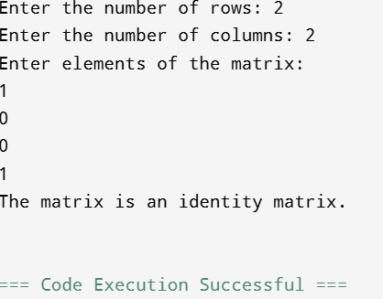

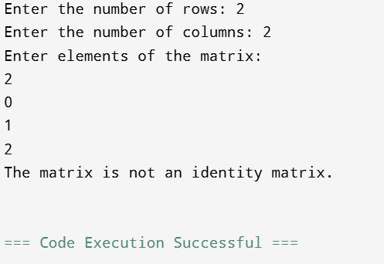

17. Write a C program to check whether a matrix is sparse matrix or not.
#include <stdio.h>
int main() {
int rows, cols, i, j, zero_count = 0;
printf("Enter the number of rows: ");
scanf("%d", &rows);
printf("Enter the number of columns: ");
scanf("%d", &cols);
int matrix[rows][cols];
printf("Enter elements of the matrix:\n");
for (i = 0; i < rows; i++) {
for (j = 0; j < cols; j++) {
scanf("%d", &matrix[i][j]);
}
}
for (i = 0; i < rows; i++) {
for (j = 0; j < cols; j++) {
if (matrix[i][j] == 0) {
zero_count++;
}
}
}
if (zero_count > (rows * cols) / 2) {
printf("The matrix is a sparse matrix.\n");
} else {
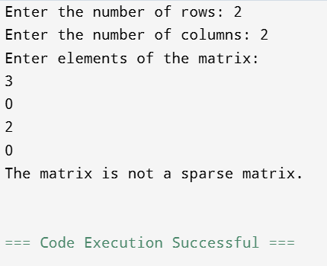
printf("The matrix is not a sparse matrix.\n");
}
return 0;}

18. Write a C program to create a structure named company which has name, address, phone and no of employee as member variables. Read name of company, its address, phone and no of Employee. Finally display these members’ value.
#include <stdio.h>
#include <string.h>
struct company {
char name[50];
char address[100];
char phone[15];
int no_of_employee;
};
int main() {
struct company c1;
printf("Enter company name: ");
fgets(c1.name, sizeof(c1.name), stdin);
c1.name[strcspn(c1.name, "\n")] = '\0';
printf("Enter company address: ");
fgets(c1.address, sizeof(c1.address), stdin);
c1.address[strcspn(c1.address, "\n")] = '\0';
printf("Enter phone number: ");
scanf("%s", c1.phone);
printf("Enter number of employees: ");
scanf("%d", &c1.no_of_employee);
printf("\nCompany Details:\n");
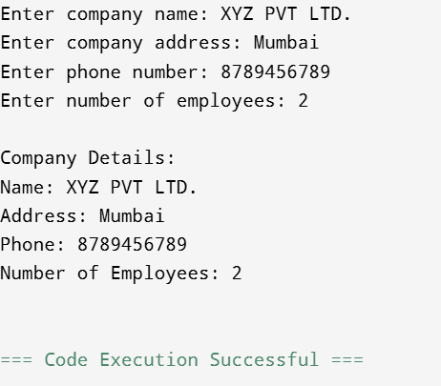
printf("Name: %s\n", c1.name);
printf("Address: %s\n", c1.address);
printf("Phone: %s\n", c1.phone);
printf("Number of Employees: %d\n", c1.no_of_employee);
return 0;
19. Define a structure “complex” (typedef) to read two complex numbers and perform addition, subtraction of these two complex numbers and display the result.
#include <stdio.h>
typedef struct {
float real;
float imag;
} complex;
int main() {
complex c1, c2, sum, diff;
printf("Enter the real and imaginary parts of the first complex number:\n");
scanf("%f %f", &c1.real, &c1.imag);
printf("Enter the real and imaginary parts of the second complex number:\n");
scanf("%f %f", &c2.real, &c2.imag);
sum.real = c1.real + c2.real;
sum.imag = c1.imag + c2.imag;
diff.real = c1.real - c2.real;
diff.imag = c1.imag - c2.imag;
printf("\nSum = %.2f + %.2fi\n", sum.real, sum.imag);
printf("Difference = %.2f + %.2fi\n", diff.real, diff.imag);
return 0;
}

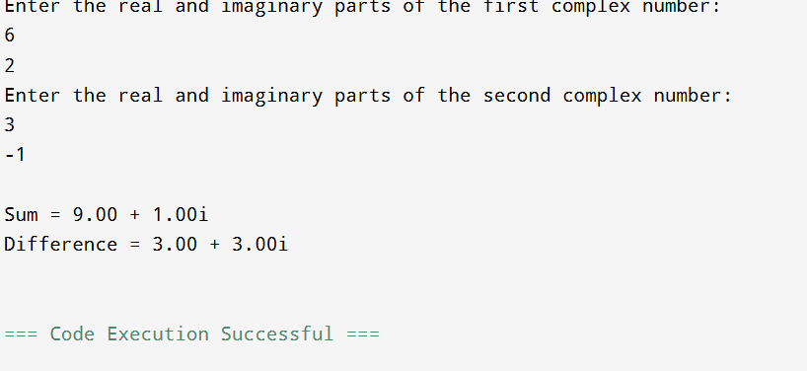

20. Write a C program to read Roll No, Name, Address, and Age marks of 12 students in the MCA class and display the details from the function.
#include <stdio.h>
#include <string.h>
struct Student {
int roll_no;
char name[50];
char address[100];
int age;
};
void display_details(struct Student students[], int size) {
int i;
printf("\nStudent Details:\n");
for (i = 0; i < size; i++) {
printf("Student %d:\n", i + 1);
printf("Roll No: %d\n", students[i].roll_no);
printf("Name: %s\n", students[i].name);
printf("Address: %s\n", students[i].address);
printf("Age: %d\n\n", students[i].age);
}
}
int main() {
struct Student students[12];
int i;
for (i = 0; i < 12; i++) {
printf("Enter details for student %d:\n", i + 1);
printf("Roll No: ");
scanf("%d", &students[i].roll_no);
getchar();
printf("Name: ");
fgets(students[i].name, sizeof(students[i].name), stdin);
students[i].name[strcspn(students[i].name, "\n")] = '\0';
printf("Address: ");
fgets(students[i].address, sizeof(students[i].address), stdin);
students[i].address[strcspn(students[i].address, "\n")] = '\0';
printf("Age: ");
scanf("%d", &students[i].age);
getchar();
}
display_details(students, 12);
return 0;
}

