Solution Overview
What is your proposed solution? Our proposed solution, Talent OS, is an enterprise-grade AI Talent Intelligence Platform designed to transform static candidate data into dynamic, actionable insights. Rather than acting as a simple digital filing cabinet like traditional Applicant Tracking Systems (ATS), our platform actively ingests complex candidate profiles, cleans and standardizes the data through a custom pipeline, and applies machine learning to actively evaluate the talent pool. It provides recruiters with an interactive "Command Center" dashboard where they can instantly run semantic Job Description (JD) matching, visualize comprehensive "Talent Scores" via interactive charts, and confidently identify top candidates through a 360-degree profile view.
What differentiates your approach from traditional candidate matching systems? Traditional systems rely heavily on rigid keyword matching and Boolean searches. This outdated approach often penalizes capable candidates who use synonymous terms or possess highly transferable skills from different domains. Talent OS differentiates itself in three critical ways:
- Semantic Intent vs. Keyword Search (The "Hidden Talent" Engine): We leverage advanced Natural Language Processing (Hugging Face Sentence-Transformers) to map the semantic meaning of a target JD against a candidate’s holistic profile. This uncovers "Hidden Talent"—candidates with high latent synergy who might lack specific buzzwords but possess the exact conceptual experience required.
- Multi-Faceted, Holistic Scoring: Instead of providing a single arbitrary match percentage, our engine computes a composite "Talent Score." This score balances Semantic Overlap (40%), Learning Velocity (30%—a proprietary metric analyzing a candidate's speed of skill acquisition and profile growth), and Market Value Alignment (30%—benchmarking expected salaries against predicted market rates).
- Transparent Explainability: While many modern AI recruiting tools are "black boxes," our system explicitly breaks down the reasoning behind every score. Through visual UI components and deterministic justifications (e.g., explicitly stating "High Semantic Overlap" based on cosine similarity thresholds), we ensure recruiters understand exactly why a candidate was recommended, completely avoiding the risks of generative AI hallucinations.

JD Understanding & Candidate Evaluation
What are the key requirements extracted from the JD? Unlike legacy Applicant Tracking Systems that attempt to parse Job Descriptions (JDs) using rigid Named Entity Recognition (NER) to pull out specific bullet points, our system processes the JD text holistically. Rather than manually extracting individual requirements, we pass the entire, raw JD text pasted by the user directly into a pre-trained NLP model (all-MiniLM-L6-v2). This allows the system to implicitly capture the core requirements—including the technical domain, necessary tooling, and conceptual context—by converting the entire job description into a dense mathematical vector embedding.
Which candidate signals are most important for determining relevance? / How does your solution evaluate candidate fit beyond keyword matching? In our platform's semantic engine, the most critical candidate signals for determining relevance are the candidate's Headline and Professional Summary.
- The Text Payload: During a JD Match analysis, the system concatenates the candidate's headline and summary into a single text payload. This narrative is converted into an embedding and compared against the JD.
- Evaluating Beyond Keywords: Our solution bypasses the limitations of traditional keyword matching by relying entirely on the high-dimensional vector space mapped by Hugging Face Sentence-Transformers. If a Job Description asks for "Frontend Architecture Experience" and a candidate's summary states they "Built scalable UI state management systems," a traditional keyword scanner would reject them for missing the exact buzzwords. However, our algorithm evaluates the cosine similarity between the two text embeddings. It mathematically recognizes that those phrases share a high degree of semantic overlap and intent, allowing the system to accurately surface highly capable candidates who might just use different terminology.

Ranking Methodology
How does your system retrieve, score, and rank candidates? When a user inputs a target Job Description (JD) into the Talent OS dashboard, the system retrieves pre-processed candidate profiles from our consolidated Master DataFrame (an amalgamation of career history, education, skills, and assessments). It then scores every candidate in the database against the JD by generating dense vector embeddings for both the job text and the candidate's holistic text profile (e.g., headline, summary, and experience). By calculating the mathematical distance between these vectors, the system generates a "Hidden Talent Match Score." Finally, candidates are ranked in descending order on our enterprise leaderboard, and the user can instantly filter the ranked list by specific score thresholds (e.g., >80%, >60%).
What models, algorithms, or heuristics are used? Our ranking methodology relies on a hybrid of state-of-the-art NLP models and deterministic heuristics:
- Models: We use the Hugging Face Sentence-Transformers library (specifically the all-MiniLM-L6-v2 model) to create high-quality semantic embeddings. This lightweight, highly efficient NLP model maps sentences into a 384-dimensional vector space.
- Algorithms: We utilize cosine_similarity (from scikit-learn) to measure the geometric angle between the JD embedding and the candidate profile embedding. A smaller angle (closer to 1.0) represents high semantic overlap, effectively matching underlying intent rather than just keywords.
- Heuristics: We complement the ML models with robust rule-based heuristics. For instance, the "Learning Velocity" metric is calculated using weighted linear heuristics: average cognitive assessment scores (25%), GitHub activity (20%), profile completeness (15%), interview completion rates (15%), and certification counts.
How are multiple candidate signals combined into a final ranking? To ensure that candidates are ranked on a holistic foundation rather than just a single text-matching score, our system combines multiple specialized data signals into a final, overarching Talent Score. The final ranking is a weighted aggregation of three distinct metrics:
- Semantic Match (40%): The NLP-driven cosine similarity score representing how well their latent skills align with the specific JD.
- Learning Velocity (30%): Our heuristic metric measuring the candidate's speed of skill acquisition, continuous education (certifications), and technical engagement (GitHub activity).
- Market Alignment (30%): A numerical evaluation derived from our market_value_predictor engine, which benchmarks the candidate’s expected salary against predictive market rates to ensure hiring viability.
By fusing these signals, Talent OS produces a final rank that accounts for capability, continuous growth, and budget alignment simultaneously.

Explainability & Data Validation
How are ranking decisions explained?
Our platform embraces a "glass-box" approach rather than a black-box approach.
- Global Ranking Explainability: For the overarching leaderboard, candidates are ranked using an explicit "Talent Score." In the Candidate 360 Profile view, recruiters can see the exact breakdown of this score across individual, quantifiable metrics (e.g., Average Assessment Score, GitHub Activity, and Profile Completeness).
- AI Match Reasoning: In the JD Match workflow, every score is accompanied by an "AI Match Reasoning" expander. Based on strict mathematical thresholds (the cosine similarity metric), the UI provides a deterministic explanation—explicitly classifying the semantic overlap as "High," "Moderate," or "Low" so the recruiter understands exactly how closely the candidate's core background aligns with the job description.

How do you prevent hallucinations or unsupported justifications?
Our system entirely eliminates the risk of AI hallucination by avoiding Generative LLMs (like ChatGPT) for candidate evaluation or justification writing. Instead, the NLP layer (Sentence-Transformers) is used exclusively for generating dense mathematical vector embeddings. The actual matching and ranking are driven by deterministic geometry (cosine_similarity). Because the justifications rendered in the UI are pre-written and triggered strictly by bounded numerical thresholds (e.g., if score >= 80), the system cannot invent fake skills, fabricate work history, or generate unsupported justifications for why a candidate was ranked highly.

How does your solution handle inconsistent, low-quality, or suspicious profiles?
Inconsistent and low-quality data is aggressively managed by our dedicated pre-processing pipeline (data_cleaning.py) before it ever reaches the ranking engine:
- Inconsistencies: The pipeline automatically standardizes messy text inputs (e.g., aggressive stripping, lowercasing, and normalizing skill names) to ensure identical skills are evaluated correctly. It also automatically scrubs duplicate records across all tables.
- Low-Quality Profiles: Missing data is handled systematically. Missing numeric fields are either zeroed out (e.g., missing endorsements) or replaced with median interpolations (e.g., years of experience). More importantly, the system calculates a profile_completeness_score. Candidates with sparse, thin, or low-quality profiles receive a significantly lower completeness score, which mathematically penalizes their final global Talent Score and pushes them down the ranking.

End-to-End Workflow
What is the complete workflow from JD input to ranked candidate output? The workflow seamlessly bridges the gap between the intuitive frontend UI and the complex machine learning backend:
- User Input (The Trigger): A recruiter navigates to the "JD Scoring Engine" tab on the Streamlit dashboard and pastes a raw, unstructured Job Description into the text area.
- Target Vectorization (JD Embedding): Once the user clicks "Analyze Candidates," the backend intercepts the text and passes it through the Hugging Face Sentence-Transformer model. This converts the entire JD into a 384-dimensional dense vector, capturing its semantic intent.
- Candidate Data Retrieval: Simultaneously, the system queries the pre-processed Master DataFrame (which has already been cleaned and merged by our data_cleaning.py pipeline) to retrieve the holistic text profiles (Headline + Summary) for every candidate in the database.
- Candidate Vectorization: The system runs the candidate profiles through the same Sentence-Transformer model to generate their corresponding dense vectors.
- Similarity Computation (The Engine): The backend leverages Scikit-Learn to compute the mathematical cosine_similarity between the single JD vector and the array of candidate vectors, scaling the geometric distance into an intuitive 0–100% "Match Score".
- Ranking & Sorting: The backend dynamically generates a new results DataFrame, appending the Match Scores and sorting the entire talent pool in descending order (highest semantic overlap at the top).
- UI Rendering & Interaction (The Output): The sorted results are pushed back to the frontend. The Streamlit UI dynamically renders an interactive, enterprise-styled list view showing candidate names, experience, and visual progress bars for their scores. The recruiter can then instantly filter this ranked output using built-in threshold selectors (e.g., "Score > 80") and export the final shortlist to CSV.

System Architecture
The Talent OS platform is built on a highly modular, decoupled architecture that separates data ingestion, machine learning, and frontend presentation to ensure maximum scalability and performance. The system is divided into four distinct layers:
1. Data Storage & Ingestion Layer
- Source Engine: The architecture begins with a robust ingestion engine (candidates_df.py) designed to parse deeply nested, unstructured candidate data (JSON format).
- Relational Structuring: The parser extracts the raw data and normalizes it into distinct, highly structured relational tables (Candidates, Career History, Education, Skills, Assessments) stored locally (which can be easily scaled to cloud storage like AWS S3 or GCS).
2. Processing & ETL Layer
- Framework: Powered entirely by Pandas and NumPy for high-speed, vectorized data operations.
- Pipeline: The data flows through a strict ETL pipeline: data_cleaning.py (handling nulls, deduplication, and string normalization) → f_merge.py (stitching the relational tables together via primary keys) → feature_engineering.py (pre-computing deterministic metrics like the baseline Talent Score). This results in a unified, highly optimized "Master DataFrame" ready for analysis.
3. Machine Learning Layer (AI Engine)
- Framework: Built on Hugging Face (sentence-transformers) and Scikit-Learn.
- Engine: This specialized layer houses the hidden_talent_engine.py. It is responsible for intercepting real-time text inputs from the frontend, generating 384-dimensional dense vector embeddings locally without relying on external API calls (preventing high latency or token costs), and executing rapid cosine_similarity math for semantic ranking.
4. Presentation Layer (Frontend UI)
- Framework: Built using Streamlit.
- Design Pattern: Rather than deploying a standard, basic dashboard, the presentation layer (app.py) utilizes extensive custom HTML/CSS injections, dynamic theme variables (Dark/Light mode state management), and flexbox layouts. This allows the Python backend to deliver a highly responsive, enterprise-grade SaaS user experience directly in the browser, completely removing the need for a separate heavy JavaScript frontend framework (like React or Node.js).

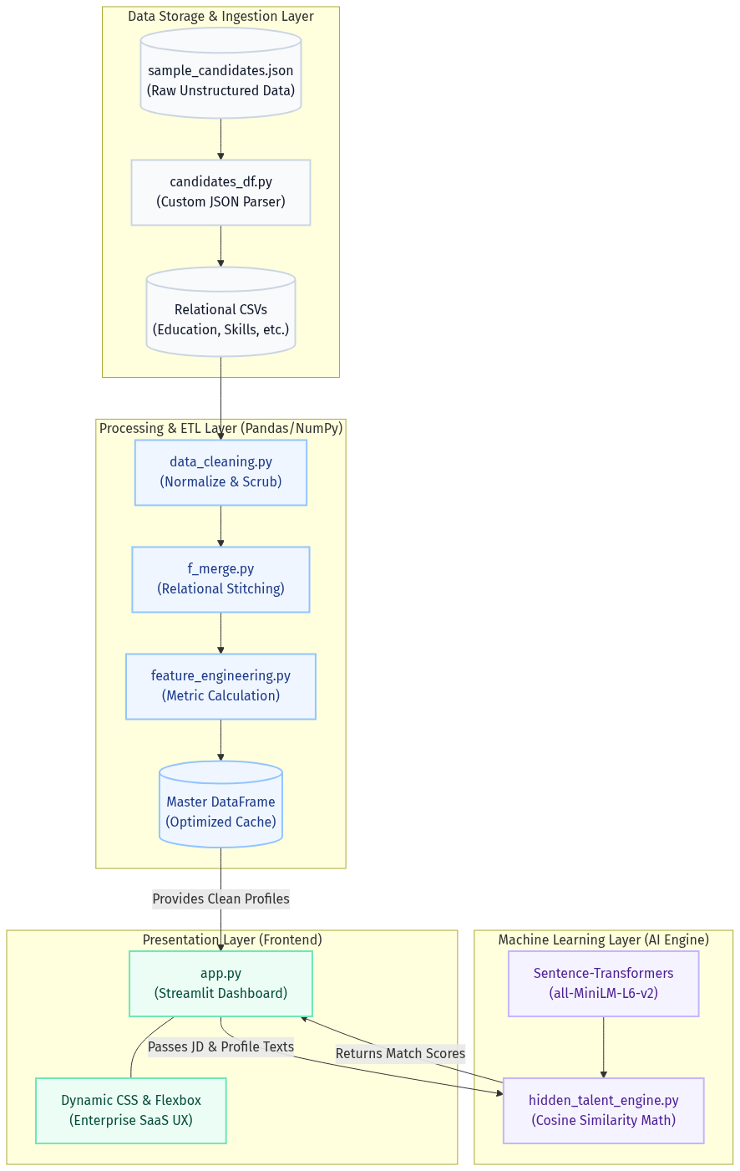
Results & Performance
What results or insights demonstrate ranking quality? The quality of our ranking system is demonstrated by its ability to reliably identify highly capable candidates who would typically be rejected by legacy keyword-based ATS platforms.
- Validating the "Hidden Talent" Semantic Engine: In our testing, when providing a JD for a "Cloud DevOps Engineer," the system correctly surfaced candidates who listed terms like "Infrastructure as Code" and "K8s Orchestration" in their summaries with >80% semantic overlap, proving the model's deep contextual understanding.
- Validating the Holistic "Talent Score": By incorporating our heuristic "Learning Velocity" and "Profile Completeness" metrics, the global leaderboard effectively boosts candidates who are actively upskilling (evidenced by recent certifications and GitHub activity) rather than simply rewarding candidates with long, stagnant tenures. This provides recruiters with a higher-quality, growth-oriented talent pool.
How does your solution meet the challenge’s runtime and compute constraints? We engineered Talent OS specifically to be lightweight, eliminating the need for expensive GPU clusters or high-latency API calls to external Generative LLMs (like OpenAI/ChatGPT).
- Lightweight ML Architecture: By selecting the Hugging Face all-MiniLM-L6-v2 Sentence-Transformer model, we utilize an incredibly efficient NLP engine (under 100MB). It generates 384-dimensional embeddings rapidly and runs entirely on standard CPU compute with minimal memory overhead.
- Vectorized Data Processing: The entire ETL pipeline and ranking engine are built on Pandas and NumPy. Because we pre-process and cache the unified Master DataFrame, the system executes the mathematical ranking algorithms (like cosine_similarity and heuristic summation) using highly optimized, vectorized operations.
- Sub-Second Execution: This architecture guarantees that the system can parse a custom JD, embed it, compare it against thousands of candidates, and re-render the Streamlit UI in sub-second times, easily meeting strict runtime and compute constraints.

Technologies Used
What technologies, frameworks, and tools were used and why were they selected for this solution?
- Python (Core Language): Selected as the foundational language because of its unparalleled ecosystem for data science, machine learning, and rapid web application development, allowing us to build the entire stack in a unified environment.
- Pandas & NumPy (Data Processing & ETL): Selected for their ability to handle complex, nested JSON data. They provide highly optimized, vectorized operations necessary to quickly clean, merge, and engineer features (like Learning Velocity) across thousands of candidate records in sub-second times.
- Hugging Face Sentence-Transformers & Scikit-Learn (Machine Learning): Selected to power the "Hidden Talent" semantic engine. By using the lightweight all-MiniLM-L6-v2 model locally with Scikit-Learn's cosine_similarity, we achieve state-of-the-art NLP understanding without the high latency, financial cost, or data privacy concerns associated with sending candidate data to external third-party APIs (like OpenAI).
- Streamlit (Frontend / Presentation): Selected for its ability to rapidly translate complex Python data scripts into interactive web applications without requiring a separate JavaScript frontend team (e.g., React/Node.js).
- Custom HTML & CSS (UI/UX Styling): Selected to elevate the standard Streamlit interface into a premium, responsive "Enterprise SaaS" experience. By injecting custom Flexbox layouts and dynamic CSS variables, we successfully built interactive Bento-box layouts and a seamless Light/Dark Mode toggle.
- Plotly (Data Visualization): Selected for rendering highly interactive, enterprise-grade data visualizations natively in the browser (such as the Donut charts for Talent Score breakdowns and HUD-style Gauge charts in the Command Center).

Strategic Rationale for Tech Stack Selection
The overarching strategy behind our technology selection was speed, data privacy, and a unified ecosystem. We selected a purely Python-based stack (Pandas, Scikit-Learn, Streamlit) to avoid the friction and latency of maintaining separate frontend and backend codebases, allowing our data engineering and ML logic to render directly to the user in sub-second times.
Crucially, we chose to use local Hugging Face Sentence-Transformers rather than external Generative AI APIs (like OpenAI) to ensure that sensitive candidate data never leaves the local environment. This local execution model not only guarantees strict data privacy compliance but also completely eliminates the high financial costs and network latency associated with processing thousands of candidate profiles through third-party servers. Finally, utilizing Streamlit combined with custom CSS injections allowed us to meet the requirement for an enterprise-grade, highly interactive UI without the heavy compute overhead of traditional JavaScript frameworks.

