A . LOGO and Tag Line ::


B. Inspiration ::

Fill the Brain with high thoughts,
highest ideals, place them day and night before you,
and out of that will come great work.
- Swami Vivekananda



C. Trustworthiness ::

- We provides Single Window Customize Services.
- Unique and creative solutions that meet the client's expectations not only by realizing the client's business objectives, but particularly by our strict adherence to the ethical principles of public relations and technical parameters.
- Continuous search for opportunities beyond the agreed communications and business objectives.
- Creative approaches to the client's special needs in order to find unique and tailored communications & quality solutions.
- Team work based on the implementation of progressive communications disciplines.
- Professional quality of services provided by a highly motivated team.
- Courage and readiness to communicate on behalf of client in crisis.
- Strong technological background with experienced professionals.
- We have excellent bench of Advisors.
- Operating in the states; Bihar, Jharkhand, UP & Chhattisgarh.
- 24 x 7 availability.
D. Competency ::
We execute turnkey projects as well as job works; here we want to express our heartfelt gratitude to our clients for the trust they have been placing in us with in last four years. We have proven our Creative art work and PR expertise. We believe that the length of our service agreements is proof of the positive effect of our activities on our client's business and demands as per respective CIP (Corporate Identity Program).

- Advertising (Indoor - Outdoor)
- PR Tools and Support
- Brand Building
- Crisis Management
- Corporate Social Responsibility
- Media Relations
- Public Affairs
- PR Strategy Consulting
- PR Education

(SERVICES)
E. PR & Brandiing ::
E.a. Advertising
- At Ideographers, we believe that effective advertising plays a vital role in delivering the right message when traditional communication channels may not be sufficient. In situations such as crisis communication, public notices, product recalls, or important public announcements, a well-designed and strategically placed advertisement can significantly improve message reach and public awareness.
- With extensive experience in advertising and brand communication, we help organizations create impactful campaigns that strengthen brand visibility, support reputation management, and communicate with clarity and confidence.

Our Advertising Services

Advertisement & Advertorial Copywriting
- Creative and persuasive copywriting for advertisements and advertorials that effectively communicate your brand message.

Creative Advertising Design
- Professional graphic design solutions for print advertisements, advertorials, promotional campaigns, and branding materials.

In-Shop Branding
- Complete planning, design, production, and execution of attractive in-store branding solutions that enhance customer experience and strengthen brand presence across retail environments.

Outdoor Branding
- Comprehensive outdoor branding solutions supported by our strong urban and rural network. We identify strategic branding locations and provide cost-effective advertising opportunities tailored to your campaign objectives.

Signage & Display Fabrication
- In-house fabrication and installation of outdoor advertising structures, including:
- Main Signage
- Flex & Vinyl Displays
- One Way Vision Graphics
- Glow Sign Boards
- Acrylic Letter Signage
- LED & Neon Sign Boards
- Pole Signage
- Highway Signage
- Road Furniture Branding
- Canopies
- Standees
- Lollipop Signage
- Advertisement Vehicles
- Custom Outdoor Display Structures

Logistics & Installation Support
- Efficient logistics coordination and timely installation to ensure smooth execution of advertising projects.

Site Monitoring & Work Audit
- Regular on-site reporting and work audit support to ensure quality, accuracy, and successful project execution.
- At Ideographers, every advertising solution is developed with a focus on creativity, visibility, quality execution, and effective brand communication, helping organizations build a strong and lasting presence in the market.

E.b. PR Tools & Support
- Successful public relations is built on strategic communication, thoughtful planning, and meaningful engagement with the right audience. At Ideographers, we work with clients from the early planning stage to identify the most effective communication tools and support services that deliver key messages with maximum impact while ensuring cost-effective execution.
- Our PR support services combine creative communication materials, event management, and production support to help organizations strengthen their public image and build lasting relationships with their stakeholders. Every project is planned and executed with a focus on quality, professionalism, and audience engagement.

Our PR Tools & Support Services

Communication Materials
- We design and develop professional communication materials, including:
- Brochures
- Information Materials
- Leaflets
- Newsletters
- Invitations

Digital & Presentation Media
- We create informative and engaging presentation resources, including:
- CD-ROM / DVD Content
- Audio Visual Presentations
- Documentary Production

Information Support
- Information Line
- Communication Support Materials

Event Management
- We plan, coordinate, and execute a wide range of professional events, including:
- Product Launches
- Road Shows
- Corporate Meetings
- Exhibitions & Fairs
- Conferences & Seminars
- Institutional Events
- Concerts
- At Ideographers, we believe that effective public relations is built through continuous dialogue between an organization and its audience. Every communication material, event, and support service is carefully developed to create meaningful engagement and leave a lasting impression.

E.c. Brand Building
- A strong brand is built on trust, consistency, and the value it delivers over time. At Ideographers, we believe that a brand is more than just a name or a logo—it is the perception people create through every experience, interaction, and communication.
- Effective brand building is a long-term strategic process that shapes how customers, stakeholders, and the public perceive a product, an organization, or an individual. A well-established brand creates credibility, inspires confidence, and strengthens customer loyalty without relying solely on promotions or discounts.
- At Ideographers, we follow an ethical and strategic approach to brand building. Our focus is on developing authentic brand identities that communicate clear values, build meaningful connections with target audiences, and contribute to long-term business growth.
- Our experience extends across diverse industries, including Fast Moving Consumer Goods (FMCG), Telecommunications, Automobiles, Infrastructure, and Business-to-Business (B2B) sectors. We create customized branding strategies that align with our clients' objectives and market positioning.

Our Brand Building Services

Product PR
- Building awareness and strengthening the public image of products through strategic communication and brand positioning.

Individual PR
- Enhancing the professional reputation and public image of individuals through planned communication strategies.

Corporate PR
- Developing and maintaining a strong corporate identity that builds trust among customers, partners, investors, and other stakeholders.

Product & Brand Launch
- Planning and executing brand and product launch strategies that create awareness, generate interest, and establish a strong market presence.

Rebranding
- Refreshing or repositioning existing brands to reflect evolving business goals, market trends, or organizational growth while preserving brand value.
- At Ideographers, we help transform ideas into trusted brands by combining strategic thinking, creative communication, and ethical brand practices that create lasting value.

E.d. Crisis Management
- Every organization may face situations that can affect its reputation, public confidence, or business continuity. While crises cannot always be predicted, they can be effectively managed through timely communication, strategic planning, and responsible decision-making.
- At Ideographers, we help organizations prepare for and respond to communication challenges with structured crisis management strategies. Our approach focuses on protecting brand reputation, maintaining stakeholder confidence, and minimizing the impact of unexpected situations through clear and effective communication.
- With practical experience in handling communication challenges across urban, rural, and remote regions—including Bihar, Jharkhand, Eastern Uttar Pradesh, and Chhattisgarh—we understand the importance of timely action and localized communication during critical situations.
- Our team is committed to providing responsive support whenever organizations need reliable communication guidance.

Our Crisis Management Services

Crisis Communication Management
- Planning and executing communication strategies that help organizations respond effectively during crisis situations while protecting their reputation.

Crisis Communication Manual
- Developing structured communication guidelines and response frameworks that enable organizations to manage potential crises with clarity and consistency.
- At Ideographers, we believe that effective crisis management is not only about responding to challenges—it is about protecting trust, preserving reputation, and ensuring business continuity through responsible communication.

E.e. Corporate Social Responsibility (CSR)
Corporate Social Responsibility is not limited to large corporations. At Ideographers, we believe that organizations of every size—including Mid-Corporate businesses and SMEs—can create meaningful social impact while building sustainable business growth.
Responsible business practices strengthen relationships with communities, employees, customers, and stakeholders. A well-planned CSR initiative reflects an organization's commitment to ethical growth, social development, and long-term sustainability.
Effective CSR requires more than financial contribution. It demands clear objectives, transparent processes, careful project selection, and measurable outcomes. At Ideographers, we assist organizations in planning, managing, and evaluating CSR initiatives that create genuine value for both society and the organization.

Our CSR Services

CSR Strategy Preparation
Developing structured CSR strategies aligned with organizational values, business objectives, and community needs.

CSR Project Management & Communication
Planning, implementing, coordinating, and communicating CSR initiatives to maximize social impact and stakeholder engagement.

CSR Project Evaluation
Assessing the effectiveness, transparency, and outcomes of CSR projects to ensure accountability and continuous improvement.
At Ideographers, we help organizations transform corporate responsibility into meaningful action through strategic planning, transparent execution, and sustainable community engagement.

E.f. Media Relations
- Strong media relations play a vital role in building and protecting an organization's reputation. At Ideographers, we help clients establish effective relationships with print, electronic, and other media platforms through well-planned communication strategies and professional public relations practices.
- Our media relations approach focuses on delivering accurate, timely, and meaningful information that strengthens public confidence and supports positive brand visibility. Every media engagement is carefully planned to ensure that key messages are communicated clearly and effectively.
- With practical experience in media communication and public relations, Ideographers also provides guidance and training to help organizations interact confidently with both print and electronic media.

Our Media Relations Services

Copywriting
- Professional preparation of press materials, media content, and communication copy tailored for effective public communication.

Identification of Key Media Contacts
- Identifying and connecting with relevant media professionals and publications to maximize communication reach and engagement.

Media Trips
- Planning and coordinating media visits, site tours, and press interactions to provide first-hand exposure to projects, initiatives, or events.

Key Message Development
- Developing clear, consistent, and impactful messages that align with organizational objectives and communication strategies.

Press Conferences
- Planning, organizing, and managing press conferences to ensure effective media interaction and accurate information dissemination.

Media Placement
- Facilitating the publication and distribution of news, announcements, and other communication materials across appropriate media platforms.
- At Ideographers, we believe that successful media relations are built on credibility, transparency, and consistent communication, helping organizations strengthen their public image and maintain lasting relationships with the media.

E.g. Public Affairs
Strong relationships with public institutions and key stakeholders play an important role in creating a supportive environment for business growth and development. At Ideographers, we assist organizations in building effective communication and coordination with government bodies, local administrations, and other institutional stakeholders.
Our Public Affairs services are focused on facilitating constructive engagement, supporting investment initiatives, and helping organizations navigate interactions with public institutions through professional communication and responsible representation.
With an understanding of administrative processes and regional governance, Ideographers works to strengthen collaboration between businesses, public authorities, and community organizations while supporting clients' long-term objectives.

Our Public Affairs Services

Government & Institutional Relations
Building and maintaining professional relationships with public administration, local government bodies, and non-governmental organizations (NGOs) to support effective communication and collaboration.

Local Body Coordination
Monitoring and coordinating with local authorities to facilitate smooth communication and support project implementation when required.

Trade & Diplomatic Mission Support
Providing communication and coordination support for trade delegations, institutional partnerships, and diplomatic initiatives.

Investment Project Support
Assisting organizations with communication support and stakeholder coordination for investment and development projects.

CSR Recommendations
Providing strategic recommendations that align Corporate Social Responsibility (CSR) initiatives with community needs and organizational objectives.
At Ideographers, we believe that successful public affairs are built on transparency, collaboration, and responsible communication, enabling organizations to establish strong relationships with public institutions and key stakeholders.

E.h. PR Strategy Consulting
- Effective public relations begin with a well-defined communication strategy. At Ideographers, our PR Strategy Consulting services focus on identifying communication opportunities that help organizations strengthen existing relationships, build new connections, and achieve their long-term business objectives.
- We work closely with organizational leadership, marketing teams, communication departments, human resources, and management teams to develop practical communication strategies that support business growth, stakeholder engagement, and organizational reputation.
- Our approach combines strategic planning with effective communication practices, enabling clients to deliver the right message to the right audience through appropriate communication channels.

Our PR Strategy Consulting Services

Internal Communications
- Developing communication strategies that improve information flow, employee engagement, and organizational alignment within the workplace.

PR Effectiveness Evaluation
- Assessing the performance and impact of public relations initiatives to measure communication outcomes and identify opportunities for improvement.

Communication Opportunity Assessment
- Identifying strategic communication opportunities that strengthen stakeholder relationships and enhance organizational visibility.

Sponsorship Opportunity Identification
- Evaluating and recommending sponsorship opportunities that align with organizational goals, brand positioning, and communication objectives.

Business-to-Business (B2B) Communications
- Developing communication strategies that support professional relationships between businesses, partners, suppliers, and corporate clients.
- At Ideographers, we believe that successful public relations are built on strategic planning, meaningful communication, and long-term relationship development, helping organizations communicate with confidence and purpose.

E.i. PR Education
- At Ideographers, we believe that effective public relations begin with knowledge, practical skills, and continuous learning. Our PR Education programs are designed to help organizations strengthen their communication capabilities and enable professionals to plan and implement public relations initiatives with confidence.
- With experience in professional training, including graphics design and printing, we provide practical learning programs that combine industry knowledge with real-world communication practices. Our training sessions are tailored to meet the needs of business leaders, executives, marketing professionals, communication teams, and support staff.
- Each program is designed with a balanced approach, incorporating practical exercises, discussions, and case-based learning to ensure participants gain valuable skills that can be applied in real business environments.

Our PR Education & Training Programs

Introduction to Public Relations
- Understanding the fundamentals of public relations, communication strategies, and their application across different markets, including urban and remote regions.

Crisis Communication
- Developing the knowledge and practical skills required to communicate effectively during challenging situations.

Media Relations
- Building confidence in working with print and electronic media through professional communication practices.

Media Training
- Preparing spokespersons and professionals for interviews, media interactions, and public communication.

Corporate Reputation & Identity
- Understanding the importance of corporate image, brand reputation, and consistent organizational communication.

Product PR
- Learning how strategic public relations can effectively support product promotion and complement advertising efforts.

Event Management
- Planning and managing events that strengthen communication and stakeholder engagement.

Communication Skills Development
- Enhancing professional communication, presentation, and interpersonal skills for effective public engagement.

Communication Optimization
- Improving communication processes and identifying opportunities for more effective information delivery.

PR Training for Support Staff
- Providing practical public relations awareness and communication training for operational and support teams.

Internet Relations
- Understanding the role of internet-based communication in supporting public relations and stakeholder engagement.
- At Ideographers, our PR Education programs are designed to equip individuals and organizations with practical communication skills, enabling them to build stronger relationships, enhance professional confidence, and support long-term organizational success.

F. Civil, Landscaping & Architectural Services

F.a. Design & Planning
Every successful project begins with thoughtful planning and a well-defined design. At Ideographers, we provide design and planning services that transform ideas into practical, functional, and sustainable project solutions. Our approach focuses on understanding client requirements, evaluating site conditions, and developing designs that balance functionality, aesthetics, and long-term usability.
From concept development to detailed planning, we work closely with our clients to ensure that every project is carefully planned before execution, helping minimize risks, optimize resources, and achieve the desired outcome.

Our Design & Planning Services

Architectural Design
Designing practical, functional, and aesthetically balanced architectural solutions that reflect project requirements and intended use.

Building Planning
Preparing well-structured building plans that support efficient space utilization, functionality, and future development needs.

Landscape Planning
Planning outdoor environments that combine natural elements, open spaces, and functional landscaping to enhance the overall project.

Site Planning
Developing site layouts that consider land utilization, accessibility, circulation, utilities, and overall project organization.

Concept Development
Transforming project ideas into clear design concepts that establish the foundation for successful planning and execution.

Working Drawings
Preparing detailed technical drawings and project documentation to support accurate construction and smooth project implementation.
At Ideographers, we believe that effective design and planning create the foundation for successful projects by combining creativity, technical understanding, and practical execution.

F.b. Execution & Development
Successful execution is the result of proper planning, effective coordination, and careful project management. At Ideographers, we support the execution and development of civil, landscaping, and architectural projects by ensuring that every stage is carried out with attention to quality, timelines, and project requirements.
Our team works closely with clients, contractors, and project stakeholders to facilitate smooth project execution while maintaining coordination throughout the development process. We focus on delivering practical solutions that meet project objectives and industry standards.

Our Execution & Development Services

Residential Projects
Execution support for residential developments, including individual homes, residential complexes, and related infrastructure.

Commercial Projects
Planning support and execution coordination for commercial buildings, office spaces, retail establishments, and business facilities.

Institutional Projects
Project execution services for educational institutions, healthcare facilities, government organizations, and other institutional developments.

Site Development
Site preparation and development support, including land development, layout implementation, and site infrastructure coordination.

Project Coordination
Coordinating project activities, stakeholders, resources, and schedules to ensure efficient project execution and smooth communication.

Construction Supervision
Monitoring construction activities to support quality workmanship, compliance with project plans, and timely project progress.
At Ideographers, we are committed to supporting every stage of project execution through effective coordination, professional supervision, and a focus on delivering quality outcomes.

F.c. Repair & Maintenance
Regular maintenance and timely repairs are essential to preserve the safety, functionality, and appearance of any structure. At Ideographers, we provide repair and maintenance services that help extend the life of residential, commercial, and institutional properties while ensuring they remain safe and well-maintained.
Our approach focuses on identifying maintenance requirements, addressing structural and functional issues, and carrying out repair work with attention to quality, durability, and long-term performance.

Our Repair & Maintenance Services

Building Repair
Repair and restoration of building components to improve structural integrity, functionality, and overall condition.

Renovation
Renovation services to upgrade, improve, or modify existing residential, commercial, and institutional spaces according to changing requirements.

Structural Maintenance
Maintenance solutions aimed at preserving the stability, strength, and long-term performance of structural elements.

Waterproofing
Waterproofing solutions designed to protect buildings from water seepage, leakage, and moisture-related damage.

Exterior & Interior Repairs
Repair and maintenance of both exterior and interior building elements to improve safety, appearance, and usability.

Preventive Maintenance
Planned maintenance services that help identify potential issues early, reduce future repair costs, and support the long-term performance of buildings.
At Ideographers, we believe that timely repair and preventive maintenance are key to protecting the value, safety, and longevity of every project.

F.d. Survey & Site Assessment
A successful project begins with a clear understanding of the site and its surrounding conditions. At Ideographers, our Survey & Site Assessment services help clients evaluate project locations before planning and execution, ensuring informed decisions and effective project development.
Our approach focuses on understanding site conditions, identifying project requirements, and providing practical assessments that support efficient planning and smooth project execution.

Our Survey & Site Assessment Services

Site Inspection
Conducting on-site inspections to understand existing site conditions, identify potential challenges, and gather essential project information.

Site Assessment
Evaluating the suitability of the project site by considering accessibility, surrounding environment, existing infrastructure, and development requirements.

Land Measurement Coordination
Coordinating land measurement activities and supporting the collection of accurate site dimensions for planning and project documentation.

Feasibility Assessment
Assessing the practical viability of proposed projects by reviewing site conditions, project requirements, and implementation considerations.
At Ideographers, we believe that careful site evaluation lays the foundation for effective planning, efficient execution, and successful project outcomes.

F.e. Project Consultancy
Every project requires careful planning, informed decision-making, and effective coordination to achieve successful outcomes. At Ideographers, our Project Consultancy services provide professional guidance and practical support throughout different stages of project planning and development.
We work closely with clients to understand project requirements, provide technical assistance, facilitate documentation, and ensure smooth communication among all stakeholders. Our objective is to support clients with reliable consultation that contributes to efficient project execution.

Our Project Consultancy Services

Technical Consultation
Providing professional guidance and technical advice to support planning, design, and project implementation.

Project Planning Support
Assisting clients in project planning by helping define objectives, organize activities, and prepare for successful execution.

Documentation Support
Supporting the preparation and coordination of project-related documents required during planning, approvals, and execution.

Client Coordination
Maintaining effective communication and coordination with clients throughout the project to ensure clarity, transparency, and timely decision-making.
At Ideographers, we are committed to delivering practical consultancy services that support informed decisions, effective coordination, and successful project development.

F.f. Landscape Development
Well-planned landscapes enhance the beauty, functionality, and overall environment of residential, commercial, and institutional spaces. At Ideographers, we provide landscape development services that combine natural elements with practical planning to create attractive, functional, and well-maintained outdoor environments.
Our approach focuses on understanding site conditions, client requirements, and the intended use of outdoor spaces to develop landscapes that complement the overall project.

Our Landscape Development Services

Garden Development
Planning and developing gardens that enhance the appearance and usability of residential, commercial, and institutional properties.

Plantation Planning
Planning and organizing plantation activities by selecting suitable vegetation and developing layouts that support healthy and sustainable growth.

Landscape Improvement
Enhancing existing landscapes through thoughtful planning, redesign, and improvements that increase both visual appeal and functionality.

Outdoor Space Development
Developing outdoor spaces that provide a balanced combination of aesthetics, accessibility, and practical use for various project requirements.
At Ideographers, we believe that well-designed landscapes contribute to the long-term value, comfort, and visual appeal of every project while creating functional outdoor environments.

F.g. Architectural Support
Thoughtful architectural planning plays an important role in creating functional, efficient, and visually balanced spaces. At Ideographers, we provide architectural support services that assist clients in planning, designing, and improving residential, commercial, and institutional projects according to their specific requirements.
Our approach emphasizes practical design solutions, efficient space utilization, and coordinated planning to ensure that every project meets both functional and aesthetic expectations.

Our Architectural Support Services

Elevation Design
Designing building elevations that enhance the visual appearance while maintaining harmony with the project's architectural style and purpose.

Space Planning
Planning interior and functional spaces to achieve efficient utilization, accessibility, and user convenience.

Interior Layout Planning
Preparing practical interior layouts that support effective space organization, movement, and day-to-day functionality.

Renovation Planning
Developing renovation plans that improve existing structures while preserving functionality, safety, and overall design integrity.
At Ideographers, we are committed to providing architectural support that combines thoughtful planning, practical design, and functional solutions to meet the unique requirements of every project.

G. IT Services

G.a. Design & Development
Technology plays a vital role in helping organizations improve efficiency, strengthen their digital presence, and achieve business growth. At Ideographers, we provide design and development services that transform ideas into reliable, scalable, and user-friendly digital solutions.
Our approach combines thoughtful planning, modern technologies, and practical development practices to create websites, applications, and software solutions tailored to each client's requirements. From initial concept to deployment, we focus on delivering solutions that are functional, secure, and aligned with business objectives.

Our Design & Development Services

Website Development
Designing and developing responsive, secure, and user-friendly websites that strengthen online presence and effectively represent businesses and organizations.

Mobile Application Development
Developing mobile applications that deliver seamless user experiences, reliable performance, and practical functionality across modern mobile platforms.

E-Commerce Development
Building secure and scalable e-commerce solutions that enable businesses to showcase products, manage online sales, and enhance customer engagement.

Custom Software Development
Designing and developing customized software solutions that address specific business requirements and improve operational efficiency.

Custom Software Integration
Integrating software applications and business systems to improve workflow, data consistency, and overall operational performance.

WordPress Development
Developing and customizing WordPress websites that are easy to manage, responsive, and aligned with organizational branding and content requirements.

API Development & Integration
Designing, developing, and integrating Application Programming Interfaces (APIs) to enable secure communication and seamless data exchange between applications and systems.
At Ideographers, we are committed to delivering reliable digital solutions that combine practical functionality, quality development, and scalable technology to support long-term business growth.

G.b. Enterprise Services
Modern organizations require technology solutions that improve operational efficiency, streamline business processes, and support long-term growth. At Ideographers, our Enterprise Services are designed to help businesses integrate technology into their daily operations through reliable, scalable, and business-focused solutions.
We work with organizations to develop and integrate enterprise applications that simplify workflows, improve collaboration, and support efficient business management. Our services are delivered with a focus on reliability, security, and future scalability.

Our Enterprise Services

CRM Development & Integration
Designing, developing, and integrating Customer Relationship Management (CRM) solutions that help organizations manage customer interactions, improve communication, and strengthen business relationships.

Cloud Services
Providing cloud-based solutions that support secure data management, application hosting, storage, and scalable business operations.

Enterprise Application Development
Developing customized enterprise applications that support organizational processes, improve productivity, and address specific business requirements.

Business Process Automation
Implementing technology solutions that automate routine business processes, improve operational efficiency, and reduce manual effort.

System Integration
Integrating business applications and enterprise systems to enable seamless communication, efficient workflows, and consistent data management.

Database Solutions
Designing, implementing, and managing database solutions that ensure secure, organized, and reliable data storage for business operations.

G.c. Digital Solutions
A strong digital presence is essential for organizations to connect with customers, improve online visibility, and enhance overall business performance. At Ideographers, our Digital Solutions are designed to help businesses strengthen their digital platforms through optimization, content management, and performance improvement.
We provide practical digital solutions that enhance website functionality, improve user experience, and support effective online operations while ensuring reliability, accessibility, and long-term growth.

Our Digital Solutions

Search Engine Optimization (SEO)
Improving website visibility and search engine performance through structured optimization techniques that help increase online reach and discoverability.

Website Performance Optimization
Enhancing website speed, responsiveness, and overall performance to provide a better user experience across different devices and platforms.

Website Analytics
Implementing analytics solutions that help organizations understand website performance, visitor behavior, and key performance indicators to support informed decision-making.

Content Management Solutions
Developing and managing content management solutions that enable organizations to efficiently update, organize, and maintain their digital content.

Email Solutions
Providing professional email setup, configuration, and management solutions that support secure and reliable business communication.
At Ideographers, we focus on delivering practical digital solutions that improve online performance, strengthen digital presence, and support long-term business growth.

G.d. Maintenance & Support
Reliable maintenance and continuous technical support are essential to ensure the long-term performance, security, and stability of digital solutions. At Ideographers, we provide maintenance and support services that help organizations keep their websites, applications, and technology systems running efficiently.
Our maintenance approach focuses on regular monitoring, timely updates, issue resolution, and preventive support to minimize disruptions and maintain smooth business operations.

Our Maintenance & Support Services

Website Maintenance
Providing regular website updates, content modifications, performance monitoring, and technical support to ensure reliable operation and an improved user experience.

Application Maintenance
Maintaining software applications through updates, performance improvements, issue resolution, and ongoing technical enhancements.

Server Maintenance
Managing and maintaining server environments to ensure system availability, security, reliability, and optimal performance.

Security Updates
Implementing regular security updates, software patches, and preventive measures to help protect applications and digital systems from potential security risks.

Backup & Recovery
Providing backup management and recovery support to help safeguard valuable business data and ensure business continuity in case of unexpected incidents.

Technical Support
Offering timely technical assistance to resolve operational issues, answer user queries, and support the smooth functioning of digital solutions.
At Ideographers, we are committed to delivering dependable maintenance and support services that help organizations maximize system performance, maintain security, and ensure uninterrupted business operations.

G.e. IT Consulting
Choosing the right technology is essential for building efficient, scalable, and sustainable digital solutions. At Ideographers, our IT Consulting services help organizations understand their technology requirements, evaluate suitable solutions, and make informed decisions that align with their business objectives.
We work closely with clients to assess project requirements, recommend appropriate technologies, and provide practical guidance throughout the planning and implementation process. Our consulting approach emphasizes reliability, efficiency, and long-term value.

Our IT Consulting Services

Technology Consulting
Providing professional guidance on selecting appropriate technologies, platforms, and digital solutions based on business requirements.

Software Consultation
Assisting organizations in evaluating software requirements and recommending suitable solutions for operational and business needs.

Digital Transformation Planning
Supporting organizations in planning their digital initiatives by identifying opportunities to improve processes, enhance efficiency, and adopt modern technologies.

Solution Architecture Guidance
Providing technical guidance on designing scalable, secure, and well-structured software solutions that align with project objectives.

Project Consultation
Working closely with clients to understand project goals, define technical requirements, and provide consultation throughout the project planning process.
At Ideographers, we are committed to providing practical IT consulting services that help organizations make informed technology decisions, optimize digital investments, and build reliable solutions for long-term growth.

H. The Team

Late Er. Baidyanath Prasad – Chairman
"Professionals cannot retire at 60's, they retire once...."
Retd. Engineer from Rural Works Department, Govt. of Jharkhand; Ex. National Quality Enabler, National Rural Roads Development Agency, Ministry of Rural Development, Govt. of India having vast experience in civil engineering works. He associated with his son Mr. Awanish Ranjan to open a Single Window Customized Consultancy Services which serves maximum sectors via single window.
He is fluent in Hindi, English & Regional Dialects.

Awanish Ranjan - Business Head
"When your desire comes in to your profession, you cannot define limitations."
Computer Science graduate; Having work corporate experience in IT, Banking, and FMCG. He has worked with HDFC Bank (Business Banking, New Delhi). He has more than 10 years of experience in business finance, market analysis, product management, brand promotion, media and management consultancy, design, events and corporate services & execution. His deep interest in creative design and brand promotion leads the floor of media and advertisement services.
He is fluent in Hindi, English & Regional Dialects.

Aftab Hussain - Head (Graphics & Visuals)
Computer Science graduate and Diploma in Graphics Design; Having more than 5 years of experience in the field of graphic designing and advertisement management. He is Diploma in Graphics Design.
He is fluent in Hindi, English & Regional Dialects.

Deepak Singh - Head (In-house Printing Operations)
Having more than 20 years of media printing (Flex, Vinyl, Oneway media, Backlit, Acrylic work etc) Advertising (Outdoor/ Indoor) Project Execution and labour management.
He is fluent in Hindi, English & Regional Dialects.

Ajay Kumar - Project Coordinator
Having more than 20 years of Advertising (Outdoor/ Indoor) Project Execution and Maintenance Management, specialised in hoarding installation, indoor branding execution, labour management.
He is fluent in Hindi, English & Regional Dialects.

Priyamvad Ranjan – IT Services
"Technology is best when it creates practical solutions for real-world challenges."
Computer Science graduate with interest in software development, web technologies, and enterprise solutions. He leads the IT Services division at Ideographers and works on delivering reliable digital solutions for businesses and organizations.

I. Our Advisors and Critics
We always believes in quality and foolproof services, so we put out our work in front of our advisory board (An excellent bench of professionals) for opinion. After necessary modifications we deliver to our clients. The Advisory and Critics are :
Name | Qualification/Profession | Advice For
Er. Madan Pratap Singh | Retd. Engineer in Chief, Bihar. Ex-State Coordinator NRRDA, PMGSY (Bihar & Jharkhand), Associate Consultant NHAI. | Project Assessment and Critics.
Vinod Kumar Singh | MBA, LLB/ Consultant & Argo-Business | Financial Viability of Project & Critics
Dr. B. K. Singh | Ex. HoD, RAU, Pusa | Agriculture and processing.
Rahul Gupta | MFC/Credit Manager, Business Banking- Trade, Axis Bank | Banking , Working Capital & Trade Management
Er. Himanshu Singh | BE (Electronics & Electricals) | Customized Electrical Services
Rakesh Kumar | MBA / GM, HT Media | Media Advice
Prof. (Dr.) Raju Prasad | Professor, Hindi Dept. Jai Prakash University, Saran | Education & Critics
Punyatma Sharan | Ex-Banker, Columnist , Polity India, USA & UK | Critics & Media
Anand Chetan Jha | B.Tech./ Columnist, Critics | Critics & Media
CA Bhupesh Tripathi | AVP, Trade, Standard Chartered Bank | Banking & Forward Linkage
Siju Vijyan | Project Manager, CSC, Thailand | IT
Sanjay Kumar | Project Manager | IT- Network Solutions
Er. Gyanda Sharan | Project head, IBM, Kolkata | IT- System Development
Dr. Navin Kr. Upadhyay (MBBS, D.Ortho,DNB) | Consultant Orthopaedic Surgeon, Bone Hospital & Ruban Patliputra Hospital | Health and Hospitals Management.  Specially for Super specialty Hospitals.
Dr. Sanjeev Jaiswal (MBBS, MD/ SR-PMCH, Patna) | Consultant Physician & Senior Resident PMCH. | Health and Hospitals Management
Nagarjuna Singh | Creative Writing | Media Management

J. Our Clients
- Royal Enfield
- BRPNNL, Patna
- Nav Jagriti Sansthan, Parsa, Saran
- Information and Public Relation Department, Chapra
- District Administration, Saran (Bihar)
- District Administration, Khagaria (Bihar)
- District Administration, Buxur (Bihar)
- DRDA, Saran
- DHS, Chapra
- ATMA, Saran
- Education Department, Saran
- ICDS, DCO, DUDA, PHED (Saran)
- Luminous
- DHS, Khagaria
- Department of Fisheries, Govt. of Bihar
- RWD, Govt. of Jharkhand
- RWD, Govt. of Bihar
- District Administration Ramanujganj-Balramur (Chhattisgarh)
- Retail Clients

K. Awards
- Prashasti Patra for excellent branding job in Harihar Kshetra Sonpur Mela from District Administration, Saran consecutive three years ( For Year 2014 to 2016).
- Prashasti Patra for excellent branding job in Tatapani Mahottsava from District Administration, Balrampur (Chhattisgarh) in 2017.

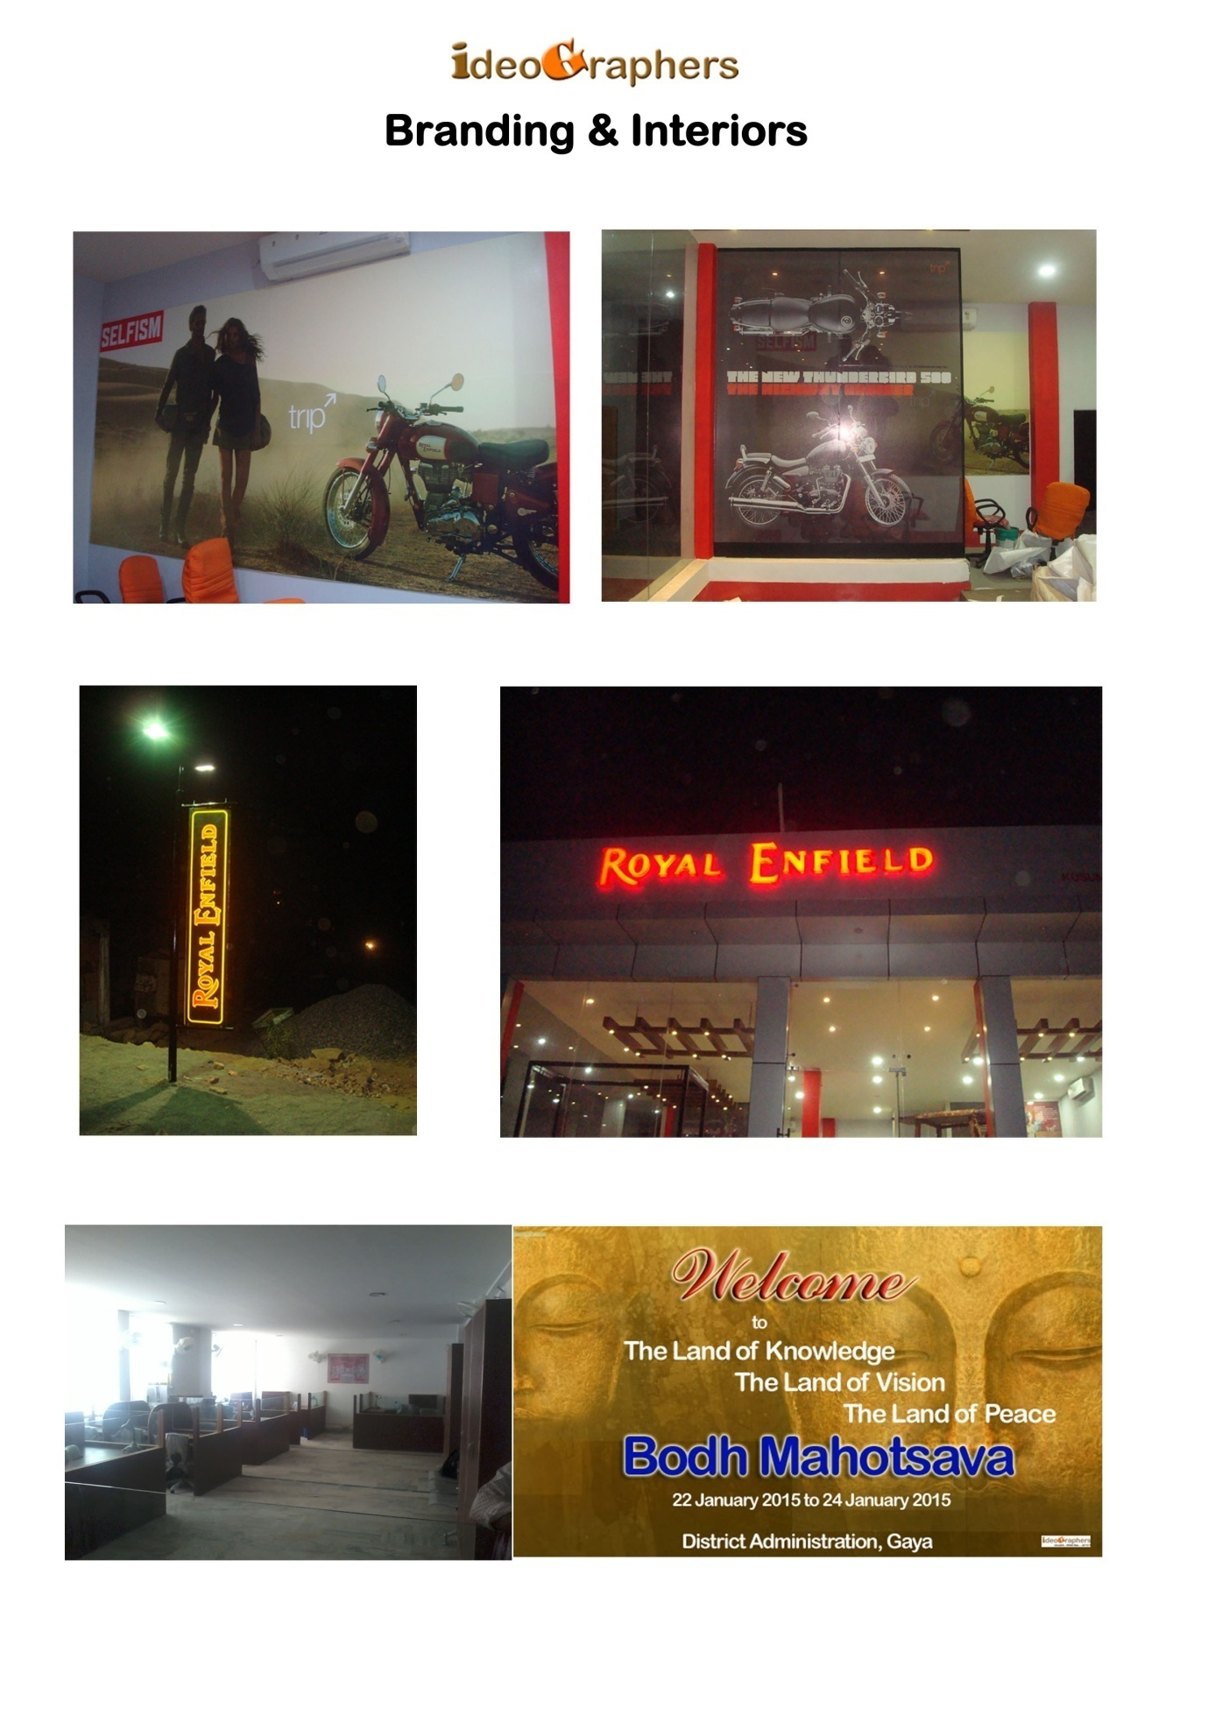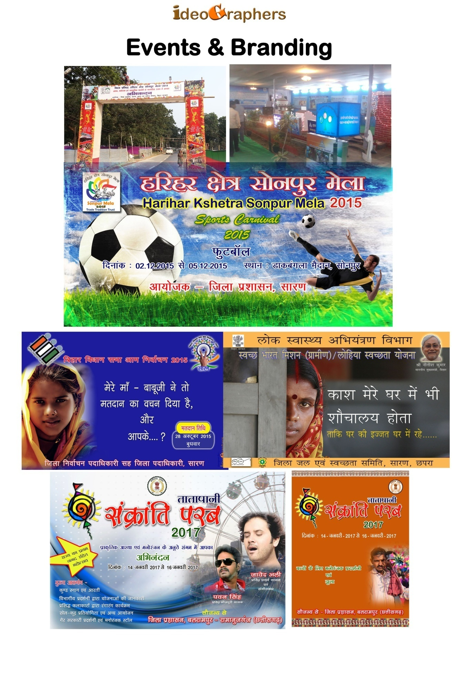

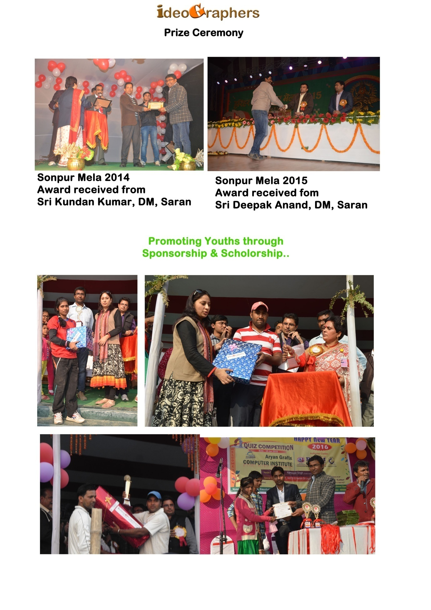

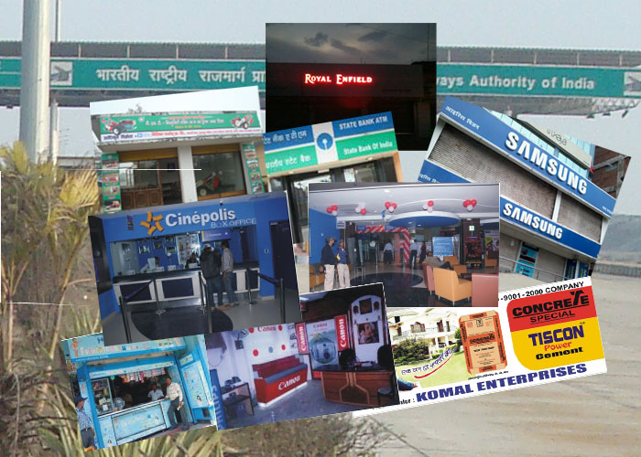

Contact Details


Regd. Office
At - Baradari (Katra)
PO - Bhagwanbazar (Chapra)
Dist - Chapra (Saran)
State - Bihar - 841301
Contacts - +91-9771173983
+91-9431093850
+91-8829926478
Web - www.ideographers.com
www.ideographers.in
www.ideographers.o
E-mail - ideographers@gmail.com
info@ideographers.com/ info@ideographers.in
contact@ideographers.com/ contact@ideographers.in

Branch Office
Ideographers
NY- 118/I, New Yarpur
Janta Road
Patna - 800001

__________________________________________________________________________________

