**Ques.1)**

**#write a SQL Query to select all customers who did their first order within the last 24 hours**

create table customer (

id int,

created_at DATETIME DEFAULT CURRENT_TIMESTAMP,

updated_at TIMESTAMP DEFAULT CURRENT_TIMESTAMP ON UPDATE CURRENT_TIMESTAMP,

first_name varchar(64),

last_name varchar(64)

);

INSERT INTO customer

VALUES

(

123, NOW(), now(), 'priya', 'Pandey'

),

(

134, NOW(), now(), 'pri12', 'Pandey'

),

(

193, NOW(), now(), 'pri56a', 'Pandey'

);

create table orders (

id int,

created_at DATETIME DEFAULT CURRENT_TIMESTAMP,

updated_at TIMESTAMP DEFAULT CURRENT_TIMESTAMP ON UPDATE CURRENT_TIMESTAMP,

status varchar(64),

cust_id int,

product_id int

);

INSERT INTO orders

VALUES

(

12453, now(), now(), 'deliver', 123,

2345

),

(

13344, now(), now(), 'approve', 345,

3456

),

(

13493, now(), now(), 'pending', 456,

4672

);

create table product (

id int,

created_at DATETIME DEFAULT CURRENT_TIMESTAMP,

updated_at TIMESTAMP DEFAULT CURRENT_TIMESTAMP ON UPDATE CURRENT_TIMESTAMP,

category varchar(64),

name varchar(64),

percent float

);

INSERT INTO product

VALUES

(

1243, now(), now(), 'cloth', 'tshirt',

23

),

(

1344, now(), now(), 'kids', 'frock',

23.44

),

(

12493, now(), now(), 'kids', 'caps',

46.72

);

Select

*

from customer

where exists(

select id from orders

where TIMESTAMPDIFF(HOUR, customer.created_at, orders.created_at) <=24

);

**##### select all customers who did their 2nd orders within 24 hours**

select c.id

from customer c

join orders o on c.id = o.cust_id

where TIMESTAMPDIFF(HOUR, c.created_at, o.created_at) <=24

group by c.id

having count(Distinct o.id) = 2;

**##### select all customers who did their 3rd orders within 24 hours**

select c.id

from customer c

join orders o on c.id = o.cust_id

where TIMESTAMPDIFF(HOUR, c.created_at, o.created_at) <=24

group by c.id

having count(Distinct o.id) = 3;

**Ques.2)**

Attaching the tableau file also:

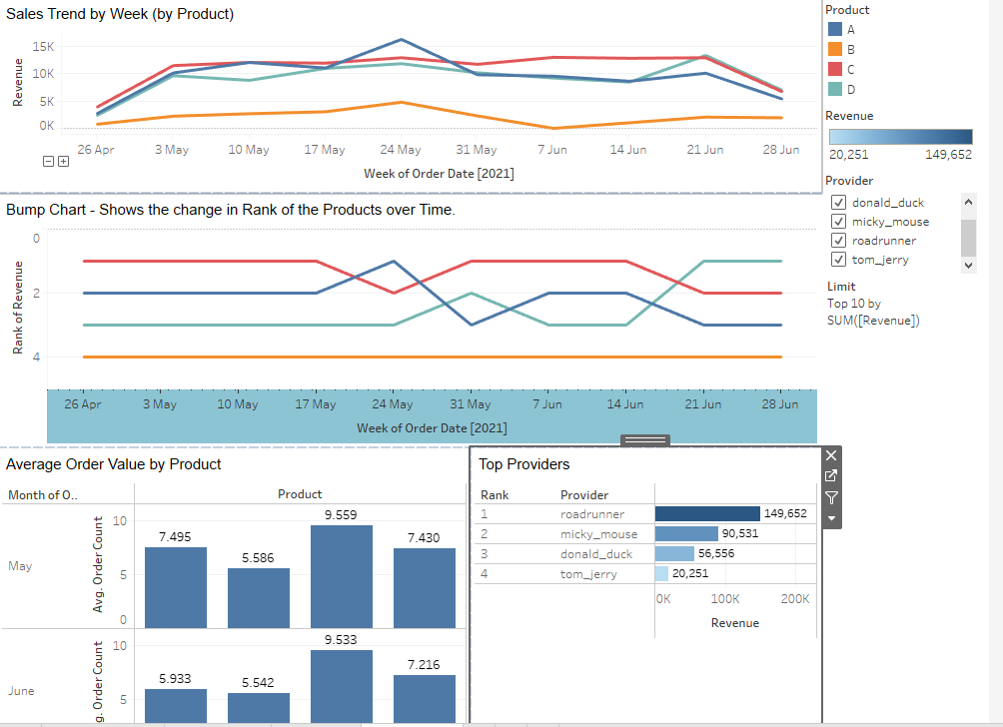Ques 3:

attached is .py file

Ques 4:

1. How would you generally rate the recent performance of our CLV? Good? Bad?--→ Bad

**Solution:** We can see most of Avg CLV is getting sudden decrease after may. It Decrease Company Profit also

2. Any ideas how to improve the chart and make it more intuitive?

**Solution:**  Here are 5 effective ways how this can be achieved and maintained.

* Offer referral program
* Provide targeted, personalized campaigns
* Put them first—hear your customers
* Optimize your customer service
* Reward your most loyal customers

Ques 5 & Ques 6 ) Python Code is attached