Case Study for Recommendation and Bidding Data Scientist Position

We are given the following datasets:
clicks.csv
hoteldetails.csv
hotelmetrics.csv

Task 1
Data Understanding:
a) Checked table wise data hotel_details is base table :
- Total number of rows is 1524 and columns is 5 .
- There are 3 categorical variables in our dataset
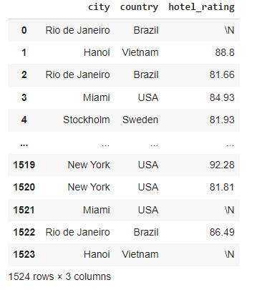

- We have 162 rows of Unknown value of City and country also have 162 rows.
- Below is graph which show the Corelation between the columns. Shows all the columns are highly correlated.
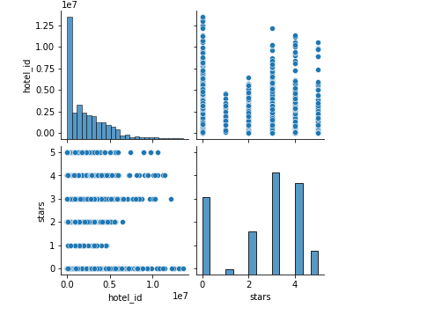

- hotel_metrics: Table (9720, 9)
- All the other details of hotel_details and hotel_metrics we will discuss in Task 3 where we are going to create Model.

Task 2: predict the DAILY number of clicks of Sept/2019.
Table Click used

Here we are using the Forecasting Model (Autoregressive Integrated Moving Averages --ARIMA Model).
The general process for ARIMA models is the following:
1)Visualize the Time Series Data.
2)Make the time series data stationary
3)Plot the Correlation and AutoCorrelation Charts
4)Construct the ARIMA Model based on the data
5)Use the model to make predictions.
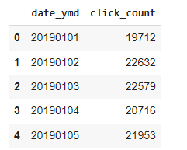

- converting date_ymd into proper date formate
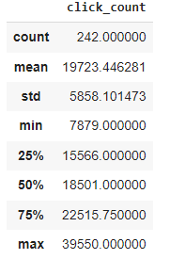
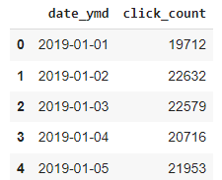

graphs to show seasonal_decompose using additive model.
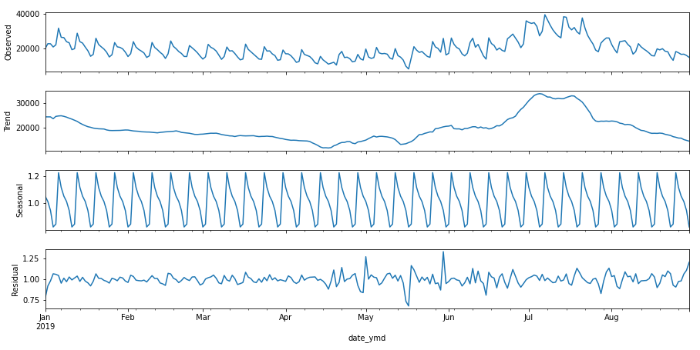

Creating a function to calculate the MAPE (mean absolute percentage error) value for test data : 36.10667
TRENDS:
- In the 8 month of data we cannot see the seasonality. With both the models (additive and Multiplicative) we are not seeing much difference.
- The data set contains values of only 8 months, by looking into the graph we can say that at month 7 to 8 there is sudden increase in the trend and after the trend went down. There is no clear patterns of seasonality in the data.
Below is the Value Predicted on daily bases for September month:
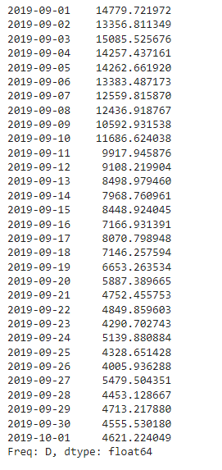

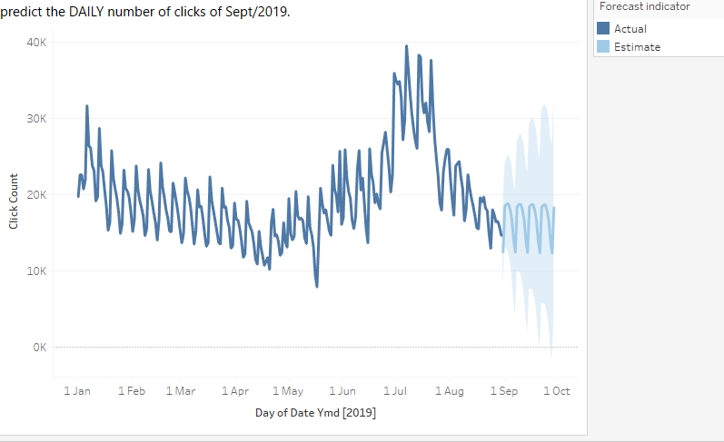
Task 3: Model Building:

Here We merged both the datasets hotel_detail and hotelmetrics. Where we are Predicting the City name which is Unknown. Based on City we can predict Country name.

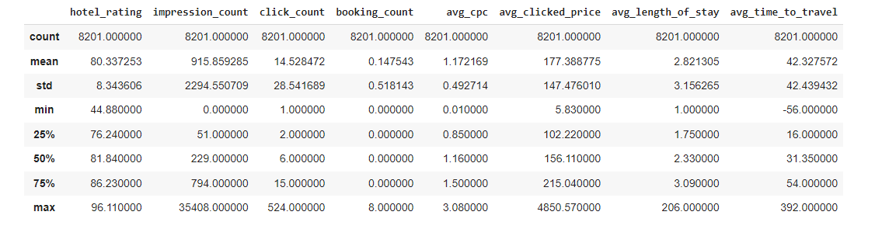

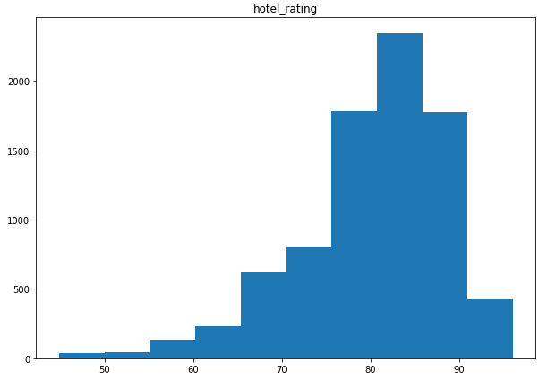
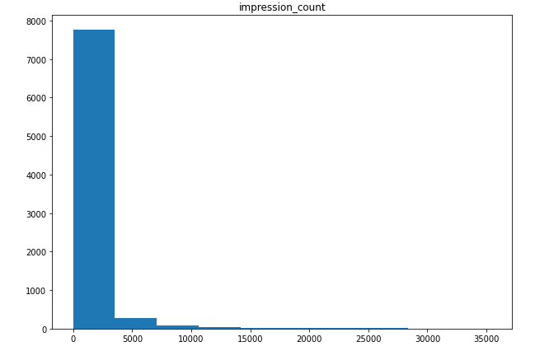
Below is list of visualization for the columns

- Check the outlier treatment (Box Plot)

- Below Graph showing the Non- Outlier as outlier, So we kept all the values and Proceed with same.
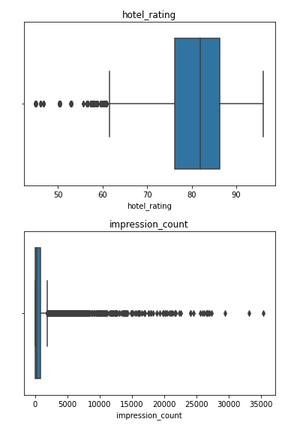
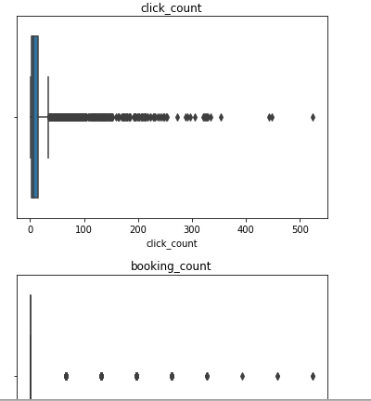

Model Building :

As Per the data set it is Multi classification problem where we can see below city
Hanoi, Los angelos, miami, Newyork, Rio de janerio, stockholm and unknown.
With the City name we can find the Country. So our main Aim is to Predict City for unknown values and Country we can guess.

- converting output variables in label encoding
(0 =Hanoi, 1 = Los angelos, 2 = miami, 3 = Newyork, 4 =Rio de janerio, 5 =stockholm)
- For Building we are using the AutoMl (Automated Machine Learning library evalml)
- Python Package evalml(we can easily evaluate which machine learning pipeline works better for the given set of data. It can automatically perform feature selection, model building, hyper-parameter tuning, cross-validation, etc. It has a wide range of tools for understanding models. It is combined with Featuretools, which is a framework to perform automated feature engineering, and Compose, a framework for automated prediction engineering.)

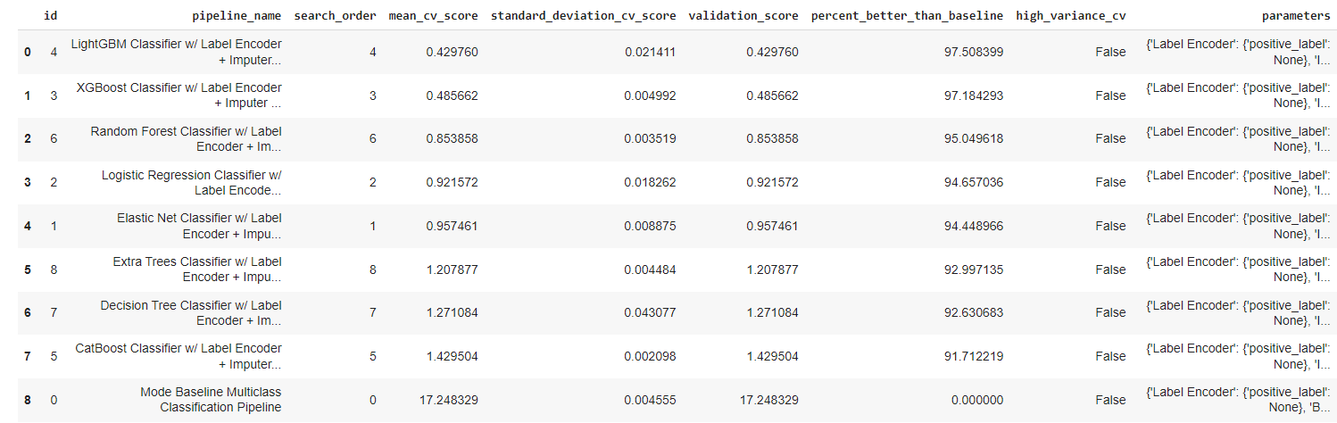
With the above code execution we will come to know the Light GBM is best model with high accuracy
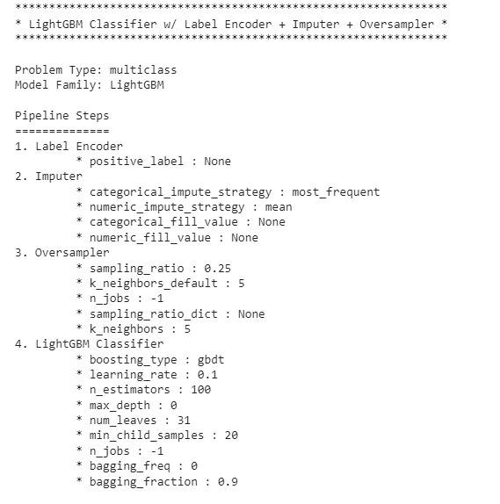

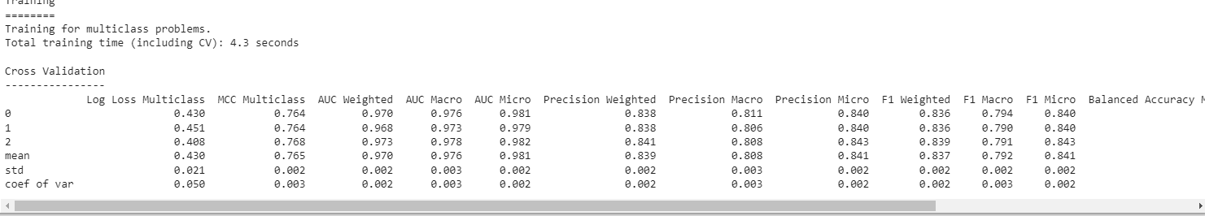
Here We come to Conclusion of our model that the best algorithm is LightGBM Multiclass algorithm with 0.81 f1 scores.

Task 4: Deployment

- Once we are done with model building, we need to do the deployment by using python flask.
- Steps are we saved this model to .pkl file.best_pipeline.save("pipeline.pkl")
- Then we downloaded this file in our local.
- Then we are using the atom.io (IDE) where we had copied and uploaded folder of download, in that we have the flask file , CSS file and html for front end API.

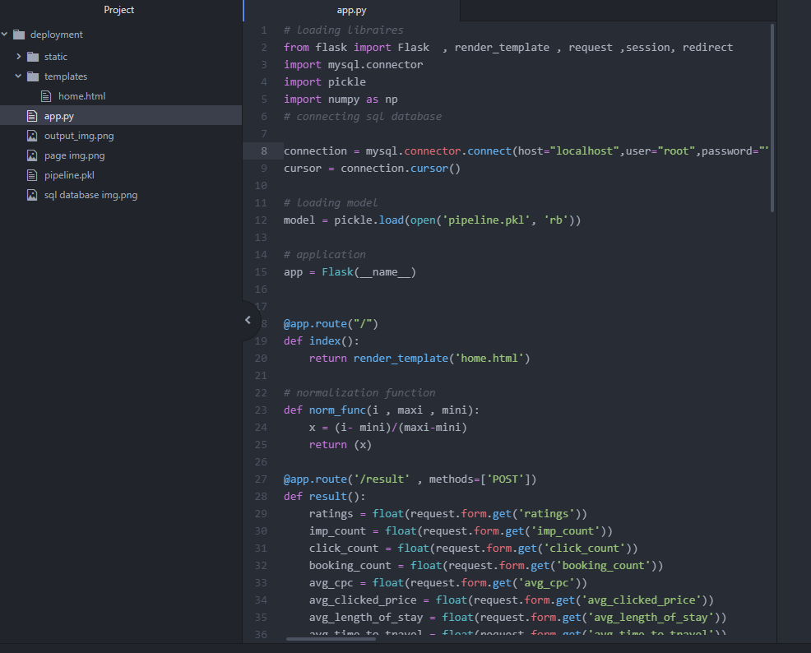
We used mysql.connector also to get installed and use XAMPP (where we are storing our data and creating the database, It is Apache product open source).

Below is SQL for table creation :
CREATE TABLE hotel_details (
User_id INTEGER NOT NULL AUTO_INCREMENT,
hotel_rating FLOAT NOT NULL,
impression_count FLOAT NOT NULL,
click_count FLOAT NOT NULL,
booking_count FLOAT NOT NULL,
avg_cpc FLOAT NOT NULL,
avg_clicked_price FLOAT NOT NULL,
avg_length_of_stay FLOAT NOT NULL,
avg_time_to_travel FLOAT NOT NULL,
stars VARCHAR(64) NOT NULL,
cities VARCHAR(64) NOT NULL,
PRIMARY KEY (User_id)
);

- Once table is created and executed then go to Flask program (app.py) provide the Data base name(hotel_db) . Once it will be executed successfully then go to browser and hit http://127.0.0.1:5000/ so it will connect to API.

- We will give all the field values and it will predict the city name below is screen: where it is predicting the New York and Country USA.
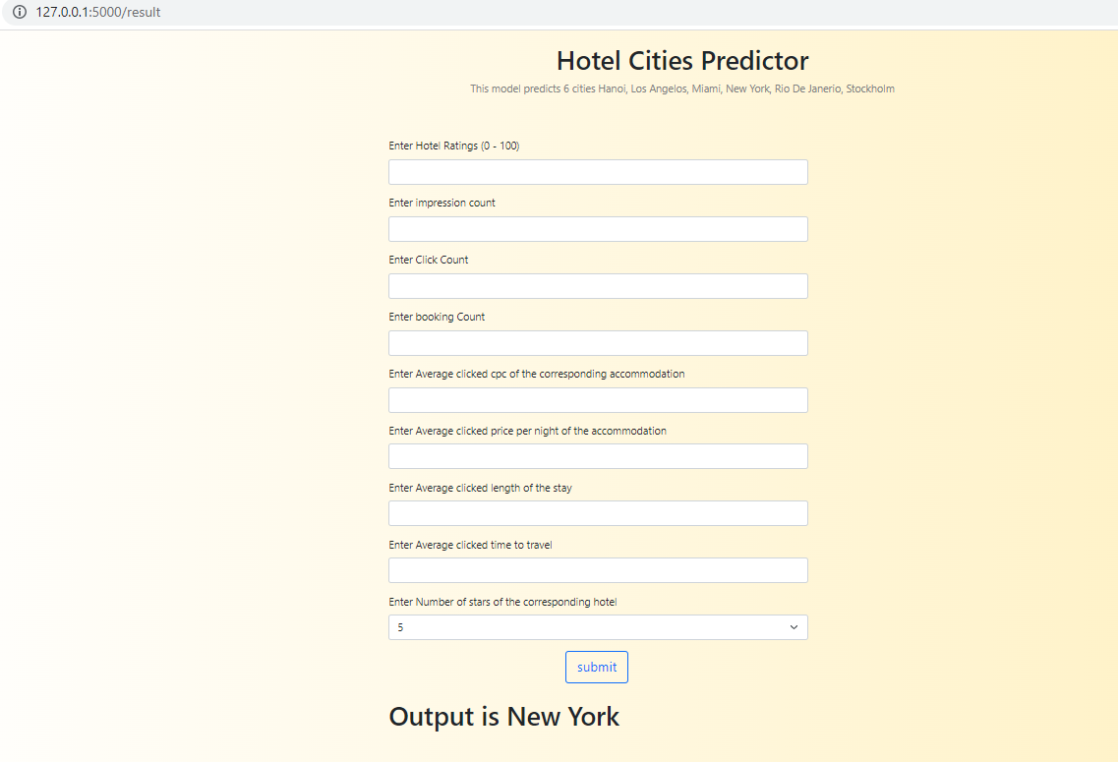
- Same it is updating in the data base also if we are submitting the values.

