**Create Teacher:**

use Nandhana;

create table Teacher (id int(20),name varchar(20),salary float,doj date,experience bool);

desc Teacher;

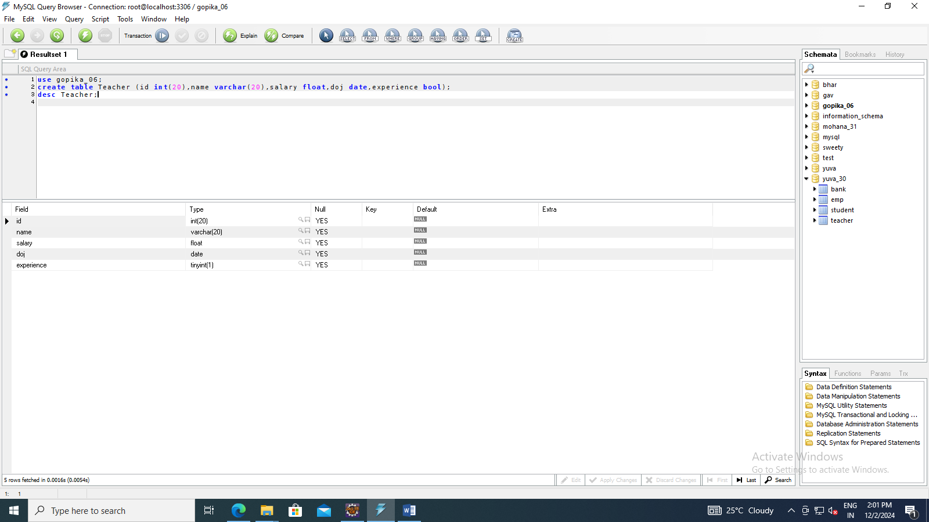

**Select**

Servlet program

**import** java.sql.*;

**import** javax.servlet.*;

**import** javax.servlet.http.*;

**import** java.io.*;

**import** javax.servlet.ServletException;

**import** javax.servlet.annotation.WebServlet;

**import** javax.servlet.http.HttpServlet;

**import** javax.servlet.http.HttpServletRequest;

**import** javax.servlet.http.HttpServletResponse;

/**

* Servlet implementation class msel

*/

@WebServlet("/msel")

**public** **class** msel **extends** HttpServlet {

**private** **static** **final** **long** ***serialVersionUID*** = 1L;

/**

* **@see** HttpServlet#HttpServlet()

*/

**public** msel() {

**super**();

// **TODO** Auto-generated constructor stub

}

/**

* **@see** HttpServlet#doGet(HttpServletRequest request, HttpServletResponse response)

*/

**protected** **void** doGet(HttpServletRequest request, HttpServletResponse response) **throws** ServletException, IOException {

// **TODO** Auto-generated method stub

response.setContentType("text/html");

PrintWriter out=response.getWriter();

**try**{

Class.*forName*("com.mysql.jdbc.Driver");

Connection c=DriverManager.*getConnection*("jdbc:mysql://localhost:3306/Nandhana","root","root");

Statement s=c.createStatement();

ResultSet rs=s.executeQuery("select * from Teacher");

out.println("2313712080006 <br>");

**while**(rs.next())

{

out.println("Id : "+rs.getString(1)+"<br>");

out.println("Name: "+rs.getString(2)+"<br>");

out.println("Salary: "+rs.getString(3)+"<br>");

out.println("DOJ: "+rs.getString(4)+"<br>");

out.println("Experience: "+rs.getString(5)+"<br>");

out.println();

}

}

**catch**(Exception e)

{

out.println("Error:"+e);

}

}

/**

* **@see** HttpServlet#doPost(HttpServletRequest request, HttpServletResponse response)

*/

**protected** **void** doPost(HttpServletRequest request, HttpServletResponse response) **throws** ServletException, IOException {

// **TODO** Auto-generated method stub

}

}

Html

<!DOCTYPE html>

<html>

<head>

<meta charset=*"ISO-8859-1"*>

<title>Student Database</title>

</head>

<body>

<h4>2313712080018</h4>

<form action=*"msel"* method=*"get"*>

<input type=*"submit"* value=*"View"*>

</form>

</body>

</html>

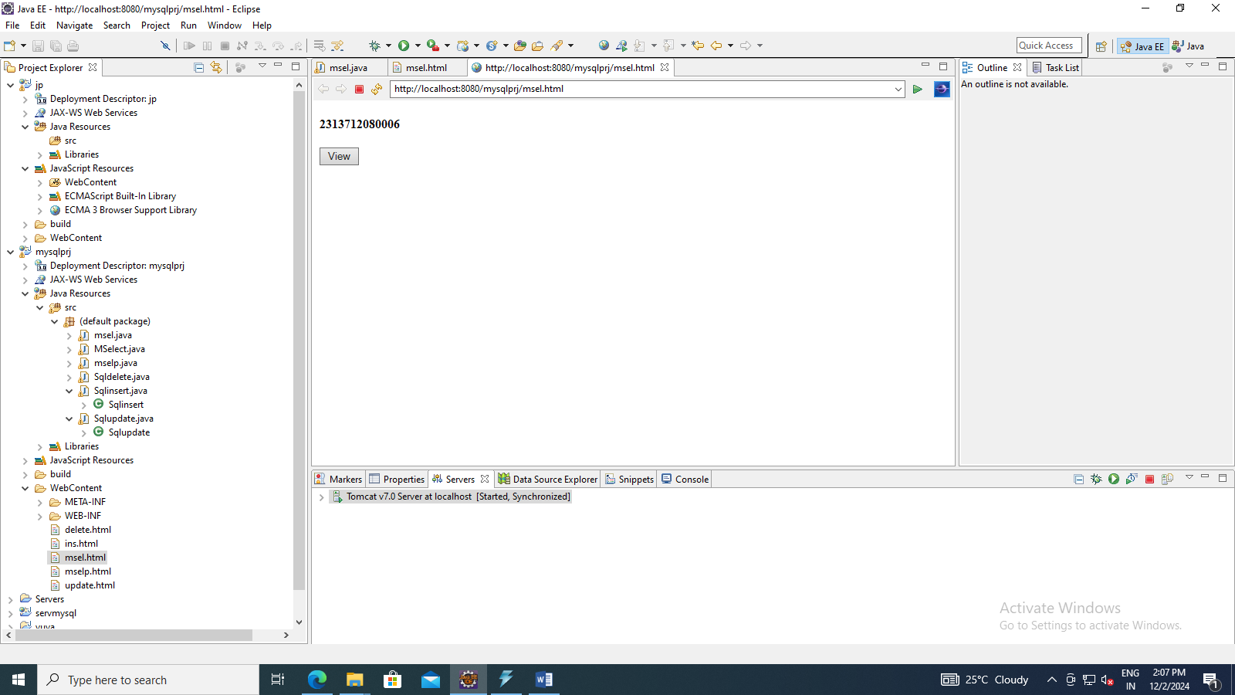

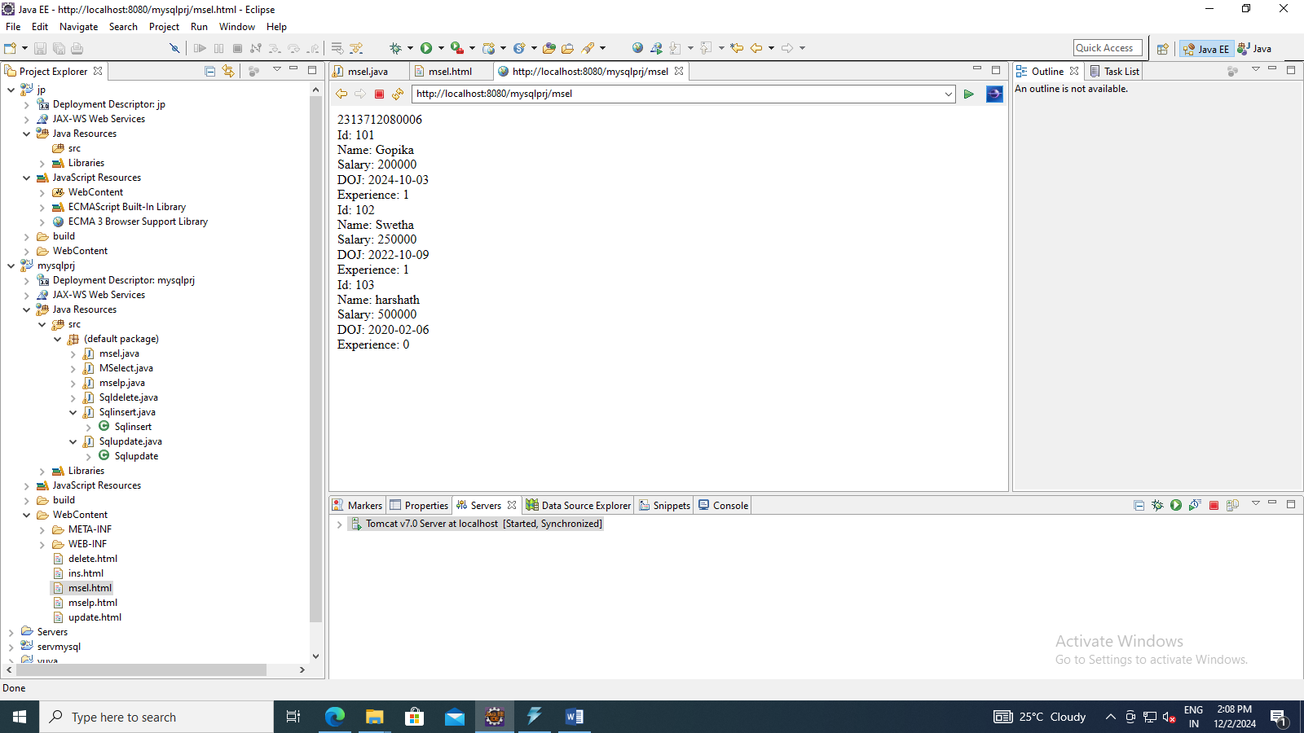

Select particular

**import** java.sql.*;

**import** java.util.Scanner;

**import** javax.servlet.*;

**import** javax.servlet.http.*;

**import** java.io.*;

**import** javax.servlet.ServletException;

**import** javax.servlet.annotation.WebServlet;

**import** javax.servlet.http.HttpServlet;

**import** javax.servlet.http.HttpServletRequest;

**import** javax.servlet.http.HttpServletResponse;

/**

* Servlet implementation class mselp

*/

@WebServlet("/mselp")

**public** **class** mselp **extends** HttpServlet {

**private** **static** **final** **long** ***serialVersionUID*** = 1L;

/**

* **@see** HttpServlet#HttpServlet()

*/

**public** mselp() {

**super**();

// **TODO** Auto-generated constructor stub

}

/**

* **@see** HttpServlet#doGet(HttpServletRequest request, HttpServletResponse response)

*/

**protected** **void** doGet(HttpServletRequest request, HttpServletResponse response) **throws** ServletException, IOException {

// **TODO** Auto-generated method stub

response.setContentType("text/html");

PrintWriter out=response.getWriter();

String id1 = request.getParameter("id");

**int** id = Integer.*parseInt*(id1);

**try**{

Class.*forName*("com.mysql.jdbc.Driver");

Connection c=DriverManager.*getConnection*("jdbc:mysql://localhost:3306/Nandhana","root","root");

Statement s=c.createStatement();

ResultSet rs=s.executeQuery("select * from Teacher where id="+id+"");

out.println("2313712080006 <br>");

**while**(rs.next())

{

out.println("Id: "+rs.getString(1)+"<br>");

out.println("Name: "+rs.getString(2)+"<br>");

out.println("Salary: "+rs.getString(3)+"<br>");

out.println("DOJ: "+rs.getString(4)+"<br>");

out.println("Experience: "+rs.getString(5)+"<br>");

out.println();

}

}

**catch**(Exception e)

{

out.println("Error:"+e);

}

}

/**

* **@see** HttpServlet#doPost(HttpServletRequest request, HttpServletResponse response)

*/

**protected** **void** doPost(HttpServletRequest request, HttpServletResponse response) **throws** ServletException, IOException {

// **TODO** Auto-generated method stub

}

}

<!DOCTYPE html>

<html>

<head>

<meta charset=*"ISO-8859-1"*>

<title>Teacher Joining</title>

</head>

<body>

<h4>23137120800018</h4>

<form action=*"mselp"* method=*"get"*>

id: <input type=*"text"* name=*"id"*>

<input type=*"submit"* value=*"View"*>

</form>

</body>

</html>

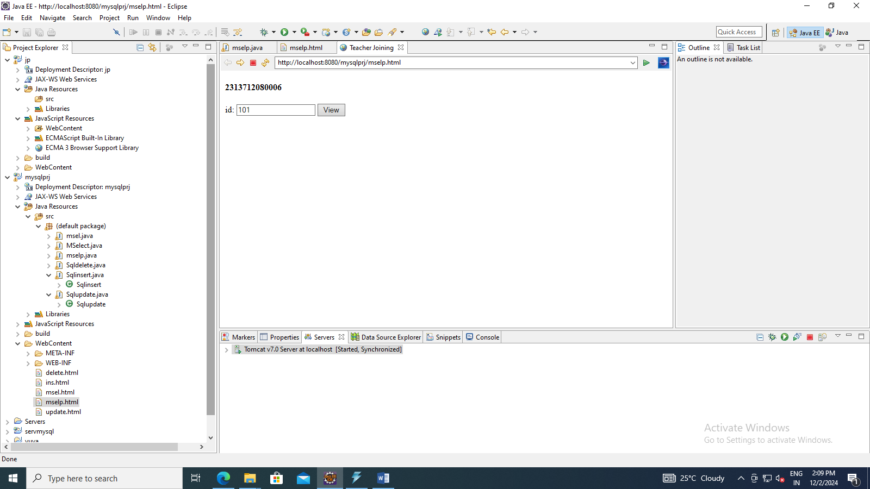

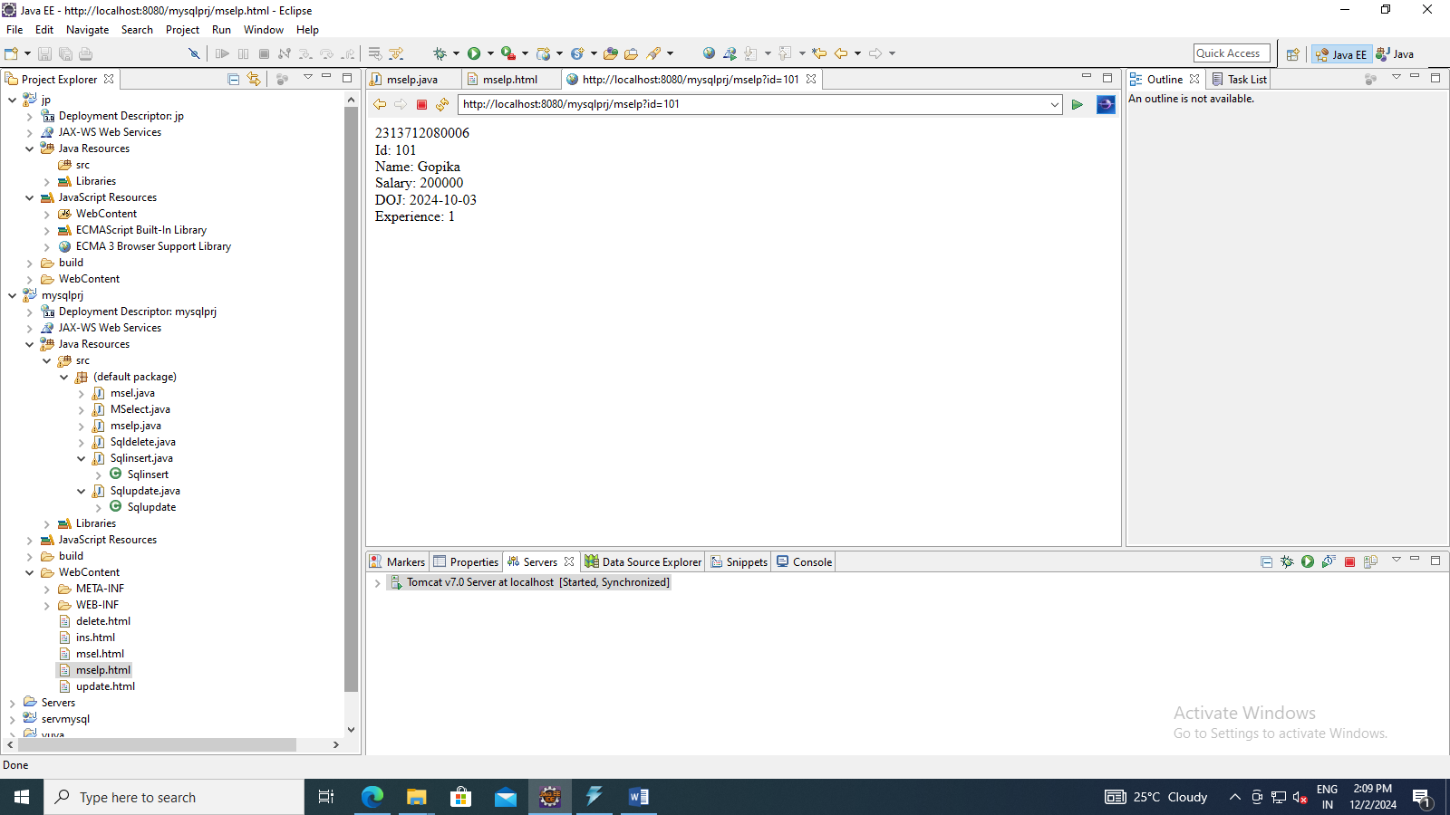

**Insert**

**import** java.sql.*;

**import** java.util.Scanner;

**import** javax.servlet.*;

**import** javax.servlet.http.*;

**import** java.io.*;

**import** javax.servlet.ServletException;

**import** javax.servlet.annotation.WebServlet;

**import** javax.servlet.http.HttpServlet;

**import** javax.servlet.http.HttpServletRequest;

**import** javax.servlet.http.HttpServletResponse;

/**

* Servlet implementation class Sqlinsert

*/

@WebServlet("/Sqlinsert")

**public** **class** Sqlinsert **extends** HttpServlet {

**private** **static** **final** **long** ***serialVersionUID*** = 1L;

/**

* **@see** HttpServlet#HttpServlet()

*/

**public** Sqlinsert() {

**super**();

// **TODO** Auto-generated constructor stub

}

/**

* **@see** HttpServlet#doGet(HttpServletRequest request, HttpServletResponse response)

*/

**protected** **void** doGet(HttpServletRequest request, HttpServletResponse response) **throws** ServletException, IOException {

// **TODO** Auto-generated method stub

String id1 = request.getParameter("id");

**int** id = Integer.*parseInt*(id1);

String name = request.getParameter("name");

String Salary = request.getParameter("salary");

**float** salary = Float.*parseFloat*(Salary);

String doj = request.getParameter("doj");

String experience = request.getParameter("experience");

response.setContentType("text/html");

PrintWriter out=response.getWriter();

**try**{

Class.*forName*("com.mysql.jdbc.Driver");

Connection c=DriverManager.*getConnection*("jdbc:mysql://localhost:3306/Nandhana","root","root");

Statement s=c.createStatement();

s.executeUpdate("insert into Teacher values("+id+",'"+name+"',"+salary+",'"+doj+"','"+experience+"')");

out.println("\n Record Inserted");

ResultSet rs=s.executeQuery("select * from Teacher");

**while**(rs.next())

{

out.println("id:"+rs.getString(1));

out.println("Name:"+rs.getString(2));

out.println("Salary:"+rs.getString(3));

out.println("Doj:"+rs.getString(4));

out.println("experience:"+rs.getString(5));

out.println();

}

}

**catch**(Exception e)

{

out.println("Error:"+e);

}

}

/**

* **@see** HttpServlet#doPost(HttpServletRequest request, HttpServletResponse response)

*/

**protected** **void** doPost(HttpServletRequest request, HttpServletResponse response) **throws** ServletException, IOException {

// **TODO** Auto-generated method stub

}

}

<!DOCTYPE html>

<html>

<head><style>**td**{padding:*10px*;}</style></head>

<body>

<h2>2313712080018</h2>

<form action=*"Sqlinsert"* method=*"get"*>

<table border=*1*>

<tr><td>Reg Number:</td><td><input type=*"text"* name=*"regno"*></td></tr>

<tr><td>Name:</td><td><input type=*"text"* name=*"name"*></td></tr>

<tr><td>Marks:</td><td><input type=*"text"* name=*"marks"*></td></tr>

<tr><td>Date of Birth:</td><td><input type=*"text"* name=*"dob"*></td></tr>

<tr><td>Result:</td><td><input type=*"text"* name=*"result"*></td></tr>

<tr><td colspan=*"2"* align=*"center"*><input type=*"submit"* value=*"Insert"*></tr>

</table>

</form>

</body>

</html>

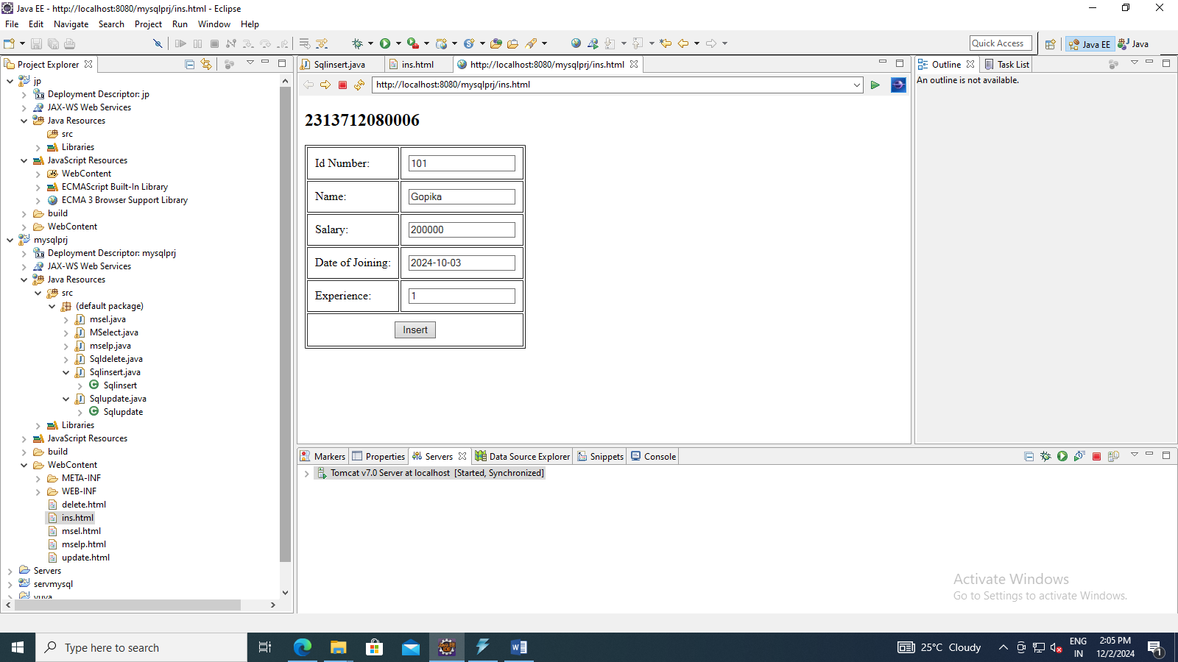

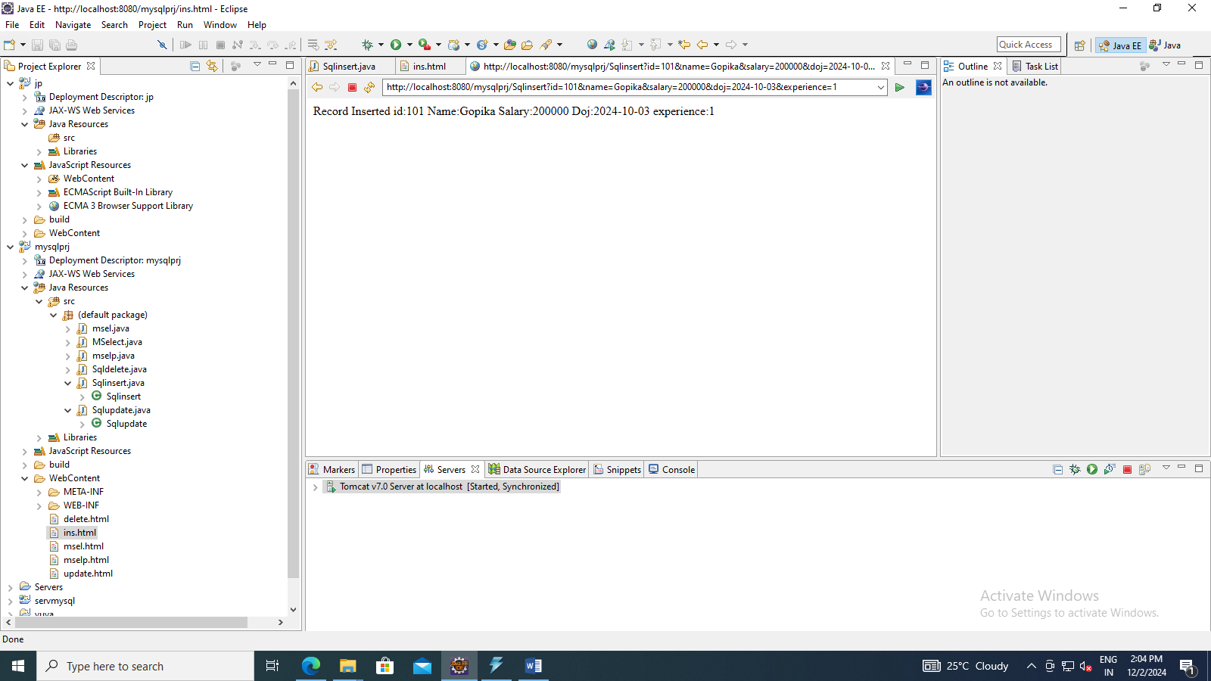

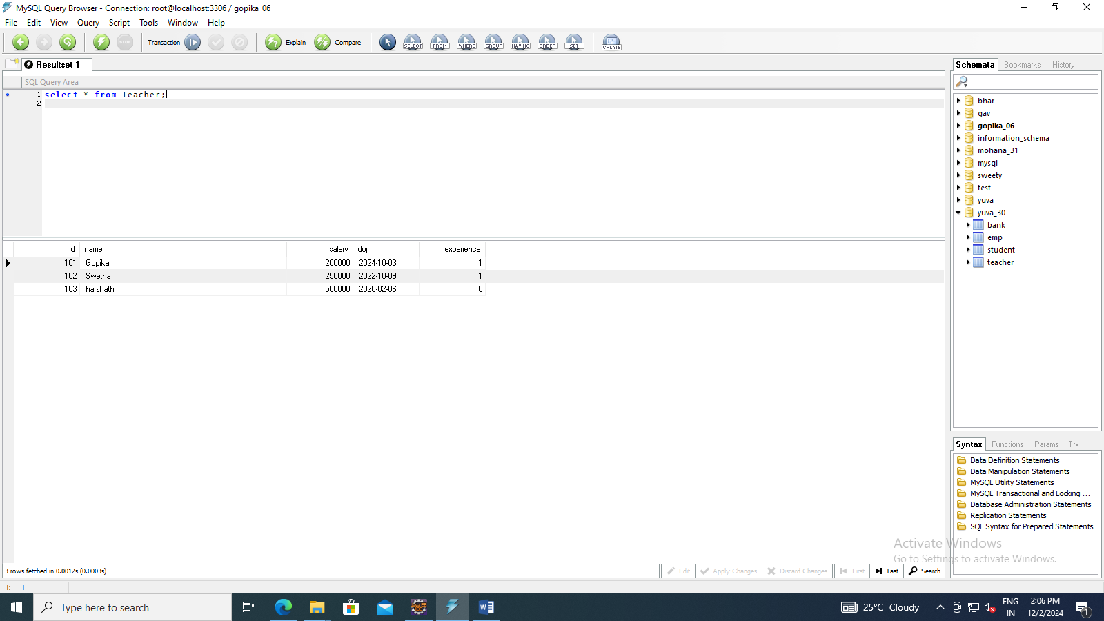

Update

**import** java.sql.*;

**import** java.util.Scanner;

**import** javax.servlet.*;

**import** javax.servlet.http.*;

**import** java.io.*;

**import** javax.servlet.ServletException;

**import** javax.servlet.annotation.WebServlet;

**import** javax.servlet.http.HttpServlet;

**import** javax.servlet.http.HttpServletRequest;

**import** javax.servlet.http.HttpServletResponse;

/**

* Servlet implementation class Sqlupdate

*/

@WebServlet("/Sqlupdate")

**public** **class** Sqlupdate **extends** HttpServlet {

**private** **static** **final** **long** ***serialVersionUID*** = 1L;

/**

* **@see** HttpServlet#HttpServlet()

*/

**public** Sqlupdate() {

**super**();

// **TODO** Auto-generated constructor stub

}

/**

* **@see** HttpServlet#doGet(HttpServletRequest request, HttpServletResponse response)

*/

**protected** **void** doGet(HttpServletRequest request, HttpServletResponse response) **throws** ServletException, IOException {

// **TODO** Auto-generated method stub

String name = request.getParameter("name");

response.setContentType("text/html");

PrintWriter out=response.getWriter();

String id1 = request.getParameter("id");

**int** id = Integer.*parseInt*(id1);

**try**{

Class.*forName*("com.mysql.jdbc.Driver");

Connection c=DriverManager.*getConnection*("jdbc:mysql://localhost:3306/Nandhana","root","root");

Statement s=c.createStatement();

s.executeUpdate("update Teacher set name='"+name+"' where id="+id+"");

out.println(" 2313712080006/n");

out.println("\n Record updated");

ResultSet rs=s.executeQuery("select * from Teacher");

**while**(rs.next())

{

out.println("Id: "+rs.getString(1)+"<br>");

out.println("Name: "+rs.getString(2)+"<br>");

out.println("Salary: "+rs.getString(3)+"<br>");

out.println("DOJ: "+rs.getString(4)+"<br>");

out.println("Experience: "+rs.getString(5)+"<br>");

out.println();

}

}

**catch**(Exception e)

{

out.println("Error:"+e);

}

}

/**

* **@see** HttpServlet#doPost(HttpServletRequest request, HttpServletResponse response)

*/

**protected** **void** doPost(HttpServletRequest request, HttpServletResponse response) **throws** ServletException, IOException {

// **TODO** Auto-generated method stub

}

}

<!DOCTYPE html>

<html>

<head>

<meta charset=*"ISO-8859-1"*>

<title>Insert title here</title>

</head>

<body>

<h2>2313712080018</h2>

<form action=*"Sqlupdate"* method=*"get"*>

<table border=*1*>

<tr><td>Id Number:</td><td><input type=*"text"* name=*"id"*></td></tr>

<tr><td>Name:</td><td><input type=*"text"* name=*"name"*></td></tr>

<tr><td colspan=*"2"* align=*"center"*><input type=*"submit"* value=*"Update"*></tr>

</table>

</form>

</body>

</html>

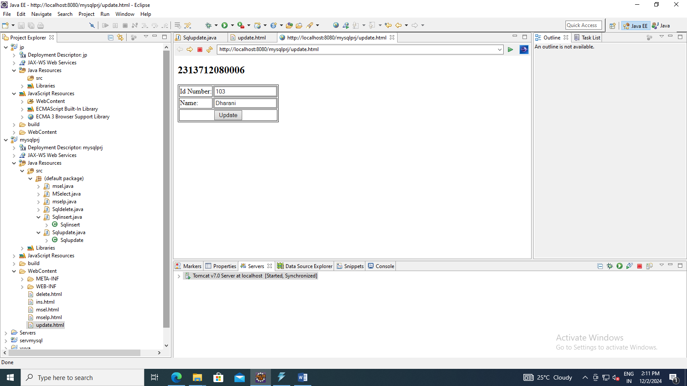

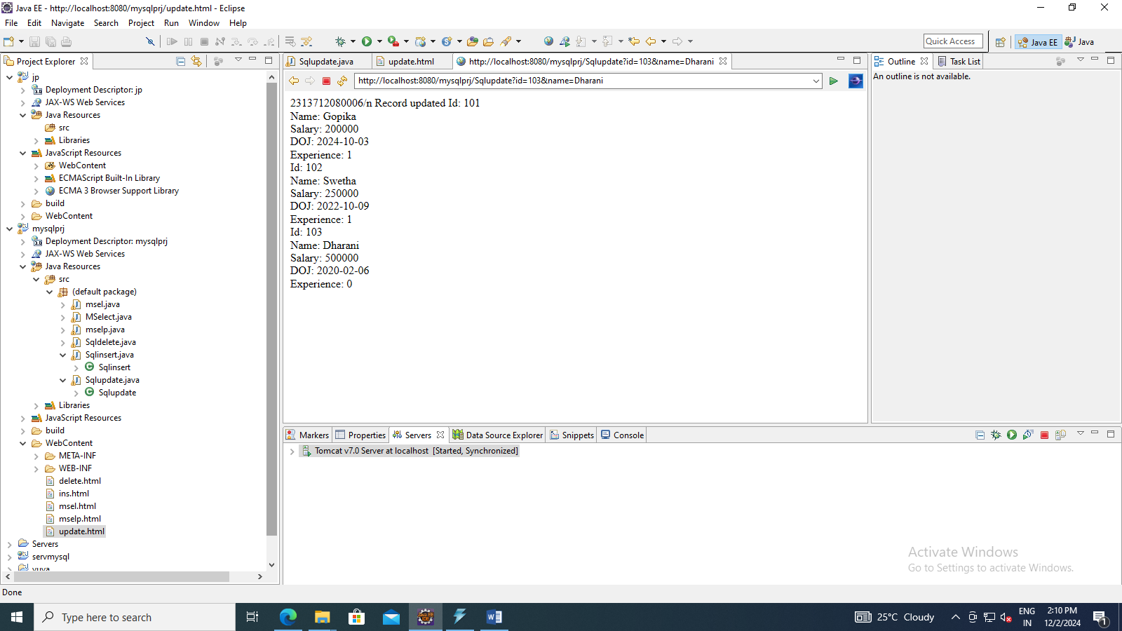

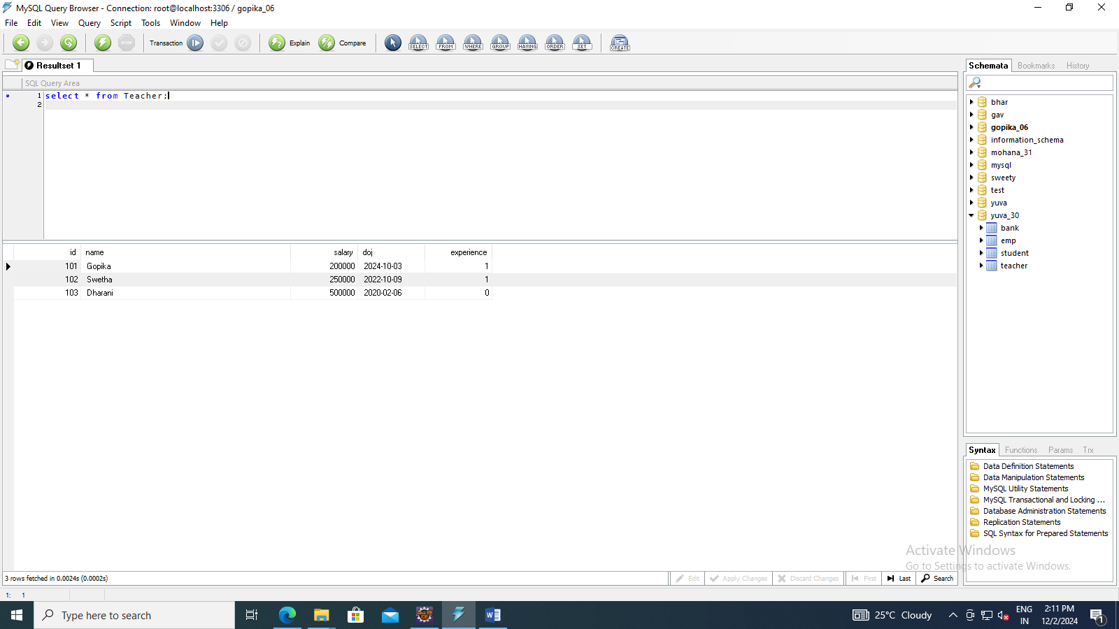

Delete

**import** java.sql.*;

**import** java.util.Scanner;

**import** javax.servlet.*;

**import** javax.servlet.http.*;

**import** java.io.*;

**import** javax.servlet.ServletException;

**import** javax.servlet.annotation.WebServlet;

**import** javax.servlet.http.HttpServlet;

**import** javax.servlet.http.HttpServletRequest;

**import** javax.servlet.http.HttpServletResponse;

/**

* Servlet implementation class Sqldelete

*/

@WebServlet("/Sqldelete")

**public** **class** Sqldelete **extends** HttpServlet {

**private** **static** **final** **long** ***serialVersionUID*** = 1L;

/**

* **@see** HttpServlet#HttpServlet()

*/

**public** Sqldelete() {

**super**();

// **TODO** Auto-generated constructor stub

}

/**

* **@see** HttpServlet#doGet(HttpServletRequest request, HttpServletResponse response)

*/

**protected** **void** doGet(HttpServletRequest request, HttpServletResponse response) **throws** ServletException, IOException {

// **TODO** Auto-generated method stub

response.setContentType("text/html");

PrintWriter out=response.getWriter();

String id1 = request.getParameter("id");

**int** id = Integer.*parseInt*(id1);

**try**{

Class.*forName*("com.mysql.jdbc.Driver");

Connection c=DriverManager.*getConnection*("jdbc:mysql://localhost:3306/Nandhana","root","root");

Statement s=c.createStatement();

s.executeUpdate("delete from Teacher where id="+id+"");

out.println("\n 2313712080006");

out.println("\n Record deleted");

ResultSet rs=s.executeQuery("select * from Teacher");

**while**(rs.next())

{

out.println("Id: "+rs.getString(1)+"<br>");

out.println("Name: "+rs.getString(2)+"<br>");

out.println("Salary: "+rs.getString(3)+"<br>");

out.println("DOJ: "+rs.getString(4)+"<br>");

out.println("Experience: "+rs.getString(5)+"<br>");

out.println();

}

}

**catch**(Exception e)

{

out.println("Error:"+e);

}

}

/**

* **@see** HttpServlet#doPost(HttpServletRequest request, HttpServletResponse response)

*/

**protected** **void** doPost(HttpServletRequest request, HttpServletResponse response) **throws** ServletException, IOException {

// **TODO** Auto-generated method stub

}

}

<!DOCTYPE html>

<html>

<head>

<meta charset=*"ISO-8859-1"*>

<title>Insert title here</title>

</head>

<body>

<h2>2313712080018</h2>

<form action=*"Sqldelete"* method=*"get"*>

<table border=*1*>

<tr><td>Id Number:</td><td><input type=*"text"* name=*"id"*></td></tr>

<tr><td colspan=*"2"* align=*"center"*><input type=*"submit"* value=*"Delete"*></tr>

</table>

</form>

</body>

</html>

\