**PHP and MYSQL**

Insert.html

<html>

<head><style>td{padding:10px;}</style></head>

<body>

<h1> Employee Database</h1>

<form action="insert.php" method="post">

<table border=1 color="red">

<tr><td>Reg Number:</td><td><input type="text" name="regno"></td></tr>

<tr><td>Name:</td><td><input type="text" name="name"></td></tr>

<tr><td>Marks:</td><td><input type="text" name="marks"></td></tr>

<tr><td>Date of Birth:</td><td><input type="text" name="dob"></td></tr>

<tr><td>Result:</td><td><input type="text" name="result"></td></tr>

<tr><td colspan="2" align="center"><input type="submit" value="Insert"></tr>

</table>

</form>

</body>

</html>Insert.php

<?php

$con = mysqli_connect("localhost","root","root");

mysqli_select_db($con,"swe29");

$regno = $_POST["regno"];

$name = $_POST["name"];

$marks = $_POST["marks"];

$dob = $_POST["dob"];

$result = $_POST["result"];

echo "Connection is done"."<br><br>";

$rs = mysqli_query($con,"insert into student values(".$regno.",'".$name."','".$dob."',".$result.",".$marks.")");

echo "Record Inserted";

?>



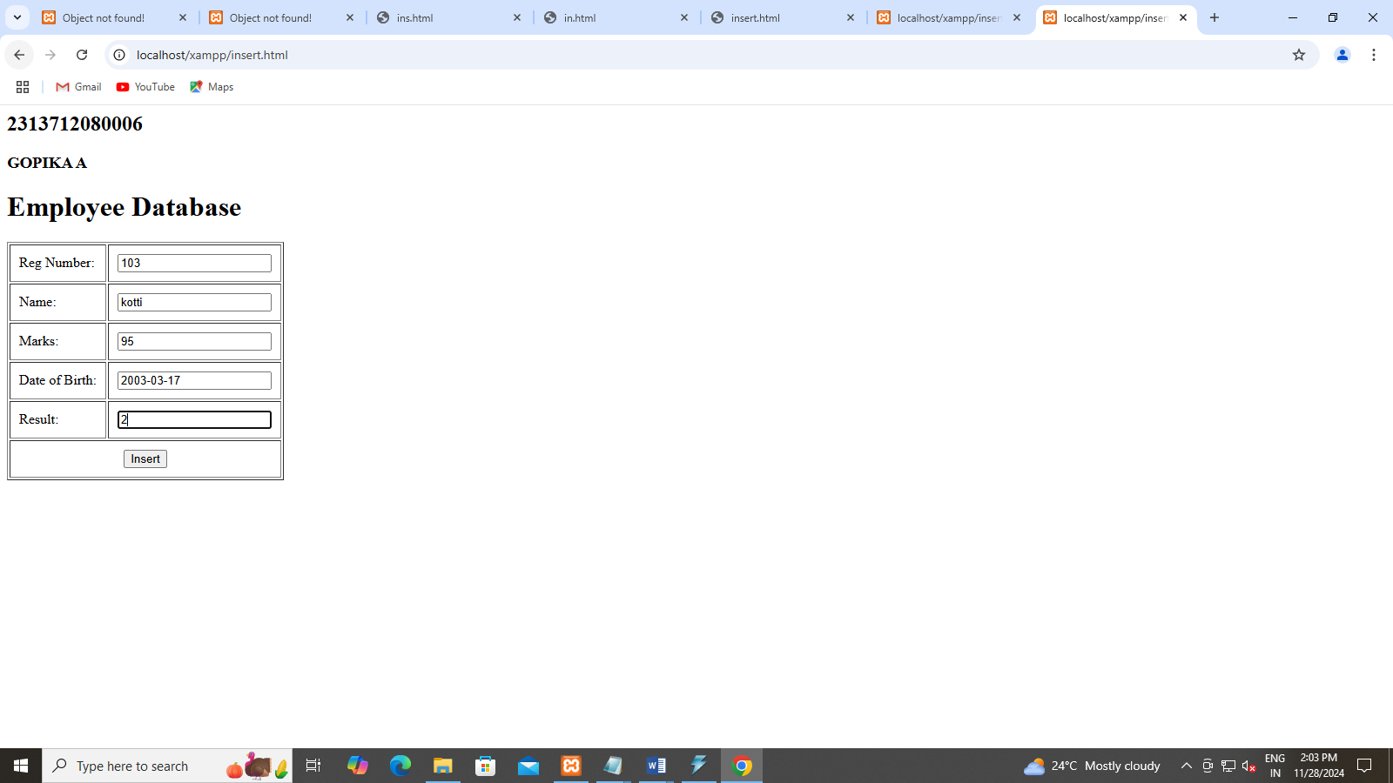

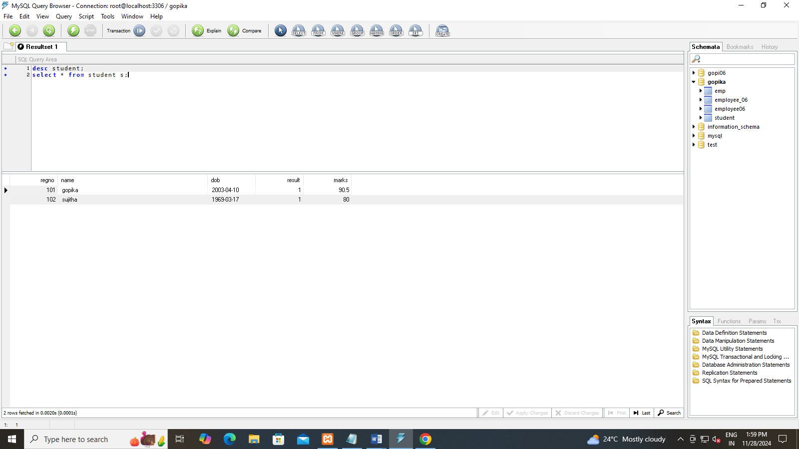

SELECT.PHP

<?php

$con = mysqli_connect("localhost","root","root");

mysqli_select_db($con,"gopika");

echo "Connection is done"."<br><br>";

$rs=mysqli_query($con,"select * from student");

echo "Your Database";

while($q=mysqli_fetch_row($rs))

{

echo "</br>".$q[0]."</br>";

echo $q[1]."</br>";

echo $q[2]."</br>";

echo $q[3]."</br>";

echo $q[4]."</br>";

echo "-----------";

}

?>

SELECT.HTML

<html>

<body>

<h1>Student Database</h1>

<form action="select.php" method="post">

<input type="submit">

</form>

</body>

</html>

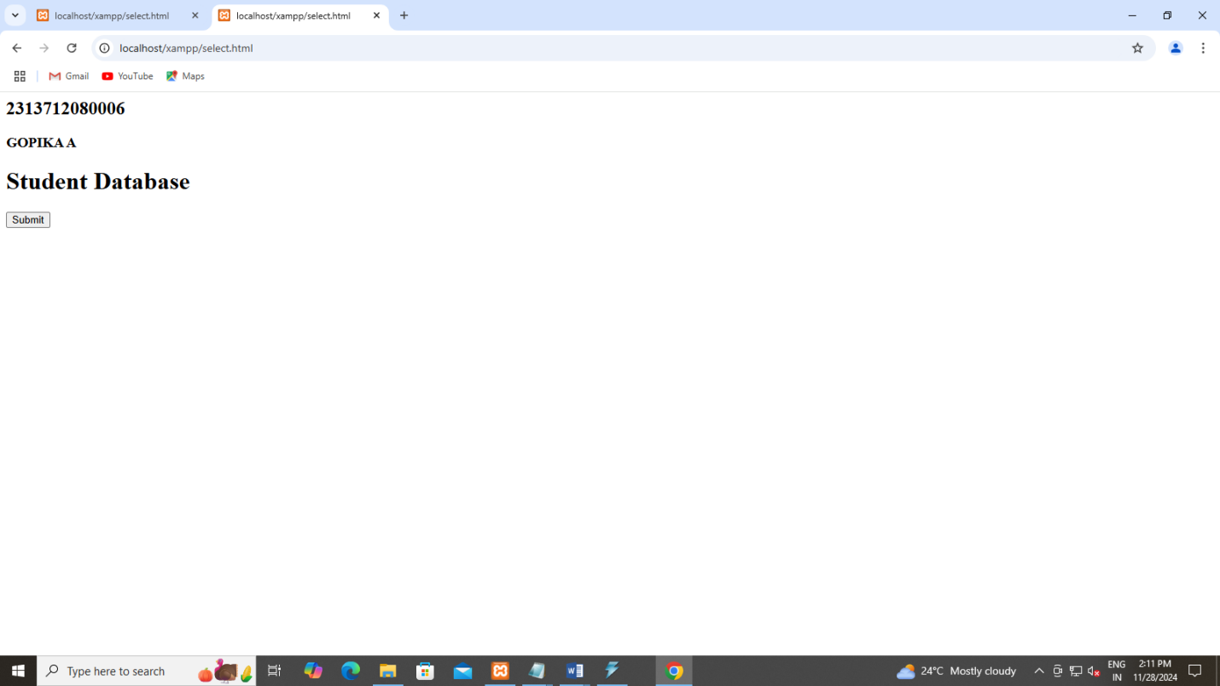



Select1.html

<html>

<body>

<h1>Student Database</h1>

<form action="select1.php" method="post">

Enter regno:<input type="text" name="regno">

<input type="submit">

</form>

</body>

</html>

Select1.html

<?php

$con = mysqli_connect("localhost","root","root");

mysqli_select_db($con,"gopika");

echo "Connection is done"."<br><br>";

$regno=$_POST['regno'];

$rs=mysqli_query($con,"select * from student where regno=".$regno.";");

echo "Your Database";

while($q=mysqli_fetch_row($rs))

{

echo "</br>".$q[0]."</br>";

echo $q[1]."</br>";

echo $q[2]."</br>";

echo $q[3]."</br>";

echo $q[4]."</br>";

echo "-----------";

}

?>

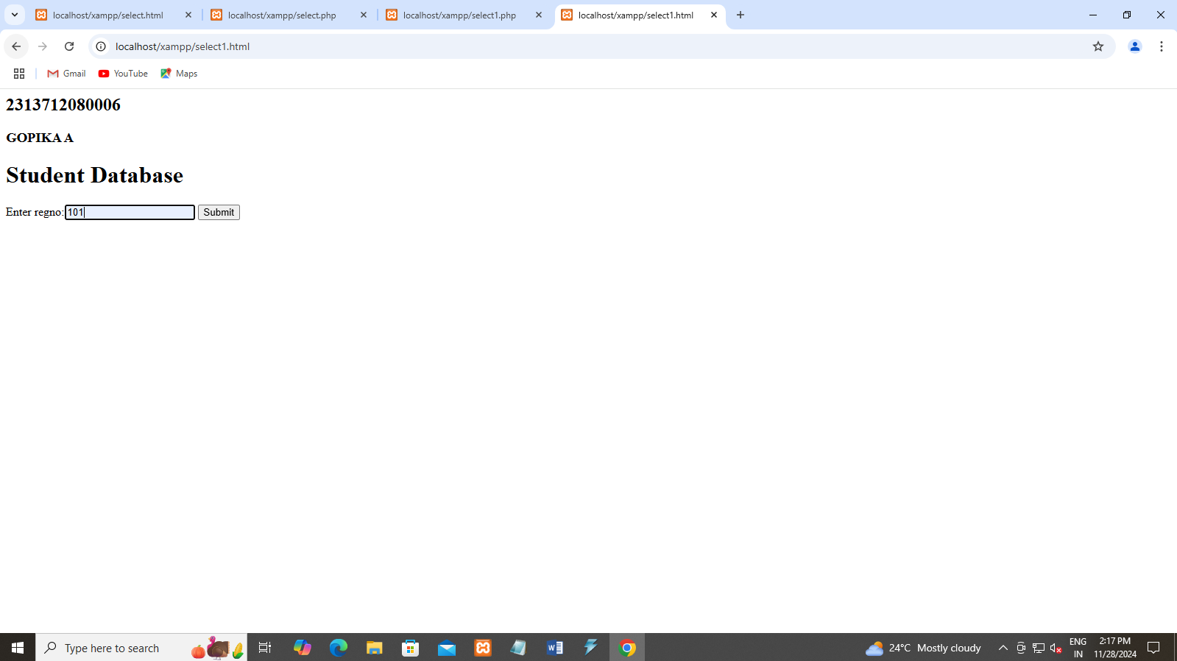



Update.php

<?php

$con = mysqli_connect("localhost","root","root");

mysqli_select_db($con,"gopika");

$regno = $_POST["regno"];

$name = $_POST["name"];

echo "Updation is done"."<br><br>";

$rs = mysqli_query($con,"update student set name='".$name."' where regno=".$regno."");

echo "Record Updated";

?>

Update.html

<html>

<head><style>td{padding:10px;}</style></head>

<body>

<h2>2313712080006</h2>

<h3>GOPIKA A</h3>

<h1> Student Database</h1>

<form action="update.php" method="post">

<table border=1 color="red">

<tr><td>Regno Number:</td><td><input type="text" name="regno"></td></tr>

<tr><td>Name:</td><td><input type="text" name="name"></td></tr>

<tr><td colspan="2" align="center"><input type="submit" value="Update"></tr>

</table>

</form>

</body>

</html>

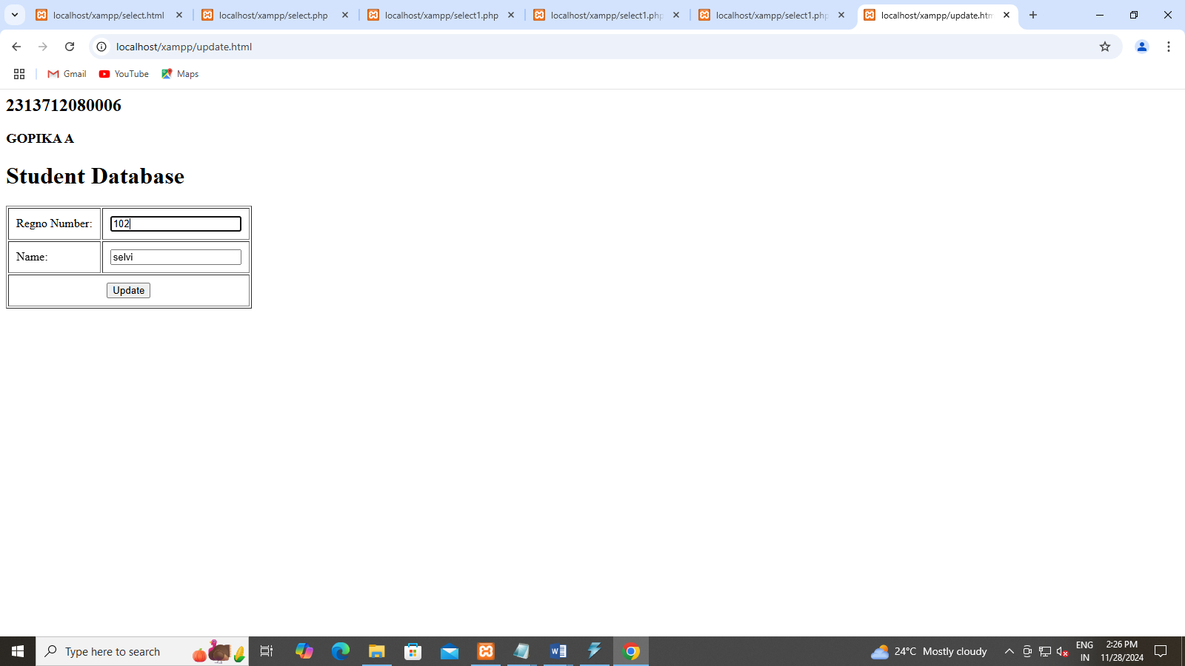



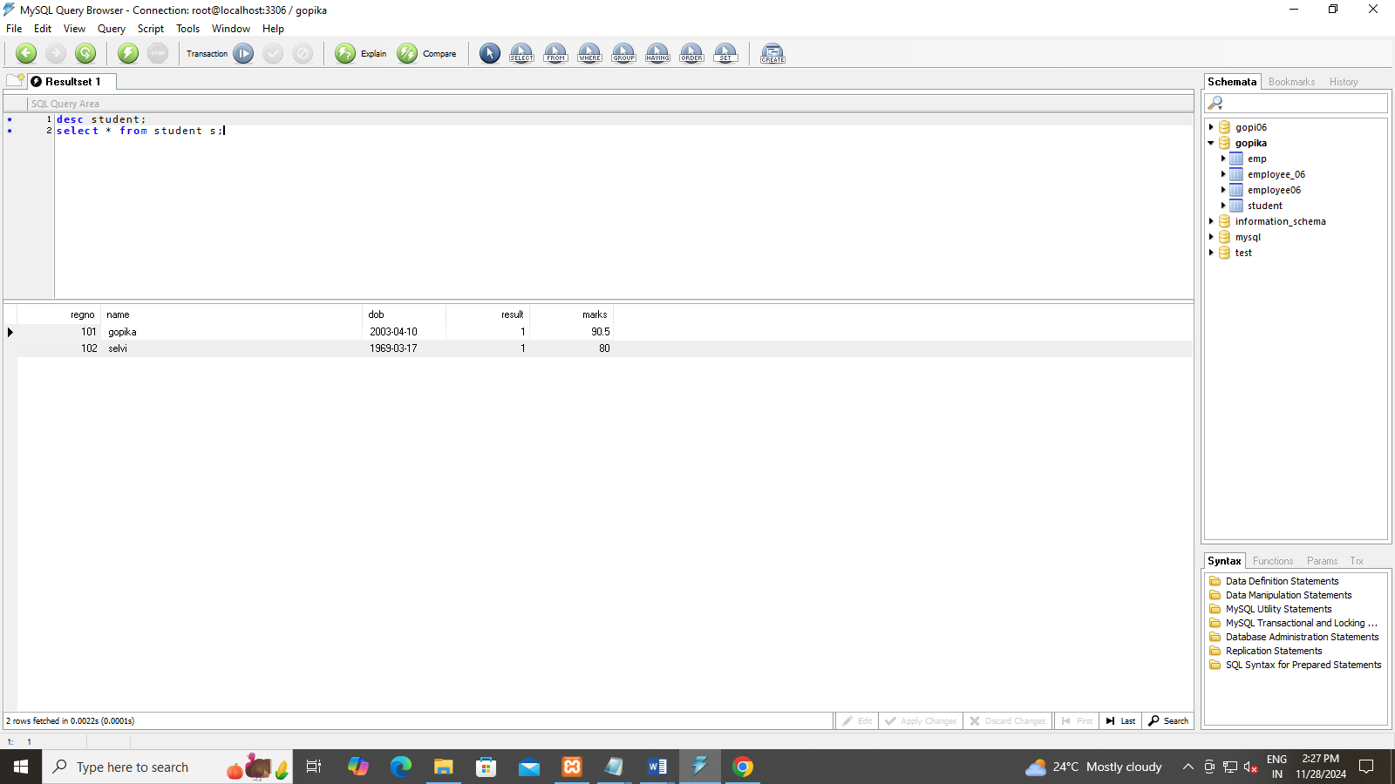

Delete.php

<?php

$con = mysqli_connect("localhost","root","root");

mysqli_select_db($con,"gopika");

$regno = $_POST["regno"];

echo "Deletion is done"."<br><br>";

$rs = mysqli_query($con,"delete from student where regno=".$regno."");

echo "Record Deleted";

?>

Delete.html

<html>

<head><style>td{padding:10px;}</style></head>

<body>

<h1> Student Database</h1>

<form action="delete.php" method="post">

<table border=1 color="red">

<tr><td>Regno Number:</td><td><input type="text" name="regno"></td></tr>

<tr><td colspan="2" align="center"><input type="submit" value="Delete"></tr>

</table>

</form>

</body>

</html>

