INTRODUCTION

  - What is Lightning?
Lightning is a powerful, natural electric discharge that is created through the mixture of hot and cold air in the cloud. Lightning results from the buildup and release of electrical charges within storm cloud or between clouds or cloud to ground. Lightning occurs when there is a separation of charge from water droplets, ice crystals and snow inside the cloud. When the electrical potential difference becomes great enough to overcome the air’s insulating properties, a massive electrical discharge occurs because the great difference in the charges rush to neutralize.

  - Why Predicting is important?
Lightning have immediate and long-term effects on people, structures and the environment, resulting in deaths, severe injuries and property damage. Lightning is a frequent occurrence with an estimated 50 occurrence per second. Jharkhand, in particular, is experiencing an increase in the number of deaths due to lightning strikes. It is estimated that 431 people have lost their lives in the 2025 monsoon period. Along with people, many animals have also lost their lives. Out of all the states in India, Jharkhand is one of the six states highly prone to lightning deaths. In the annual report of Climate Resilient Observation System Promotion Council (CROPC), 1669 people have died in Jharkhand due to lightning strikes with an average of 436,250 lightning strikes in last five years. To prevent this from happening, we should have a Lightning Prediction System, to prevent from these casualties and damage. A good Lightning Prediction System can save crores of the Government from structural damages and also save millions of lives, not only in Jharkhand but all across the world. [1]

  - Global and Local Impact of Lightning
As many as 18.5 million lightning strikes were recorded in India between April 1, 2020 and March 31, 2021, according to India’s second annual report on lightning released by Lightning Resilient India Campaign (LRIC) recently. At least 1697 people died in India in 2020-21 with Jharkhand having the most deaths of 401.

  - Real-Life Applications
Some of the Real-Life Application of an accurate Lightning Prediction System could be Disaster Management, Aviation Safety, Outdoor Activities, Agriculture and many more. By predicting early lightning, we can save the environment from huge damage. Lakhs of trees are destroyed from lightning every year with forest fire a very common phenomenon. In the aviation sector, a proper lightning prediction system is very useful as many aircrafts gets damaged from lightning strikes, not only damaging the aircraft but also endangering the lives of thousands of people travelling. In outdoor activities, many children and athletes get killed by lightning every year. In agriculture, acres of land and crops get damaged due to heavy lightning, resulting not only in damaged crops but also employment for farmers. Especially in India, where it is a farmer heavy country, a proper lightning prediction system is a must.

  - Overview of the Project
Our Lightning Prediction System focuses on the lightning data of Jharkhand. Weather monitoring sensors are planted over all the 24 districts in Jharkhand collecting data from 2017-2022. The data is present in two part- first being the Lightning Dataset (LIS) which consist of the district name, date and other parameters exclusive to Jharkhand, second being the Meteorological dataset (MTS) which consist of meteorological parameters like temperature, humidity, rain in mm, etc. The merging of the two dataset was crucial for the prediction of lightning as we needed both lightning parameters as well as the meteorological parameters. So we were required to merge the two datasets on the values of District and Date as they were common in both the dataset. The project contains feature engineering to overcome the simpleness of the dataset. The new dataset was again faced with the challenge of class imbalance which was overcame by building pipeline (Scalar + SMOTE + Model). We then have trained the dataset using various ML Models like Random Forest Classifier, SVM, Logistic Regression and Ensemble (Logistic Regression, Multi-Layer Perceptron and Gradient Descent) where Ensemble had the best accuracy among all.
The project uses a bunch of methodologies, methodologies for overcoming different type of challenges. At the end, the model is proficient in predicting lightning with some parameters given. The project demonstrates how lightning can be predicted from various LIS and MTS parameters, how to overcome simpleness of dataset, how to overcome the problem of class imbalance as well as training of different models to get the best among them.

LITERATURE REVIEW

1. The shift from Numerical to Data-Driven Forecasting
Weather forecasting has traditionally been based on Numerical Weather Prediction (NWP), which is a complex fluid dynamics calculation that is used to model atmospheric conditions. Although NWP has experienced consistent advancement in terms of improved data assimilation and resolution, it has major setbacks. NWP models are computationally costly, in many cases fail to capture sub-grid processes such as microphysics in clouds, and fail to be internally consistent when post-processing is used. As such, the paradigm has shifted to data-driven approaches. Deep Learning (DL) has become able to compete or complement traditional methods due to the "third wave" of Artificial Intelligence, which is powered by GPUs and large datasets. Researchers claim that end-to-end DL systems have the potential of substituting the major components of the NWP workflow, with shorter inference times and inherently lower-reduction of model bias. But data-only models are not trusted in terms of their absence of physical constraints and explainability.

2. The Evolution of Deep Learning Algorithms
he Evolution of the Random Forest. Recent studies emphasize that there has been increased sophistication in algorithms that are applied in lightning prediction. RF has been preferred due to its preciseness and capability of working with different meteorological data. Deep Learning (DL) Architectures: The recent research shifted to DL in order to reflect on the complex spatio-temporal dependencies that the traditional ML lacks. Convolutional Neural Networks are currently popularly used to derive spatial features of satellite imagery. Recurrent neural networks (RNNs) and Long short term memory (LSTM) networks have been used to deal with temporal evolution. tate-of-the-Art Architectures: The most sophisticated strategies are an integration of such methods. As an example, spatiotemporal networks such as ConvLSTM and PredRNN have been trained, but they can occasionally have a problem with high-risk probability calibration. More recent designs are Encoder-Decoder based encoder-decoder designs with attention (e.g., ED-DRAP) and enhanced ability to capture rapid and chaotic lightning events.

3. Challenges of Importance in existing methodology

There are three gaps in the literature despite the advancement: The Lead-Time/Accuracy Trade-off: It has been been sufficiently documented that there is an inverse relationship between lead time and accuracy; the longer the forecast horizon (ex: 15 minutes to 1 hour), the more the accuracy is decreased.
Class Imbalance Problem: Lightning The lightning is a "bad event" in spatial data (typically occupying less than 1 percent of pixels). These situations cause Standard loss functions to fail as they enable models to predict only the background (no lightning).

Calibration Problems: One of the biggest weaknesses of most DL weather models is poor calibration- that is, the desired level of confidence scores do not give the desired frequency of events. Models can be very accurate, but they tend to overestimate probabilities of high risk. The low Expected Calibration Error (ECE) is necessary to ensure the safety of operation especially in the aviation sector.

METHODOLOGY

This section describes the complete flow of the project adopted for the lightning prediction system. This section include various steps followed for lightning prediction like dataset preprocessing, feature engineering, class balancing, pipeline construction, model training, ensemble learning and evaluation metrics.

3.1 System Architecture
The architecture of the proposed system was followed using the following steps:

  - Data Acquisition and Loading
  - Data Preprocessing and Cleaning
  - Feature Engineering
  - Train-Test Spilt
  - Handling Class Imbalance
  - Pipeline Construction
  - Model Training
  - Ensemble Learning
  - Evaluation

3.2 Dataset Description
There were two datasets, one was All District Lightning Data of Jharkhand (LIS) and the other was Jharkhand All District Weather (MTS). The LIS data consisted of UTC Time, Month, Month_Number, Date, Latitude, Longitude, Radiance, Duration, Groups, Events, OrbitID and District. This data set had the details of the days when lightning occurred exclusive to Jharkhand. The MTS data consisted of District, Pressure, Density, Rain_mm, State, Shape, WindSpeed, Temp_C, Date and the .geo(coordinates)fields. Both the datasets contains atmospheric and environmental variables relevant to lightning formation. Some of the salient features include:

    - Meteorological variable: Temperature (in Celcius), Pressure (hPa), Relative Humidity, Wind Speed, Rainfall.

    - Temporal Attributes: Date, Month, UTC Time.

    - Spatial Attributes: Longitude, Latitude.

3.3 Data Preprocessing
Data Preprocessing is one of the most important stages of the project. Data Preprocessing helps to improve dataset quality and ensures we have clean, consistent inputs. Without data preprocessing, we have unclean, unstructured data we may hamper our AI model.

3.3.1 Duplicate Value Handling
Duplicate Values were removed from the dataset to avoid noise in training. A proper dataset contains only unique data failing in which results in noise which in turn hampers the AI Model process.

3.3.2 Irrelevant Column Handling
Irrelevant columns or system generated columns like State (since we only work on Jharkhand), .geo, IDs, Remarks, etc were removed from the dataset. These columns do not contribute to AI Model process. These redundant columns only make the dataset more complex.

3.3.3 Null and Missing Value Handling
Rows with missing values or null values were removed. This helped us prevent skewing of feature distributions.

3.3.4 Encoding Categorical Variables
The dataset had categorical variables like District, Session which are not understood by the ML Model. ML Model only understands binary values. One Hot Encoding technique were used on these features during feature engineering. This helped us in eliminating Ordinality, improving compatibility.

3.3.5 Regularization
Regularization in datasets are crucial as they help to improve prediction accuracy, prevent overfitting. The primary regularization technique used was L2 Regularization (Ridge) which penalizes large weights, helps overfitting. L2 Regularization + Early stopping was also used in MLP classifier which prevents neuron from overfitting small noisy details and Early Stopping helps to stop training when validation loss stops improving.

3.4 Feature Engineering
Feature Engineering was carried out to improve the prediction of the model. Both the MTS and LIS contain raw atmospheric features which should be transformed.

3.4.1 Handling Missing Values
Numerical meteorological fields were filled with mean using Imputer. This prevent any error caused by missing sensor value.

3.4.2 Feature Scaling
Some models like SVM, logistic regression needed normalization. This was done by applying StandardScaler. This is used to simplify features or parameters with different units.

3.4.3 Feature Selection
Principal Component Analysis was used for feature selection and to reduce dimensionality in the dataset. We used Random Forest Feature Importance, that ranks features based on their respective information gain. Gradient Boosting was also used which helped in identifying the strongest predictor for lightning.

3.5 Handling Class Imbalance
The dataset only contained data of days when lightning occurred, but no value of days when lightning did not occur. This lead to class imbalance. Suppose we signify Lightning with 1 and non-lightning with 0. To handle the class imbalance, we applied SMOTE + Tomek Links technique. While SMOTE is used to generate new lightning samples, Tomek Links is used to remove ambiguous samples improving class separability. Combining both the techniques ensures a clean decision boundary. When SMOTE oversamples the minority class, Tomek Links removes overlapping majority samples.

3.6 Train-Test Split and Cross Validation
The combined LIS + MTS dataset was split into 80 and 20 for training and testing respectively. The split was done using stratification which helped to maintain class balance. This ensured a proper model evaluation. Furthermore, Cross-Validation was also used to ensure model generalization. This means the 80% data for training was further split to training data and testing data. K-Fold Cross-Validation technique was used in our project.

3.7 Pipeline
A pipeline is basically an algorithm (sequence of steps) used to process data and train models. The pipeline used in our project included StandardScaler, One Hot Encoding, Feature Selection and ML Model.

3.8 Machine Learning Models
Several machine learning models were used, especially classification models. This project features a combination of multiple ML models.

3.8.1 Logistic Regression
Logistic Regression is a classification model which used a baseline algorithm. It learnt relationships between features like temperature, humidity, etc.

3.8.2 Support Vector Machine
Support Vector Machine is also a classification model. It uses a hyperplane which tries to separate classes perfectly. This model did not perform well and failed in experimentation only.

3.8.3 Gradient Boosting
Gradient Boosting is a ensemble model which builds trees sequentially. This sequentially improves weak learners. This also gave good results.

3.8.4 Random Forest Classifier
This is a classical ML Model which uses an ensemble of decision trees. Random Forest Classifier model was used in every lightning prediction system earlier made as it is good at handling noisy data. This model also gave steady predictions.

3.8.5 Multi-Layer Perceptron
This is an artificial-neural network which is capable of learning complex patters which is especially needed in this project. This is a neural network based classifier model and gave good results.

3.9 Ensemble Model
The final lightning prediction model used a ensemble of Logistic Regression, Gradient Boosting and Multi-Layer Perceptron. This helped in reducing overfitting, give better probability estimate and achieved higher accuracy than any single model.

3.10 Evaluation Metrics
The following metrics were used to evaluate the model :

- Accuracy
- Precision
- Recall
- F1-Score
- ROC-AUC

EXPERIMENTAL RESULTS & DISCUSSION

4.1 Introduction
This chapter shows the results of tests done so far on the Lightning Prediction System after it was build and tested. We tested the system’s parts, such as data preprocessing, model training, model evaluation, prediction interface, and deployment readiness, in different situation to make sure they were accurate, strong and easy to use.

4.2 Experimental Setup
We used the following tools, frameworks, and environments to test the model and interface we made:
• Python is the programming language.
• Jharkhand all district weather (MTS) and All district Lightning Dataset (LIS) were used as the main datasets.
• Choose your model type: Random Forest Classifier, Support Vector Machine, Multi Layer Perceptron, Logistic Regression, Gradient Boosting.
• Tools for testing: Jupyter Notebook
• Environment: A local machine with support for both GPU and CPU
• Libraries : numpy, pandas, matplotlib, math, pickle, scikit-learn, imblearn.

4.3 Experimental Results
1. Dataset Summary and Pre-Processing Results:
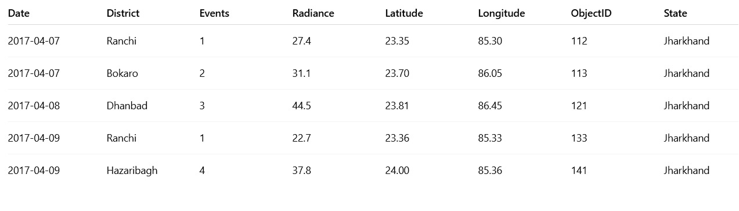
[figure:1]

The above figure shows the data in the LIS dataset.
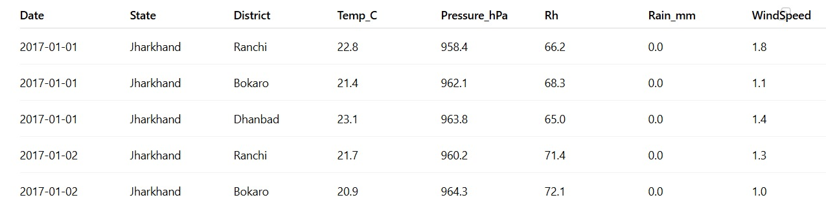
[figure:2]

The above figure shows the data in the MTS dataset.

2. Feature Engineering Results
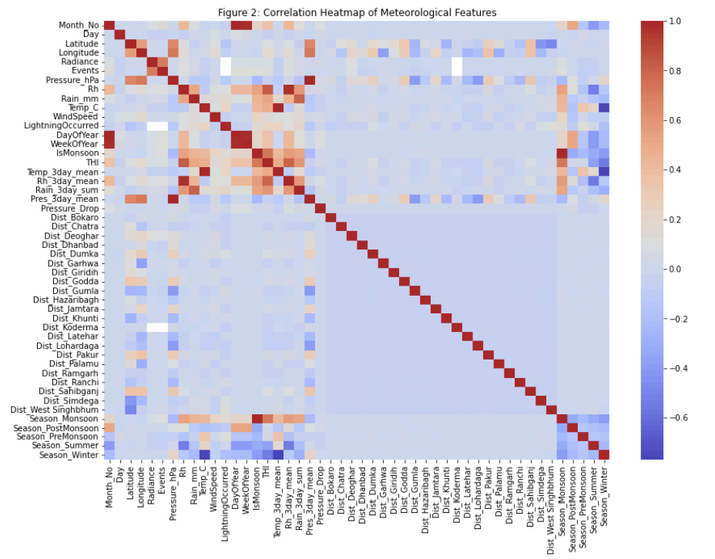
[figure:3]
The above figure is the Correlation Heatmap.

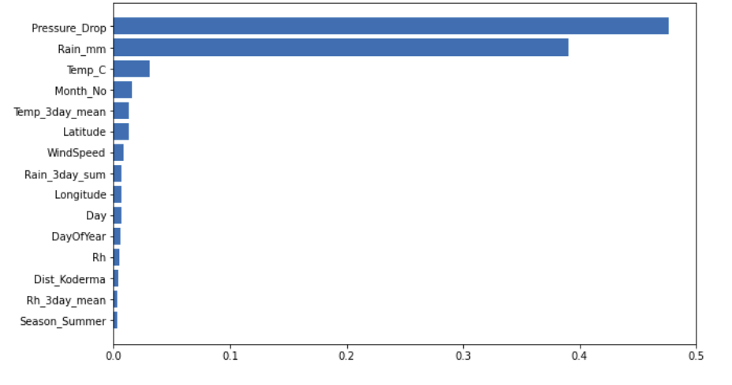
[figure:4]
The above figure shows the top 15 important features.

3.Class Imbalance Handling
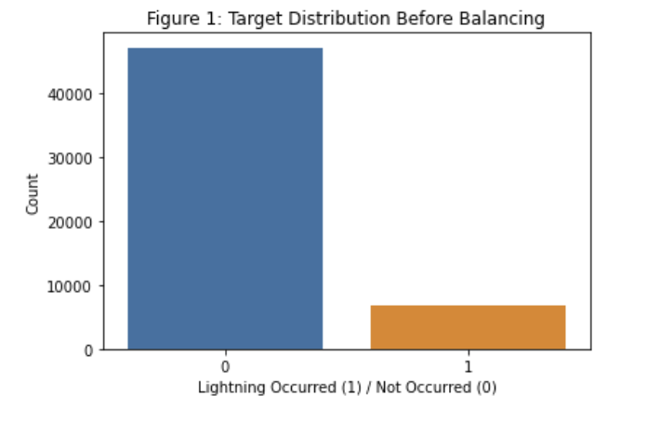
[figure:5]
The above figure shows Target Distribution before Balancing.
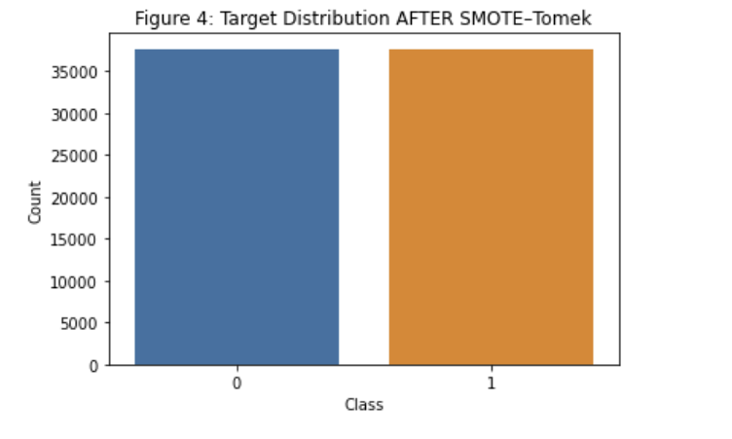
[figure:6]

The above figure shows Target Distribution after Balancing.

4. Performance Metric for Individual Models

SL NO. | MODEL | ACCURACY | F1 SCORE | ROC-AUC
0 | Logistic Regression | 0.89 | 0.35 | 0.87
1 | Linear SVM | 0.87 | 0.00 | 0.85
2 | SGD Classifier | 0.88 | 0.36 | 0.86
3 | Random Forest | 0.97 | 0.89 | 0.99
4 | MLP | 0.94 | 0.79 | 0.97
5 | Gradient Boosting | 0.92 | 0.74 | 0.96
6 | Ensemble Model | 0.93 | 0.79 | 0.97
[table:4.1]

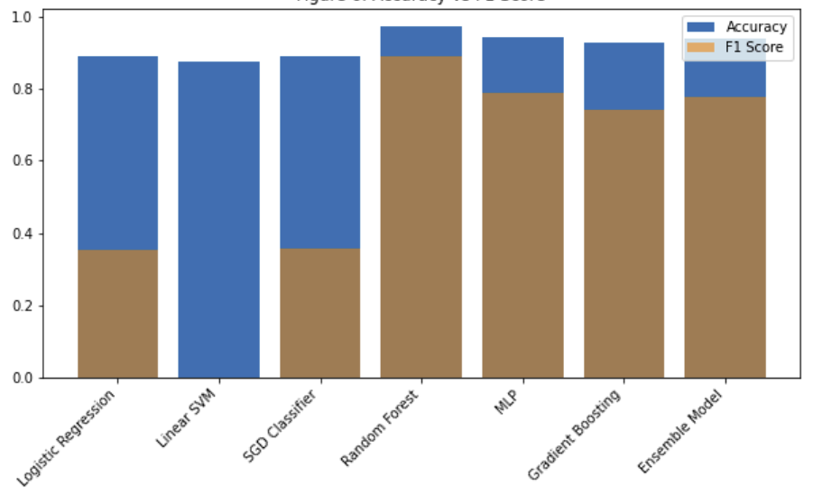
[figure:7]

The above figure shows Accuracy vs F! Score of different models.

5. Confusion Matrix
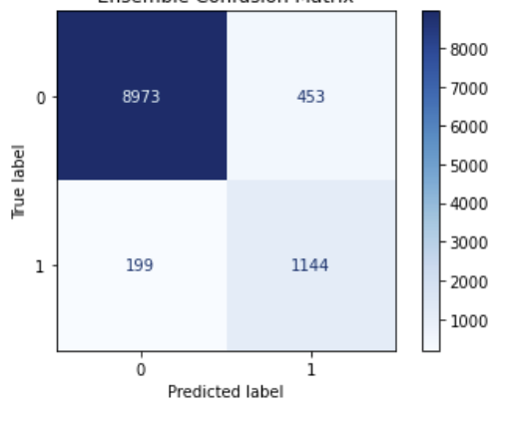
[figure:8]
The above figure shows Confusion Matrix.
6. ROC-AUC Curve
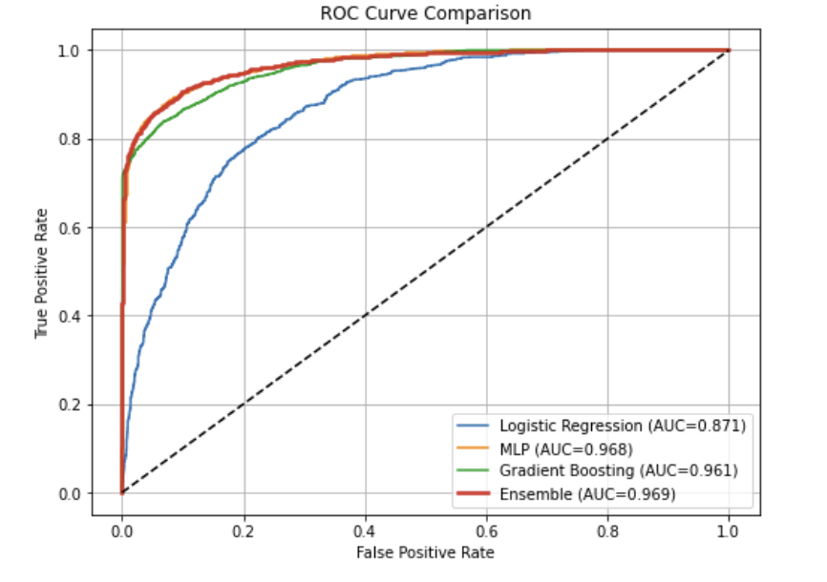
[figure:9]
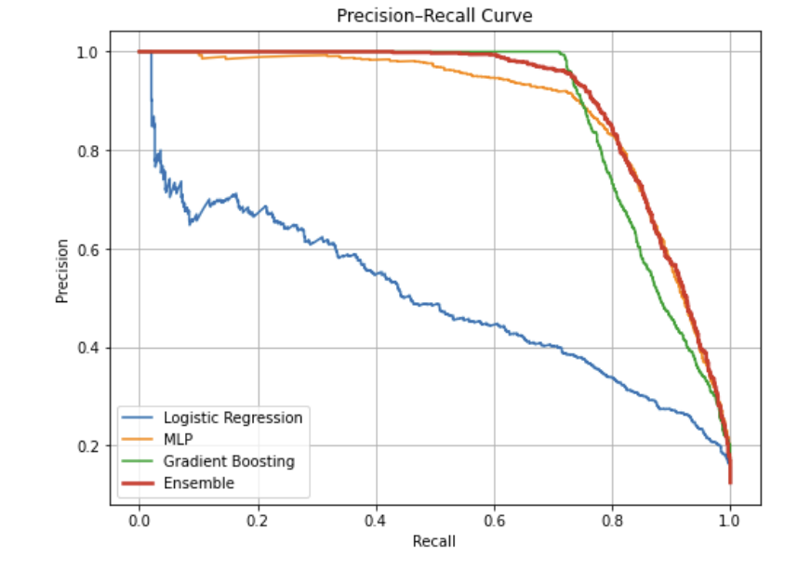
[figure:10]
7. Ensemble Model Results

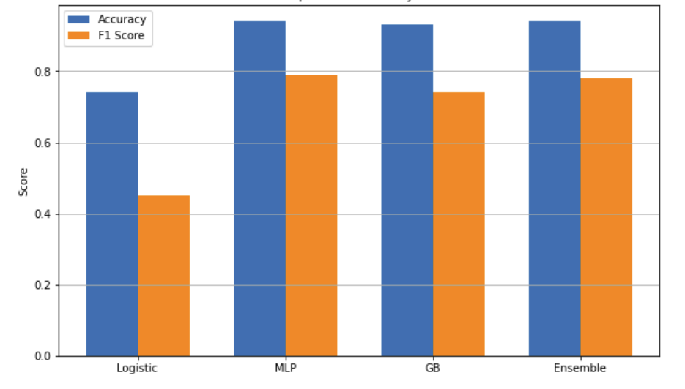
[figure:11]

4.4 Discussions
This project aimed to create an efficient machine-learning-powered lightning prediction system that could be reliable and use the meteorological parameters of MTS and LIS data sets. During the work on the project, a number of significant observations, challenges, and improvements were made. First, there was a large class imbalance in the dataset, since the number of cases with No-Lightning (0) was a large number compared to the number of Lightning (1) cases. This bias resulted in the initial case when models yielded high accuracy and poor lightning event recall. Consequently, the last models, particularly the Gradient Boosting and the calibrated ensemble demonstrated a far more consistent and significant detection ability.
Various algorithms were tested in the course of model experimentation, among them being the Logistic Regression, the Random Forest, the SVM, the MLP and the Gradient Boosting. Gradient Boosting and MLP possessing the highest discriminative power were among them, whereas the Logistic Regression offered stability and interpretability. A combination of these models into a soft-voting ensemble gave a more continuous, more calibrated probability output and fewer spikes in predictions were unnecessary.

CONCLUSION & FUTURE SCOPE

5.1 Conclusion
The current project offered Lightning Prediction System, a machine learning system meant to detect the probability of lightning strike using environmental and meteorological conditions. The system also included full workflow such as data preprocessing, feature engineering, imbalanced data resampling with SMOTE Tomek Links, and the classification model training of Logistic Regression, Support Vector Machine (SVM), Random Forest, Gradient Boosting, and Multi-Layer Perceptron. A scaling, resampling, and classification in the form of a pipeline-based approach have been combined to avoid data leaking as well as provide the same preprocessing across all stages.

It was shown in the comparative analysis that the ensemble learning and tree-based approaches offered a high predictive power, and appropriate regularization and noise addition served to reduce overfitting due to the high correlation of the atmospheric characteristics. Measures of evaluation, including accuracy, precision, recall, F1-score, and ROC-AUC revealed that the system had reliable performance, especially in the detection of non-lightning cases but also enhanced sensitivity on non-minority lightning cases.

Altogether, the suggested system has offered a strong, effective, and scalable architecture of short-term lightning forecasting with the use of machine learning. Through balancing data, parameter optimization in a model, and use of ensemble techniques, the study has been able to increase dependability of lightning forecasting systems and lead to ease and preparedness in weather sensitive industries.

5.2 Future Scope
Despite the fact that the existing system is currently working efficiently, a number of improvements can be made to ensure the accuracy, strength, and reliability of lightning prediction models. The satellite and radar images are integrated into the system, enabling the project to cover long distances and provide a significantly more precise assembly of aerial maps of all regions required by the project.

- Incorporation of Satellite and Radar Imagery
The satellite and radar images are combined into the system which will allow the project to cover a long distance and will accumulate a much more accurate set of aerial maps of all the areas needed by the project.

- Use of more advanced ML Models
Future work can also use spatio-temporal deep learning architecture like CNN, LSTM and GRU Networks, ConvLSTM and Vision Transformers.

- Real Time Deployment
Implementing the model as a real-time alerting system on cloud or edge systems can be used to support lightning early-warning systems in operations of: Airports, Outdoor Events, Power Grid Infrastructures.

The Lightning Prediction System successfully demonstrates the potential machine learning based forecasting. With future improvements involving satellite data, deep learning models and real-time deployment, the system can evolve into a powerful operational tool.

