CS23633 – Cloud Computing Laboratory

EXPERIMENT NO: 2

Aim:
To develop and deploy a simple web application using Render, a Platform as a Service (PaaS), and understand how cloud platforms host applications without requiring users to manage servers.

Objective:
- To understand the concept of Platform as a Service (PaaS).
- To create a simple web application using the Flask framework.
- To deploy the Flask application on the Render cloud platform.
- To access the deployed application through a public URL and verify its functionality.

Theory:
Platform as a Service (PaaS) is a cloud computing model that provides a complete platform for developing, deploying, and managing applications without requiring users to manage the underlying infrastructure. The cloud service provider is responsible for managing the servers, operating system, networking, software installation, and maintenance, while developers only need to write the application code.
In this experiment, Render is used as the PaaS platform. Render automatically creates the server environment, installs the required Python packages, deploys the Flask application, provides a public URL, and manages the application without requiring manual server configuration. This simplifies application deployment and allows developers to focus on building their applications rather than managing infrastructure.

Software Requirements:
- Operating System: Windows 10/11 or Linux
- Python 3.10 or later
- Flask Framework
- Gunicorn
- Git
- GitHub Account
- Render Account
- Visual Studio Code (or any Python IDE)
- Web Browser (Google Chrome/Microsoft Edge)
- Internet Connection

Procedure:
- Installed the required software, including Python, Git, and Visual Studio Code. Created GitHub and Render accounts.
- Created a project folder named RenderHelloApp and added the files app.py and requirements.txt.
- Developed a Flask web application in app.py with two routes:
  - / – displays "Hello! Welcome to Render PaaS."
  - /about – displays "This application is deployed on Render."
- Added the required Python dependencies (Flask and Gunicorn) in the requirements.txt file.
- Tested the application locally using:
python app.py
Verified that both the Home page and About page worked correctly in the browser.
- Created a public GitHub repository named RenderHelloApp and uploaded the project files.
- Logged in to Render, created a Web Service, selected the GitHub repository, and configured the deployment with:
  - Runtime: Python
  - Build Command: pip install -r requirements.txt
  - Start Command: gunicorn app:app
- Deployed the application successfully on Render and obtained a public URL.

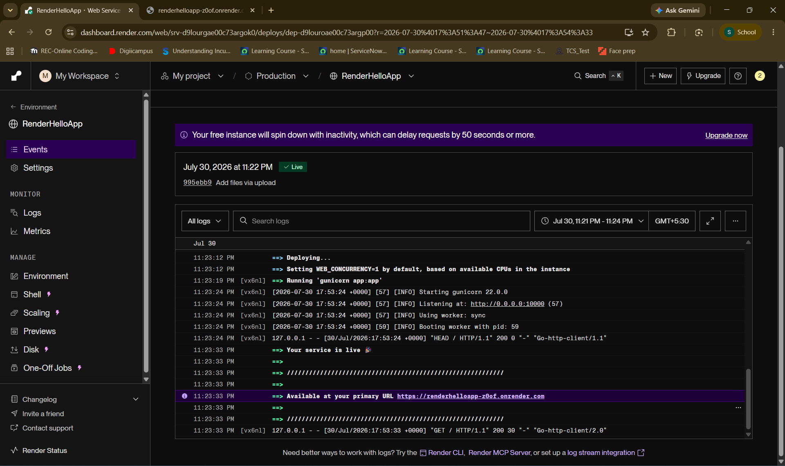
Render Dashboard showing "Live" deployment.
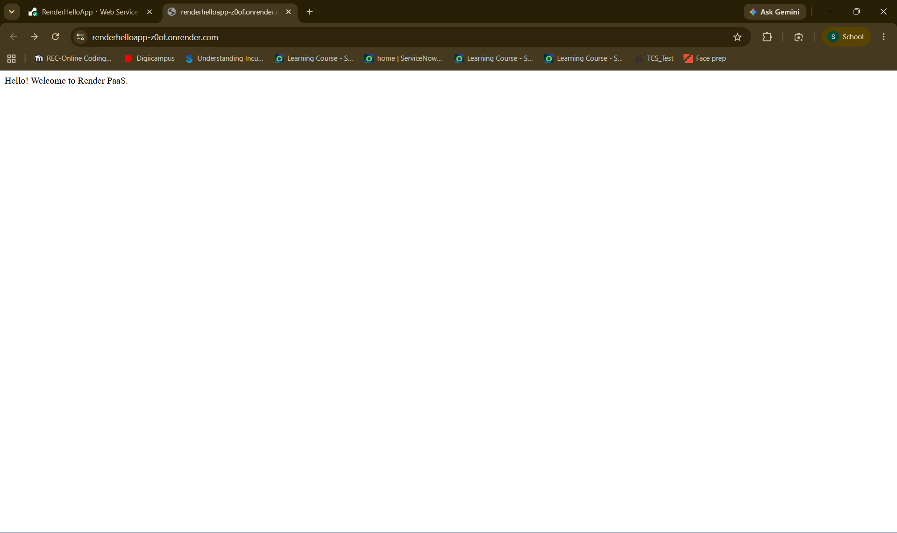
Home page displaying "Hello! Welcome to Render PaaS."

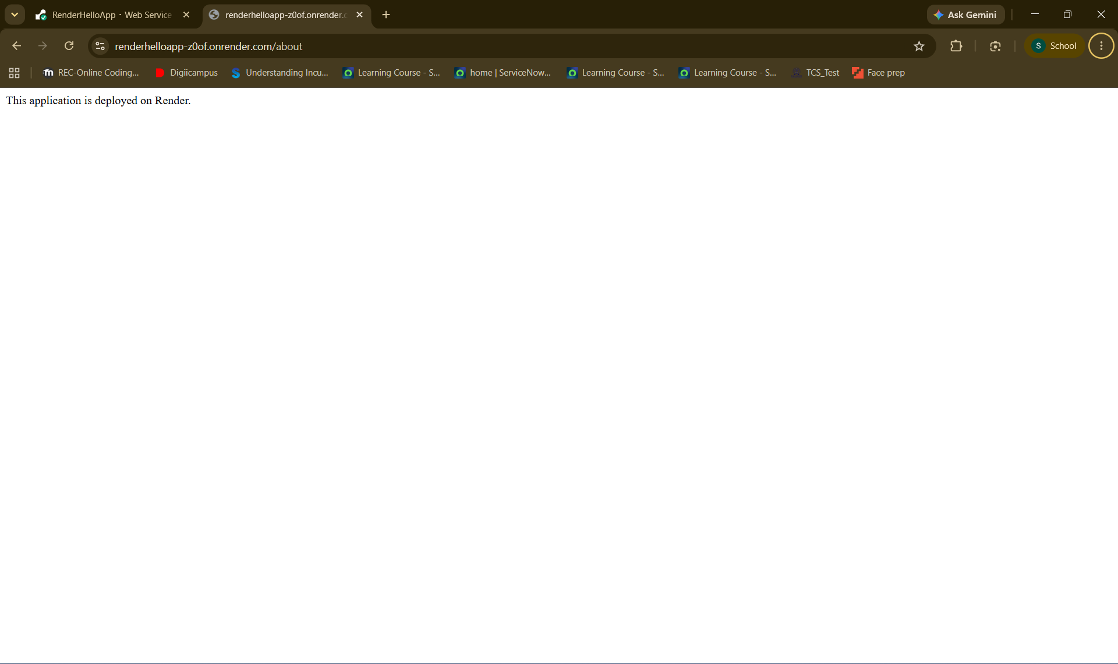
About page displaying "This application is deployed on Render."

Result:
The Flask web application was successfully developed and deployed on the Render cloud platform. The application was accessible through a public URL, and both the Home and About pages functioned correctly. This experiment demonstrated the use of Platform as a Service (PaaS) for deploying web applications without managing the underlying infrastructure

