Experiment 1

Private Cloud using OpenStack

AIM:

To create a private cloud environment by installing and configuring OpenStack (MicroStack) on a single Ubuntu system. The experiment also helps in learning how cloud resources such as virtual machines, networking, and storage are managed in a private cloud.

What is Openstack?

OpenStack is an open-source cloud platform used to build and manage cloud infrastructure. It is mainly used for Infrastructure as a Service (IaaS), where users can create and control virtual machines whenever required. It provides services for computing, networking, and storage in a cloud environment.

What is Microstack?

MicroStack is a lightweight version of OpenStack that runs on a single computer. It is mainly used for learning, testing, and small-scale development. Since it requires only minimal configuration, it is a good choice for beginners who want to understand how OpenStack works.

PROCEDURE:

Step 1

Create a new Ubuntu virtual machine using Oracle VirtualBox with the following configuration:

- Memory: 8 GB RAM
- Processor: 4 CPU Cores
- Storage: 20 GB Virtual Disk

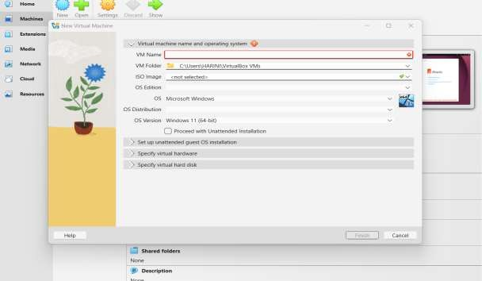

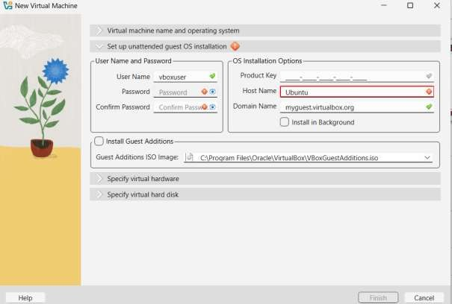

Step 2
Install the Ubuntu operating system and log in using the username and password created during installation.
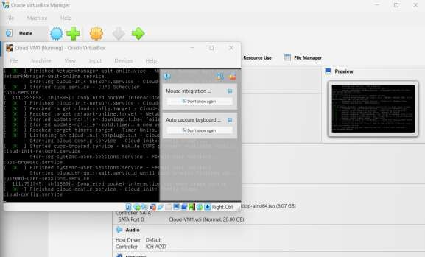

Step 3
Update the Ubuntu packages: sudo apt update
sudo apt upgrade

Step 4
Install MicroStack (Beta channel): sudo snap install microstack –beta

Step 5

Check whether MicroStack has been installed successfully. snap list microstack

Step 6

Initialize the OpenStack services automatically by executing the following command. sudo microstack init --auto --control
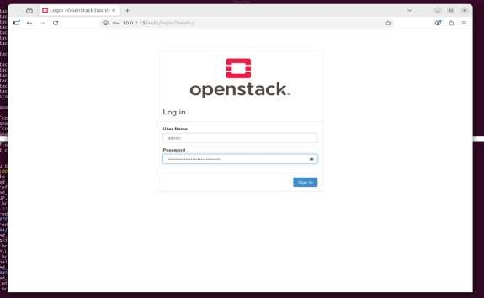
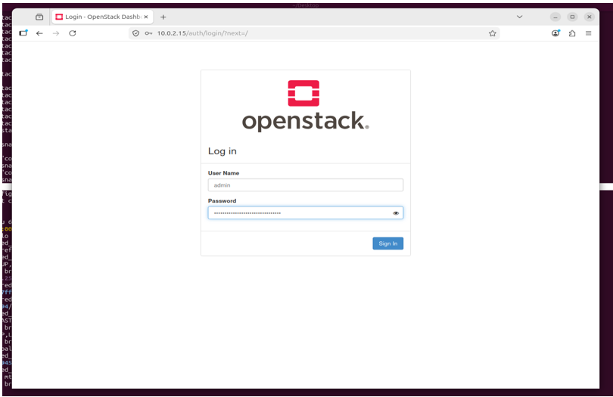

Step 7

Verify the installed OpenStack version:

microstack.openstack --version

Step 8

Retrieve the Keystone administrator password:

sudo snap get microstack config.credentials.keystone-password

Step 9

Open the OpenStack Horizon Dashboard in the web browser using the IP address provided after initialization and log in using:
- Username: admin

- Password: (obtained from the previous command)
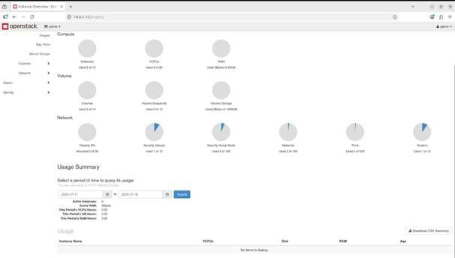

CONCLUSION:

OpenStack (MicroStack) was successfully installed and configured on Ubuntu, and the Horizon Dashboard was accessed s

