Experiment 4: Provision a VPS instance from a cloud provider or set up a virtual machine on your local system using software like VirtualBox or VMware. 2. Install a Linux distribution such as Ubuntu, CentOS, or Debian as the operating system. Configure network settings, including IP address, subnet mask, gateway, and DNS.

AIM:
To provision a Virtual Private Server (VPS) using VirtualBox, install Ubuntu Server, configure network settings (IP Address, Subnet Mask, Gateway, DNS), and enable SSH remote access.

What is VPS?
A Virtual Private Server (VPS) is a software-based server created using virtualization technology. It operates independently with its own operating system, storage, memory, and network configuration while sharing the physical hardware with other virtual machines. Virtualization allows efficient utilization of resources and forms the foundation of cloud computing platforms.
Network configuration parameters include:

IP Address
A unique address assigned to a device on a network.

Subnet Mask
Determines the network and host portions of an IP address.

Gateway
Provides access to networks outside the local network.

DNS (Domain Name System)
Converts domain names into IP addresses.

SSH (Secure Shell)
A secure protocol used for remote administration of Linux systems.

PROCEDURE:
- Open the Ubuntu terminal and verify the internet connection using the ping google.com command.
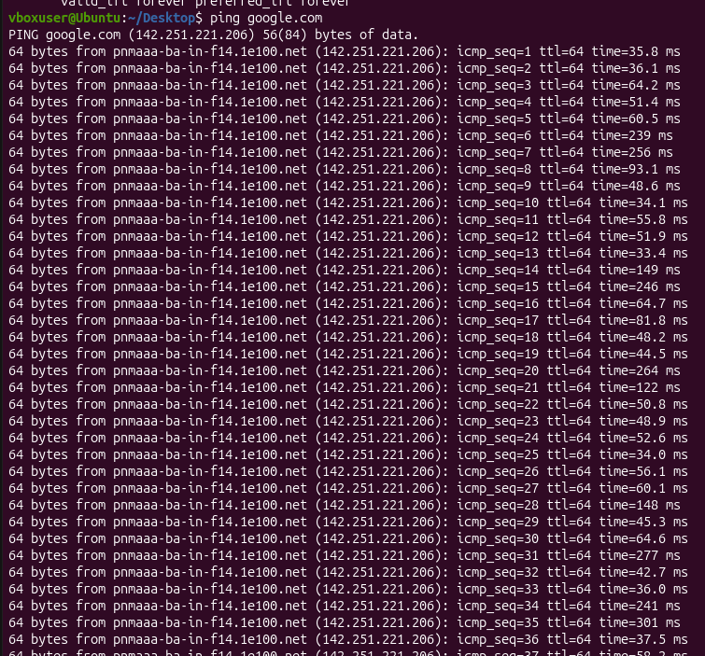
- Check the network routing information using the ip route command.

- Verify the DNS (Domain Name System) configuration of the system using the cat /etc/resolv.conf command.

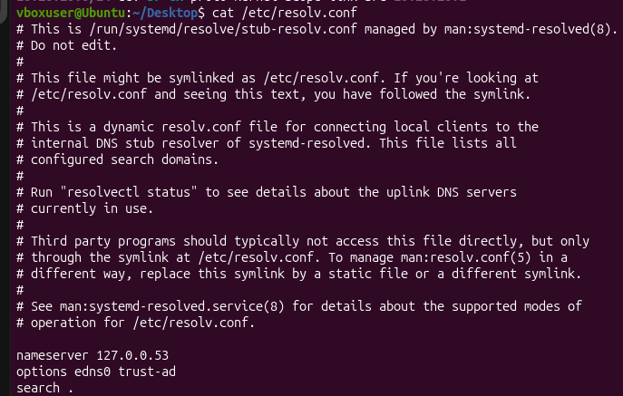
- Update the Ubuntu package list (if required) using: sudo apt update
- Install the OpenSSH Server package using: sudo apt install openssh-server -y
- Enable and start the SSH service using:
- sudo systemctl enable ssh sudo systemctl start ssh
- Check whether the SSH service is running successfully using: sudo systemctl status
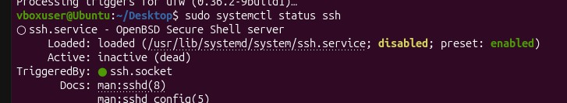
- Find the IP address of the Ubuntu system using: Hostname -I
- Establish an SSH connection to the Ubuntu system using: ssh <username>@<IP_address>

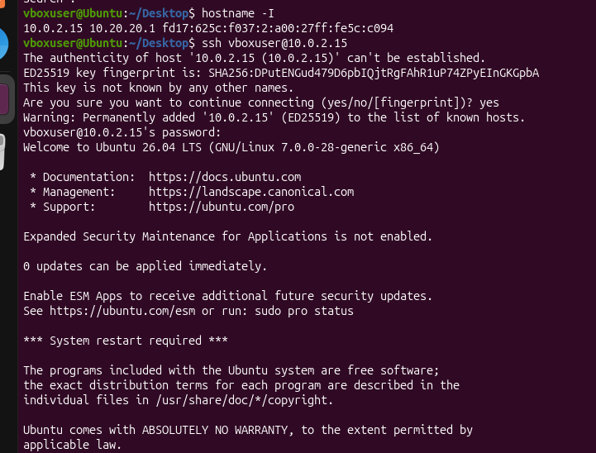
- Verify the successful SSH login by checking the "Welcome to Ubuntu" message displayed on the terminal.

CONCLUSION:
The Ubuntu system was successfully configured and verified for network connectivity. The OpenSSH Server was installed and enabled, and the SSH service was confirmed to be running. The system's IP address was obtained, and a successful SSH login was performed. Thus, secure remote access to the Ubuntu system was successfully established and verified.

