CS23633 – Cloud Computing Laboratory
EXPERIMENT NO: 5
Cloud Migration – Backup Setup experiment using Google Drive as the cloud storage service
Aim:
To create a cloud backup system by storing important files in Google Drive, scheduling automatic backups, and verifying successful backup completion.
Objective:
- To understand the concept of cloud backup and cloud migration.
- To create sample data files and store them in Google Drive.
- To install Google Drive for Desktop and enable folder synchronization.
- To modify a local file and verify that the change is automatically backed up to the cloud.
Theory:
Cloud Backup means storing a copy of important files on cloud servers instead of keeping them only on a local computer. This provides a safe copy of the data in the cloud so that the files can still be accessed if the local computer fails.
Cloud Migration means moving files, applications, or data from a local computer to a cloud service. In this experiment, Google Drive is used as the cloud storage service. The local OfficeData folder is synchronized with Google Drive using Google Drive for Desktop, so that changes made to the local files are automatically reflected in the cloud.
Software Requirements:
- Operating System: Windows 10/11
- Google Account
- Google Drive / Google Drive for Desktop
- Web Browser (Google Chrome/Microsoft Edge)
- Internet Connection
Procedure:
1. Created a folder named OfficeData on the Desktop.
2. Created three text files inside OfficeData: Student.txt, Attendance.txt, and Marks.txt, and added sample content to each file.
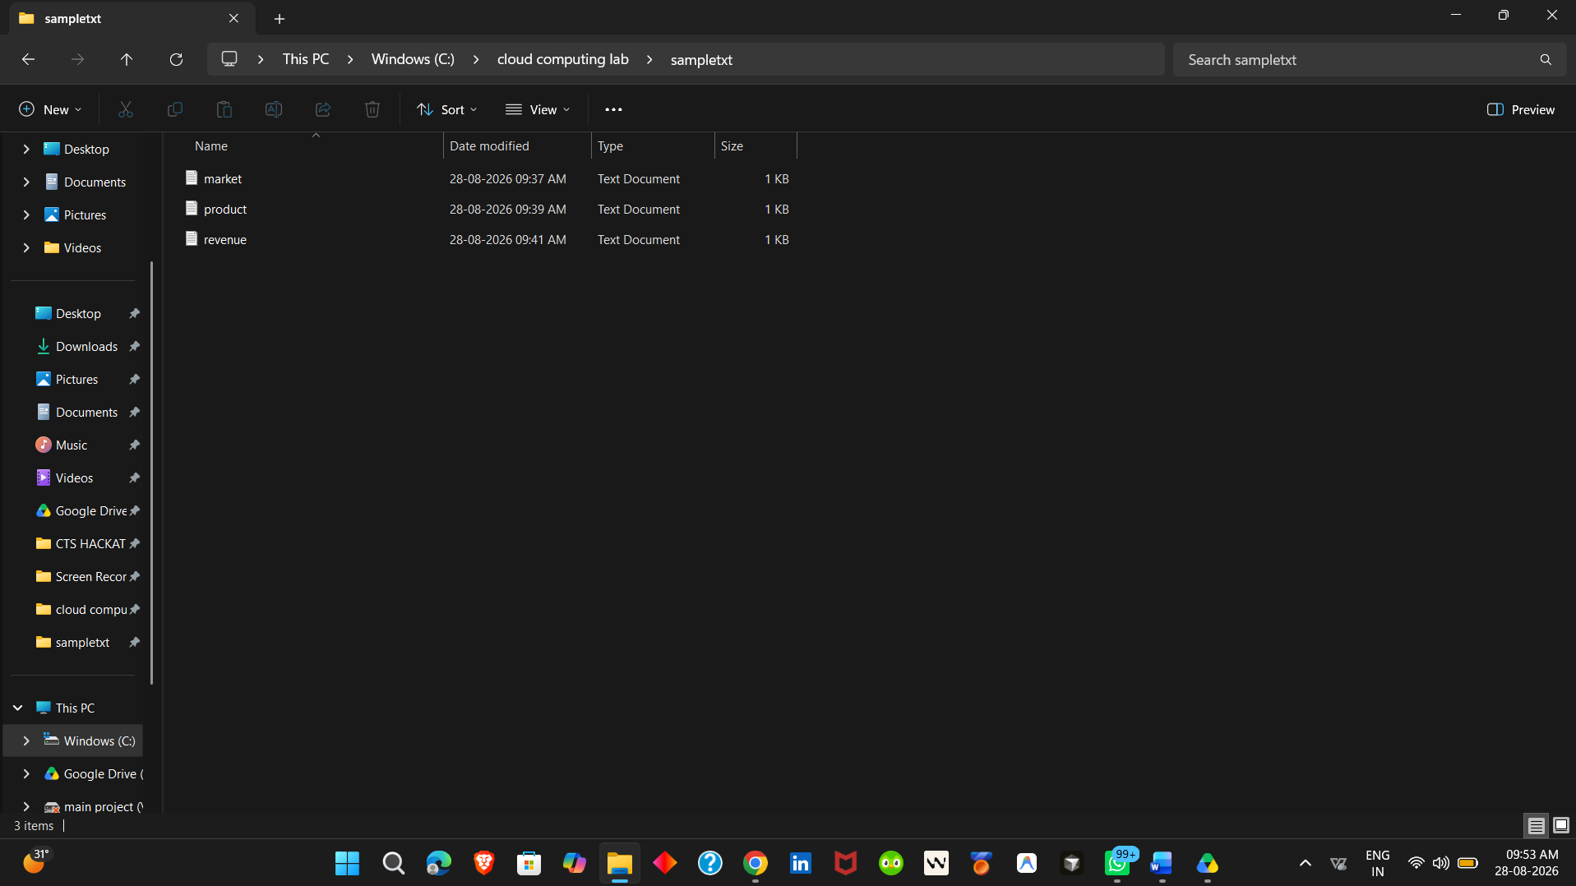
3. Opened Google Drive in the browser and logged in using the Google account.
4. Created a folder named CloudBackup in Google Drive.
5. Opened CloudBackup and uploaded Student.txt, Attendance.txt, and Marks.txt.
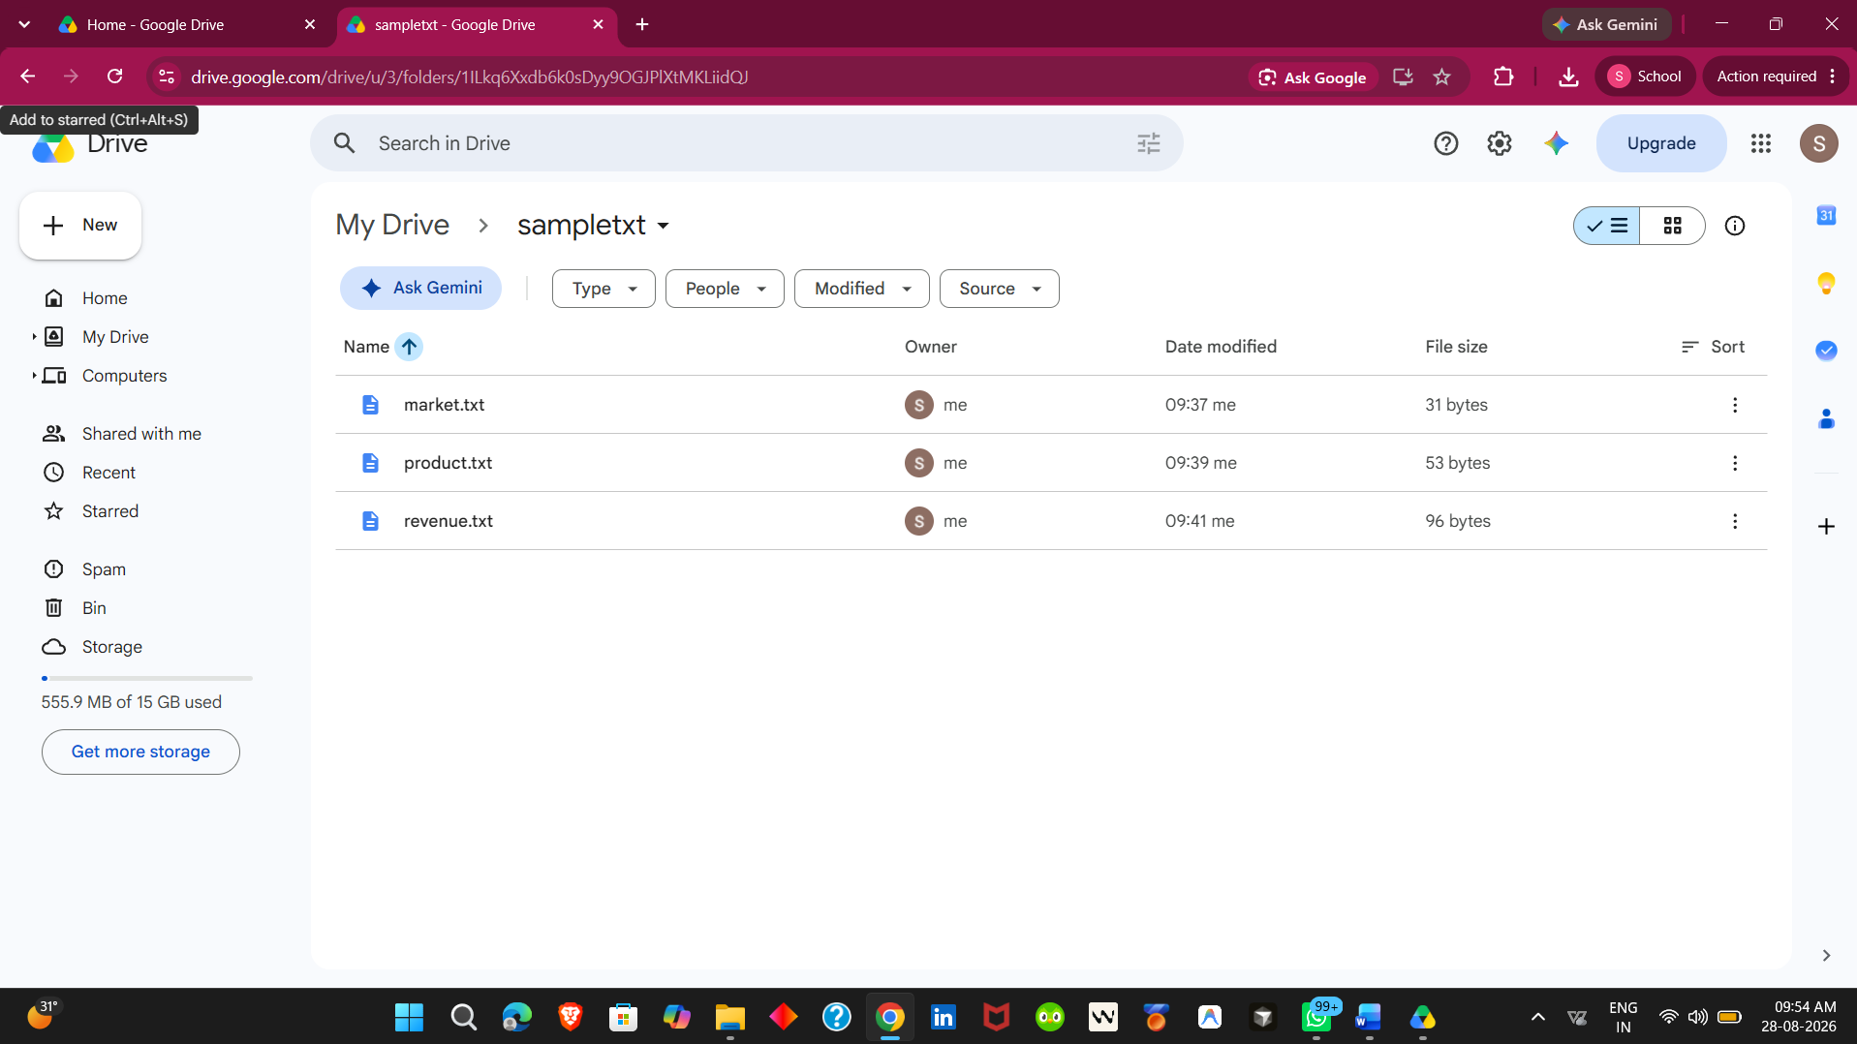
6. Downloaded and installed Google Drive for Desktop and signed in using the same Google account.
7. Opened Google Drive Settings, added the Desktop\OfficeData folder, enabled Sync with Google Drive, and completed the setup.
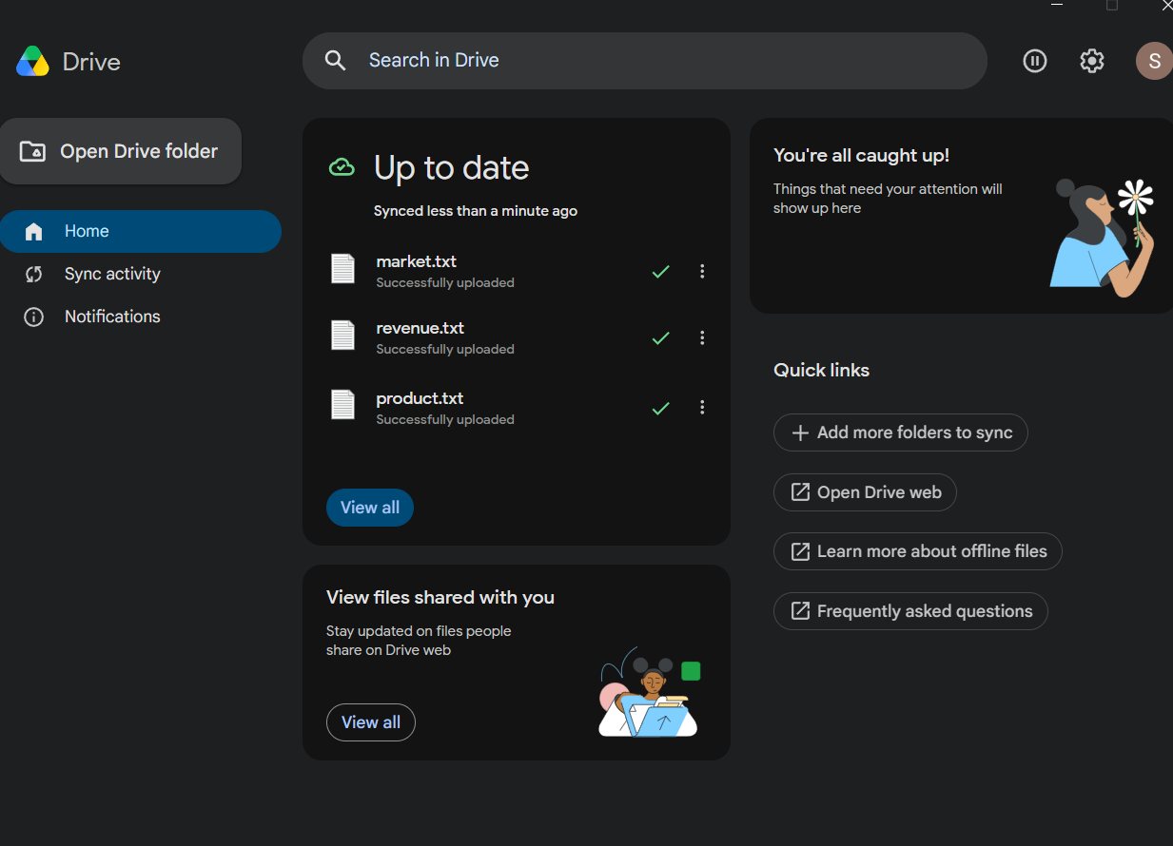
8. Verified in Google Drive that the synchronized OfficeData folder contained Market.txt, Renvenue.txt, and Products.txt.
9. Opened the local Student.txt file and added the line: Cloud Backup Test - Successfully Synchronized. Saved the file.
10. Waited for synchronization and verified that Google Drive showed the file as successfully uploaded / up to date.
11. Refreshed Google Drive in the browser, opened Student.txt, and verified that the added test line was present.
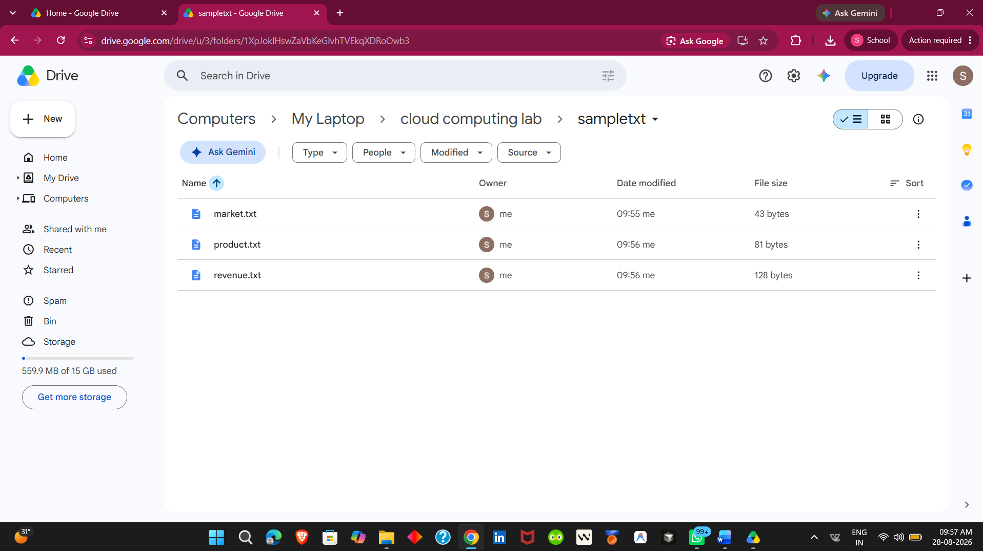
Observation:
The OfficeData folder and its three text files were successfully synchronized with Google Drive. After modifying Student.txt locally, the same change appeared in the cloud copy after synchronization.
Result:
The cloud backup setup was successfully completed using Google Drive. Local files were migrated to cloud storage, automatic synchronization was enabled, and the update made to Student.txt was successfully reflected in Google Drive. Thus, an effective cloud backup mechanism was demonstrated.

