CREDIT CARD FRAUD DETECTION
USING MACHINE LEARNING

A
Project Report
submitted in partial fulfillment of the
requirements for the Elements of AIML

BACHELOR OF TECHNOLOGY
in
COMPUTER SCIENCE & ENGINEERING

by

Name Roll no.
PRIYANK SINHA 590023136

under the guidance of
Self

School of Computer Science
University of Petroleum & Energy Studies
Bidholi, Via Prem Nagar, Dehradun, Uttarakhand
April-2026

ABSTRACT
This project presents a machine learning-based approach for detecting fraudulent credit card transactions. With the rapid growth of digital payments, fraud detection has become a critical challenge in the financial sector. The dataset used in this study is highly imbalanced, making classification a difficult task.
To address this issue, SMOTE (Synthetic Minority Over-sampling Technique) is applied to balance the dataset and improve model performance. Two supervised learning algorithms, Logistic Regression and Random Forest, are implemented and evaluated using performance metrics such as accuracy, precision, recall, and F1-score.
The results indicate that Random Forest significantly outperforms Logistic Regression due to its ability to capture complex and non-linear patterns in the data. The project highlights the importance of data preprocessing, handling class imbalance, and using appropriate evaluation metrics in real-world fraud detection systems.

TABLE OF CONTENTS

S. No | Contents | Page No.
1 | Introduction | 6
2 | Model / Technique / Algorithm | 7-8
3 | Implementation | 9-13
4 | Output / Key Results | 14-16
5 | Limitations and Future Enhancements | 17
6 | Conclusion | 18
7 | Appendix A: Code | 19-21
8 | Dataset Description | 22
9 | References | 23

LIST OF FIGURES

S. No | Figure | Page No.
Fig 3.1 | Dataset loading and preview | 9
Fig 3.2 | Dataset info, missing values, duplicates | 10
Fig 3.3 | Class distribution of transactions | 11
Fig 3.4 | Transaction Amount Distribution | 11
Fig 3.5 | Outlier detection using boxplot | 12
Fig 3.6 | Correlation heatmap | 12
Fig 3.7 | Dataset before and after SMOTE | 13
Fig 4.1 | Confusion Matrix- Logistic Regression | 15
Fig 4.1 | Confusion Matrix-  Random Forest | 15
Fig 4.3 | Model Performance Comparison | 15
Fig A1. | Implementation Code | 19
Fig A2,  Fig A3. | Implementation Code | 20
Fig A4. | Implementation Code | 21

LIST OF TABLES

S. No | Table | Page No.
Table 4.1 | Model Performance Comparison | 14

- INTRODUCTION

With the rapid growth of digital transactions, credit card fraud has become a major concern in the financial sector. Fraudulent activities not only result in financial losses but also affect customer trust and system security.
Traditional rule-based systems are often ineffective in detecting evolving fraud patterns. Machine learning provides a more efficient and scalable solution by analysing historical transaction data and identifying hidden patterns.
However, fraud detection systems face several challenges:
- Highly imbalanced datasets
- Large volume of transaction data
- Requirement of high recall for fraud detection
This project aims to develop a machine learning model that can accurately classify transactions as fraudulent or genuine while addressing these challenges through preprocessing, data balancing, and model optimization techniques.

- MODEL / TECHNIQUE / ALGORITHM

- Overview
This project uses supervised machine learning techniques for binary classification, where transactions are classified as fraudulent or normal based on learned patterns from historical data.

- Logistic Regression
Logistic Regression is a fundamental classification algorithm used as a baseline model in this project. It predicts the probability of a transaction being fraudulent using a sigmoid function.
It is computationally efficient, easy to interpret, and works well for linearly separable data. However, its performance may be limited when dealing with complex, non-linear relationships in real-world datasets.

- Random Forest

Random Forest is an ensemble learning algorithm that constructs multiple decision trees and combines their predictions using majority voting.
It is capable of handling complex and non-linear relationships in data and significantly reduces overfitting. Due to these advantages, Random Forest provides higher accuracy and better generalization compared to Logistic Regression in this project

- SMOTE (Synthetic Minority Over-Sampling Technique)

SMOTE is used to handle the issue of class imbalance in the dataset. It generates synthetic samples of the minority class (fraud cases) by interpolating between existing samples.
This helps in improving the model’s ability to learn patterns associated with fraudulent transactions and enhances recall performance.

- Justification of Techniques

- Logistic Regression is used as a baseline model
- Random Forest is used for improved performance
- SMOTE is used to balance the dataset

- IMPLEMENTATION

- Overview

This project follows a structured machine learning pipeline consisting of data preprocessing, exploratory data analysis, feature scaling, data balancing using SMOTE, model training, and evaluation.

- Data Preprocessing

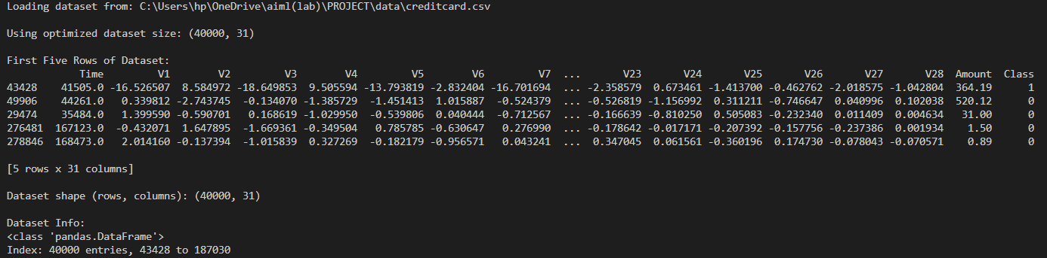
Fig 3.1 Dataset loading and preview of first five rows

The dataset is successfully loaded and the first five rows are displayed using the head () function. It contains anonymized features (V1–V28), along with Time, Amount, and Class. This step verifies that the dataset is correctly loaded and structured.
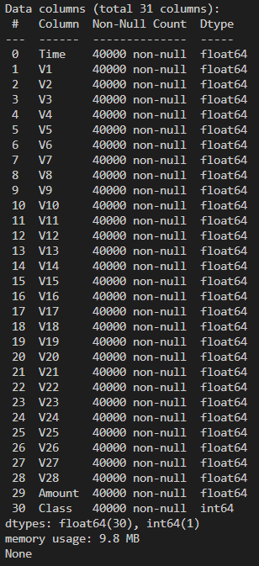 | 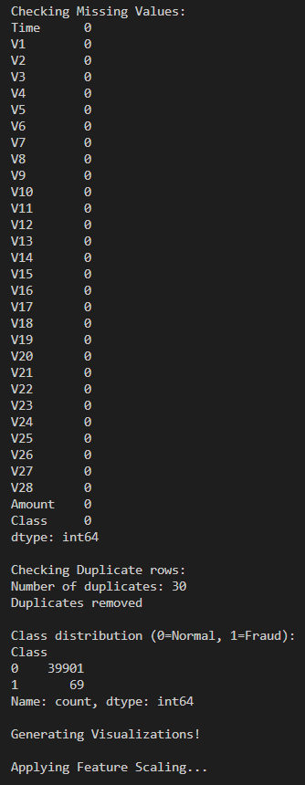
Fig 3.2 Dataset information, missing values, duplicate handling, and class distribution
The dataset information shows that all features are numerical and there are no missing values, ensuring data completeness. Duplicate records (30 rows) were identified and removed to improve data quality. The class distribution confirms a severe imbalance, with significantly fewer fraud cases compared to normal transactions.

- Exploratory Data Analysis (EDA)
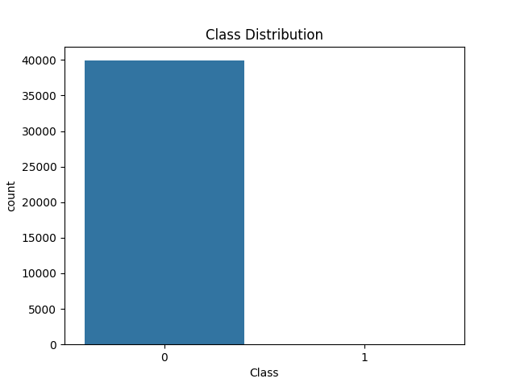
Fig 3.3 Class Distribution of Transactions

The dataset is highly imbalanced, with fraud cases being extremely rare compared to normal transactions. This imbalance can bias the model toward predicting the majority class.

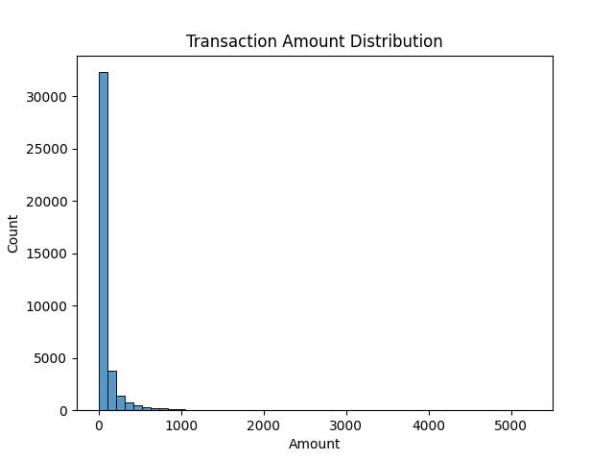
Fig 3.4 Transaction Amount Distribution

The distribution shows that most transactions are of low value, while a few transactions have very high amounts, indicating a skewed distribution.

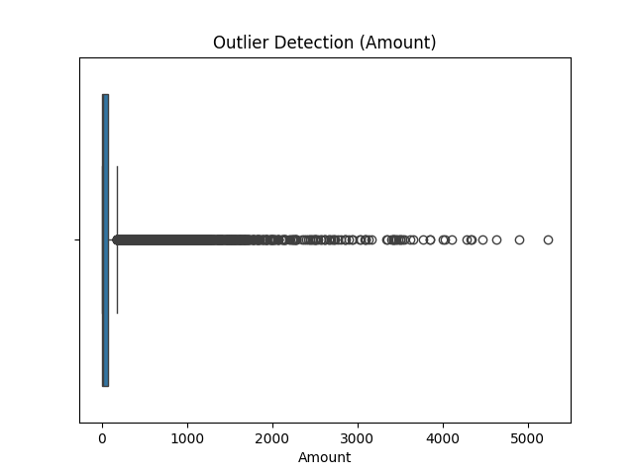
Fig 3.5 Outlier Detection Using Boxplot

The boxplot highlights the presence of outliers, which may correspond to unusual or potentially fraudulent transactions.

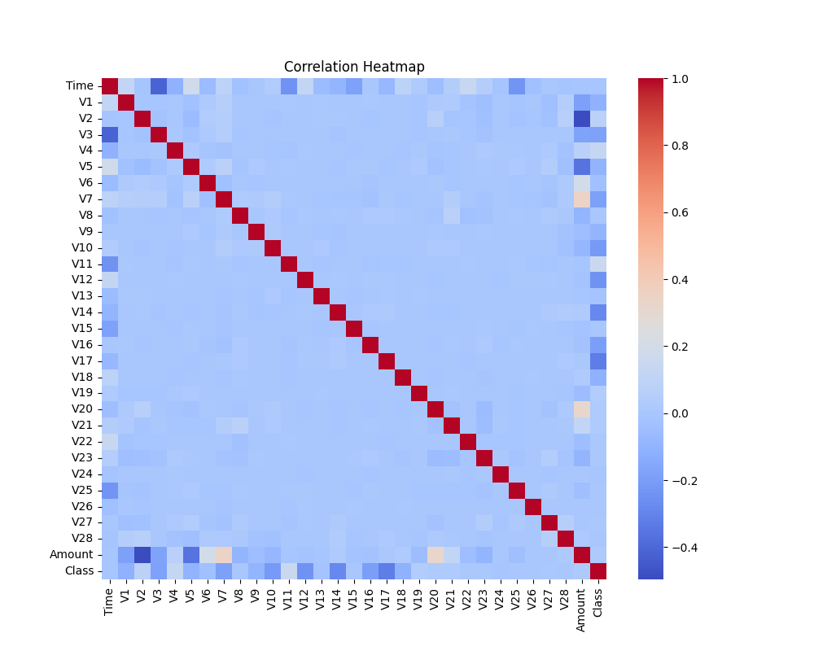
Fig 3.6 Correlation heatmap of features

The heatmap shows relationships between features. Most features are weakly correlated due to PCA transformation, which is expected in this dataset.

- Feature Scaling

Feature scaling is applied using Standard Scaler to normalize feature values. This ensures that all features contribute equally during model training and improves model performance.

- Handling Class Imbalance

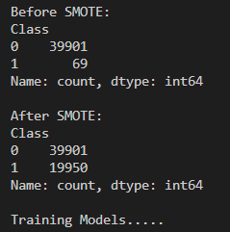 | 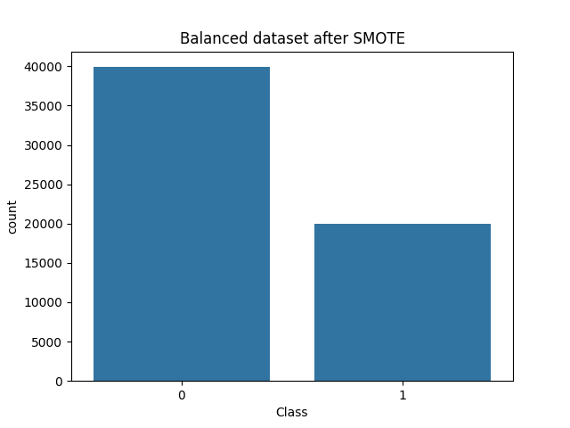
Fig 3.7 Dataset Before and After Applying SMOTE

Before SMOTE, the dataset is highly imbalanced (39901 normal vs 69 fraud). After applying SMOTE with a 0.5 ratio, fraud cases increase significantly, improving the model’s ability to detect fraud.

- Model Training

Two machine learning models are trained:
- Logistic Regression (baseline model)
- Random Forest (ensemble model)

Random Forest is expected to perform better due to its ability to capture complex patterns.

- OUPUT / KEY RESULTS

- Model Performance Table

Model | Accuracy | Precision | Recall | F1- score
Logistic Regression | 96% | 0.97 | 0.93 | 0.95
Random Forest | 99% | 1.00 | 0.98 | 0.99

Table 4.1 Model Performance Comparison

- Model Evaluation Output

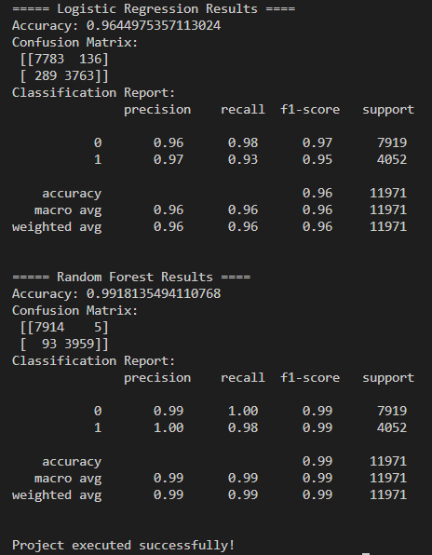

The evaluation results show that Random Forest achieves higher accuracy and better classification performance compared to Logistic Regression.

- Confusion Matrix Analysis
The confusion matrix provides a detailed breakdown of correct and incorrect predictions.
- Logistic Regression
- Some fraud cases are mis-classified as normal.
- Slightly lower recall compared to Random Forest

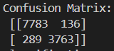
Fig 4.1 Confusion Matrix - Logistic Regression

- Random Forest
- Very few miscalculations.
- High precision and recall
- More reliable in detecting fraudulent transactions.

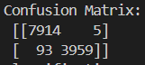
Fig 4.2 Confusion Matrix – Random Forest
- Model Comparison
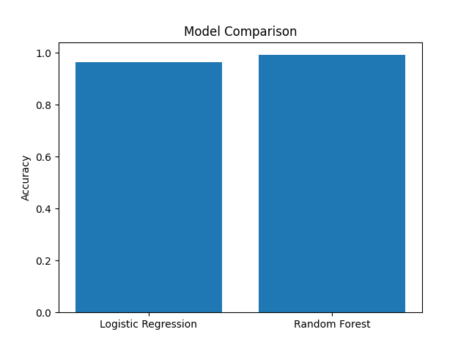
Fig 4.3 Model Performance Comparison

The graph clearly shows that Random Forest outperforms Logistic Regression in terms of accuracy.

- Key Insight

Recall is more important than accuracy in fraud detection because missing a fraudulent transaction can lead to significant financial loss.

- LIMITATION AND FUTURE ENHANCEMENT

Limitations:
- Dataset is anonymized, limiting interpretability
- Not implemented for real-time detection
- Limited number of models used

Future Enhancement:
- Real-time fraud detection system
- Deployment using Flask
- Use of deep learning models
- Integration with banking systems

6. CONCLUSION

The project successfully demonstrates the application of machine learning techniques in detecting fraudulent credit card transactions. The major challenge of class imbalance is effectively handled using SMOTE, which improves the model’s ability to detect fraud cases.

Among the models used, Random Forest performs better due to its capability to capture complex patterns and provide higher recall. The project highlights the importance of proper preprocessing, model selection, and evaluation metrics in solving real world problems.

7. APPENDIX

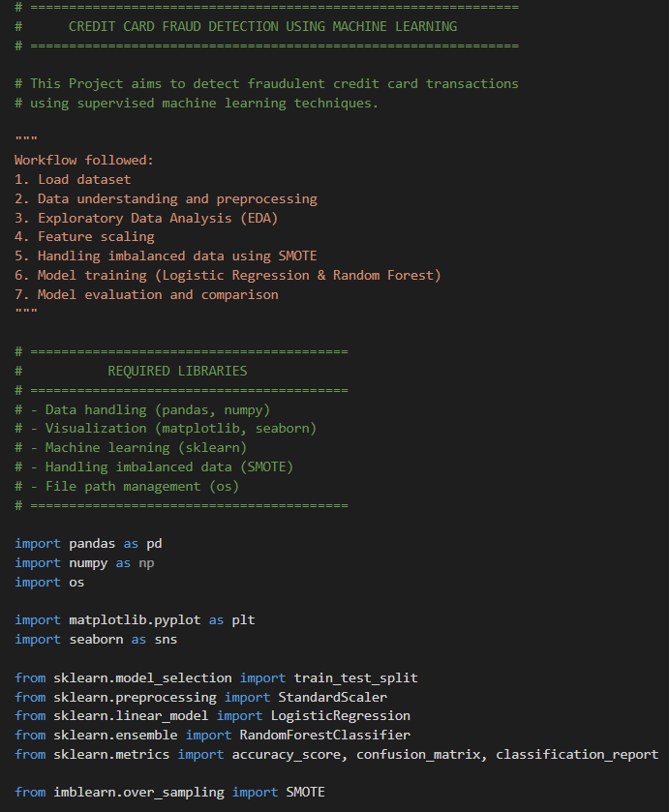
Appendix A: Code

Fig A1. Implementation code

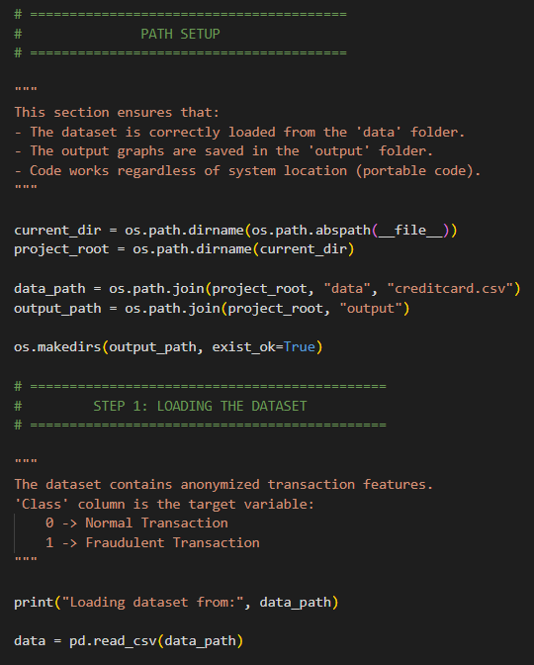 | 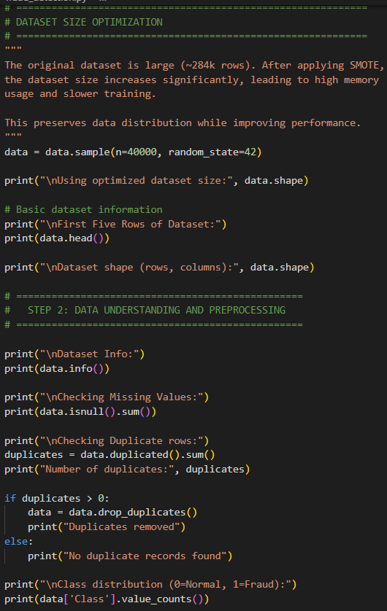
Fig A2. Implementation Code

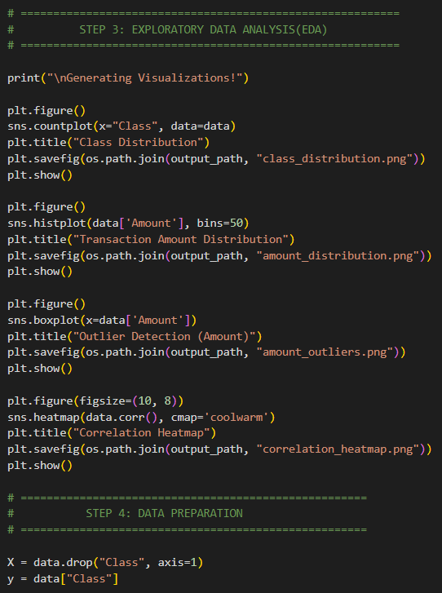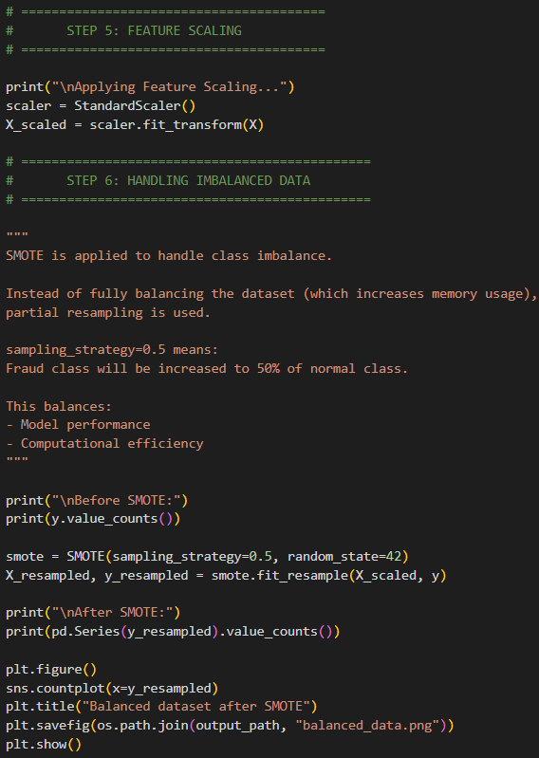
Fig A3. Implementation Code
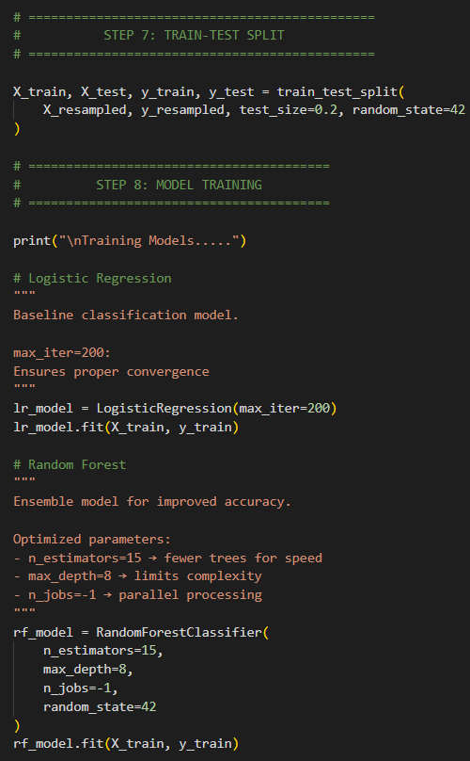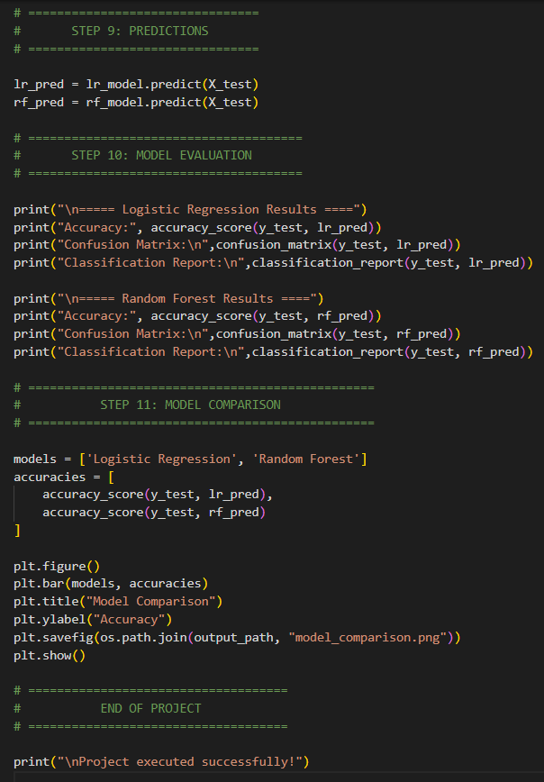
Fig A4. Implementation Code

8. DATASET DESCRIPTION

Dataset Name: Credit Card Fraud Detection Dataset
Source: https://www.kaggle.com/datasets/mlg-ulb/creditcardfraud

Description
The dataset contains anonymized credit card transaction data collected over a period of time. Due to privacy concerns, the original features have been transformed using Principal Component Analysis (PCA) and are represented as V1 to V28.
In addition to these features, the dataset includes:
  - Time: Time elapsed between transactions
  - Amount: Transaction Amount
  - Class: Target Variable
Target Variable
- 0 → Normal Transaction
- 1 → Fraudulent Transaction

Key Characteristics
- Highly imbalanced dataset
- Fraud cases represent a very small percentage of total transactions
- Contains only numerical features
- Real-world financial transaction data

Dataset Size Used in Project
For optimization purposes, a subset of 40,000 rows was used from the original dataset to reduce computational load while maintaining data distribution.

9. REFERRENCES

- Credit Card Fraud Detection Dataset, Kaggle
- Scikit-learn Documentation – https://scikit-learn.org
- Imbalanced-learn (SMOTE) Documentation – https://imbalanced-learn.org
- Pandas Documentation – https://pandas.pydata.org
- NumPy Documentation – https://numpy.org
- Matplotlib Documentation – https://matplotlib.org
- Seaborn Documentation – https://seaborn.pydata.org

