**Practical: 5**

**AIM: -** **Dictionary**

1. Create and print a dictionary that contains keys a,b,c,d with their values1,2,3 and 4 respectively using curly bracket syntax and ‘dict’ in built function.

**Code :**



**Output:**



1. Using above create dictionary perform following operations:
2. Write a code to print out the value of a,c and d. Code :

**Code:**

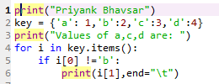

**Output:**



1. Calculate the sum of the value of a,b,c,d and print it. Code :

**Code:**

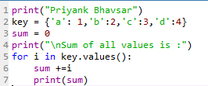

**Output:**

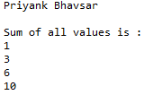

1. Add a new key, value pair (e,5) to the dictionary and print dictionary. Code :

**Code:**



**Output:**



1. Filter the dictionary by removing all items with a value greater than 2.

D ={“a”:1, “b”:2, “c”:3, “d”:4, “d”:5}.

**Code:**

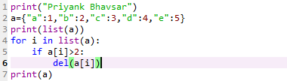

**Output:**



1. Print the names which contain the character 'a' from the dictionary containing 2 lists of male and female students given below: "male": ["Tom", "Charlie", "Harry", "Frank"], "female":["Sarah", "Huda", "Samantha", "Emily", "Elizabeth"].

**Code:**

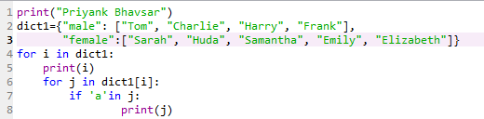

**Output:**

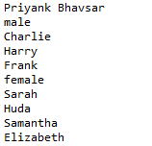

1. Dictionary has 4 films with viewer age and number of seats available as indicated below:

"War": [3,5], "Bourne": [18,5], "Gully boy": [15,5], "Uri":[12, 5]

Write a program to ask for a film and check person is eligible to watch movie or not, also check availability of ticket and movie in the theatre.

**Code :** 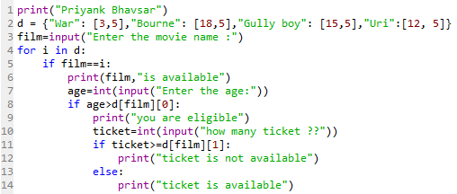

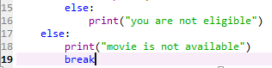

**Output :**

