## **1.) Create Table Name: Student and Exam**

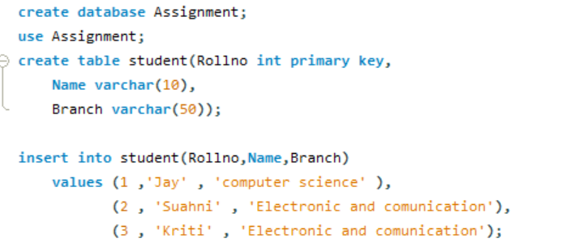

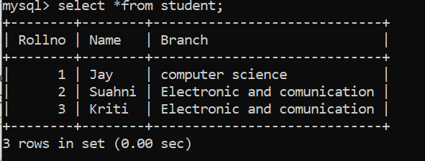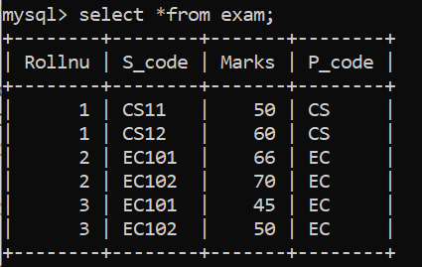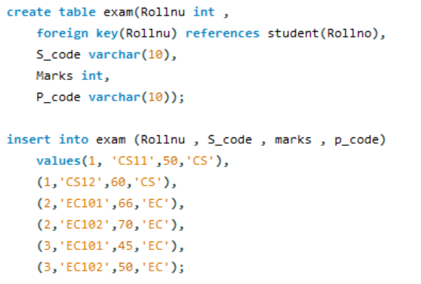

## **2.) Create table given below: Employee and Incentive Table**

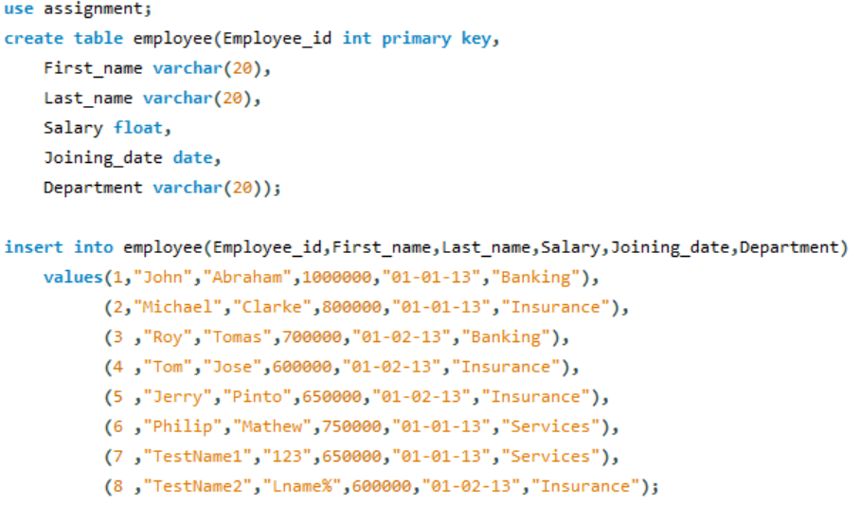

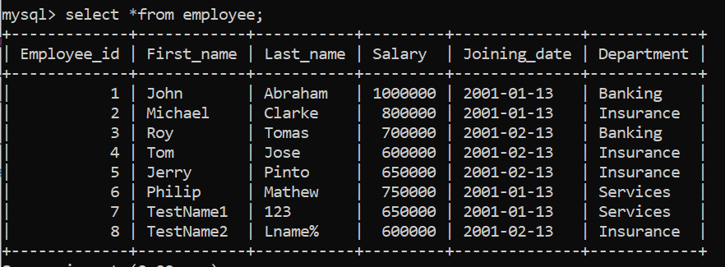

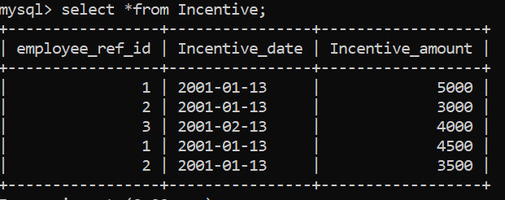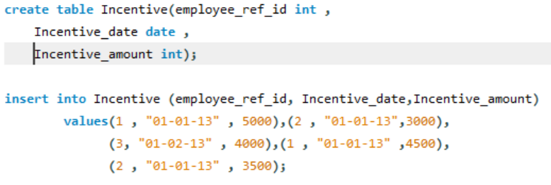

3

**3.) Get First_Name from employee table using name “Employee Name”.**

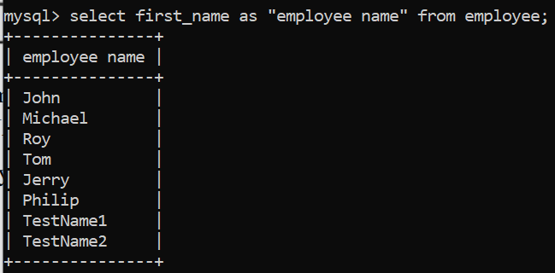

**4,) Get FIRST_NAME, Joining Date, and Salary from employee table.**

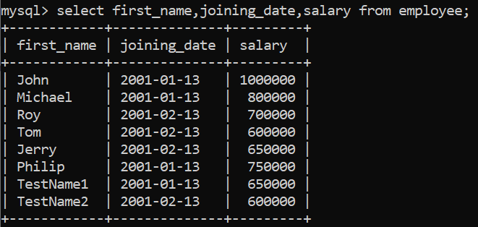

**5.) Get all employee details from the employee table order by First_Name Ascending and Salary descending?**

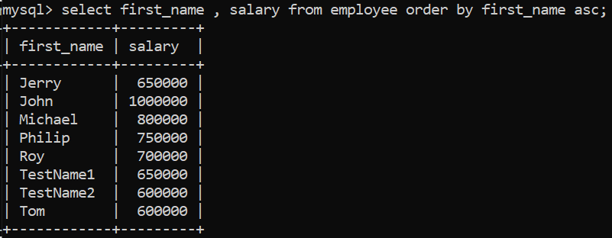

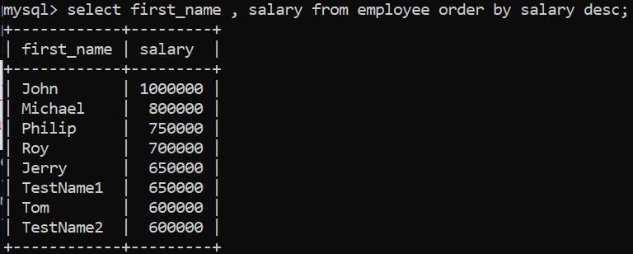

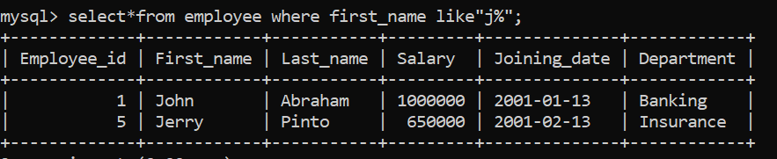**6.) Get employee details from employee table whose first name contains ‘J’.**

**7.) Get department wise maximum salary from employee table order by salary ascending?**

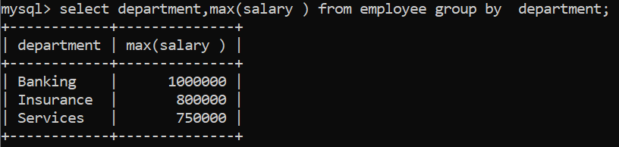

**8.) Select first_name, incentive amount from employee and incentives table forthose employees who have incentives and incentive amount greater than 3000.**

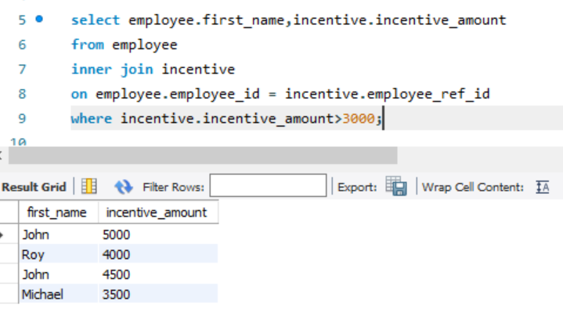

**9.) Create After Insert trigger on Employee table which insert records in viewtable.**

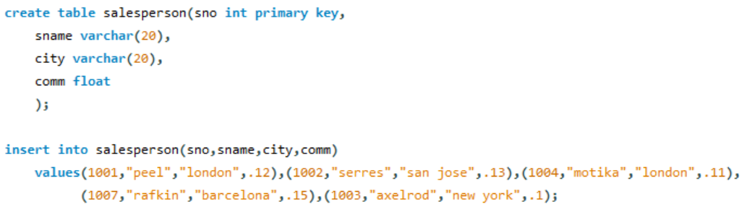**11. Create table given below: Salesperson and Customer**

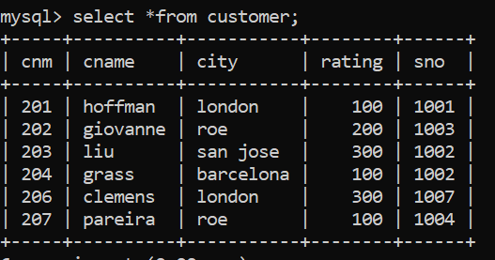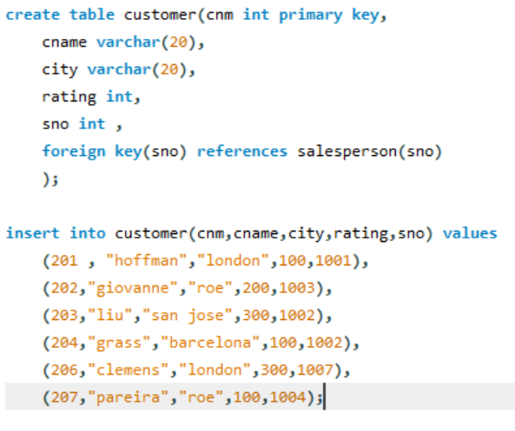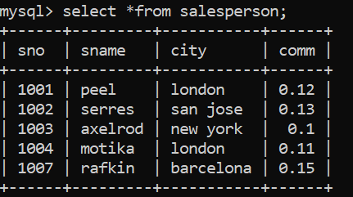

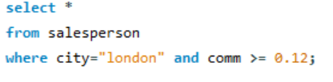**12.) Names and cities of all salespeople in London with commission above 0.12.**

**13.) All salespeople either in Barcelona or in London.**

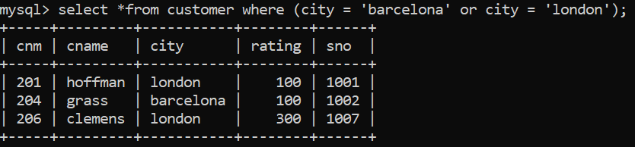

**14.) All salespeople with commission between 0.10 and 0.12.**

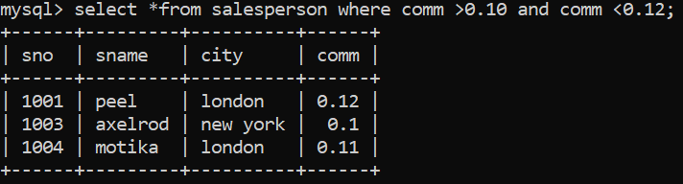

**15.) All customers excluding those with rating <= 100 unless they are located In Roe.**

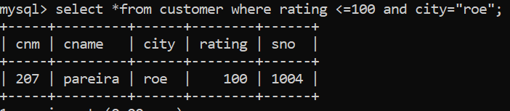

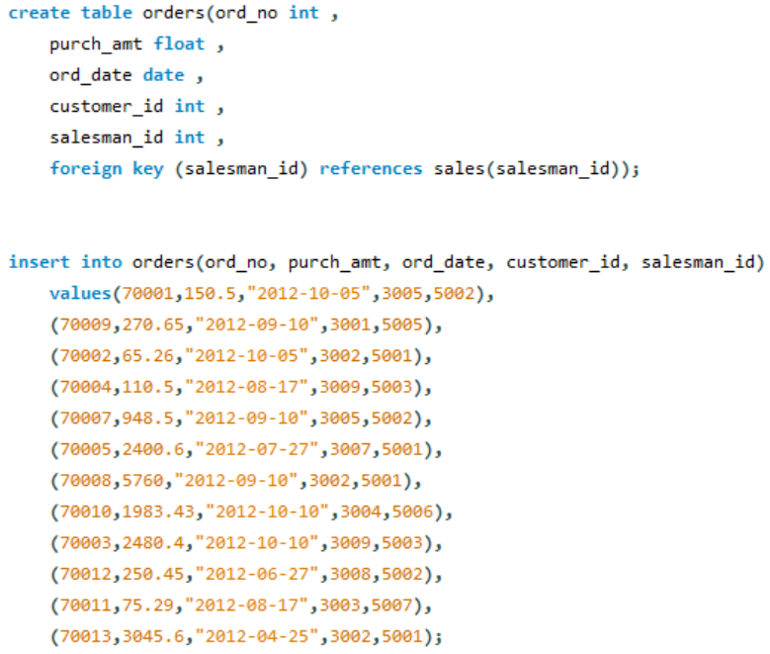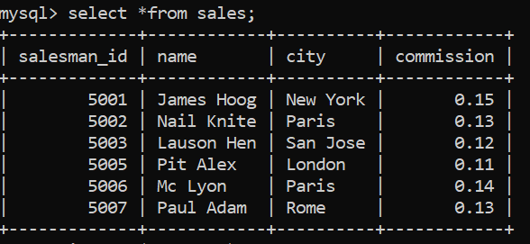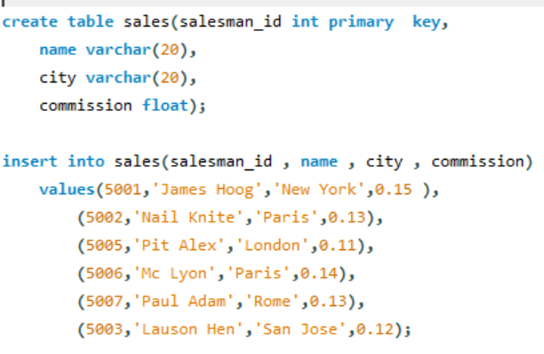**16.) Write a SQL statement that displays all the information about all salespeople.**

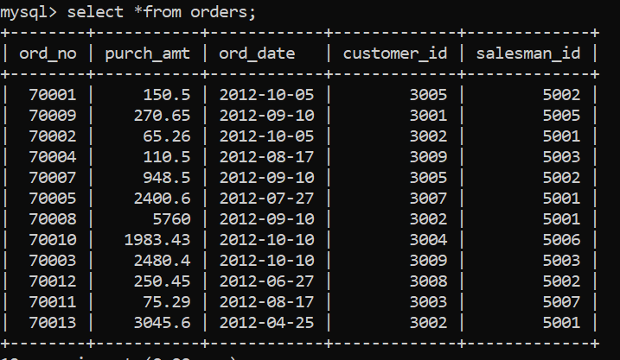

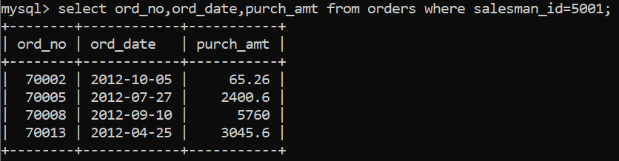**17.) From the following table, write a SQL query to find orders that are delivered by a salesperson with ID. 5001. Return ord_no, ord_date, purch_amt.**

**18.) Create table :**

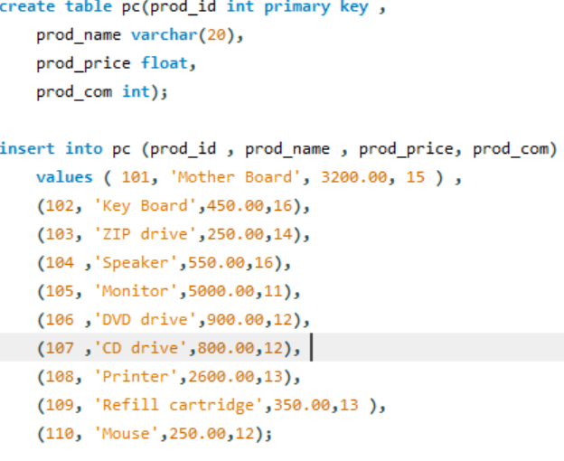

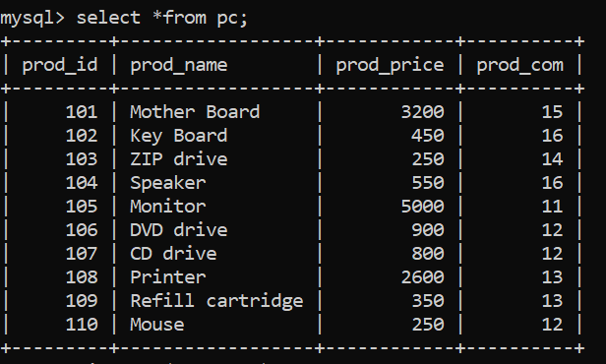

**19.) From the following table, write a SQL query to calculate the average price for a manufacturer code of 16. Return avg.**

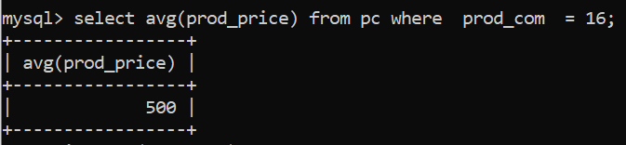

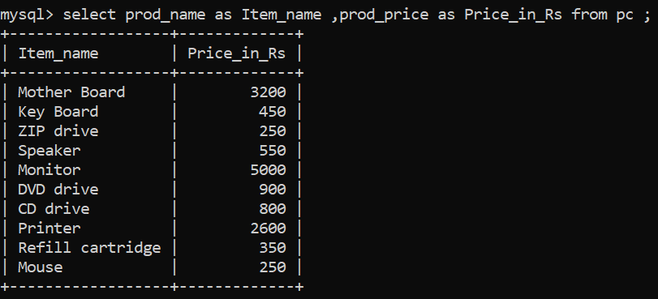**20.)** **From the following table, write a SQL query to display the pro_name as 'Item Name' and pro_price as 'Price in Rs.'**

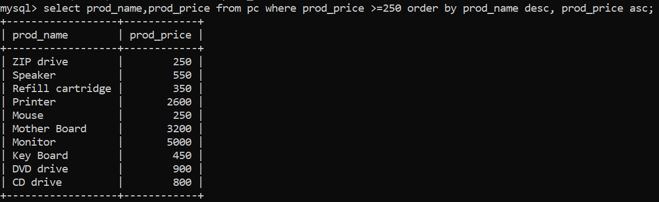**21.) From the following table, write a SQL query to find the items whose prices are higher than or equal to $250. Order the result by product price in descending, then product name in ascending. Return pro_name and pro_price.**

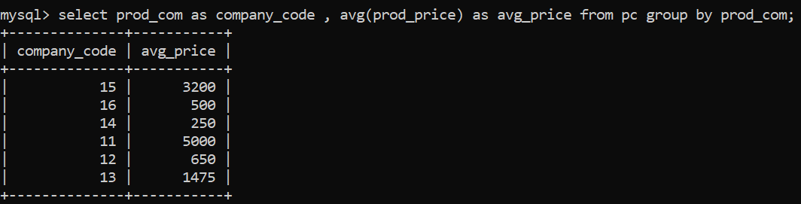**22.) From the following table, write a SQL query to calculate average price of the items for each company. Return average price and company code.**