## Project Name: Buss Pass Maintenance

Team: H7

Team Members’ names: janeshs@, ankushm@, ithikkat@

# Objective:

* To help Amazon manage their employee transportation service within a city.
* Enable the transport administrator to manage users, busses, routes and bus stops.
* Assist the end user to register themselves in the transportation service and view request for a bus-pass corresponding to their stop.

# System setup (software):

Environment: Java 8 or above  
DataBase : RDS MySQL platform AWS

JDBC driver: mysql-connector-java-8.0.19.jar

# Class Diagram:

# C:\Users\ithikkat\AppData\Local\Microsoft\Windows\INetCache\Content.Word\Class Diagram.jpg

# ER Diagram:

# 

# Project Files:

Please find all the files google drive.

# Test Case document:

Please find in the google drive with the name: TestCases.xlsx

# 

# Project Summary:

The Bus Pass system has been developed to cater to the Administrator, User and Visitors on the platform. The system manages Bus Stops , Commute Routes, Busses, User Bus Pass.

**Approach & Methodology:**

Our approach is to help the user to opt in our service and get a Bus Pass for a Stop which is closest to his home. These stops are available in four directions from the Amazon office as shown in the diagram below.



Using these stops we have allowed the Admin to create new Routes. Every route is unique and contains stops of a single direction.

***Stops****: Nodes/location in a single direction that the user can choose.*

***Routes****: A group of stops are clubbed together to form a route such that no stop is duplicated in another route. This ensures that every route is unique.*

*Ex. Route: R1 | Direction : East | Stops: E1🡪 E3 🡪 E10*

*Route: R2 | Direction : West | Stops: W2 🡪 W5🡪 W10🡪W13*

After creation of a new route by Admin, buses can be assigned to these routes. Here, our assumption is that in a route there should not be more than 3 busses.

***Busses****: These are categorized by their capacity. Every bus is registered in the database and only once available it can be assigned to a route by the Admin.*

A user is given the choice to select any stop from their direction. This request is forwarded to the admin who decides 1) if the user can be accommodated in an existing bus 2) if bus capacity needs to be increased to add user 3)if a new route needs to be created to accommodate user 4) reject the user’s request and not create a pass.

***Visitor/Guest User****: A guest who is not registered with the transportation service and can check the active routes and the percentage of seat occupied in it with which the guest will decide if they want to register and apply for a bus pass.*

***User****: A registered user who is currently availing the service. The user can check the status of their buss pas. The user can request a change in their stop.*

***Admin****: Admin manages the routes, bus registration, user pass approval and has access to make changes in the system.*

**Requirements Met:**

|  |  |  |  |  |
| --- | --- | --- | --- | --- |
| **Type** |  | **Requirements** | **Within SRS** | **Outside SRS scope** |
| ADMIN | 1 | Approve/reject bus pass applications, and allocate a bus pass-ID. | ✔ |  |
| 2 | Pending Pass requests notification | ✔ |  |
| 3 | Generate reports that can be sent to finance team/admin team for billing. | ✔ |  |
| 4 | Add/remove routes | ✔ |  |
| 5 | Change the type of bus, number of buses on each route | ✔ |  |
| 6 | Change the route of the bus. | ✔ |  |
| 7 | No of vehicles of each type being used | ✔ |  |
| 8 | Register a bus to a vendor (RC, owner details) |  | ✔ |
| 9 | Check available busses |  | ✔ |
| 10 | Allocate Buses to a route |  | ✔ |
| USER | 12 | View all the routes, their stops | ✔ |  |
| 13 | Request to cancel a bus pass / request to change to another route. | ✔ |  |
| 14 | Request for new route/alteration of existing route | ✘ |  |
| 15 | Give feedback to the administrator about the bus-facilities/improvements; or complaints on the driver. | ✘ |  |
| 16 | Update their contact details. | ✔ |  |
| 17 | Get status and details of buss pass | ✔ |  |
| GUEST/VISITOR | 18 | View all the routes | ✔ |  |
| 19 | Percentage of seats occupied in each route | ✔ |  |
| 20 | Register as a user | ✔ |  |
| 21 | Apply for a bus pass. | ✔ |  |

# 

# User Manual:

Please read txt file in google drive Instructions_To_Run_Project.

**Guest**: The guest does not need to provide any login password. Below is the workflow for a guest/visitor.

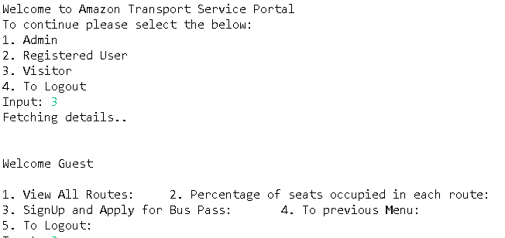

Guest/Visitor has 2 non-interactive services to choose from. And one service to registers themselves as a user.

Below the guest/visitor can register as a user and select the direction in which they are looking for a stop.  
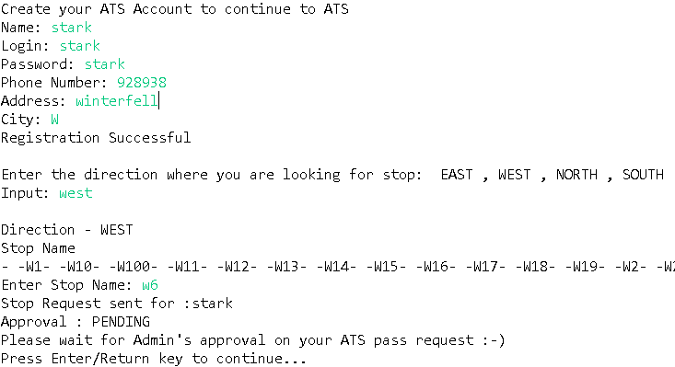

**User**:   
User is provided the below options.   
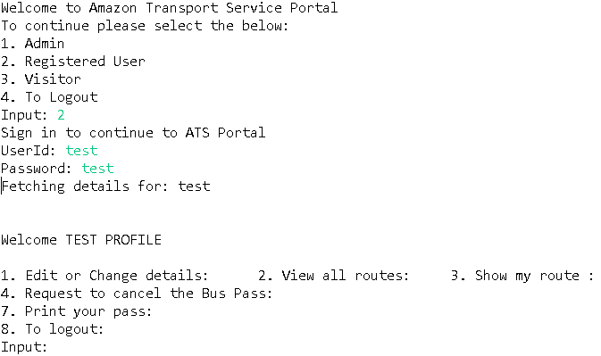

Here, Edit or Change details is an interactive service where the user can update their details along with their Stop.  
If User wants to Edit his details which include Phone, Address, City, Request Stop Change, Password. Below is the workflow. Request Stop change is where he can select a new stop.  
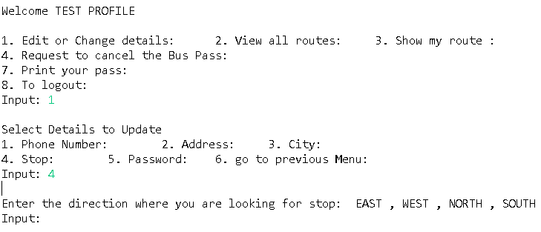

**Admin**: Below are the functionalities of Admin

1. View pending buss pass request.
2. Add a new route to the system.
3. Remove an existing route.
4. Change the bus type/capacity assigned to a route.
5. Assign an available bus to a route depending on the bus capacity required.
6. View the registered list of vehicles/busses
7. Register a new bus to the transportation service.

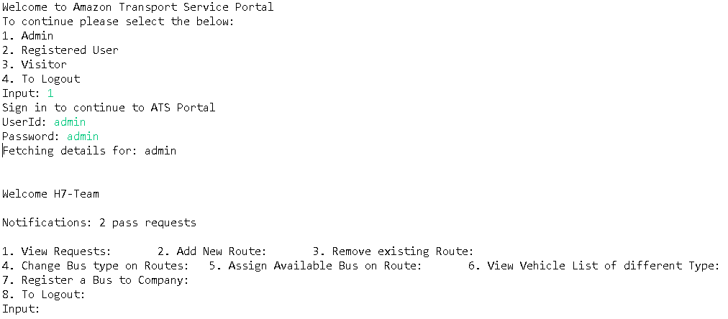

# Learning Outcomes

* Learning how JDBC works.
* Better understanding of design principles and OOPS.
* Implementing the entire project on SQLlite database before migrating to AWS.
* Hands on experience on using data structures like HashMap, ArrayList where needed.
* Learnt importance of closing resources, like scanner, JDBC connections, JDBC resources.
* Learned to work on Git as a team.
* Better understanding of external libraries and their paths.