Assignment - 11 (MySQL Programs)

Q.1] Write a program to create MySQL database and table and perform

following task :

1. Insert and retrieve data from table
2. Alter table add new column
3. Add information in new column

Ans :

Create_Database.php

<?php

$server = "localhost";

$db_uname = "root";

$db_pwd = "";

$db_name = "login";

$link = mysqli_connect($server, $db_uname, $db_pwd) or die("Piyu");

mysqli_select_db($link, $db_name);

$query = "select * from login";

$result = mysqli_query($link, $query);

$count = mysqli_num_rows($result);

if($count > 0)

{

echo "<br/>"."<br/>";

echo "<table border='1'>";

echo "<tr>";

echo "<td><b>Username</b></td>";

echo "<td><b>Password</b></td>";

echo "</tr>";

while($row = mysqli_fetch_array($result))

{

echo "<tr>";

echo "<td>".$row['username']."</td>";

echo "<td>".$row['password']."</td>";

echo "</tr>";

}

echo "</table>";

}

else

{

echo "Data Not Found..!!";

}

echo "<br/>"."<br/>";

echo "Want to Insert More Data ?";

echo "<br/>"."<br/>";

echo "If Yes, then ";

echo "<a href = 'Insert_[Data]_Operator.php'>Click here</a>";

echo "<br/>"."<br/>";

echo "Want to Add New-Column to the Current Data ?";

echo "<br/>"."<br/>";

echo "If Yes, then ";

echo "<a href = 'Alter_[Column]_Operator.php'>Click here</a>";

?>

Output :

1. Frontend View :

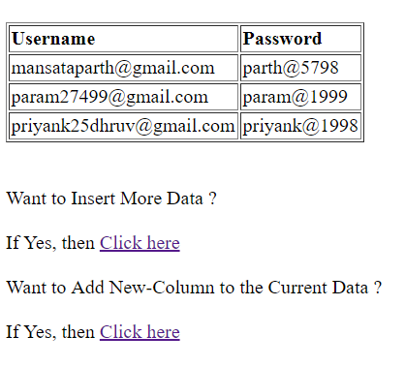

1. Backend View :

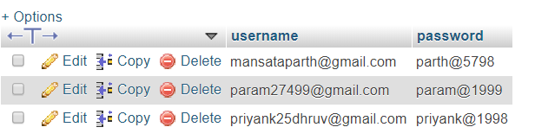

Insert_[Data]_Operator.php

<html>

<head>

<title>Insert_Data_Operator</title>

</head>

<body>

<fieldset style = "width:15%">

<legend>Enter Login Details</legend>

<form name = "insert" method = "post" action = "Insert_[Data]_Operator.php">

<br/>

<input type = "text" name = "username" placeholder = "Username"/>

<br/>

<br/>

<input type = "password" name = "password" placeholder = "Password"/>

<br/>

<br/>

<input type = "submit" name = "Submit" value = "Submit"/>

<br/>

</form>

</fieldset>

</body>

</html>

<?php

if(isset($_POST['Submit']))

{

$uname = $_POST['username'];

$pwd = $_POST['password'];

$server = "localhost";

$db_uname = "root";

$db_pwd = "";

$db_name = "login";

$link = mysqli_connect($server, $db_uname, $db_pwd) or die("Piyu");

mysqli_select_db($link, $db_name);

$query = "insert into login values('".$uname."','".$pwd."')";

$result = mysqli_query($link, $query);

echo "<br/>";

echo "Data Inserted Successfully..!!";

echo "<br/>"."<br/>";

echo "Want to View Inserted Data ? ";

echo "If Yes, then ";

echo "<a href = 'View_Database.php'>Click here</a>";

}

?>

Output :

1. Frontend View :
2. Before Inserting Data :

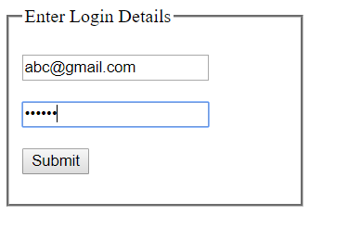

1. After Inserting Data :

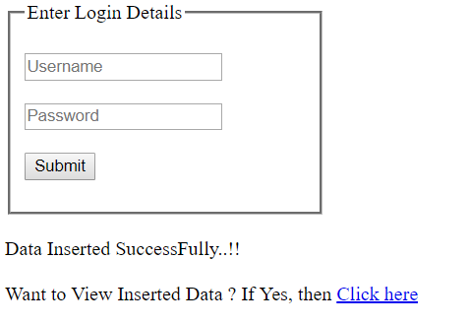

1. View Inserted Data :

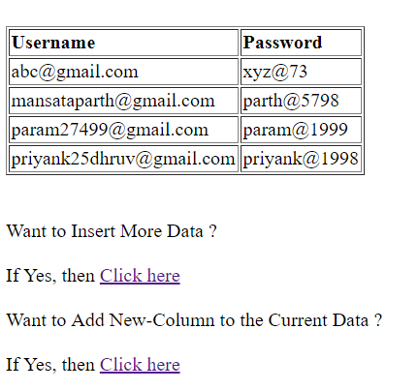

(b.) Backend View :

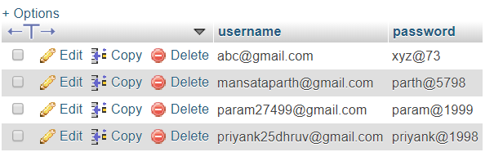

Alter_[Column]_Operator.php

<html>

<head>

<title>Alter_Data_Operator</title>

</head>

<body>

<fieldset style = "width:15%">

<legend>Enter New-Column Details</legend>

<form name = "alter" method = "post" action = "Alter_[Column]_Operator.php">

<br/>

<input type = "text" name = "column_name" placeholder = "Column Name"/>

<br/>

<br/>

<input type = "text" name = "type" placeholder = "Type"/>

<br/>

<br/>

<input type = "number" name = "size" placeholder = "Size"/>

<br/>

<br/>

<input type = "submit" name = "Submit" value = "Submit"/>

<br/>

</form>

</fieldset>

</body>

</html>

<?php

if(isset($_POST['Submit']))

{

$column_name = $_POST['column_name'];

$type = $_POST['type'];

$size = $_POST['size'];

$server = "localhost";

$db_uname = "root";

$db_pwd = "";

$db_name = "login";

$link = mysqli_connect($server, $db_uname, $db_pwd) or die("Piyu");

mysqli_select_db($link, $db_name);

$query = "alter table login add ".$column_name." ".$type."(".$size.")";

$result = mysqli_query($link, $query);

echo "<br/>";

echo "Data Altered SuccessFully..!!";

echo "<br/>"."<br/>";

echo "<br/>";

echo "Want to Insert Data in the Newly Added Column ? ";

echo "<br/>"."<br/>";

echo "If Yes, then ";

echo "<a href = 'Add_Info[New_Column].php'>Click here</a>";

}

?>

Output :

1. Frontend View :
2. Filling Column Name, Data-Type and its Size :

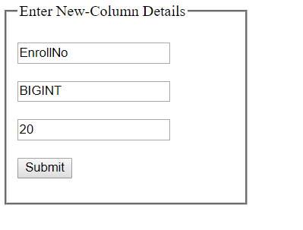

1. After Submitting New Column Details :

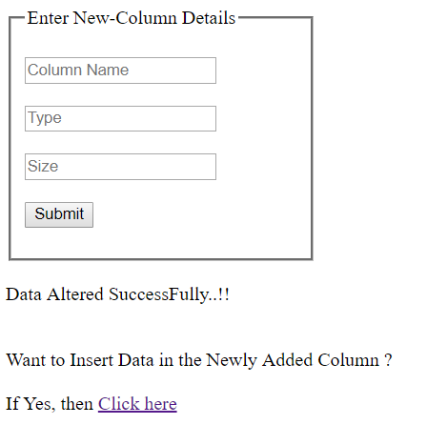

1. Backend View :

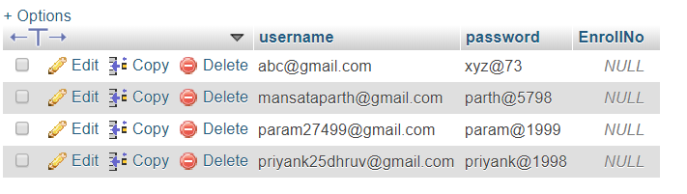

Add_Info[New_Colum].php

<html>

<head>

<title>Add_Info_Operator</title>

</head>

<body>

<fieldset style = "width:15%">

<legend>Enter New-Column Data</legend>

<form name = "add_Data" method = "post" action = "Add_Info[New_Column].php">

<br/>

<input type = "text" name = "column_data" placeholder = "Data"/>

<br/>

<br/>

<input type = "submit" name = "Submit" value = "Submit"/>

<br/>

</form>

</fieldset>

</body>

</html>

<?php

if(isset($_POST['Submit']))

{

$column_data = $_POST['column_data'];

$server = "localhost";

$db_uname = "root";

$db_pwd = "";

$db_name = "login";

$link = mysqli_connect($server, $db_uname, $db_pwd) or die("Piyu");

mysqli_select_db($link, $db_name);

$query = "update login set EnrollNo = '".$_POST['column_data']."' where username =

'priyank25dhruv@gmail.com'";

$result = mysqli_query($link, $query);

echo "<br/>";

echo "Data Inserted into Newly Added Column SuccessFully..!!";

}

?>

Output :

1. Frontend View :
2. Before filling Data into the New Column :

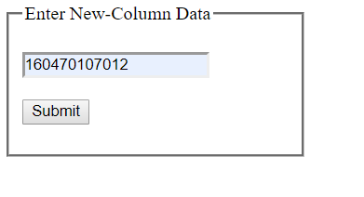

1. After Submitting Data into the New Column :

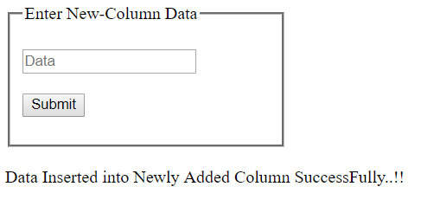

1. Backend View :

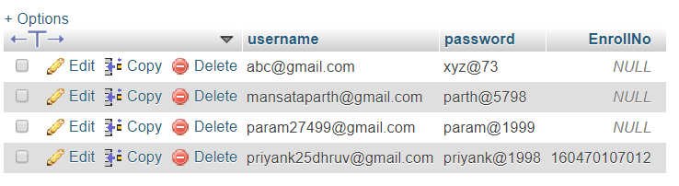

Q.2] Write module using php and html to store employee id, job title,

experience in employee table and output the information in

ascending order of its experience.

Ans :

Employee_[Data_Storage]_Driver.php

<html>

<head>

<title>Employee_Data_Fetcher</title>

</head>

<body>

<fieldset style = "width:15%">

<legend>Employee Data Entry</legend>

<form name = "emp" method = "post" action = "Employee[Data_Storage]_Driver.php">

<br/>

<input type = "number" name = "emp_id" placeholder = "Employee Id"/>

<br/>

<br/>

<input type = "text" name = "job_title" placeholder = "Job Title"/>

<br/>

<br/>

<input type = "number" name = "year" placeholder = "Year Of Experience"/>

<br/>

<br/>

<input type = "submit" name = "Submit" value = "Submit">

<br/>

</form>

</fieldset>

</body>

</html>

<?php

if(isset($_POST['Submit']))

{

$emp_id = $_POST['emp_id'];

$job_title = $_POST['job_title'];

$year = $_POST['year'];

$server = "localhost";

$db_uname = "root";

$db_pwd = "";

$db_name = "emp";

$link = mysqli_connect($server, $db_uname, $db_pwd) or die("Niti");

mysqli_select_db($link, $db_name);

$query_1 = "insert into emp values('".$emp_id."', '".$job_title."', '".$year."')";

$result_1 = mysqli_query($link, $query_1);

$query_2 = "select * from emp order by year asc";

$result_2 = mysqli_query($link,$query_2);

$count = mysqli_num_rows($result_2);

if($count > 0)

{

echo "<table border='1' cellpadding='5'>";

echo "<tr>";

echo "<td><b>emp_ID</b></td>";

echo "<td><b>Job_Title</b></td>";

echo "<td><b>Year_Of_Expr</b></td>";

echo "</tr>";

while($row = mysqli_fetch_array($result_2))

{

echo "<tr>";

echo "<td>".$row['emp_id']."</td>";

echo "<td>".$row['job_title']."</td>";

echo "<td>".$row['year']."</td>";

echo "</tr>";

}

echo "</table>";

}

else

{

echo "Data Not Found..!!";

}

echo "Want to Insert More Data ?";

echo "If Yes, then ";

echo "<a href = 'Employee[Data_Storage]_Driver.php'>Click here</a><br>";

}

?>

Output :

1. Frontend View :
2. Before Inserting Data into the “emp” table :

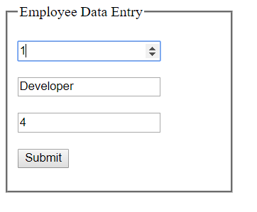

1. After Submitting Data :

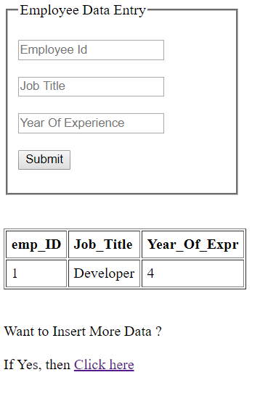

(3.) Adding More Data into the “emp” table :

Step-1 :

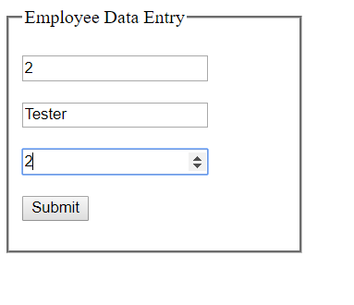

Step-2 :

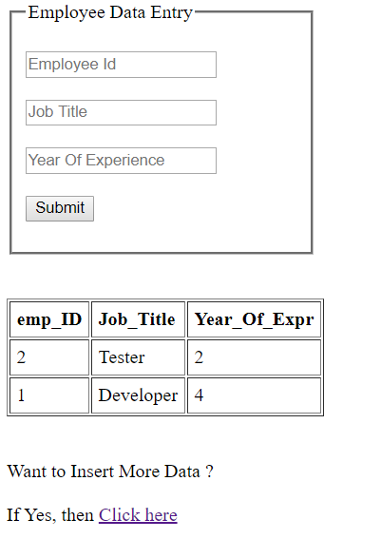

(b.) Backend View :

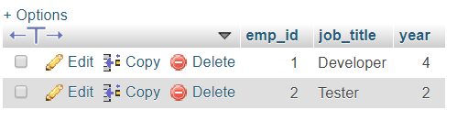

Q.3] Create a database country and create table city having field: city

name, area, population using php command.

Create HTML form to get city data and write a script to insert and

delete data into table.

Ans :

Country_[Database]_Manipulator.php

<html>

<head>

<title>Country_Data_Manipulator</title>

</head>

<body>

<fieldset style = "width:15%">

<legend>Country Data Entry</legend>

<form name = "country" method = "post" action = "Country[Database]_Manipulator.php">

<br/>

<input type="text" name = "city_name" placeholder = "City Name"/>

<br/>

<br/>

<input type = "text" name = "area" placeholder = "Area"/>

<br/>

<br/>

<input type = "number" name = "population" placeholder = "Population"/>

<br/>

<br/>

<input type = "submit" name = "Submit" value = "Submit"/>

<br/>

</form>

</fieldset>

</body>

</html>

<?php

if(isset($_POST['Submit']))

{

$city_name = $_POST['city_name'];

$area = $_POST['area'];

$population = $_POST['population'];

$server = "localhost";

$db_uname = "root";

$db_pwd = "";

$db_name = "country";

$link = mysqli_connect($server, $db_uname, $db_pwd) or die("Niti");

mysqli_select_db($link, $db_name);

$query_1 = "insert into country values('".$city_name."','".$area."','".$population."')";

$result_1 = mysqli_query($link, $query_1);

$query_2 = "select * from country";

$result_2 = mysqli_query($link, $query_2);

$count = mysqli_num_rows($result_2);

if($count > 0)

{

echo "<br/>"."<br/>";

echo "<table border='1'>";

echo "<tr>";

echo "<td><b>City Name<b/></td>";

echo "<td><b>Area<b/></td>";

echo "<td><b>Population<b/></td>";

echo "</tr>";

while($row = mysqli_fetch_array($result_2))

{

echo "<tr>";

echo "<td>".$row['city_name']."</td>";

echo "<td>".$row['area']."</td>";

echo "<td>".$row['population']."</td>";

echo "</tr>";

}

echo "</table>";

}

else

{

echo "Data Not Found..!!";

}

echo "<br/>"."<br/>";

echo "Want to Insert More Data ?";

echo "<br/>"."<br/>";

echo "If Yes, then ";

echo "<a href = 'Country[Database]_Manipulator.php'>Insert</a>";

echo "<br/>"."<br/>";

echo "Want to Delete Current Data ?";

echo "<br/>"."<br/>";

echo "If Yes, then ";

echo "<a href = 'Delete[Country_Data].php'>Delete</a>";

}

?>

Output :

1. Frontend View :
2. Before Inserting Data into the “country” table :

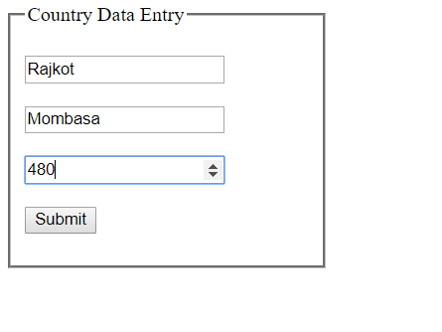

1. After Submitting Data :

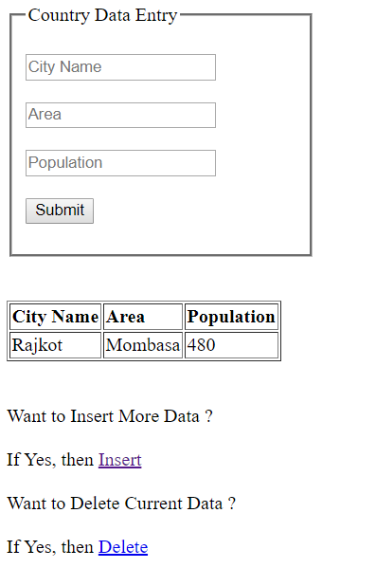

(3.) Adding More Data into the “country” table :

Step-1 :

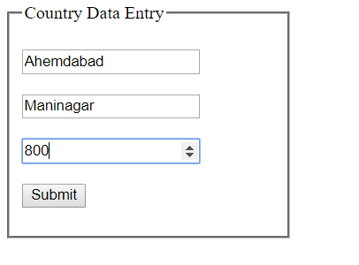

Step-2 :

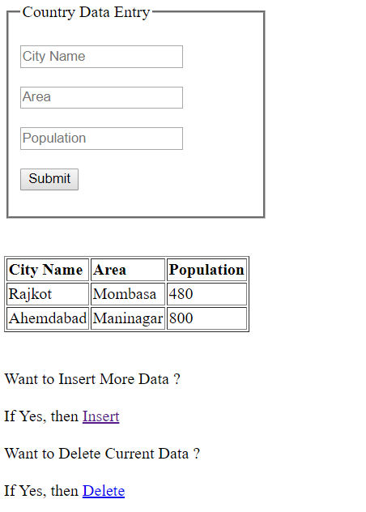

(b.) Backend View :

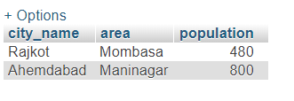

Delete_[Country_Data].php

<?php

$server = "localhost";

$db_uname = "root";

$db_pwd = "";

$db_name = "country";

$link = mysqli_connect($server, $db_uname, $db_pwd) or die("Niti");

mysqli_select_db($link, $db_name);

$query_1 = "delete from country where city_name = 'Rajkot'";

$result_1 = mysqli_query($link, $query_1);

echo "Data Deleted Successfully..!!";

$query_2 = "select * from country";

$result_2 = mysqli_query($link, $query_2);

$count = mysqli_num_rows($result_2);

if($count > 0)

{

echo "<br/>"."<br/>";

echo "<table border='1'>";

echo "<tr>";

echo "<td><b>City Name<b/></td>";

echo "<td><b>Area<b/></td>";

echo "<td><b>Population<b/></td>";

echo "</tr>";

while($row = mysqli_fetch_array($result_2))

{

echo "<tr>";

echo "<td>".$row['city_name']."</td>";

echo "<td>".$row['area']."</td>";

echo "<td>".$row['population']."</td>";

echo "</tr>";

}

echo "</table>";

}

else

{

echo "Data Not Found..!!";

}

?>

Output :

1. Frontend View :

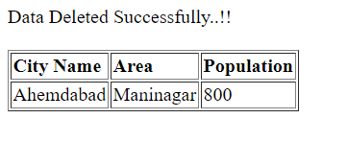

1. Backend View :

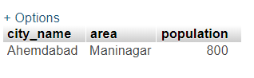

Q.4] Read and store student information such as enrollment, name,

semester and percentage in database table student, output the

data in tabular format.

Ans :

Student_[Data_Storage]_Driver.php

<html>

<head>

<title>Student_Data_Reader</title>

</head>

<body>

<fieldset style = "width:15%">

<legend>Student Data Entry</legend>

<form name = "stud" method = "post" action = "Student[Data_Storage]_Driver.php">

<br/>

<input type = "number" name = "stud_enroll" placeholder = "Enrollment No."/>

<br/>

<br/>

<input type = "text" name = "stud_name" placeholder = "Student Name"/>

<br/>

<br/>

<input type = "number" name = "stud_sem" placeholder = "Current Semester"/>

<br/>

<br/>

<input type = "number" name = "stud_percentage" placeholder = "Percentage"/>

<br/>

<br/>

<input type = "submit" name = "Submit" value = "Submit">

<br/>

</form>

</fieldset>

</body>

</html>

<?php

if(isset($_POST['Submit']))

{

$stud_enroll = $_POST['stud_enroll'];

$stud_name = $_POST['stud_name'];

$stud_sem = $_POST['stud_sem'];

$stud_percentage = $_POST['stud_percentage'];

$server = "localhost";

$db_uname = "root";

$db_pwd = "";

$db_name = "student";

$link = mysqli_connect($server, $db_uname, $db_pwd) or die("Niti");

mysqli_select_db($link, $db_name);

$query_1 = "insert into student values('".$stud_enroll."','".$stud_name."','".$stud_sem."','".$stud_percentage."')";

$result_1 = mysqli_query($link, $query_1);

$query_2 = "select * from student";

$result_2 = mysqli_query($link, $query_2);

$count = mysqli_num_rows($result_2);

if($count > 0)

{

echo "<table border='1'>";

echo "<tr>";

echo "<td>Enrollnment No</td>";

echo "<td>Name</td>";

echo "<td>Semester</td>";

echo "<td>Percentage</td>";

echo "</tr>";

while($row = mysqli_fetch_array($result_2))

{

echo "<tr>";

echo "<td>".$row['stud_enroll']."</td>";

echo "<td>".$row['stud_name']."</td>";

echo "<td>".$row['stud_sem']."</td>";

echo "<td>".$row['stud_percentage']."%</td>";

echo "</tr>";

}

echo "</table>";

}

else

{

echo "Data Not Found..!!";

}

}

?>

Output :

1. Frontend View :
2. Before Inserting Data into the “student” table :

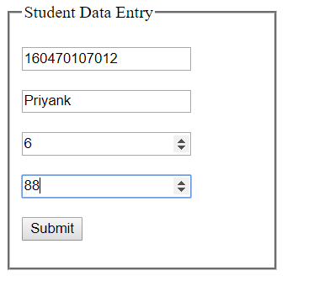

1. After Submitting Data :

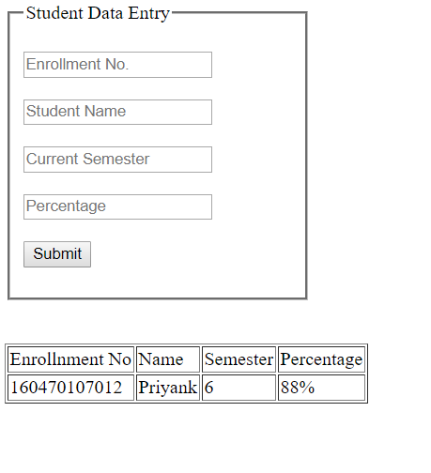

(b.) Backend View :

