Assignment - 10 (PHP Advance Programs)



Q.1] Write a php program to demonstrate cookies in php :

(i) **get** the cookie.

(ii) **set** the cookie.

Ans :

Retrieve_Cookie.php

<?php

$Cookie_Name = "Priyank_Dhruv";

$Cookie_Value = "Piyu";

setcookie($Cookie_Name, $Cookie_Value, time() + (86400 * 30), "/"); // 86400 = 1 day

?>

<html>

<body>

<?php

if(!isset($_COOKIE[$Cookie_Name]))

{

echo "Cookie Name : " . $Cookie_Name . " is not set!";

}

else

{

echo "Cookie Name : " . $Cookie_Name . " is set!"."<br>";

echo "Cookie Value : " . $_COOKIE[$Cookie_Name];

}

?>

</body>

</html>

Output :

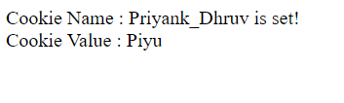

Enable_Cookie.php

<?php

setcookie("Test_Cookie", "Enable", time() + 3600, '/');

?>

<html>

<body>

<?php

if(count($_COOKIE) > 0)

{

echo "Cookies are enabled.";

}

else

{

echo "Cookies are disabled.";

}

?>

</body>

</html>

Output :



Delete_Cookie.php

<?php

setcookie("Priyank", "", time() - 3600); // set the expiration date to one hour ago

?>

<html>

<body>

<?php

echo "Cookie Name : 'Priyank' is deleted.";

?>

</body>

</html>

Output :

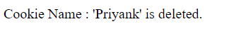

Q.2] Write a program to parse XML file using php.

Ans :

Niti.xml

<?xml version="1.0" encoding="UTF-8"?>

<note>

<to>Niti</to><br/>

<from>Priyank</from><br/>

<heading>BirthDay_Party</heading><br/>

<body>Don't forget to come at my birthday party..!!</body>

</note>

DOM_Parser.php

<?php

$Xml_Docx = new DOMDocument();

$Xml_Docx -> load("Niti.xml");

print $Xml_Docx -> saveXML();

?>

Output :

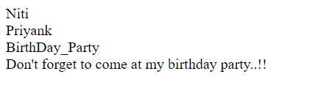

Looping_XmlDocx.php

<?php

$Xml_Docx = new DOMDocument();

$Xml_Docx -> load("Niti.xml");

$x = $Xml_Docx -> documentElement;

foreach ($x -> childNodes AS $item)

{

print $item -> nodeName . " = " . $item -> nodeValue . "<br>";

}

?>

Output :

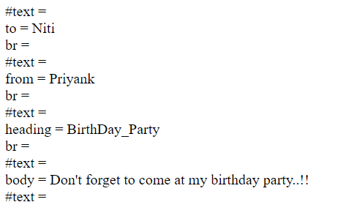

Q.3] Write a php program to demonstrate use of session.

Ans :

Create_Session.php

<?php

session_start();

?>

<html>

<body>

<?php

$_SESSION["Employee_1"] = "Priyank Dhruv";

$_SESSION["Employee_2"] = "Parth Makadiya";

$_SESSION["Employee_3"] = "Shyam Virani";

$_SESSION["Employee_4"] = "Param Ardesna";

$_SESSION["Employee_5"] = "Hepi Chaniyara";

$_SESSION["Employee_6"] = "Pritesh Sengra";

echo "All Employees are Set..!!";

?>

</body>

</html>

Output :



Access_Session.php

<?php

session_start();

?>

<html>

<body>

<?php

echo "<table border = '1'>";

echo "<tr>";

echo "<td><b>Emp_id</b></td>";

echo "<td><b>Emp_Name</b></td>";

echo "</tr>";

echo "<tr>";

echo "<td><center>1</center></td>";

echo "<td>".$_SESSION["Employee_1"]."</td>";

echo "</tr>";

echo "<tr>";

echo "<td><center>2</center></td>";

echo "<td>".$_SESSION["Employee_2"]."</td>";

echo "</tr>";

echo "<tr>";

echo "<td><center>3</center></td>";

echo "<td>".$_SESSION["Employee_3"]."</td>";

echo "</tr>";

echo "<tr>";

echo "<td><center>4</center></td>";

echo "<td>".$_SESSION["Employee_4"]."</td>";

echo "</tr>";

echo "<tr>";

echo "<td><center>5</center></td>";

echo "<td>".$_SESSION["Employee_5"]."</td>";

echo "</tr>";

echo "<tr>";

echo "<td><center>6</center></td>";

echo "<td>".$_SESSION["Employee_6"]."</td>";

echo "</tr>";

echo "</table>";

?>

</body>

</html>

Output :

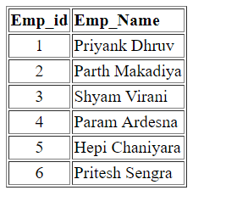

Destroy_Session.php

<?php

session_start();

?>

<html>

<body>

<?php

session_unset();

session_destroy();

echo "All Employees went for a Holiday."."<br/>";

echo "<br/>";

echo "Thus, the Session is Destroyed."

?>

</body>

</html>

Output :

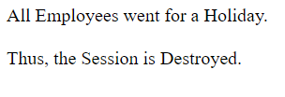

Q.4] Write a php program to detect Browser.

Ans :

<?php

echo $_SERVER['HTTP_USER_AGENT'];

?>

Output :



Q.5] Write a php program to demonstrate use of Inheritance &

Constructors.

Ans :

Demonstrate_Inheritance.php

<?php

class Tony

{

PUBLIC function MyStmt($String)

{

echo "Tony : ".$String.PHP_EOL;

}

PUBLIC function printStmt()

{

echo "I am Ironman..!!"."<br/>"."<br/>".PHP_EOL;

}

}

class Ironman extends Tony

{

PUBLIC function MyStmt($String)

{

echo "Ironman : ".$String.PHP_EOL;

}

}

$Tony = new Tony();

$Ironman = new Ironman();

$Tony -> MyStmt("The truth is.."."<br/>"."<br/>");

$Tony -> printStmt();

$Ironman -> MyStmt("The truth is.."."<br/>"."<br/>");

$Ironman -> printStmt();

?>

Output :

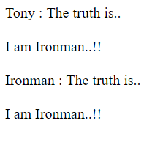

Demonstrate_Constructor.php

<?php

class Avengers

{

function __construct()

{

print "But, One thing we can't Change that we are Avengers."."<br/>"."<br/>";

}

}

class Age_Of_Ultron extends Avengers

{

function __construct()

{

print "Ultron's Revenge againts Avengers."."<br/>";

parent::__construct();

}

}

class Infinity_War extends Avengers

{

function __construct()

{

print "Thanos' Conquering of different Miles-Stones."."<br/>";

parent::__construct();

}

}

class Endgame extends Avengers

{

function __construct()

{

print "Avengers' Revenge of fallen against Thanos."."<br/>";

parent::__construct();

}

}

$obj = new Age_Of_Ultron();

$obj = new Infinity_War();

$obj = new Endgame();

?>

Output :

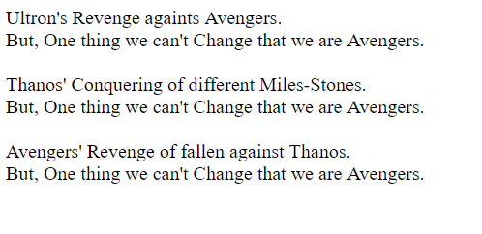

Demonstrate_Destructor.php

<?php

class Vision

{

function __construct()

{

print "Avengers &nbsp;: United we Stand."."<br/>"."<br/>";

}

function __destruct()

{

print "Civil-War : Divided we Fall.";

}

}

$Obj = new Vision();

?>

Output :

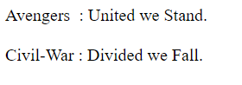

Q.6] Write a php program to display below pattern :

1

1. 1
2. 0 1

0 1 0 1

1 0 1 0 1

Ans :

Display_Pattern(1_01_101_0101_10101).php

<?php

$count = 1;

$k = 5;

for($i = 1; $i <= 5; $i++)

{

for($j = 1; $j <= $i; $j++)

{

echo $count % 2;

$count = $count + 1;

}

if ($i % 2 == 0)

{

$count = 1;

} else {

$count = 0;

}

echo "<br/>";

}

?>

Q.7] Write a php program to display below pattern :

1

a b

2 3 4

c d e f

5 6 7 8 9

Ans :

<?php

$x = 1;

$ascii = 97;

for($i = 1; $i <= 5; $i++)

{

for($j = 1; $j <= $i; $j++)

{

if($i % 2 == 1)

{

echo $x;

$x++;

} else {

echo chr($ascii);

$ascii++;

}

}

echo "<br/>";

}

?>

Q.8] Write a php program to validate email address using following

method : **preg_match**(**<regular-expression>**, **string**)

Ans :

Email_Validator.php

<?php

function valid_email($str)

{

Return (!preg_match("/^([a-z0-9\+_\-]+)(\.[a-z0-9\+_\-]+)[*@([a-z0-9\-]+\.)+[a-z]{2,6}$/ix](mailto:*@([a-z0-9\-%5d+\.)+%5ba-z%5d%7b2,6%7d$/ix)",

$str)) ? FALSE : TRUE;

}

if(!valid_email("priyank25dhruv@gmail.com"))

{

echo "Invalid Email Address.";

} else {

echo "Valid Email Address.";

}

?>

Output :



Q.9] Write a php program to Upload Image file with size less than 2MB.

Ans :

Image_Uploader.php

<html>

<head>

<title>Image_Uploader</title>

</head>

<body>

<form method = "post" enctype = "multipart/form-data">

<input type = "file" name = "file"/>

<br/>

<br/>

Note : Only .png, .jpg, .jpeg, .gif file Supported.

<br/>

<br/>

<input type = "submit" name = "submit" value = "submit"/>

</form>

</body>

</html>

<?php

$target_dir = "Uploads/";

$target_file = $target_dir . basename($_FILES["file"]["name"]);

$uploadOk = 1;

$imageFileType = pathinfo($target_file, PATHINFO_EXTENSION);

// Check if file already exists

if (file_exists($target_file))

{

echo "Sorry, file already exists.";

$uploadOk = 0;

}

// Check file size

if ($_FILES["file"]["size"] > 2000000)

{

echo "Sorry, your file is too large.";

$uploadOk = 0;

}

// Allow certain file formats

if($imageFileType != "jpg" && $imageFileType != "png" && $imageFileType != "jpeg" && $imageFileType != "gif")

{

echo "Sorry, only JPG, JPEG, PNG & GIF files are allowed.";

$uploadOk = 0;

}

// Check if $uploadOk is set to 0 by an error

if ($uploadOk == 0)

{

echo "Sorry, your file was not uploaded.";

// if everything is ok, try to upload file

}

else

{

if (move_uploaded_file($_FILES["file"]["tmp_name"], $target_file))

{

echo "The file ". basename( $_FILES["file"]["name"]). " has been uploaded.";

}

else

{

echo "Sorry, there was an error uploading your file.";

}

}

?>

Output :

**Case-1 : file size less than or equal to 2MB.**

1. Open Image_Uploader.php file using XAMPP Server.

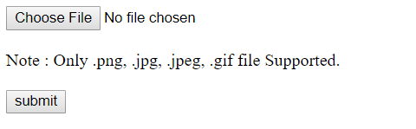

1. Choose any Image file.

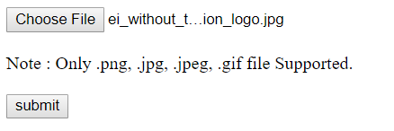

1. File Uploaded to “Uploads” directory Successfully.

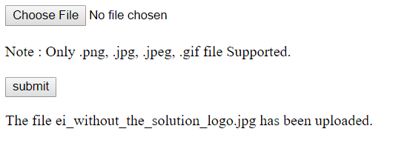

**Case-2 : file size more than 2MB.**

1. Open Image_Uploader.php file using XAMPP Server.



1. Choose any Image file.

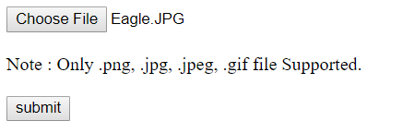

1. Error occurred while submitting Image file.

Reason : file size is more than 2MB.

