Assignment - 9 (PHP Basic Programs)

Q.1 ] Write a php program to demonstrate include & require function.

Ans :

Mark-X.php

<?php

echo "I think that we all do heroic things, but hero is not a noun, it's a verb.<br/>";

echo "There is unpanned gold in every soul you run into, no matter what walk of life they are from.<br/>";

echo "If you want to make God laugh, tell him your plan.";

?>

Mark-Y.php

<?php

$x = "There's a little bit of asshole in every nice guy, and there's a little bit of genius in every moron.<br/>";

echo $x;

$y = "Job one is get out of that cave. A lot of people do get out but don't change.<br/>";

echo $y;

?>

Demonstrate_(include, require)function.php

<?php

include("Mark-X.php"); //to include Mark-X.php

echo"<br>";

require("Mark-Y.php"); //to include Mark-Y.php

?>

Output :

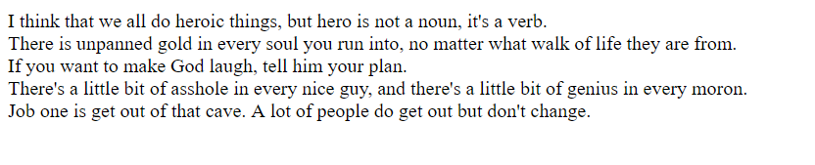

Q.2] Write a php program to perform url redirect(header command).

Ans :

Url_Redirect.php

<?php

header("Location: https://www.marvel.com/movies/avengers-endgame");

//for redirecting the page

?>

Output :

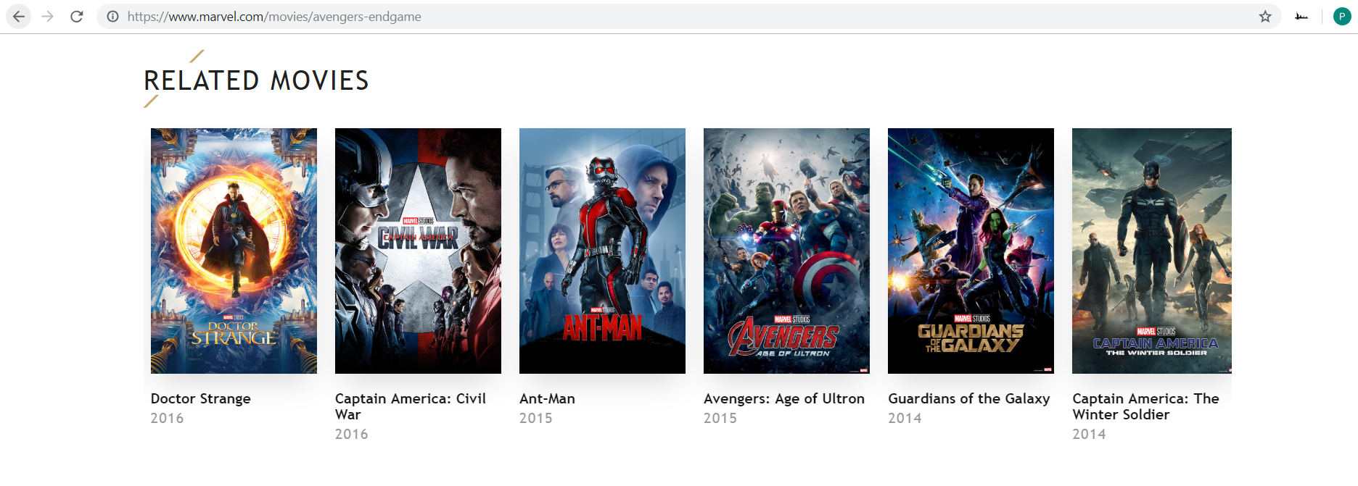

Q.3] Write a php program to display cube of 1 to 10.

Ans :

Display_Cubes.php

<?php

echo "<table border='1'>";

for($a=1;$a<=10;$a++)

{

echo "<tr>";

echo "<td>"."Cube of ".$a." is : </td>";

echo "<td>".($a*$a*$a)."</td>";

echo "</tr>";

}

echo "</table>";

?>

Output :

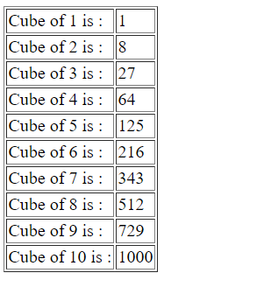

Q.4] Write a php program to process any associative array.

Ans :

Process_Associative_Array.php

<?php

$MembersOfSSIP = array("Member1" => "Parth",

"Member2" => "Abhay",

"Member3" => "Dhyey",

"Member4" => "Shreyas");

foreach($MembersOfSSIP as $Member => $name)

{

echo $Member." Of SSIP is : " .$name;

echo "<br/>";

}

?>

Output :

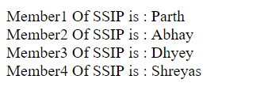

Q.5] Write a php program to print wheather a current year is leap year

or not.

Q.6] write a php program to check entered year is leap year or not.

Ans(5, 6) :

Identify_LeapYear.php

<html>

<head>

<title>LeapYear_Identifier</title>

</head>

<body>

<form name = "leapYear" method = "get">

<input type = "text" name = "yr" placeholder = "Enter any Year" required = "required"/>

&nbsp;<input type = "submit" name = "check_leapYear" value = "CheckOut"/>

</form>

</body>

</html>

<?php

if (isset($_GET["check_leapYear"] ) ) {

$year = $_GET["yr"];

if($year%4 == 0) {

echo "Year : ". $year ." is a leap year.";

}

Else {

echo "Year : ". $year ." is not a leap year.";

}

}

?>

Output :

Before :

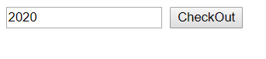

After :

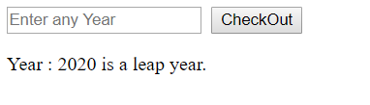

Q.7] Write a php program to print wheather a given number is odd or

even.

Ans :

Number(Odd-Even)_Identifier.php

<html>

<head>

<title>Odd-Even_Number_Identifier</title>

</head>

<body>

<form name = "oddEven" method = "get">

<input type = "text" name = "number" placeholder = "Enter any Number" required = "required"/>

&nbsp;<input type = "submit" name = "check_oddEven" value="CheckOut"/>

</form>

</body>

</html>

<?php

if (isset($_GET["check_oddEven"] ) )

{

$number = $_GET["number"];

if($number%2 == 0)

{

echo "Number : ". $number ." is an even number.";

}

else

{

echo "Number : ". $number ." is a odd number.";

}

}

?>

Output :

Case 1 : Input any Odd Number.

Before :

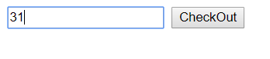

After :

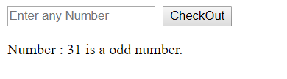

Case 2 : Input any Even Number

Before :

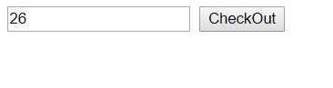

After :

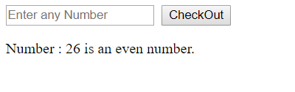

Q.8] Write a php program to print first 10-fibonnaci numbers.

Ans :

Fibonnaci_Numbers[1_to_10].php

<?php

$a=0;

$b=0;

$c=1;

echo "First 10 fibonacci numbers are as follows : <br>";

for($i=0;$i<10;$i++)

{

echo $a."&nbsp;&nbsp;";

$a=$b;

$b=$c;

$c=$a+$b;

}

?>

Output :

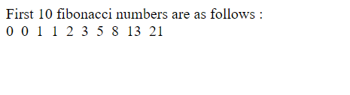

Q.9] Write a php program to store student information such as Name, Percentage, Enrollment Number & Semester using an array & output the data using Webpage.

Ans :

Student(Info)_Database.php

<html>

<head>

<title>Enter_Student_Information</title>

</head>

<body>

<form name="StudentInfo" method = "get">

<input type = "text" name = "name" placeholder = "Enter Your Name : "/><br/><br/>

<input type = "floatval" name = "cgpa" placeholder = "Enter Your Curent CGPA : "/><br/><br/>

<input type = "Number" name = "enroll" placeholder = "Enter Your Enrollment No. : "/><br/><br/>

<input type = "Number" name = "sem" placeholder = "Enter Your Current Semester : "/><br/><br/>

<input type = "submit" name = "display" value = "DisplayInfo"/>

</form>

</body>

</html>

<?php

if (isset($_GET["display"] ) )

{

echo "Name Of Student&nbsp;&nbsp; : ".$_GET["name"]."<br/><br/>";

echo "Current CGPA Of Student&nbsp;&nbsp;: ".$_GET["cgpa"]."<br/><br/>";

echo "Enrollment Number&nbsp;&nbsp;: ".$_GET["enroll"]."<br/><br/>";

echo "Current Semester&nbsp;&nbsp; : ".$_GET["sem"]."<br/><br/>";

}

?>

Output :

Before :

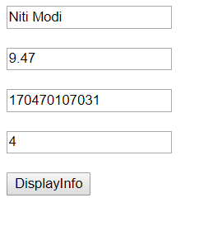

After :

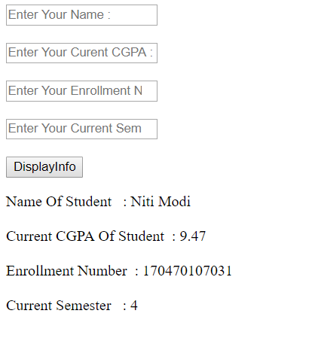

Q.10] Write a php program to read & write a text file based on user

Input.

Ans :

Text_File(Read-Write)_Opn.php

<html>

<head>

<title>Read_Write_FileOperator</title>

</head>

<body>

<center>

<fieldset style = "width:15%">

<form method = "post">

<input type = "text" name = "file_name_holder" placeholder = "Enter file Name"/>

<div style = "text-align:left">

<input type = "radio" name = "file_Opn" value = "read">Read

</div>

<div style = "text-align:left">

<input type = "radio" name = "file_Opn" value = "write">Write

</div>

<input type = "text" name = "text_holder" placeholder = "Enter text to write into file"/>

<input type = "submit" name = "Submit_Button" value = "Submit"/>

</form>

</fieldset>

</center>

</body>

</html>

<?php

if(isset($_POST["Submit_Button"]))

{

$file = fopen($_POST["file_name_holder"], "a+");

if($_POST["file_Opn"] == "read")

{

echo fread($file, filesize($_POST["file_name_holder"]));

}

else if($_POST["file_Opn"] == "write")

{

fwrite($file, $_POST["text_holder"]);

echo "Data written successfully..!!";

}

else

{

echo "Please, Select any one File-Operation.";

}

fclose($file);

}

?>

Output :

Case 1 : Read Operation

Before :

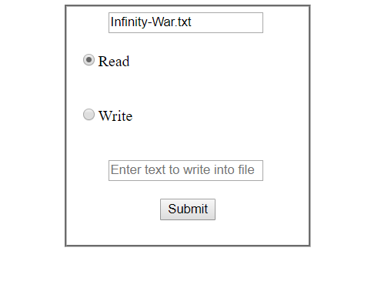

After :

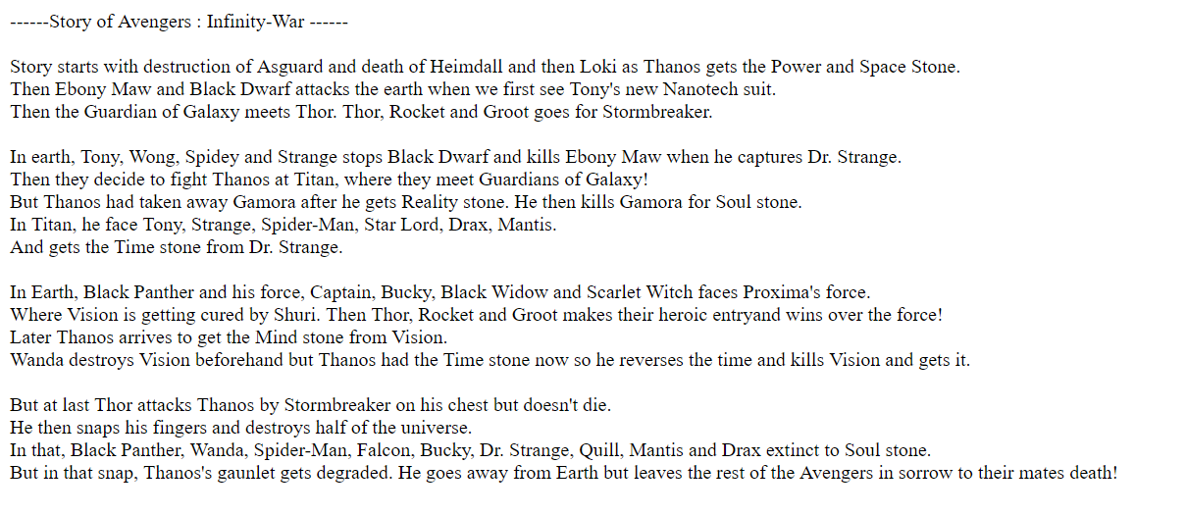

Case 2 : Write Operation

Before :

1.)

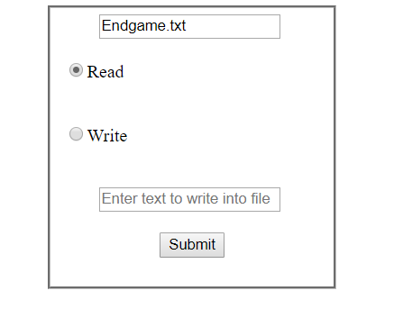

2.)

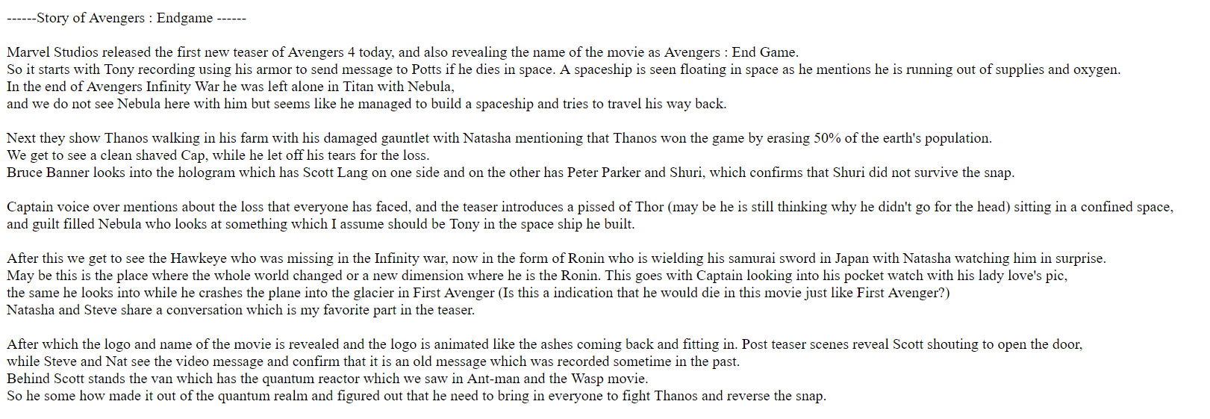

After :

1.)

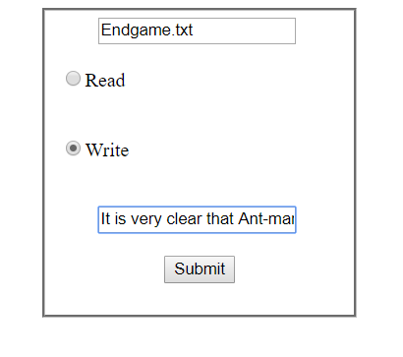

2.)

