`

Docker Images:

Kubernetes Pods:

Kubernetes services:

Helm deployment:

Frontend Application:
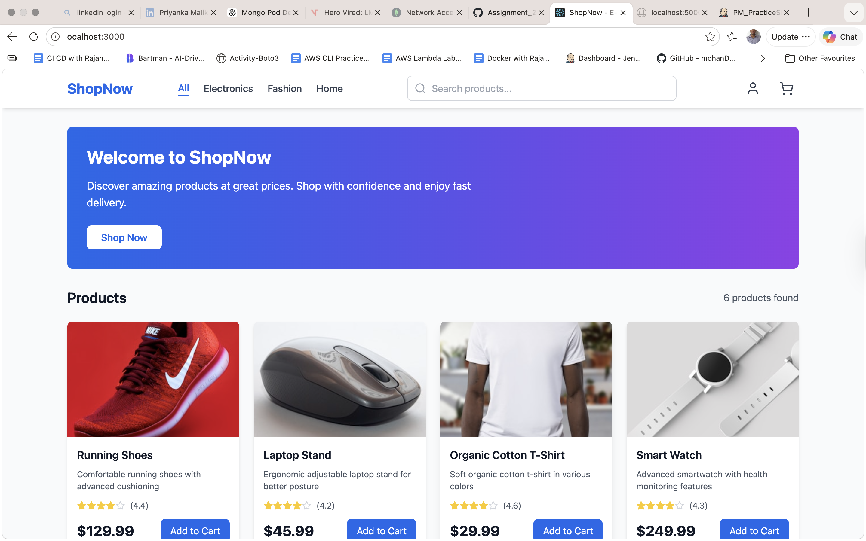

Backend health check:
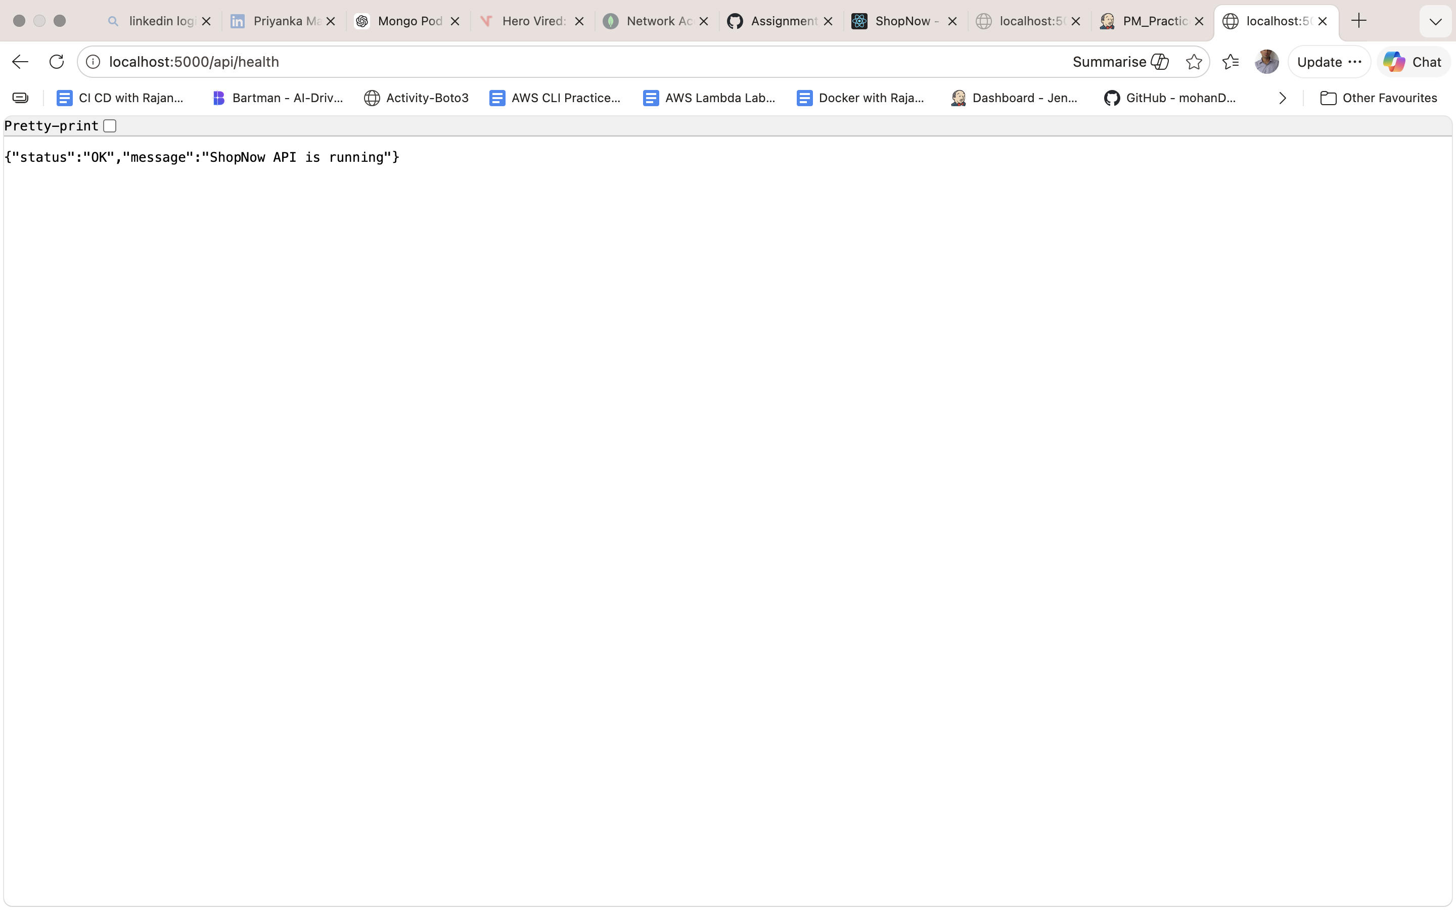

Github Repo:
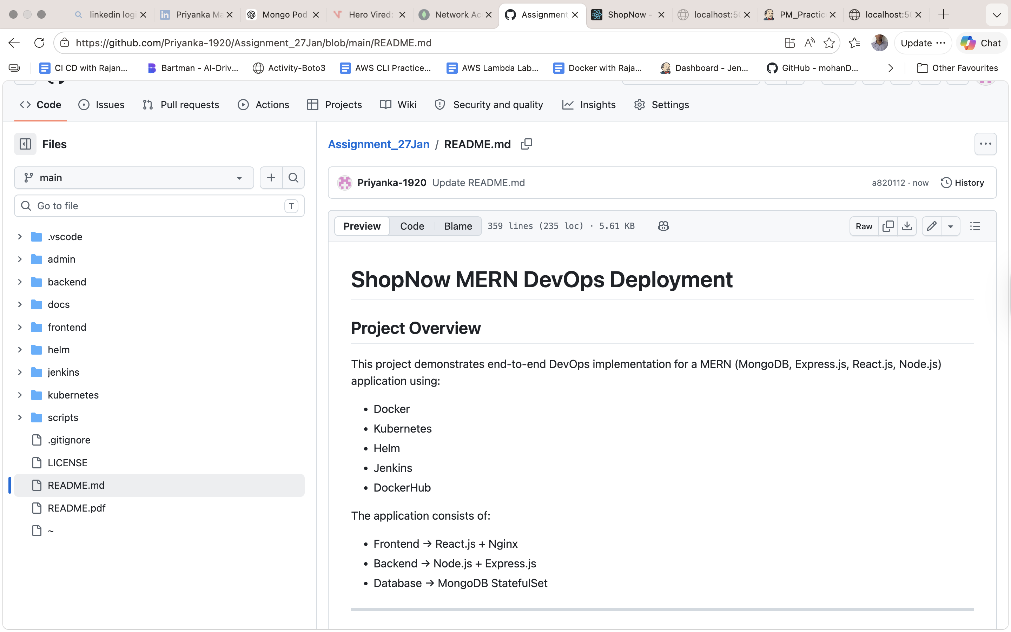
Helm Chart Folder Structure:
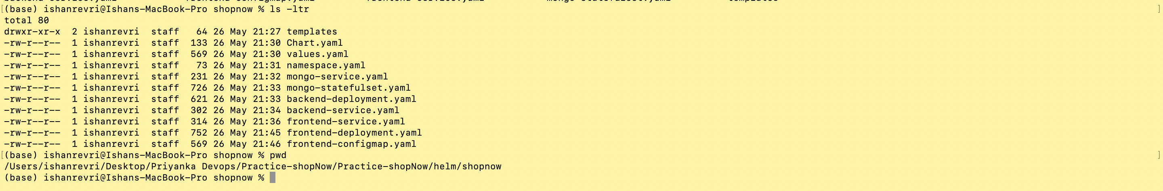

Jenkin pipeline:
