Work Report
On

AN INTERACTIVE TKINTER-BASED TOOL FOR CO-OCCURRENCE AND CLUSTER VISUALISATION

Submitted by

Priyanka Rath
Department of Computer Science and Technology Silicon University Patia, Odisha – 751025
(Duration of Summer Internship: from June 02, 2025 to July 18, 2025)

Under the guidance of
Dr. Satya Ranjan Sahu Senior Principal Scientist
CSIR –IMMT, Bhubaneswar



CSIR – Institute of Minerals and Materials Technology
Bhubaneswar – 751013, Odisha, India

CERTIFICATE

This is to certify that the work incorporated in the report entitled
“AN INTERACTIVE TKINTER-BASED TOOL FOR CO-OCCURRENCE AND CLUSTER VISUALISATION” is a
record of research work carried out by Priyanka Rath under my guidance and supervision from June 02, 2025 to July 18, 2025 in the Department of CNIT (Computer Networking and Information Technology) at CSIR – Institute of Minerals and Materials Technology (CSIR – IMMT).

Signature of the Student Date: ……………
Priyanka Rath
Department of Computer Science Silicon University, Patia,
Bhubaneswar, Odisha – 751025
Signature of the Guide Date: ……………
Dr. Satya Ranjan Sahu Senior Principal Scientist CSIR IMMT

ACKNOWLEDGEMENT

I would like to express my deep sense of gratitude to Dr. Satya Ranjan Sahu, Senior Principal Scientist, at CSIR – Institute of Minerals and Materials Technology (CSIR – IMMT), for his constant support, expert guidance, and valuable feedback throughout the duration of this internship. His insightful suggestions and meticulous supervision have been instrumental in shaping the direction and execution of this work.
I am also thankful to the team and staff members at CSIR – IMMT for providing a professional and research-driven environment that supported my learning and development. Their cooperation and timely assistance helped me navigate various challenges during the implementation of the address cleaning and deduplication system.
Participating in this two-month summer internship has greatly enriched my understanding of real-world data quality challenges. It gave me the opportunity to apply theoretical concepts to practical problems and enhanced my skills in Python programming, data preprocessing, and software development. I am truly grateful for the experience and exposure provided by CSIR – IMMT.

CONTENTS

Description | Page No.
a. Introduction | 1
b. Literature Review | 2
c. Objectives | 3
d. Methodology | 4-15
e. Implementation Details | 16-23
f. Results and Discussions | 24-27
g. Challenges | 28-29
h. Conclusion &  Future Scope | 30
i. References | 31

Introduction

The explosive growth of research in the field of nanoscience has generated an overwhelming volume of scientific publications and technical documents. These resources, though rich in information, are predominantly unstructured, making it challenging for researchers to extract coherent insights or detect emerging scientific trends manually.

This project addresses that gap by systematically analyzing the co- occurrence patterns between scientific phrases and nano-related terms in nanoscience literature. By applying advanced techniques in data mining, data filtering, natural language processing (NLP), and interactive data visualization, the project aims to empower researchers with tools for insightful exploration of nano-related knowledge domains.

The centerpiece of this work is the development of a Tkinter-based interactive tool that facilitates the visualization of relationships between extracted phrases and categorized nano-terms, also allowing temporal trend analysis. This tool helps in discovering associations, observing research trends, and identifying potential areas of interest in nanoscience.

Literature Review

The exponential growth of scientific literature, particularly in fields like nanoscience, has made knowledge extraction from unstructured text a critical challenge for researchers. Traditional manual methods are insufficient when dealing with large datasets, leading to the emergence of automated text mining and co-occurrence analysis techniques.
Co-occurrence analysis is widely used in bibliometric studies to explore relationships between terms or concepts within textual data. It helps identify research trends, emerging technologies, and concept linkages by examining how frequently terms appear together in scientific documents. Tools like VOSviewer and Bibliometrix have been extensively used for such analyses but are often web-based or lack customization for domain- specific needs.
Phrase extraction relies on natural language processing techniques such as tokenization, stopword removal, and part-of-speech tagging. Libraries like NLTK offer robust support for this purpose. However, domain-specific challenges like nano-term variations require tailored approaches combining regex-based extraction and manual curation
For visualizing co-occurrence data, NetworkX and Matplotlib are popular Python libraries that enable dynamic network graph generation. They help represent complex relationships between phrases and nano-terms in an interactive, interpretable manner. However, these tools typically demand coding knowledge.
Despite the availability of various tools, a significant gap remains for a standalone, user-friendly desktop application that integrates phrase extraction, nano-term grouping, co-occurrence analysis, and interactive visualization in one platform. This project addresses that gap by combining data mining, filtering, and visualization into a Tkinter-based GUI tool tailored for nanoscience research exploration.

Objectives

The main objective of this project is to develop an interactive system that automatically extracts, analyzes, and visualizes the co-occurrence patterns between scientific phrases and nano-related terms in nanoscience literature, enabling researchers to identify trends and relationships efficiently.
The specific objectives of the project are:
- Extract and clean scientific phrases from nanoscience titles using tokenization and regex.
- Identify and group nano-related terms using prefix-based clustering.
- Build a co-occurrence matrix between phrases and nano-terms with frequency-based filtering.
- Develop a Tkinter-based GUI for data input, filtering, and graph visualization.
- Support researchers with exportable outputs and insights into emerging nano-trends.
Through these objectives, the project aims to empower researchers with a robust tool that bridges the gap between unstructured nanoscience literature and actionable insights, promoting informed research and exploration.

Methodology
3.1Data Collection and Aggregation

Overview
The foundation of this project relies heavily on the comprehensive and accurate collection of nanoscience-related research data. The objective is to gather a significant dataset of scientific literature, particularly focusing on titles, abstracts, and other bibliographic metadata related to nanoscience. These records serve as the raw material for subsequent phrase extraction, nano-term identification, and co-occurrence analysis.

Source of Data
The dataset utilized in this project comprises 155 text files, each containing structured metadata extracted from nanoscience research repositories and publication databases. These files represent diverse research publications, including journal articles, conference proceedings, and technical reports. The data reflects the interdisciplinary nature of nanoscience, encompassing contributions from fields such as materials science, physics, chemistry, and biotechnology.

Data Characteristics
Each text file follows a tab-separated format, typically encoded in UTF-16 or UTF-8, which contains both header information (denoting column names) and rows of corresponding data. The fields include bibliometric attributes such as:
PT (Publication Type) , AU (Authors) , TI (Title) ,PY (Publication Year) ,
AB (Abstract) , DE (Author Keywords) ,ID (Keywords Plus) and other relevant metadata.

Data Reading and Extraction Process
The data extraction process involves systematically reading each file to parse the headers and corresponding data rows. The following steps outline the process:
      - File Reading: Each text file is opened in reading mode
with appropriate decoding based on its encoding format.

      - Header Extraction: The first line of each file, representing
the column headers, is read and split using the tab delimiter \t.
These headers are essential for maintaining a consistent data structure across all files.

      - Row Extraction: Subsequent lines, each representing a unique research record, are read, split by tab, and stored as a list of field values.

Data Aggregation
Given that the headers across different files may slightly vary (due to missing or additional fields), the aggregation process uses a flexible strategy:
      - A dictionary structure (combined_columns) is initialized to map each unique column header to a list of values.

      - If a column appears for the first time, it is added to the
dictionary; otherwise, new values are appended to the existing list.

      - This ensures that all records are aligned according to their
headers, with empty strings filling any missing data to maintain data integrity.

Data Storage
Once all records are read and aggregated:
      - The data is converted into a Pandas DataFrame, a powerful

data structure suitable for further manipulation and analysis.
      - The final DataFrame comprises 72,950 records and
67 distinct attributes, representing a rich and extensive dataset.

      - This DataFrame is then exported to a structured
Excel (.xlsx) file, serving as the primary input for subsequent phrase extraction and analysis tasks.

Significance of Data Collection Stage
This stage is critical as it directly influences the quality of analysis:
      - Ensures a comprehensive coverage of the nanoscience research landscape.

      - Preserves the integrity and consistency of the dataset across all subsequent processes.

      - Lays a solid foundation for reliable extraction of scientific phrases and nano-related terms.
3.2 Phrase Extraction

Introduction
The extraction of meaningful scientific phrases is a crucial preprocessing step in this project. Given that the titles of research articles often encapsulate the core themes and focus areas of the study, they serve as a rich source of domain-specific phrases. The goal of phrase extraction in this context is to isolate concise, relevant terms and multi-word expressions from research titles, which can later be analyzed for co- occurrence with nano-related terms.

Data Source for Phrase Extraction
The primary column targeted for phrase extraction is the ‘TI’ (Title) column from the aggregated dataset. This column contains the full titles of the research publications, often comprising keywords, scientific terminologies, material names, and thematic expressions directly relevant to the study.

Cleaning and Preprocessing Steps
To ensure the quality and relevance of the extracted phrases, several preprocessing operations were performed sequentially:

Removal of Stopwords:
Common English stopwords such as “and,” “or,” “the,” “of,” and similar terms were removed using the NLTK stopword corpus. These words, while common in language, do not contribute meaningful semantic value in a scientific analysis context.

Elimination of Common Nano-Term Prefixes:
As the project focuses on mapping the relationship between general scientific phrases and nano-terms, it is essential to filter out terms starting with common prefixes like "nano" to prevent bias in phrase extraction. This step ensures that the phrase list remains diverse and is not dominated by nano-related words, which are analyzed separately in the next stages.

Punctuation and Special Character Cleaning:
Titles often contain punctuation marks such as commas, colons, hyphens, and parentheses. These were removed or handled using Regular Expressions (re) to prevent them from splitting or altering phrase boundaries during tokenization.

Tokenization and Phrase Formation
Using NLTK’s word_tokenize(), each title was broken down into individual tokens (words). The following logic was applied for phrase formation:
      - Tokens that were non-stopwords and did not start with "nano" were grouped together into phrases.

      - When a stopword or a nano-term was encountered, the
current phrase grouping was ended, and the phrase was stored
if it met the minimum length requirement (to avoid trivial phrases).

      - This process continued for all tokens within the title, ensuring

that multi-word phrases capturing meaningful concepts were extracted.
    - Handling Edge Cases and Phrase Validation Special attention was given to:
      - Abbreviations: Retained if they carried scientific meaning.
      - Numerical Data: Numbers were kept when part of a scientific term (e.g., “TiO2 Nanoparticles”).
      - Capitalization: Converted to lowercase for consistency while preserving scientific nomenclature.
      - Extracted phrases were further reviewed for:
      - Length (to filter out single characters or irrelevant tokens)
      - Semantic relevance to scientific discourse
      - Duplication and redundancy removal

Output and Storage
The final list of meaningful phrases was saved into a new Excel file, which serves as a structured dataset for further analysis. This phase generated a comprehensive inventory of scientific
expressions derived from the titles of over 70,000 research articles.

Significance of Phrase Extraction
This stage plays a pivotal role in the success of the co-occurrence analysis by:
      - Ensuring that only domain-relevant phrases are included.
      - Providing a clean and meaningful dataset for accurate co- occurrence mapping.
      - Enhancing the interpretability and quality of the visualization output.
3.3 Nano-Term Extraction and Grouping

Introduction
Nano-related terms are at the heart of this project, as the objective is to analyze how scientific phrases interact with key terms specific to nanoscience. Given the rapid evolution of the field, nano-terms such as nanoparticles, nanocomposites, nanotubes, and nanomaterials are frequently coined and varied in form. The challenge lies in

systematically extracting these terms and grouping them in a meaningful way that captures their scientific relevance without redundancy.

Rationale for Nano-Term Extraction
Nanoscience literature often contains a wide variety of nano- prefix terms, many of which are variations of the same root concept. For example:
      - Nanoparticle, Nanoparticles, Nano-particles
      - Nanocomposite, Nanocomposites
      - Nanotube, Nanotubes, Carbon Nanotube
A naive extraction would treat each as separate entities, leading to fragmented analysis. Hence, a systematic approach is required to identify, normalize, and group these terms effectively.

Extraction Methodology
A specialized regular expression pattern was designed to capture any word beginning with the prefix “nano,” followed by any combination of alphanumeric characters or hyphens. The pattern used was:
\b(nano[\w\-]*)\b
This ensured the capture of terms like nanoparticles, nano-particle, nanostructures, and similar variants.
Frequency Counting with collections.Counter
Each occurrence of a matched nano-term was logged and its frequency counted using Python’s collections.Counter module. This allowed for:
      - Identification of the most common nano-terms in the dataset
      - Prioritization of terms based on their prevalence in the literature

Grouping Nano-Terms
Recognizing that variations of a nano-term should be analyzed as a single group, a grouping strategy was employed based on:
      - Shared Prefixes: Grouping terms that share the first 8 characters (e.g., nanopart covers nanoparticle, nanoparticles).

      - Linguistic Normalization: Manually reviewing clusters to ensure that grouped terms are semantically related.
This clustering method successfully categorized:

Initial Groups Formed: 885
      - After Filtering for Groups with ≥6 Terms: 84 strong and significant groups retained
    - Filtering and Cleaning Nano-Term Groups To focus the analysis on meaningful associations:
      - Groups with fewer than 6 unique terms were filtered out.
      - Outlier terms that did not fit within the intended nano- scientific context were manually reviewed and removed.
      - Each group was labeled with a representative term, typically the most frequent or widely recognized term in that group.

Output and Usage
The finalized nano-term groups were saved in a structured text file format, serving as a ready reference for:
      - Co-occurrence analysis with extracted phrases
      - Labeling in network visualizations
      - Future reference for expanding the term database

    - Significance of Nano-Term Grouping This stage is crucial for:
      - Avoiding redundancy in the co-occurrence matrix
      - Providing clarity in the visualization by reducing noise
      - Enhancing the analytical depth by grouping semantically identical terms
The combination of automated extraction and expert-guided grouping ensures a balanced approach between scalability and scientific accuracy.

3.4 Co-occurrence Matrix Construction

    - Introduction
A co-occurrence matrix is a foundational analytical tool used to quantify how often two sets of elements appear together in a given context. In this project, the two sets are:
      - Extracted scientific phrases from research titles
      - Grouped nano-related terms
By systematically recording their co-occurrence within the same research title, we can reveal patterns of association that may highlight thematic linkages, emerging trends, and interdisciplinary connections within nanoscience literature.

Concept of Co-occurrence in Scientific Text
In bibliometric and text analysis studies, a co-occurrence event is registered when two terms appear together within the same document or textual unit (e.g., title, abstract). The frequency of these events helps measure the strength of association between terms.
In this project:
      - Each row of the matrix represents a unique scientific phrase.
      - Each column represents a grouped nano-term.
      - Each cell value contains the count of how many times that phrase co-occurred with that nano group across the entire dataset.

Matching Logic and Rules
To ensure consistency and accuracy, the following logic was applied when constructing the matrix:
      - For each research title, check if it contains any nano-term from each grouped nano category.
      - If a match is found, increment the count for the corresponding phrase and nano-group pair.

      - A single phrase can be linked to multiple nano-groups if it co-occurs with terms from different groups within the same title.

Technical Implementation
      - Phrase-Nano Matching: Implemented using Python Regular Expressions (re) to detect substring matches within titles.
      - Data Handling: All records processed using Pandas DataFrames for efficient tabular computation.
      - Incremental Counting: Co-occurrence counts accumulated in a matrix initialized with zero values.
    - Filtering and Refinement of the Matrix Given the high dimensionality of the data:

Verb Phrase Filtering:
Using NLTK’s POS tagging, phrases containing verbs were removed. This ensures that the matrix focuses on noun phrases, which typically carry more semantic significance in scientific contexts.

Frequency Thresholding:
To avoid sparsity and reduce noise, phrases and nano groups were filtered based on their summed co-occurrence values. Multiple thresholds were tested (e.g., ≥5, ≥10), and a balance was struck to retain meaningful data without overwhelming complexity.

Final Matrix Overview
The refined co-occurrence matrix had:
      - 130 phrases as rows
      - 25 nano groups as columns
This reduced and cleaned matrix formed the core dataset for visualization and further analysis, providing an optimal balance between detail and clarity.

    - Significance of the Co-occurrence Matrix The matrix serves multiple purposes:
      - Quantitative analysis of term relationships
      - Basis for generating network visualizations
      - Tool for trend analysis and research mapping
It translates unstructured textual data into a structured, analyzable form, making it possible to uncover hidden patterns in nanoscience research.

3.5 Interactive Visualization Tool

Introduction
Visualization is a powerful means of translating complex data relationships into intuitive, human-understandable formats. In this project, the visualization component plays a pivotal role in helping researchers explore the associations between scientific phrases and nano-related terms. Unlike static charts or tables, interactive visualization provides a dynamic, exploratory environment where users can discover patterns, filter information, and gain insights from the data.

Rationale for Developing a Desktop-Based GUI
Many existing co-occurrence visualization tools are either web- based or require significant coding expertise. To overcome these barriers, this project integrates an interactive visualization system within a desktop-based Graphical User Interface (GUI) built using Tkinter—a standard Python library for creating lightweight applications.
The key reasons for choosing a desktop-based interface include:
      - Offline Accessibility: Users can operate the tool without an internet connection.
      - User-Friendly Operation: Intuitive design allows non- technical users to interact with the system.
      - Customization: Allows for personalized filtering and data input based on user needs.

    - Core Features of the Visualization Tool

User Input Options
      - Nano-Term Entry: Users can specify the nano-prefix or term they are interested in analyzing.
      - Year Range Selection: Allows users to filter data based on publication years (e.g., 2010–2020).
      - Phrase Limit Setting: Users can set a limit on the number of top phrases to display or choose to visualize all available phrases.

Data Display Features
      - Interactive Table Output: Displays a tabular summary of selected phrases, authors, publication years, and co- occurrence counts.
      - Sorting and Filtering: Users can sort the displayed data and apply filters based on relevance or frequency.
    - Network Graph Visualization

Technical Components
      - NetworkX: Used for creating the network structure of phrases and nano-terms.
      - Matplotlib: Integrated for rendering the visual graphs within the Tkinter application.
      - FigureCanvasTkAgg: Allows Matplotlib visualizations to be embedded directly in the GUI window.

Visualization Logic
      - Nodes: Represent scientific phrases and nano-term groups.
      - Edges: Denote the co-occurrence relationships, weighted by the frequency of their association.
      - Node Sizing: Reflects the overall significance or frequency of the node.
      - Edge Weighting: Thicker edges indicate stronger co- occurrence relationships.

Export Options
      - Users can export the generated graphs as image files for inclusion in reports or presentations.
      - Data tables can also be saved in Excel format for offline analysis.

Significance of the Interactive Tool
This visualization tool empowers researchers by:
      - Offering an intuitive interface for complex data exploration.
      - Allowing flexible interaction with the dataset based on individual research needs.
      - Providing immediate visual feedback on nano-term and phrase relationships.
      - Serving as a foundational platform for future enhancements like real-time data updates or integration with external bibliometric databases.

System Implementation

Tools and Technologies
To ensure efficiency, flexibility, and ease of deployment, a range of open-source tools and libraries were utilized in this project. Each was chosen based on its suitability for the corresponding task in the data processing, analysis, and visualization pipeline.

Tool/Technology | Purpose
Python 3.x | Core programming language used for scripting, data handling, and GUI development.
Pandas | Data manipulation and analysis, especially for DataFrame- based operations like aggregation, filtering, and matrix generation.
NLTK (Natural Language Toolkit) | Used for tokenization, stopword removal, and part-of-speech tagging in phrase extraction and filtering.
Regular Expressions (re) | Text pattern matching for nano-term extraction and cleaning operations.
collections.Counter | Efficient frequency counting of extracted terms.
NetworkX | Construction and management of co-occurrence graphs.
Matplotlib | Rendering network graphs and integrating visual output with GUI components.
Tkinter | Development of the user-friendly, standalone desktop application with interactive controls and data display.

Code Snippets with Explanations

Column Headers
    - It reads the first line of each file and splits it by tab \t to get the column names like PT, AU, TI, etc.

Data Rows
    - It processes every other line after the header, splits them by tab, and stores each row as a list of values.

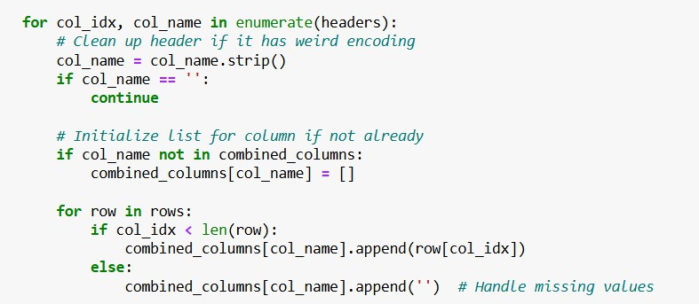
    - ​

- Loop through each column in the header row.

Clean column name
  - Removes extra whitespace or weird formatting.
  - Skips empty or unnamed columns.

Initialize storage
  - Creates a new list for the column in the combined_columns dictionary
  - If it already exists (from earlier files), skips initialization
- Append values to the correct column For each row:
  - If value exists at col_idx, add it to the column list
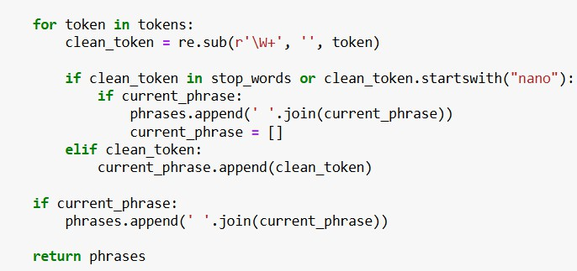
  - If value is missing, append an empty string ' ' to
maintain alignment
- Loop through each word (token) in the title
- Clean the token using re (removes punctuation)
- If token is a stopword or starts with "nano": End current phrase (if any) and store it
- Else:
Add the clean token to the current phrase
  - After the loop:
Add any remaining phrase to the final list
  - Return all extracted phrases

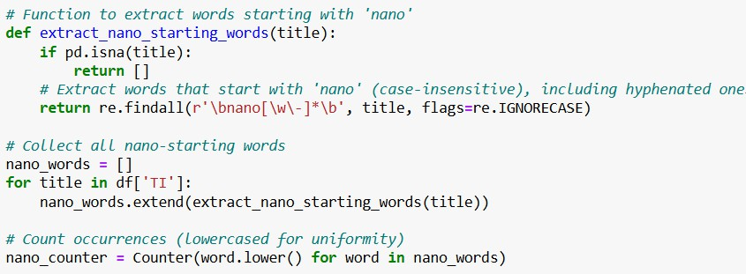
  - Extracts words starting with "nano" (e.g., nanotube, nano-particle)
  - \bnano[\w\-]*\b matches hyphenated and alphanumeric nano-words
  - A list of all nano-words + their frequency counts

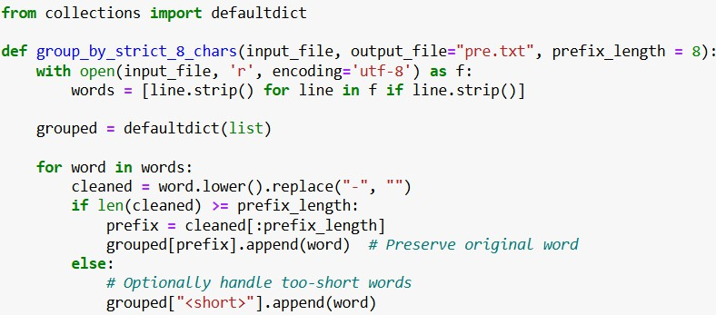

  - reads words from an input file, normalizes them
(lowercasing and removing hyphens), and groups them based on their first 8 characters.

  - The code utilizes Python's defaultdict(list) to simplify appending words to groups. This ensures efficient collection of grouped words without needing manual initialization for each key.

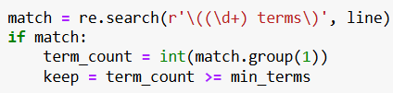

  - Used Regular Expression to identify group sizes and filter based on the min_terms threshold.
  - Keeping only those groups with ≥ 6 terms.

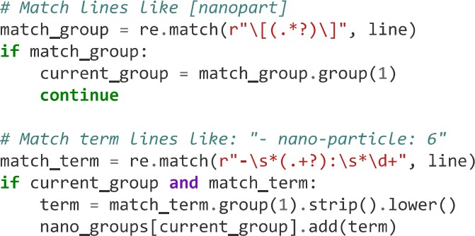
  - Uses regular expressions to distinguish between group headers (e.g., [nanopart]) and grouped terms (e.g., - nano- particle: 6).
  - Ensures that every extracted nano-term is only assigned to an already detected group.

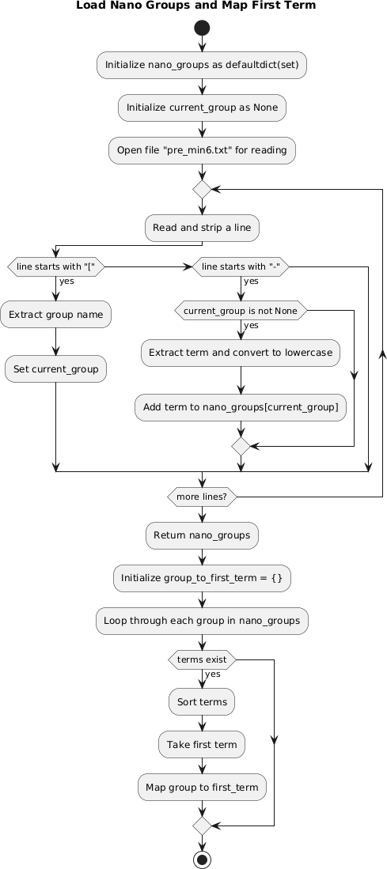
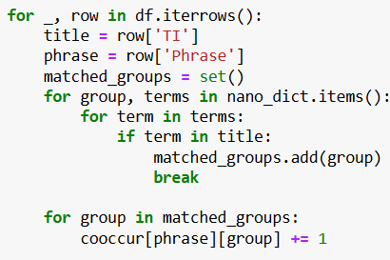
    - Extracts title and phrase
    - Matches title with terms from nano groups
    - Counts co-occurrence for each phrase-group pair

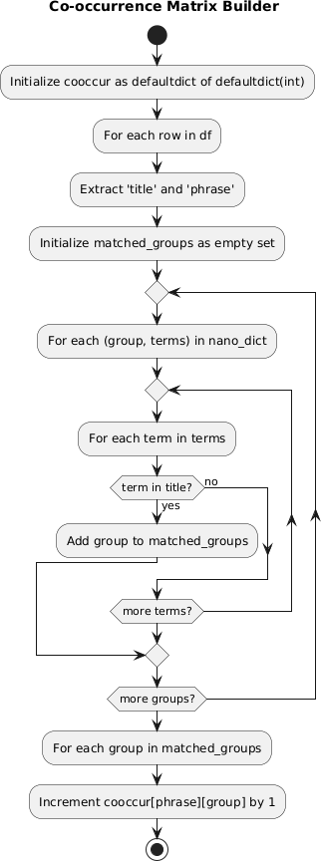

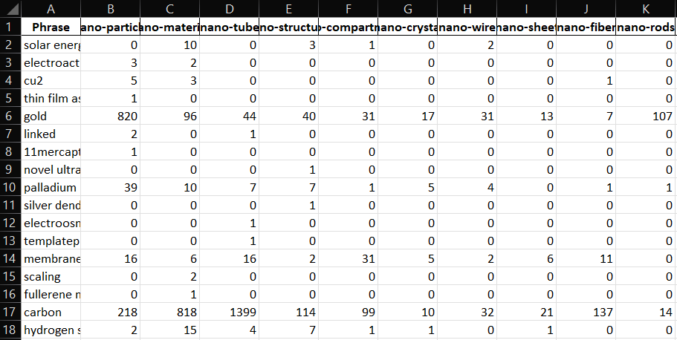
  - ROWS : 97351
  - COLUMNS : 84

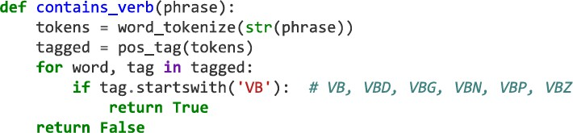
Removing Verb-Containing Phrases

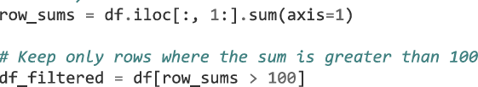

Row-Wise Filtering (Phrases):
    - Removed rows where the sum of co-occurrences = 1 very narrow context
    - Continued filtering with thresholds: sum ≤ 5, 10, ..., up to 100

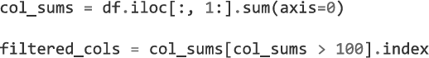

Column-Wise Filtering (Nano-Term Groups):
    - Dropped columns (nano groups) having very low frequency Or insignificant linkage to phrases

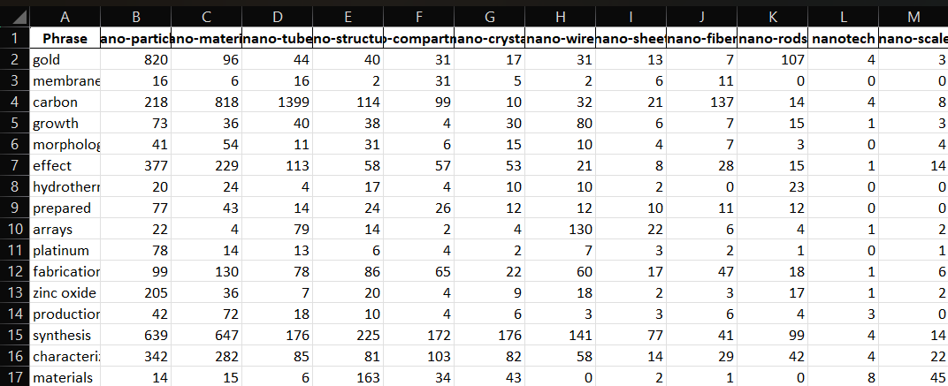
FINAL MATRIX

    - ROWS : 130
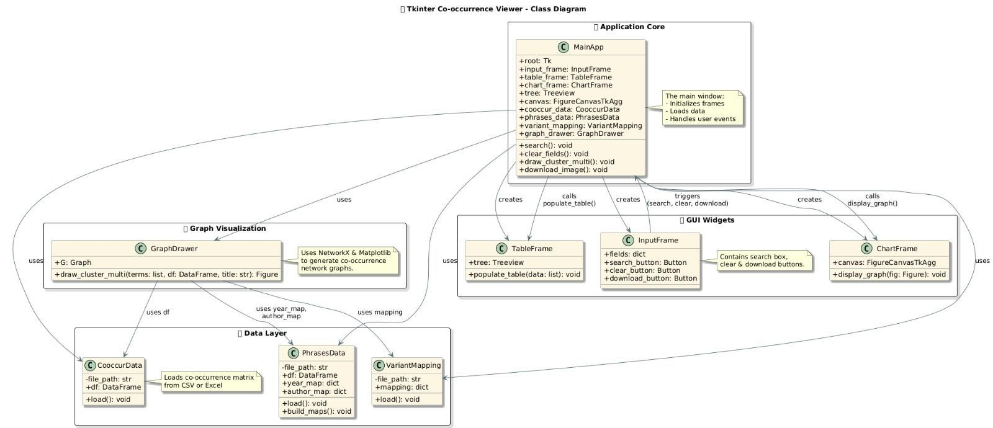
    - COLUMNS : 25
Interactive Visualization Graphical Interface

Results and Discussions
  - Data Statistics and Observations
The project processed an extensive dataset sourced from 155 nanoscience research text files, which after aggregation resulted in 72,950 unique records and 67 distinct attributes. These records represented a broad spectrum of publications spanning various journals, conferences, and research reports. The diversity and volume of data provided a robust foundation for meaningful co- occurrence analysis.
Key observations from the data:
    - The ‘TI’ (Title) field contained a high density of domain- specific phrases, affirming its suitability for phrase extraction.
    - Nano-related terms appeared with significant frequency, validating the assumption that nanoscience literature is heavily populated with "nano" prefixed terminologies.
    - Initial extraction yielded 885 nano-term groups, which after applying a threshold (groups with ≥6 terms) were refined to 84 significant nano groups.
    - Phrase extraction resulted in thousands of distinct scientific phrases, which after filtering for frequency and verb content, were reduced to 130 high-relevance phrases used for analysis.
These statistics underline the success of the preprocessing pipeline in distilling meaningful and manageable datasets from a massive corpus of unstructured text.

Sample Outputs of the Matrix
The co-occurrence matrix is the centerpiece of this analysis, representing the relationship between extracted phrases and grouped nano-terms.

Phrase | Nanoparticle | Nanocomposite | Nanotube | Nanostructure
Carbon-based materials | 12 | 8 | 14 | 7
Polymer composites | 5 | 17 | 0 | 3
TiO2 particles | 21 | 4 | 0 | 2
Graphene oxide composites | 2 | 9 | 5 | 1
Magnetic materials | 11 | 0 | 0 | 8

Key insights from the matrix:
    - High co-occurrence counts were observed for terms like "TiO2 particles" with "Nanoparticle" groups.
    - Certain phrases like "Polymer composites" strongly linked with "Nanocomposite" groups, validating known research trends.
    - Sparse connections for some phrases indicated niche research areas or emerging fields.
This matrix serves as both an analytical and visual input for network generation.

Visual Outputs with Screenshots
The interactive network graphs generated through the visualization tool provided clear and insightful representations of the co-occurrence data.
Example Visualizations:
    - Cluster Graphs: Displayed clusters of related phrases connected to common nano-groups. Node sizes reflected global relevance, while edge thickness denoted co- occurrence strength.
    - Network Diagrams: Enabled visual tracking of how phrases like "Carbon nanotube composites" linked to multiple nano groups simultaneously.

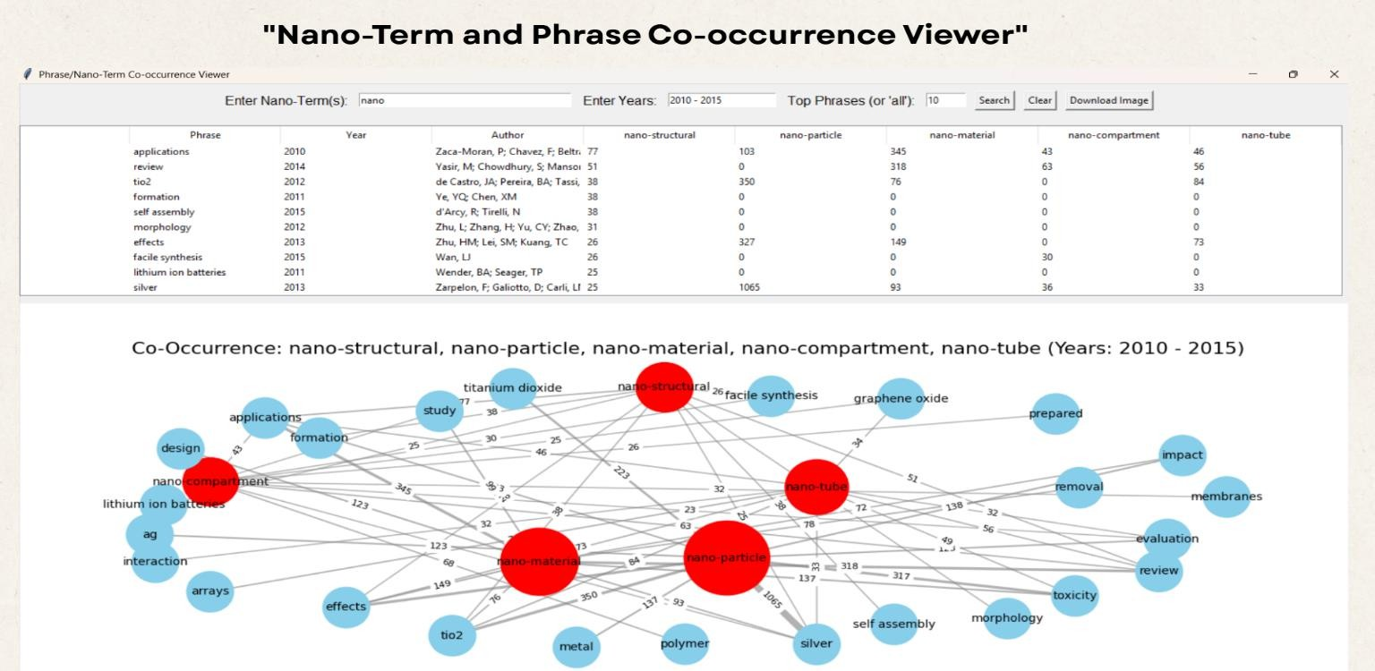
Observations:
    - Clusters were denser around frequently occurring nano- terms like nanoparticles and nanotubes.
    - Peripheral nodes represented emerging or niche research phrases.
    - The visualization enabled easy identification of research hotspots and underexplored areas.

User Interaction with GUI
The Tkinter-based GUI played a pivotal role in enhancing user experience by allowing seamless interaction with the data.
Key user interface features:
    - Nano-Term Input Field: Allowed users to enter any nano- prefix or term of interest for focused analysis.
    - Year Range Selector: Enabled time-bound filtering to observe research trends across specific periods.
    - Phrase Limit Setting: Gave users control over the volume of data visualized, from top N phrases to complete datasets.
    - Interactive Table View: Presented results in a sortable, filterable format directly within the application window.
    - Visualization Canvas: Embedded Matplotlib-generated graphs directly in the interface for immediate analysis.
    - Export Options: Allowed users to download both the data and the visual outputs for offline reporting or further study.

Overall, the GUI offered a balance between simplicity for novice users and powerful options for advanced exploration.

Performance Analysis
The system was evaluated on parameters including data handling capacity, processing speed, and visualization responsiveness.
    - Data Handling: Successfully processed datasets with over 70,000 records without significant slowdowns, showcasing efficient use of Pandas and optimized looping structures.
    - Phrase Extraction and Filtering: Executed within seconds on standard desktop hardware, proving the scalability of the implemented algorithms.
    - Co-occurrence Matrix Generation: Completed within acceptable timeframes even with large matrix dimensions, thanks to pre-filtering strategies.
    - Visualization Rendering: Network graphs with up to 150 nodes and 500 edges displayed smoothly, with interactivity supported through Tkinter integration.
    - System Resource Usage: The application maintained a low memory footprint during typical operations, making it suitable for mid-range systems.
Challenges noted:
    - Visualization performance degraded slightly with very large graphs (>500 nodes), indicating scope for future optimization using advanced visualization libraries.
    - GUI responsiveness depended on system specifications when handling maximum threshold settings.

Challenges

Data Cleaning Complexity Challenge:
The nanoscience literature contained highly inconsistent data, with variations in capitalization, punctuation, special characters, abbreviations, and linguistic patterns. Direct extraction often captured noisy, irrelevant, or fragmented phrases, making automated analysis unreliable.

Solution Implemented:
    - Multi-Stage Cleaning Pipeline: Applied stopword removal, regular expression filtering, and punctuation cleaning in sequence.
    - Custom Regex Patterns: Tailored expressions to capture domain-specific terms while avoiding over-cleaning that might remove meaningful data.
    - Manual Validation: After automated cleaning, manual checks ensured that critical scientific terms were retained.

Handling Sparse Data in Co-occurrence Matrices Challenge:
The initial co-occurrence matrix was extremely sparse, with many phrases appearing only once or linked weakly to nano groups.
This sparsity diluted meaningful insights and complicated visualization efforts.

Solution Implemented:
    - Frequency Thresholding: Applied multiple filters based on the sum of co-occurrence counts to retain only significant phrase–nano group pairs.
    - Verb Phrase Filtering: Removed phrases containing verbs to narrow focus on key noun-based scientific expressions.
    - Progressive Refinement: Iteratively tested different
thresholds (e.g., ≥5, ≥10 occurrences) to balance matrix density and analytical depth.

Visualization Scaling Challenge:
Visualizing large networks with hundreds of nodes and edges led to cluttered, unreadable graphs. Performance also degraded when rendering large graphs, affecting user experience.

Solution Implemented:
    - Node and Edge Filtering: Allowed users to limit the number of nodes (phrases/nano terms) displayed through the GUI settings.
    - Edge Weight Thresholding: Displayed only those connections exceeding a certain co-occurrence value, reducing visual noise.

Conclusion and Future Scope
This project successfully addressed the challenge of analyzing co- occurrence relationships between scientific phrases and nano- related terms in nanoscience literature. By implementing a systematic pipeline involving data aggregation, phrase extraction, nano-term grouping, co-occurrence matrix construction, and interactive visualization, the project provided a comprehensive solution for literature-based trend analysis.
The Tkinter-based desktop application empowered users to explore relationships dynamically, filter data based on nano- terms, years, and phrase limits, and visualize results in an intuitive network format. The system performed efficiently even with large datasets, confirming its practical applicability for researchers, analysts, and academicians in the field of nanoscience.
Beyond achieving its immediate objectives, the project demonstrated the potential of combining natural language processing, data mining, and network visualization within a single platform. The insights derived from this tool can aid in research planning, academic analytics, and the identification of emerging scientific trends.
Future enhancements may include incorporating machine learning for automatic trend detection, supporting full-text analysis, adopting advanced visualization libraries for richer interactivity, and extending the tool to other scientific domains. With continued development, this project has the potential to evolve into a robust research support system for bibliometric and scientific literature analysis.

References

- Pandas Documentation – Data manipulation and Excel file handling https://pandas.pydata.org/docs

- Python re Module – Regular expression operations for text processing https://docs.python.org/3/library/re.html

- Python collections Module – Specialized data structures like Counter https://docs.python.org/3/library/collections.html

- Python OS Module – File system and path operations https://docs.python.org/3/library/os.html

- NumPy Documentation – Numerical computing and array handling in Python https://numpy.org/doc/

- NetworkX – Network Analysis in Python
https://networkx.org/

- Tkinter – Python Interface to Tcl/Tk for GUI Development https://docs.python.org/3/library/tkinter.html

- VOSviewer – Visualizing Scientific Landscape and Bibliometric Networks
https://www.vosviewer.com/

- NLTK – Natural Language Toolkit for Text Processing
https://www.nltk.org/

