React.js Component Creation

Name: Priyanka Bellamkonda

Email: priyankabellamkonda222@gmail.com

Roll No: 20NN1A0505.

College Name: Vignan’s Nirula Institute of Technology and Science For women

University: JNTUK

Source Code:

CARD COMPONENT:

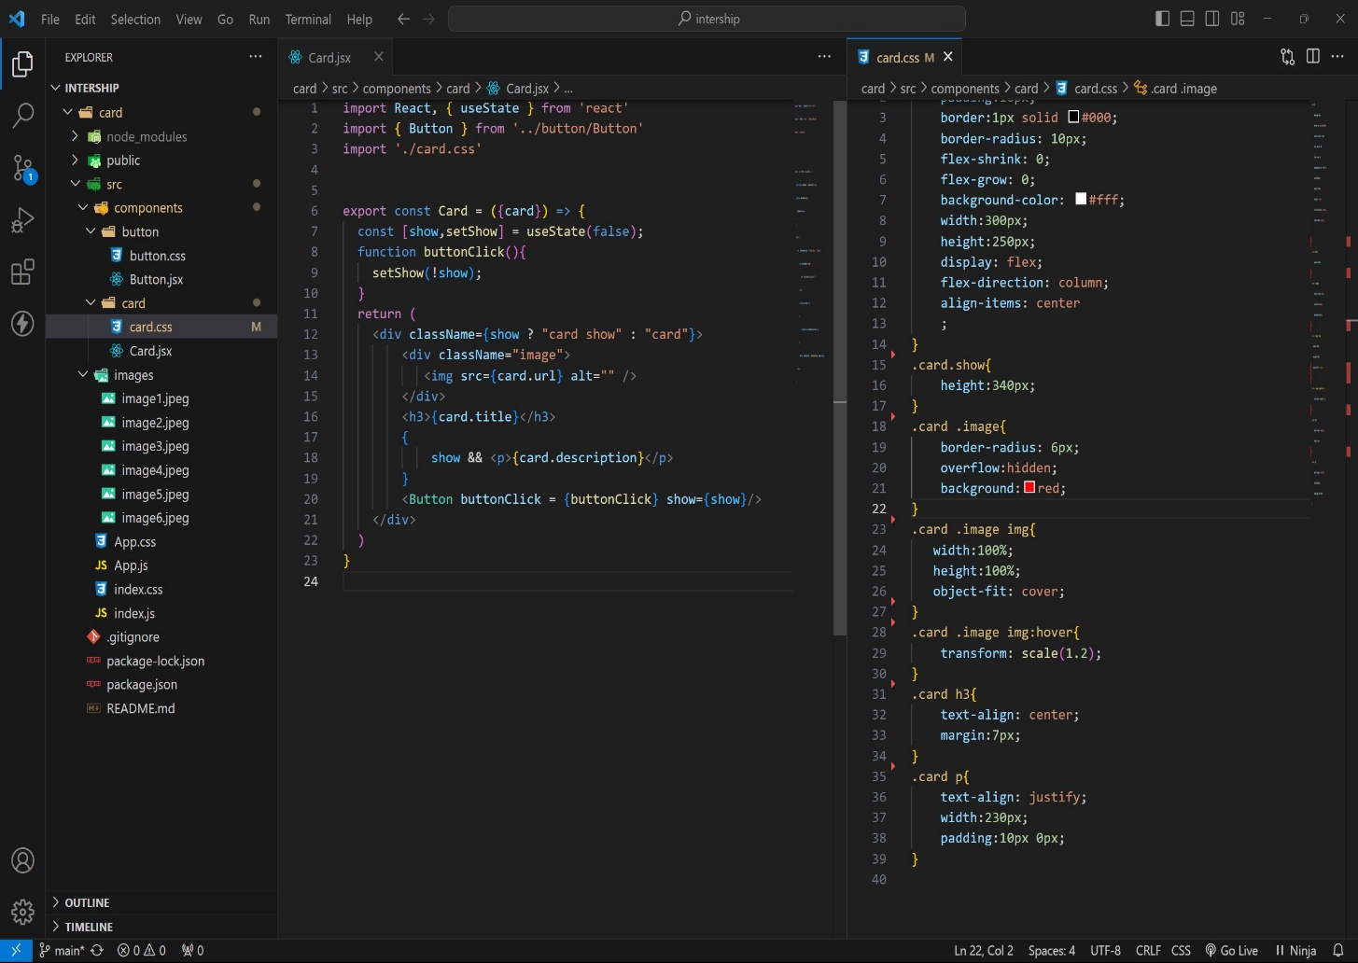

BUTTON COMPONENT:

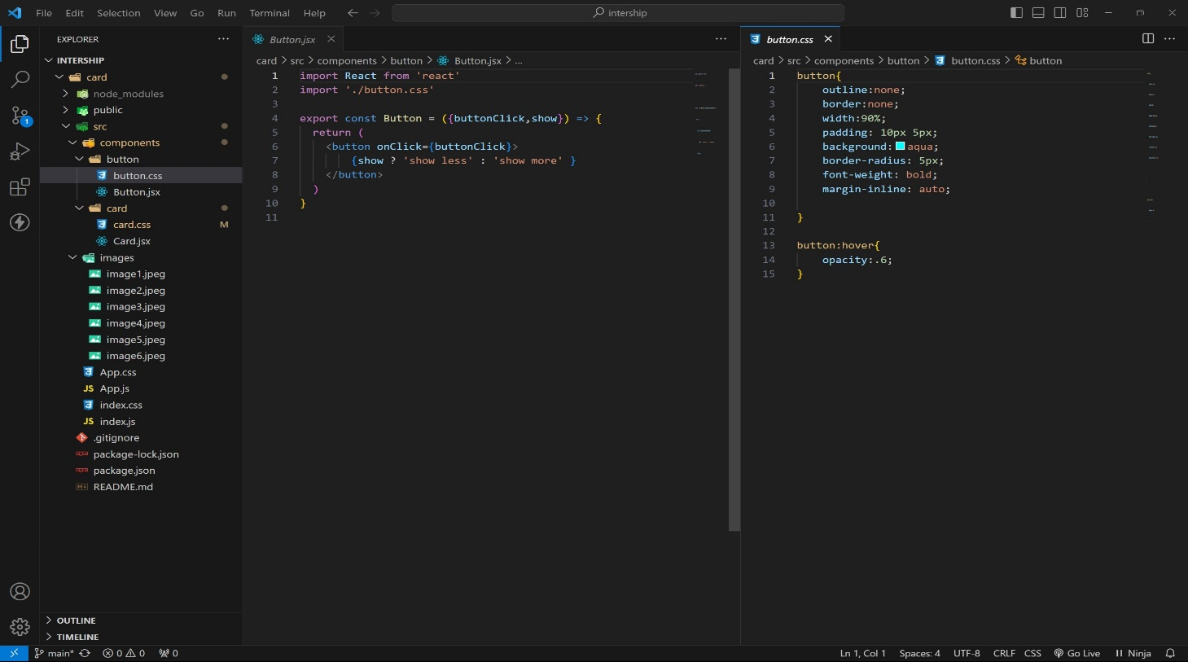

APP COMPONENT:

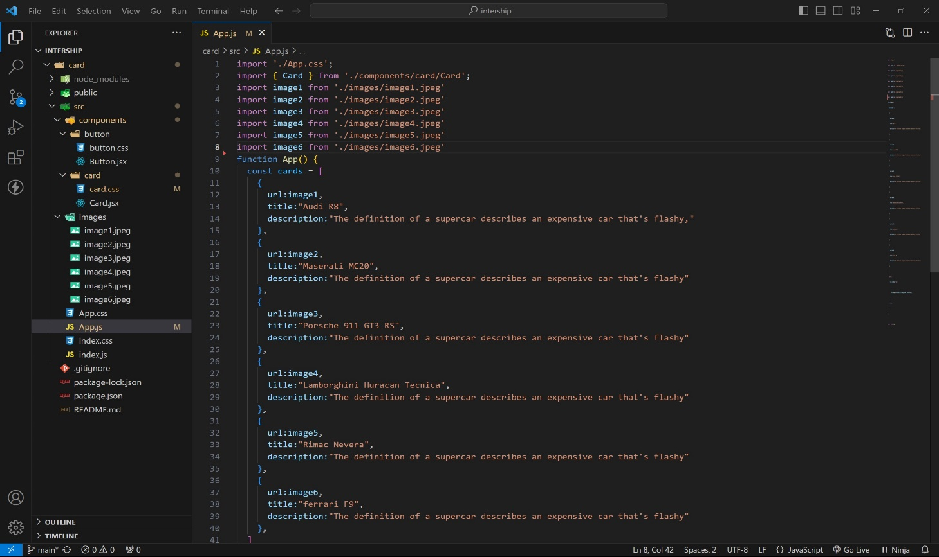

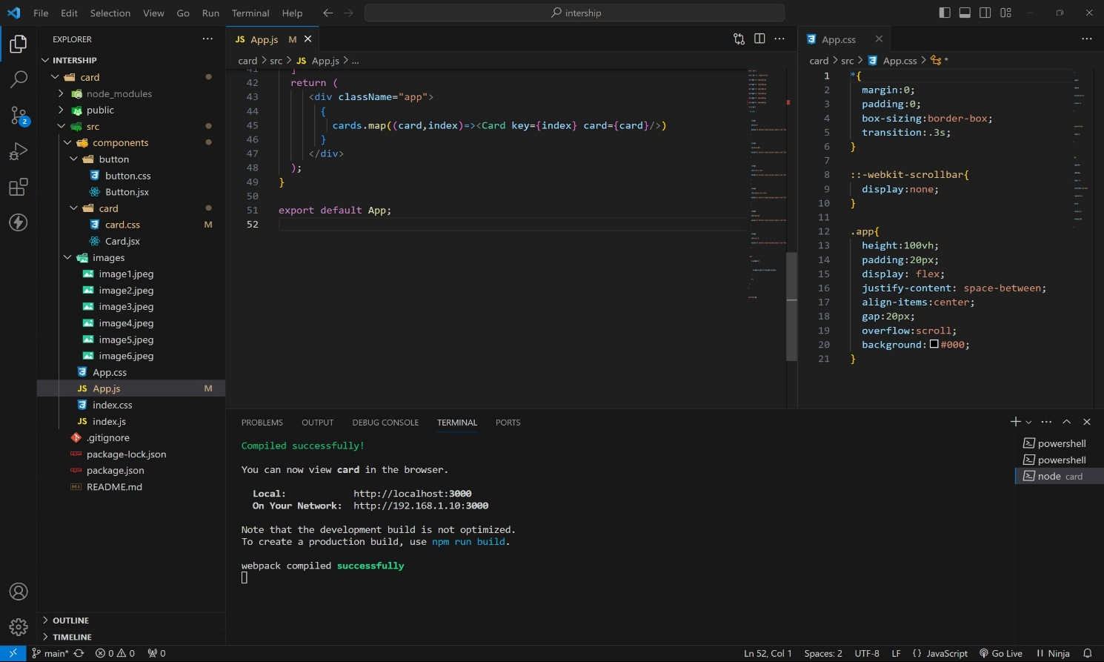

Approach:

1. initially taking an array of objects like below

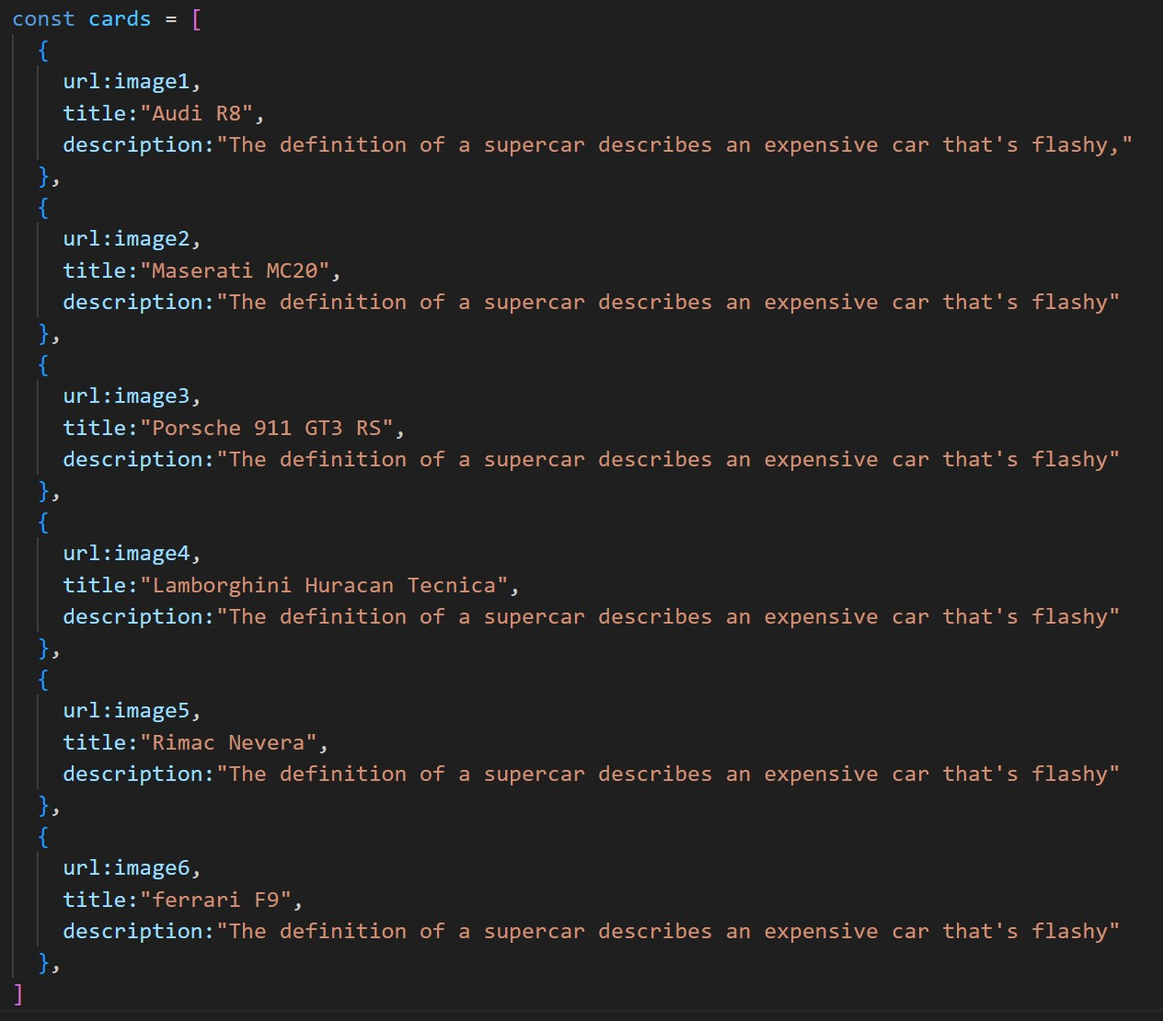

1. . Passing this card array to child (card component) of App component by using props.
2. . Getting data as argument like {card} in card component.
3. . In card component i use one state [show, set Show] to get extra info as

description.

1. .When we click the button then show becomes true by assigning set Show (!show).

OUTPUT:

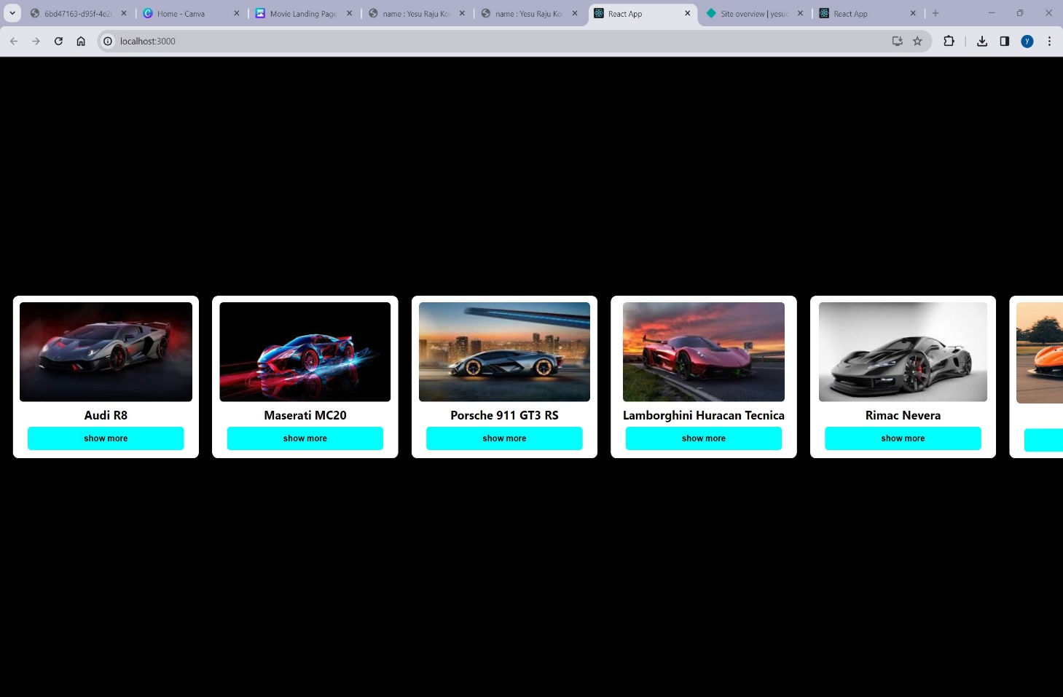

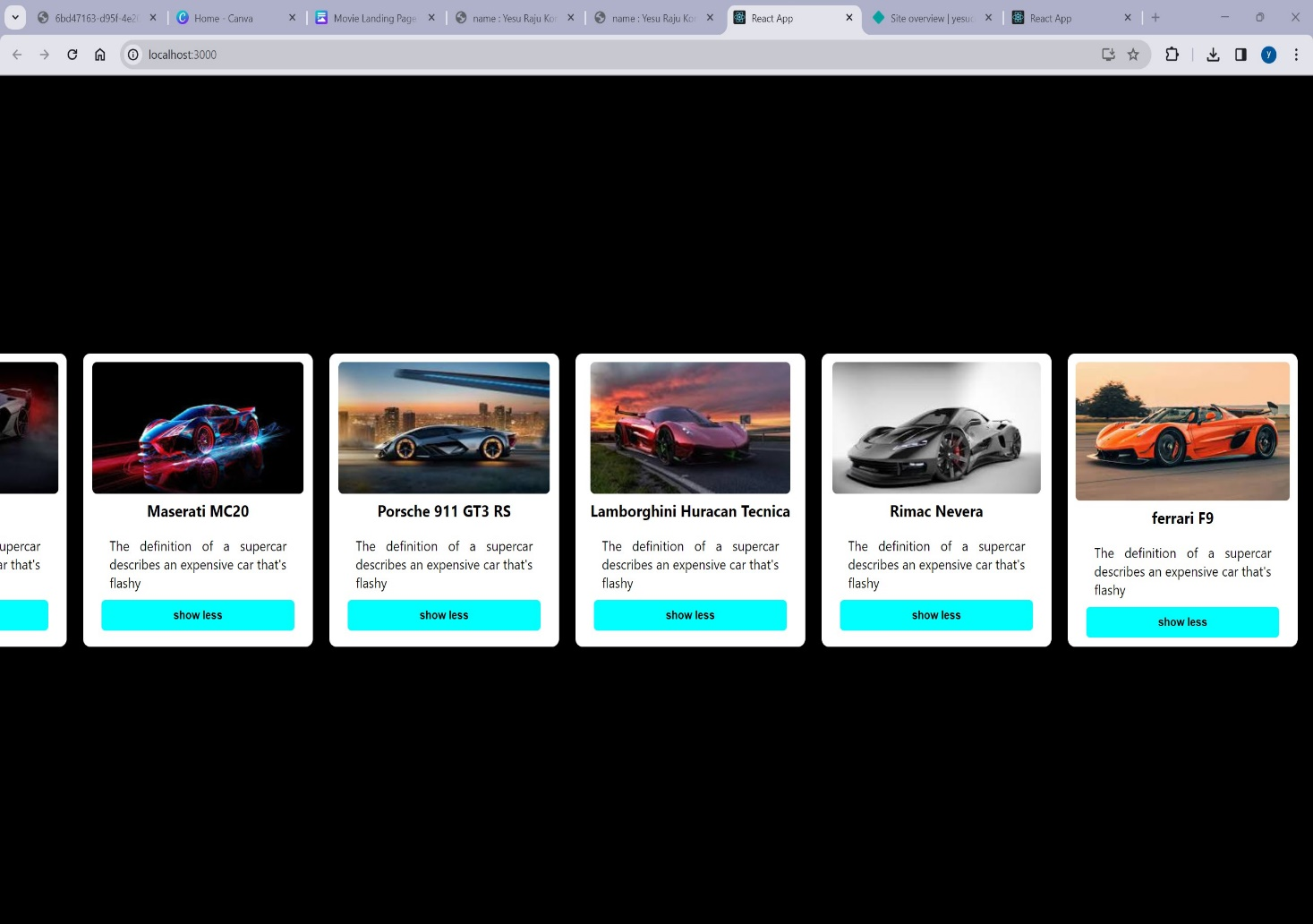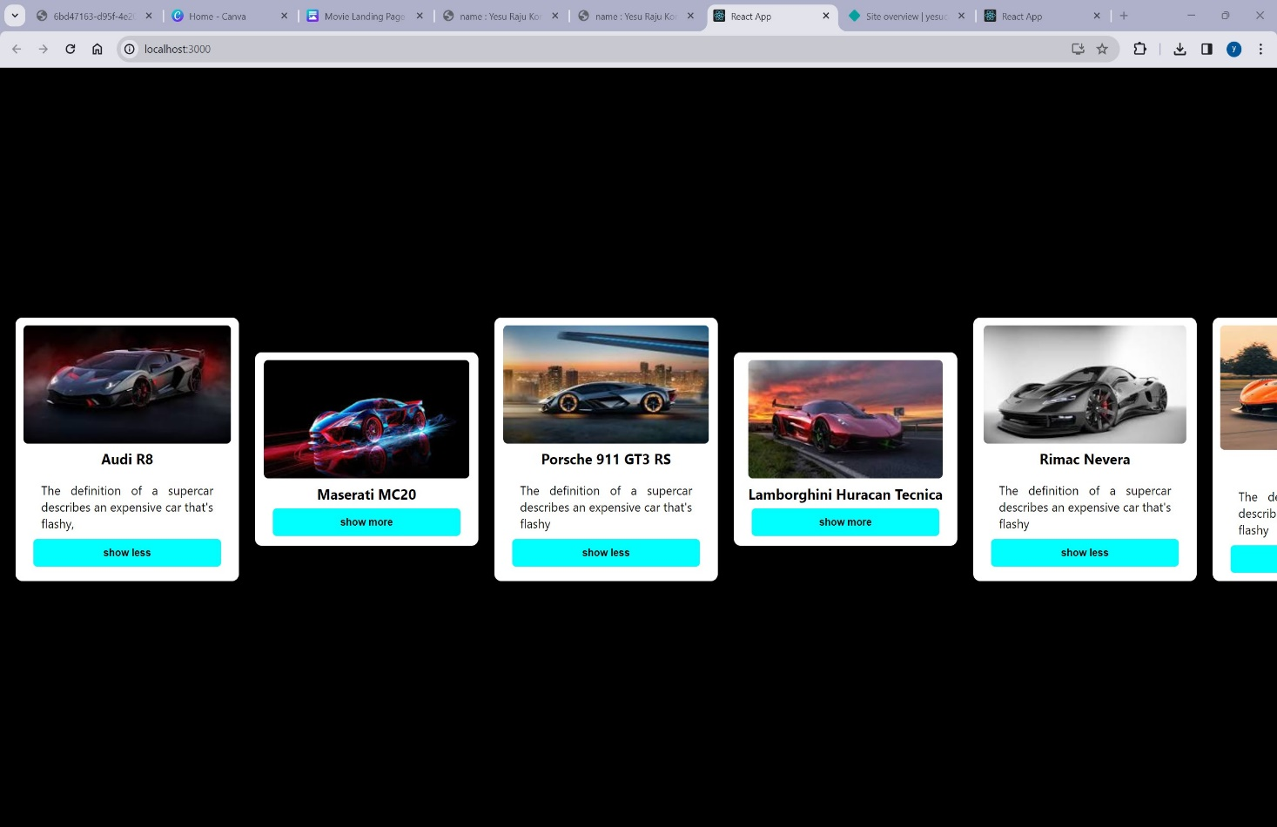

AFTER BUTTON CLICKS :