**DAY-10&11&12**

1. **Go through the concept on Group by, Having clause, Union, group by v/s distinct**

ANS:

* GROUP CLAUSE: It is used to group rows that have same values in result set.

Syntax:

SELECT column_name(s)

FROM table_name

WHERE condition

GROUP BY column_name(s)

ORDER BY column_name(s);

* HAVING CLAUSE: The HAVING clause was added to SQL because the WHERE keyword cannot be used with aggregate functions.

Syntax:

SELECT column_name(s)

FROM table_name

WHERE condition

GROUP BY column_name(s)

HAVING condition

ORDER BY column_name(s);

* UNION: The UNION operator is used to combine the result-set of two or more SELECT statements.

Every SELECT statement within UNION must have the same number of columns

The columns must also have similar data types

The columns in every SELECT statement must also be in the same order

Syntax:

SELECT column_name(s) FROM table1

UNION

SELECT column_name(s) FROM table2;

* GROUP BY V/S DISTINCT:

The SELECT DISTINCT statement is used to return only distinct (different) values.Inside a table, a column often contains many duplicate values; and sometimes you only want to list the different (distinct) values.

Syntax

SELECT DISTINCT column1, column2, ...

FROM table_name;

If one of them is faster, it's going to be DISTINCT. This is because, although the two are the same, a query optimizer would have to catch the fact that your GROUP BY is not taking advantage of any group members, just their keys.

DISTINCT makes this explicit, so you can get away with a slightly dumber optimizer.

1. **Write a query to demonstrate the use of group by**

**ANS:**

SELECT r.mentor,r.s_id,s.name,s.SUB_1

FROM priyanka.stu_sheet s

inner join priyanka.stu_records r

on r.s_id=s.Id

GROUP BY (r.Id);

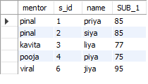

1. **Find the second highest marks scored by each student along with the student and subject name [Tables: student,subject,marks]**

**ANS: Table1(student)**

CREATE TABLE `priyanka`.`student` (

`id` INT NOT NULL,

`name` VARCHAR(45) NULL,

PRIMARY KEY (`id`));

insert into priyanka.student(id,name) values (11,' harshit');

insert into priyanka.student(id,name) values (12,' nisha');

insert into priyanka.student(id,name) values (13,'reshma');

SELECT * FROM priyanka.student;

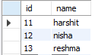

**Table2. subject**

CREATE TABLE `priyanka`.`subject` (

`id` INT NOT NULL,

`subjects` VARCHAR(45) NULL,

`stu_id` INT NULL,

PRIMARY KEY (`id`));

insert into priyanka.subject(id,sub1,sub2) values (10,'maths',11);

insert into priyanka.subject(id,sub1,sub2) values (20,'sci', 11);

insert into priyanka.subject(id,sub1,sub2) values (30, 'eng', 12);

insert into priyanka.subject(id,sub1,sub2) values (40,'hindi', 13);

insert into priyanka.subject(id,sub1,sub2) values (50, 'social', 12);

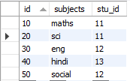

**TABLE3. marks**

CREATE TABLE `marks` (

`id` int NOT NULL,

`sid` int DEFAULT NULL,

`marks` int DEFAULT NULL,

PRIMARY KEY (`id`)

);

INSERT INTO marks (`id`, `sid `, `marks `) VALUES ('21',10,85);

INSERT INTO marks (`id`, `sid `, `marks `) VALUES ('22',20,69);

INSERT INTO marks (`id`, `sid `, `marks `) VALUES ('23',30,75);

INSERT INTO marks (`id`, `sid `, `marks `) VALUES ('24',40,84);

INSERT INTO marks (`id`, `sid `, `marks `) VALUES ('25',50,92);

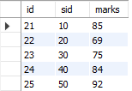

SELECT max(marks),stu_id

FROM marks

WHERE marks NOT IN (SELECT max(marks)

FROM marks GROUP BY stu_id)

GROUP BY stu_id ;

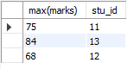

1. **Write a query to demonstrate the use of having clause along with aggregate functions.**

**ANS**: SELECT stu_id,COUNT(*) AS "Number of subjects"

FROM priyanka.subject

GROUP BY (stu_id)

HAVING COUNT(*)<11;

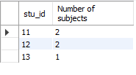

1. **Write two queries which help us to compare and understand the concept of distinct and group by**

**ANS: GROUP BY:**

SELECT s.id,s.name,t.subjects

FROM priyanka.student s

inner join priyanka.subject t

on s.id=t.stu_id

GROUP BY (s.id);

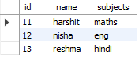

**DISTINCT:**

SELECT distinct (s.id),s.name,t.subjects

FROM priyanka.student s

inner join priyanka.subject t

on s.id=t.stu_id;

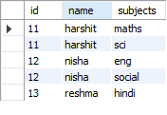

1. **Write Query which includes union keyword**

**ANS:** select student.id from priyanka.student

union

select subject.stu_id from priyanka.subject

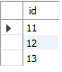

1. **Write a single query which includes group by, having,where ,from ,select,union and order by.**

**ANS:** SELECT id,guide

FROM priyanka.subject

where id>10

GROUP BY (id)

union

SELECT sid,s_guide

FROM priyanka.marks

where sid>10

GROUP BY (id)

having id<=50

order by (id) DESC;

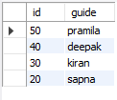

1. **Write a query which captures duplicate records by the of union**

ANS: select s.id from priyanka.student s

union all

select t.stu_id from priyanka.subject t;

