**DAY-13 & 14**

1. **ODD EVEN NUMBERS (switch case)**

import java.util.Scanner;

class OddEven{

public static void main(String args[]){

Scanner scan=new Scanner(System.in);

System.out.print("Enter the number: ");

int num=scan.nextInt();

switch(num%2){

case 0:

System.out.println(num+" is a Even number");

break;

case 1:

System.out.println(num+" is a Odd number");

}

}

}

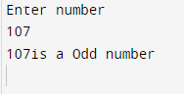

1. **STRING LENGTH**

import java.util.Scanner;

public class StringLength {

public static void main(String[] args) {

Scanner scan = new Scanner(System.in);

System.out.println("Enter any string: ");

String ab=scan.nextLine();

System.out.println("Enter 1 for finding string length and enter 2 for finding data type: ");

int str=scan.nextInt();

switch (str){

case 1:

int len = ab.toCharArray().length;

System.out.println(len);

break;

case 2:

System.out.println("type :"+((Object)str).getClass().getSimpleName());

break;

default:

System.out.println("invalid string");

}

}

}

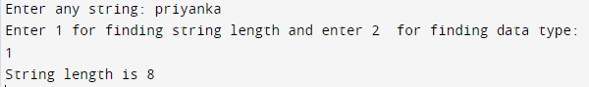

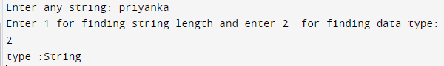

1. PALINDROME

import java.util.*;

import java.util.Scanner;

public class Main

{

public static void main(String[] args)

{

Scanner sc = new Scanner(System.in);

System.out.println("Enter the number: ");

int num=sc.nextInt();

int r,sum=0;

int temp=num;

while(num>0)

{

r=num%10;

sum=(sum*10)+r;

num=num/10;

}

if(temp==sum)

System.out.println("The entered number "+temp+" is a palindrome number ");

else

System.out.println("The entered number "+temp+" is not a palindrome");

}

}

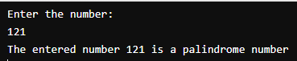

1. **PRIME NUMBER (1 to N prime number by user)**

import java.util.Scanner;

public class PrimeNumber

{

public static void main(String [] args) {

Scanner scan=new Scanner(System.in);

int i =0;

int j =0;

String primeNumbers = "";

System.out.println("Enter the value of n:");

int x = scan.nextInt();

for (i = 1; i <= x; i++) {

int counter=0;

for(j=i; j>=1; j--) {

if(i%j==0) {

counter = counter + 1;

}

}

if (counter ==2) {

primeNumbers = primeNumbers + i + " ";

}

}

System.out.println("Prime numbers from 1 to n are :");

System.out.println(primeNumbers);

}

}

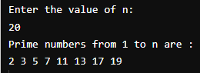

1. **Fibonacci**

import java.util.Scanner;

public class FibonacciSeries{

public static void main(String[] args) {

Scanner scan = new Scanner( System.in );

System.out.println("Enter number: ");

int num = scan.nextInt();

System.out.println("List of fibonacci number:");

int n1=0,n2=0,sum=1,i;

for (i=1;i<=num;i++)

{

n1=n2;

n2=n3;

sum=n1+n2;

if(n1<num)

{

System.out.println (n1+" ");

}

}

}

}

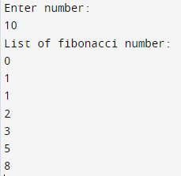

**5 PROGRAMS IN ONE(through switch case):**

import java.util.Scanner;

import static java.lang.Math.abs;

public class Test {

public static void main(String[] args) {

Scanner scan = new Scanner(System.in);

int num=0;

do {

System.out.println("Enter 1 for finding oddeven \n enter 2 for finding string length \n enter 3 for palindrome \n enter 4 for prime number \n enter 5 for fibonacci series :\n");

num=scan.nextInt();

switch(num) {

case 1:

System.out.println("Enter the number: ");

int n=scan.nextInt();

if(n%2==0) {

System.out.println("Even number");

} else {

System.out.println("Odd number");

}

break;

case 2:

System.out.println("Enter any string: ");

String ab=scan.next();

System.out.println("string length is: "+ab.length());

break;

case 3:

System.out.println("Enter the number: ");

int no=scan.nextInt();

if(no<0){

no=no*(-1);

}

int r,sum=0;

int temp=no;

while(no>0) {

r=no%10;

sum=(sum*10)+r;

no=no/10;

}

if(temp==sum)

System.out.println("The entered number "+temp+" is a palindrome number \n");

else

System.out.println("The entered number "+temp+" is not a palindrome \n");

break;

case 4:

int i =0;

int j =0;

String primeNumbers = "";

System.out.println("Enter the value of n:");

int x = scan.nextInt();

for (i = 1; i <= x; i++) {

int counter=0;

for(j=i; j>=1; j--) {

if(i%j==0) {

counter = counter + 1;

}

}

if (counter ==2) {

primeNumbers = primeNumbers + i + " ";

}

}

System.out.println("Prime numbers from 1 to n are :");

System.out.println(primeNumbers);

break;

case 5:

System.out.println("Enter number: ");

int key = scan.nextInt();

System.out.println("List of fibonacci number:");

int n1=0,n2=0,n3=1,k;

for (k=1; k<=key; k++) {

n1=n2;

n2=n3;

n3=n1+n2;

if(n3<key) {

System.out.println (n1+" ");

}

}

break;

default:

System.out.println("Invalid numbers");

}

} while(num<6);

}

}

