**DAY 5**

1. **Address_type:**

CREATE TABLE `address_type` (

 `Id` int NOT NULL,

  `type` varchar(45) DEFAULT NULL,

PRIMARY KEY (`Id`) ) ;

Select * from adress_type;

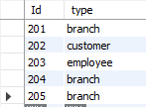

1. **Department:**

CREATE TABLE `department` ( `id` int NOT NULL, `department_name` varchar(45) DEFAULT NULL, `hod_id` int DEFAULT NULL, `status` varchar(45) DEFAULT NULL, `created_on` varchar(45) DEFAULT NULL, PRIMARY KEY (`id`) )

insert into department (id,department_name,hod_id,status,created_on) values (601,'CSE',666,'on','june')

insert into department (id,department_name,hod_id,status,created_on) values (602,'CSE',662,'on','jan');

insert into department (id,department_name,hod_id,status,created_on) values (603,'IT',663,'off','dec');

insert into department (id,department_name,hod_id,status,created_on) values (604,'IT',664,'on','sept');

insert into department (id,department_name,hod_id,status,created_on) values (605,'CSE',665,'off','feb');

select * from department;

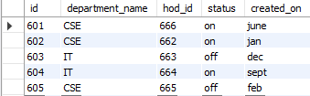

1. **Contact_details:**

CREATE TABLE `contact_details` ( `Id` int NOT NULL, `email_id` varchar(45) DEFAULT NULL, `contact_no` varchar(10) DEFAULT NULL, `contact_type_id` int DEFAULT NULL, `rep_id` int DEFAULT NULL, `status` varchar(45) DEFAULT NULL, `created_on` varchar(45) DEFAULT NULL, `updated_on` varchar(45) DEFAULT NULL, PRIMARY KEY (`Id`) )

insert into contact_details( Id,email_id,contact_no,contact_type_id,rep_id,status,created_on,updated_on) values (1,'abc@gmail.com','6578958477',701,333,'on','feb','mar');

insert into contact_details( Id,email_id,contact_no,contact_type_id,rep_id,status,created_on,updated_on) values (2,'rty@gmail.com','6395664485',702,334,'off','june','jul');

insert into contact_details( Id,email_id,contact_no,contact_type_id,rep_id,status,created_on,updated_on) values (3,'zxc@gmail.com','9685746352',703,335,'on','nov','dec');

insert into contact_details( Id,email_id,contact_no,contact_type_id,rep_id,status,created_on,updated_on) values (4,'asd@gmail.com','7485965274',704,336,'on','feb','apr');

insert into contact_details( Id,email_id,contact_no,contact_type_id,rep_id,status,created_on,updated_on) values (5,'qwe@gmail.com','9452637485',705,337,'off','dec','jan');

select * from contact_details;

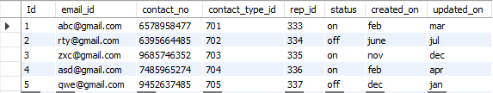

1. **Contact_type:**

CREATE TABLE `contact_type` ( `Id` int NOT NULL, `type` varchar(45) DEFAULT NULL, PRIMARY KEY (`Id`) )

insert into contact_type(Id,type) values(1,'branch');

insert into contact_type(Id,type) values(2,'customer');

insert into contact_type(Id,type) values(3,'branch');

insert into contact_type(Id,type) values(4,'customer');

insert into contact_type(Id,type) values(5,'employee');

select * from contact_type;

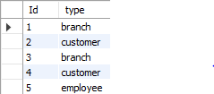

1. **branch_department_mapping :**

CREATE TABLE `branch_department_mapping` ( `Id` int NOT NULL, `branch_id` int DEFAULT NULL, `department_id` int DEFAULT NULL, `status` varchar(45) DEFAULT NULL, `created_on` varchar(45) DEFAULT NULL, `updated_on` varchar(45) DEFAULT NULL, PRIMARY KEY (`Id`) )

insert into branch_department_mapping(Id,branch_id,department_id,status,created_on,updated_on) values (1,901,601,'on','june','july');

insert into branch_department_mapping(Id,branch_id,department_id,status,created_on,updated_on) values (2,902,602,'off','jan','mar');

insert into branch_department_mapping(Id,branch_id,department_id,status,created_on,updated_on) values (3,903,603,'off','mar','apr');

insert into branch_department_mapping(Id,branch_id,department_id,status,created_on,updated_on) values (4,904,604,'on','dec','dec');

insert into branch_department_mapping(Id,branch_id,department_id,status,created_on,updated_on) values (5,905,605,'off','nov','dec');

select * from branch_department_mapping;

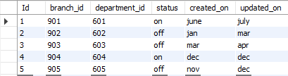

1. **branch_product_type_mapping:**

CREATE TABLE `branch_product_type_mapping` ( `Id` int NOT NULL, `branch_id` int DEFAULT NULL, `product_type_code` varchar(45) DEFAULT NULL, `status` varchar(45) DEFAULT NULL, `created_on` varchar(45) DEFAULT NULL, `updated_on` varchar(45) DEFAULT NULL, PRIMARY KEY (`Id`) )

insert into branch_product_type_mapping(Id,branch_id,product_type_code,status,created_on,updated_on) values(1,901,21,'on','jan','feb');

insert into branch_product_type_mapping(Id,branch_id,product_type_code,status,created_on,updated_on) values(2,902,22,'on','feb','mar');

insert into branch_product_type_mapping(Id,branch_id,product_type_code,status,created_on,updated_on) values(3,903,23,'off','jan','feb');

insert into branch_product_type_mapping(Id,branch_id,product_type_code,status,created_on,updated_on) values(4,904,24,'off','nov','nov');

insert into branch_product_type_mapping(Id,branch_id,product_type_code,status,created_on,updated_on) values(5,905,25,'on','dec','jan');

select * from branch_product_type_mapping;

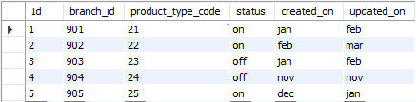

1. **organization:**

CREATE TABLE `organization` ( `Id` int NOT NULL, `organization_name` varchar(45) DEFAULT NULL, `status` varchar(45) DEFAULT NULL, `created_on` varchar(45) DEFAULT NULL, `updated_on` varchar(45) DEFAULT NULL, PRIMARY KEY (`Id`) )

insert into organization (Id,organization_name,status,created_on,updated_on) values (1,'ICMR','on','mar','apr');

insert into organization (Id,organization_name,status,created_on,updated_on) values (2,'IBM','off','dec','jan');

insert into organization (Id,organization_name,status,created_on,updated_on) values (3,'RBI','on','sept','oct');

insert into organization (Id,organization_name,status,created_on,updated_on) values (4,'IRDA','on','feb','mar');

insert into organization (Id,organization_name,status,created_on,updated_on) values (5,'ICAR','on','apr','may');

select * from organization;

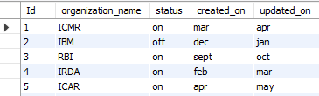

1. **product_type:**

CREATE TABLE `product_type` ( `product_type_code` int NOT NULL, `product_type` varchar(45) DEFAULT NULL, `description` varchar(45) DEFAULT NULL, `status` varchar(45) DEFAULT NULL, `created_on` varchar(45) DEFAULT NULL, `updated_on` varchar(45) DEFAULT NULL, PRIMARY KEY (`product_type_code`) )

insert into product_type(product_type_code,product_type,description,status,created_on,updated_on) values (21,'WOW',’ Products are safe, nature’ ,'on','25th june','2nd july’);

insert into product_type(product_type_code,product_type,description,status,created_on,updated_on) values (22,'Mamaearth','Only Toxin Free Madesafe','on','25th june','2nd july');

insert into product_type(product_type_code,product_type,description,status,created_on,updated_on) values (23,'Nykaa','Buy cosmetics & beauty products online','on','28th september','30th september');

insert into product_type(product_type_code,product_type,description,status,created_on,updated_on) values (24,'Patanjali','Natural ayurvedic products','on','4th october','7th october');

insert into product_type(product_type_code,product_type,description,status,created_on,updated_on) values (25,'Ponds','Nourishing Moisturizer','on','14th december','18th december');

select * from product_type;

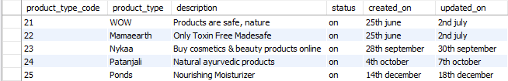

1. **inventory:**

CREATE TABLE `inventory` ( `Id` int NOT NULL, `product_id` int DEFAULT NULL, `branch_id` int DEFAULT NULL, `inventory_count` varchar(45) DEFAULT NULL, `status` varchar(45) DEFAULT NULL, `created_on` varchar(45) DEFAULT NULL, `updated_on` varchar(45) DEFAULT NULL, PRIMARY KEY (`Id`) )

insert into inventory(Id,product_id,branch_id,inventory_count,status,created_on,updated_on)values(1,300,901,'5','on','jan','feb');

insert into inventory(Id,product_id,branch_id,inventory_count,status,created_on,updated_on)values(2,301,902,'6','off','feb','mar');

insert into inventory(Id,product_id,branch_id,inventory_count,status,created_on,updated_on)values(3,302,903,'7','on','dec','jan');

insert into inventory(Id,product_id,branch_id,inventory_count,status,created_on,updated_on)values(4,303,904,'8','on','nov','dec');

insert into inventory(Id,product_id,branch_id,inventory_count,status,created_on,updated_on)values(5,304,905,'9','off','oct','nov');

select * from inventory;

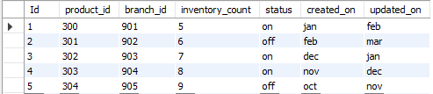

1. **location:**

CREATE TABLE `location` ( `Id` int NOT NULL, `pincode` varchar(6) DEFAULT NULL, `city` varchar(45) DEFAULT NULL, `state` varchar(15) DEFAULT NULL, `country` varchar(20) DEFAULT NULL, PRIMARY KEY (`Id`) )

insert into location (Id,pincode,city,state,country) values(1,'396198','VAPI','GUJARAT','INDIA');

insert into location (Id,pincode,city,state,country) values(2,'300195','VALSAD','GUJARAT','INDIA');

insert into location (Id,pincode,city,state,country) values(3,'256914','JAIPUR','RAJASTHAN','INDIA');

insert into location (Id,pincode,city,state,country) values(4,'612045','LUCKNOW','PRAYAGRAJ','INDIA');

insert into location (Id,pincode,city,state,country) values(5,'001542','PUNE','MAHARASHTRA','INDIA');

select * from location;

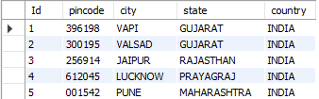

1. **customer:**

CREATE TABLE `customer` ( `Id` int NOT NULL, `customer_name` varchar(45) DEFAULT NULL, `address_id` int DEFAULT NULL, `contact_id` int DEFAULT NULL, `date_of_birth` date DEFAULT NULL, `status` varchar(45) DEFAULT NULL, `created_on` varchar(45) DEFAULT NULL, `updated_on` varchar(45) DEFAULT NULL, PRIMARY KEY (`Id`) )

insert into customer(Id,customer_name,address_id,contact_id,date_of_birth,status,created_on) values(1,"sonu",201,701,"1978-05-26",'on','jan','feb');

insert into customer(Id,customer_name,address_id,contact_id,date_of_birth,status,created_on) values(2,"monu",202,702,"1998-08-06",'on','sept','oct');

insert into customer(Id,customer_name,address_id,contact_id,date_of_birth,status,created_on) values(3,"sanu",203,703,"1999-10-09",'off','dec','dec');

insert into customer(Id,customer_name,address_id,contact_id,date_of_birth,status,created_on) values(4,"tony",204,704,"2016-10-29",'on','oct','nov');

insert into customer(Id,customer_name,address_id,contact_id,date_of_birth,status,created_on) values(5,"thor",205,705,"2005-12-08",'off','mar','apr');

select * from customer;

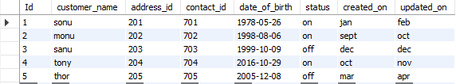

1. **orderr:**

CREATE TABLE `orderr` ( `Id` int NOT NULL, `product_id` int DEFAULT NULL, `customer_id` int DEFAULT NULL, `order_status_id` int DEFAULT NULL, `order_quantity` int DEFAULT NULL, `order_date` date DEFAULT NULL, `status` varchar(45) DEFAULT NULL, `created_on` varchar(45) DEFAULT NULL, `updated_on` varchar(45) DEFAULT NULL, PRIMARY KEY (`Id`) )

insert into orderr(Id,product_id,customer_id,order_status_id,order_quantity,order_date,status,created_on,updated_on) values(1,401,701,110,3,'2002-04-06','on','jan','feb');

insert into orderr(Id,product_id,customer_id,order_status_id,order_quantity,order_date,status,created_on,updated_on) values(2,402,702,111,30,'2016-06-10','off','sept','oct');

insert into orderr(Id,product_id,customer_id,order_status_id,order_quantity,order_date,status,created_on,updated_on) values(3,403,703,112,45,'2018-12-25','off','dec','jan');

insert into orderr(Id,product_id,customer_id,order_status_id,order_quantity,order_date,status,created_on,updated_on) values(4,404,704,113,6,'2001-01-27','on','jan','feb');

insert into orderr(Id,product_id,customer_id,order_status_id,order_quantity,order_date,status,created_on,updated_on) values(5,405,705,114,39,'2021-05-14','off','mar','apr');

select * from orderr;

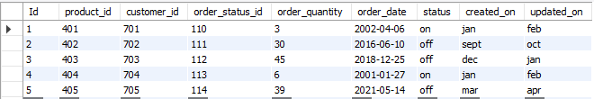

1. **order_status:**

insert into order_status(Id,order_status,status) values (1,'delivered','done');

insert into order_status(Id,order_status,status) values (2,'pending','on the way');

insert into order_status(Id,order_status,status) values (3,'active','completed');

insert into order_status(Id,order_status,status) values (4,'rejected','cancelled');

select * from order_status;

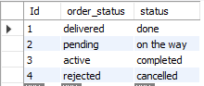

1. **employee_salary_details:**

CREATE TABLE `employee_salary_details` ( `Id` int NOT NULL, `employee_id` varchar(45) DEFAULT NULL, `month` varchar(45) DEFAULT NULL, `year` varchar(45) DEFAULT NULL, `salary_type` varchar(45) DEFAULT NULL, `salary_date` date DEFAULT NULL, `created_on` varchar(45) DEFAULT NULL, `updated_on` varchar(45) DEFAULT NULL, PRIMARY KEY (`Id`) )

Insert into employee_salary_details (Id,employee_id,month,year,salary_type,salary_date,created_on,updated_on) values (1,41,'JANUARY','2012','regular','2012-05-02','jan','feb');

insert into employee_salary_details(Id,employee_id,month,year,salary_type,salary_date,created_on,updated_on) values (2,42,'MAY','2019','bonus','2019-08-04','july','aug');

insert into employee_salary_details(Id,employee_id,month,year,salary_type,salary_date,created_on,updated_on) values (3,43,'NOV','2003','regular','2003-05-02','june','july');

insert into employee_salary_details(Id,employee_id,month,year,salary_type,salary_date,created_on,updated_on) values (4,44,'SEPT','2020','bonus','2020-08-06','sept','oct');

insert into employee_salary_details(Id,employee_id,month,year,salary_type,salary_date,created_on,updated_on) values (5,45,'DECEMBER','2000','regular','2000-02-02','feb','mar');

select * from employee_salary_details;

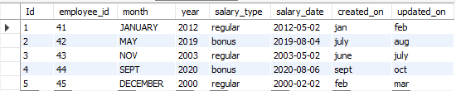

1. **branch:**

CREATE TABLE `branch` ( `Id` int NOT NULL, `name` varchar(45) DEFAULT NULL, `headquarter_id` int DEFAULT NULL, `address_id` int DEFAULT NULL, `contact_id` int DEFAULT NULL, `organization_id` int DEFAULT NULL, `branch_head_in` int DEFAULT NULL, `status` varchar(45) DEFAULT NULL, `created_on` varchar(45) DEFAULT NULL, `updated_on` varchar(45) DEFAULT NULL, PRIMARY KEY (`Id`) )

insert into branch (Id,name,headquarter_id,address_id,contact_id,organization_id,branch_head_in,status,created_on,updated_on) values (71,'branch',11,201,1,1,11,'on','jan','mar');

insert into branch (Id,name,headquarter_id,address_id,contact_id,organization_id,branch_head_in,status,created_on,updated_on) values (72,'customer',12,202,2,2,12,'on','dec','dec');

insert into branch (Id,name,headquarter_id,address_id,contact_id,organization_id,branch_head_in,status,created_on,updated_on) values (73,'employee',13,203,3,3,13,'off','sept','oct');

insert into branch (Id,name,headquarter_id,address_id,contact_id,organization_id,branch_head_in,status,created_on,updated_on) values (74,'branch',14,204,4,4,14,'off','feb','mar');

insert into branch (Id,name,headquarter_id,address_id,contact_id,organization_id,branch_head_in,status,created_on,updated_on) values (75,'branch',15,205,5,5,15,'on','jan','feb');

select * from branch;

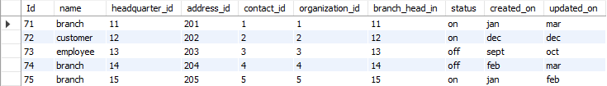

1. **product:**

CREATE TABLE `product` ( `product_type_code` int NOT NULL, `product_code` int DEFAULT NULL, `description` varchar(45) DEFAULT NULL, `price` decimal(10,0) DEFAULT NULL, `status` varchar(45) DEFAULT NULL, `created_on` varchar(45) DEFAULT NULL, `updated_on` varchar(45) DEFAULT NULL, PRIMARY KEY (`product_type_code`) )

insert into product (product_type_code,product_code,description,price,status,created_on,updated_on) values (21,211,'Products are safe, nature','299','on','june','july');

insert into product (product_type_code,product_code,description,price,status,created_on,updated_on) values (22,212,'Only Toxin Free Madesafe','259','on','june','july');

insert into product (product_type_code,product_code,description,price,status,created_on,updated_on) values (23,213,'Buy cosmetics & beauty products online','579','on','september','september');

insert into product (product_type_code,product_code,description,price,status,created_on,updated_on) values (24,214,'Natural ayurvedic products','159','on','october','october');

insert into product (product_type_code,product_code,description,price,status,created_on,updated_on) values (25,215,'Nourishing Moisturizer','499','on','december','december');

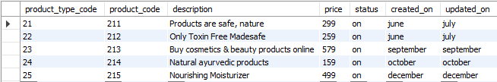

1. **dispatchment_detail:**

CREATE TABLE `dispatchment_detail` ( `Id` int NOT NULL, `order_id` int DEFAULT NULL, `dispatched_date` date DEFAULT NULL, `dispatched_quantity` int DEFAULT NULL, `dispatched_by` varchar(45) DEFAULT NULL, `created_on` varchar(45) DEFAULT NULL, `updated_on` varchar(45) DEFAULT NULL, PRIMARY KEY (`Id`) )

insert into dispatchment_detail(Id,order_id,dispatched_date,dispatched_quantity,dispatched_by,created_on,updated_on) values(1,1,'2019-05-19',50,'on','jan','feb');

insert into dispatchment_detail(Id,order_id,dispatched_date,dispatched_quantity,dispatched_by,created_on,updated_on) values(2,2,'2007-05-08',5,'off','mar','apr');

insert into dispatchment_detail(Id,order_id,dispatched_date,dispatched_quantity,dispatched_by,created_on,updated_on) values(3,3,'2019-09-06',20,'on','sept','oct');

insert into dispatchment_detail(Id,order_id,dispatched_date,dispatched_quantity,dispatched_by,created_on,updated_on) values(4,4,'2002-11-25',35,'off','oct','nov');

insert into dispatchment_detail(Id,order_id,dispatched_date,dispatched_quantity,dispatched_by,created_on,updated_on) values(5,5,'2006-06-14',65,'on','apr','may');

select * from dispatchment_detail;

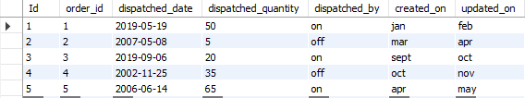

1. **designation:**

CREATE TABLE `priyanka_sql`.`designation` (

`Id` INT NOT NULL,

`Name` VARCHAR(45) NULL,

`status` VARCHAR(3) NULL,

`created_on` VARCHAR(45) NULL,

`updated_on` VARCHAR(45) NULL,

PRIMARY KEY (`Id`));

insert into designation(Id,Name,status,created_on,updated_on) values (1,'Manager','on','mar','june');

insert into designation(Id,Name,status,created_on,updated_on) values (2,'Executive','on','nov','dec');

insert into designation(Id,Name,status,created_on,updated_on) values

(3,'Secretary','off','june','jul');

insert into designation(Id,Name,status,created_on,updated_on) values (4,'Coordinator','on','mar','apr');

insert into designation(Id,Name,status,created_on,updated_on) values (5,'Receptionist','on','apr','may');

select * from designation;

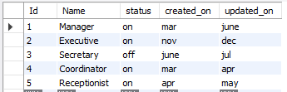

1. **employee:**

CREATE TABLE `priyanka_sql`.`employeee` (

`Id` INT NOT NULL,

`name` VARCHAR(45) NULL,

`manager_id` INT NULL,

`date_of_birth` DATE NULL,

`addressId` INT NULL,

`department_id` INT NULL,

`contact_details_id` INT NULL,

`designation_id` INT NULL,

`branch_id` INT NULL,

`status` VARCHAR(3) NULL,

`created_on` VARCHAR(45) NULL,

`updated_on` VARCHAR(45) NULL,

PRIMARY KEY (`Id`));

INSERT INTO employeee` (`Id`, `name`, `manager_id`, `date_of_birth`, `addressId`, `department_id`, `contact_details_id`, `designation_id`, `branch_id`, `status`, `created_on`, `updated_on`) VALUES ('1', 'ANKITA', '91', '1992-06-13', '201', '601', '701', '801', '901', 'on', 'jan', 'feb');

INSERT INTO `employeee` (`Id`, `name`, `manager_id`, `date_of_birth`, `addressId`, `department_id`, `contact_details_id`, `designation_id`, `branch_id`, `status`, `created_on`, `updated_on`) VALUES ('2', 'CHIRAG', '92', '1999-08-04', '202', '602', '702', '802', '902', 'on', 'sept', 'oct');

INSERT INTO `employeee` (`Id`, `name`, `manager_id`, `date_of_birth`, `addressId`, `department_id`, `contact_details_id`, `designation_id`, `branch_id`, `status`, `created_on`, `updated_on`) VALUES ('3', 'PRATHVI', '93', '1996-12-26', '203', '603', '703', '803', '903', 'on', 'may', 'june');

INSERT INTO `employeee` (`Id`, `name`, `manager_id`, `date_of_birth`, `addressId`, `department_id`, `contact_details_id`, `designation_id`, `branch_id`, `status`, `created_on`, `updated_on`) VALUES ('4', 'RATAN', '94', '2000-01-11', '204', '604', '704', '804', '904', 'off', 'nov', 'nov');

INSERT INTO `employeee` (`Id`, `name`, `manager_id`, `date_of_birth`, `addressId`, `department_id`, `contact_details_id`, `designation_id`, `branch_id`, `status`, `created_on`, `updated_on`) VALUES ('5', 'SUCHI', '95', '2000-011-28', '205', '605', '705', '805', '905', 'on', 'dec', 'dec');

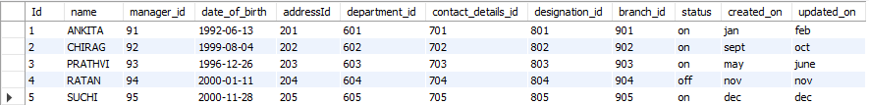

**Foreign Keys:**

* ALTER TABLE employeee

ADD INDEX `department_id_idx` (`department_id` ASC) VISIBLE;

ALTER TABLE employeee

ADD CONSTRAINT `department_id`

FOREIGN KEY (`department_id`)

REFERENCES department (`department_id`);

* alter table address

add foreign key (address_type_id)

references address_type (address_type_id);

|  |  |
| --- | --- |
|  |  |

* ALTER TABLE address

ADD FOREIGN KEY (location_id)

REFERENCES location (location_id);

* ALTER TABLE employeee

ADD FOREIGN KEY (contact_details_id)

REFERENCES contact_details (Id);

* ALTER TABLE employeee

ADD FOREIGN KEY (branch_id)

REFERENCES branch (Id);

* ALTER TABLE branch_product_type_mapping

ADD FOREIGN KEY (branch_id)

REFERENCES branch (Id);

* ALTER TABLE branch_product_type_mapping

ADD FOREIGN KEY (product_type_code)

REFERENCES product_type (product_type_code);

* ALTER TABLE employeee

ADD FOREIGN KEY (addressId)

REFERENCES address (Id);

* alter table customer

add foreign key (address_id)

references address (Id);

* alter table customer

add foreign key (contact_id)

references contact_type (Id);

* ALTER TABLE employee_salary_details

ADD FOREIGN KEY (employee_id)

REFERENCES employeee (Id);

* ALTER TABLE branch

ADD FOREIGN KEY (address_id)

REFERENCES address (Id);

* ALTER TABLE branch

ADD FOREIGN KEY (contact_id)

REFERENCES contact_details (Id);

* ALTER TABLE branch

ADD FOREIGN KEY (organization_id)

REFERENCES organization (Id);

**SELF JOIN:-**

SELECT br1.headquarter_id, br2.headquarter_id

from branch as br1, branch as br2

where br1.headquarter_id=br2.headquarter_id;

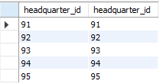

SELECT mr1.manager_id, mr2.manager_id

from employeee as mr1, employeee as mr2

where mr1.manager_id=mr2.manager_id;

