DAY-7&8

Q.1 Write a query to list the employee details along with manager name ,manager's phone number and employees department detail

ANS: select d.department_id, d.department_name,

d.hod_id,

d.created_on,

d.updated_on,

e.name,

c.contact_no

from department d inner join

employeee e on e.department_id= d.department_id

inner join

contact_details c on e.contact_details_id=c.Id

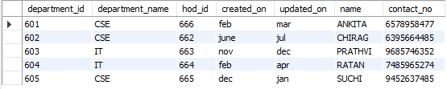

Q.2 Write a query to list customers with there overall order amount

ANS: SELECT c.customer_name,o.order_quantity,p.price,

p.product_code,

sum(order_quantity*price) as amount

FROM product p

inner join orderr o

on p.Id=o.product_id

inner join customer c

on c.Id=o.customer_id

group by (customer_name)

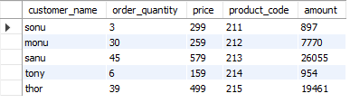

~ customer_id=’701’ in order table (for getting group by customer_name with amount)

SELECT c.customer_name,o.order_quantity,p.price,

p.product_code,

sum(order_quantity*price) as amount

FROM product p

inner join orderr o

on p.Id=o.product_id

inner join customer c

on c.Id=o.customer_id

group by (customer_name)

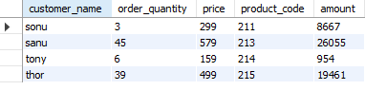

Q.3 Write a query to list the number of orders yet to be dispatched to the customer

ANS: select count(s.Id) as yet_to_be_dispatched

from orderr o

inner join customer c

on c.Id=o.customer_id

inner join order_status s

on o.order_status_id=s.Id

where s.status='on the way';



Q.4 Write a query which calculate the average bonus amount received by group of employees based on their department

ANS: SELECT department_name,

salary_type,

avg(amount) as average_amount

from department d

inner join employeee e

on e.department_id=d.id

inner join employee_salary_details s

on e.Id=s.employee_id

where salary_type='bonus'

group by (department_name);



Q.5 List the customer details along with there order details [amount,price,order date,quantity,order_status and the percentage of order completed, product details]

ANS:

select o.order_date,o.order_quantity,p.price,s.order_status,p.product_code,

sum(order_quantity*price) as amount,

sum(dispatched_quantity)/(order_quantity)*100,

concat(p.product_type_code,p.product_code) as product_id

from product p

inner join orderr o

on p.Id=o.product_id

inner join order_status s

on o.order_status_id=s.Id

inner join dispatchment_detail d

on d.order_id=o.Id

where (s.status='completed')

group by (product_id);

