House Price Prediction Using Machine Learning in PrediBot

Objective
To create a machine learning model to predict house prices using Excel sheets and PrediBot.

Dataset Information
Dataset contains two sheets:
- Seen_Data (Training)
- Unseen_Data (Prediction)

Dataset Columns
Column Name | Description
House_Size_sqft | Size of the house in square feet
Bedrooms | Number of bedrooms
Bathrooms | Number of bathrooms
Location_Score | Location rating from 1 to 10
Age_Years | Age of the house in years
Price | House price (Target variable in Seen sheet)

STEPS:
Step 1: Open PrediBot and Log in
1. Open PrediBot website / app
2. Sign in or create account

Step 2: Click on “Create New Project”
- Enter details:
  - Project Name → House Price Prediction
  - Problem Type → Regression (Predict Numeric Value)

Step 3: Upload Training (Seen) Data

- Upload your Seen Data sheet Excel file
- Select House Size sqft → numeric
- Select Bedrooms → numeric
- Select Bathrooms → numeric
- Select Location Score → numeric
- Select Age → numeric
- Select Price → Target Column

Step 4: Wait for Model Training
PrediBot will automatically:
- Clean data
- Train ML model
- Tune the model
- Show Accuracy Metrics

Step 5: Upload Unseen Test Sheet for Predictions

- Go to Predict / Deployment tab
- Upload Unseen Data sheet
- Click Predict
PrediBot generates Predicted Price column.

Step 6: Download Predicted Results
Click Download Results
You will get a new Excel file like:

Housesqft | Bedrooms | Bathrooms | Location | Age | Price
2915 | 2 | 1 | 5 | 7 | 15446585
977 | 3 | 3 | 4 | 20 | 4422879
862 | 1 | 1 | 10 | 8 | 2479112
2022 | 2 | 1 | 2 | 5 | 10750974
2370 | 2 | 1 | 10 | 27 | 7211910
2948 | 3 | 1 | 1 | 5 | 8758508
3419 | 4 | 1 | 5 | 5 | 18295069
1121 | 4 | 4 | 8 | 25 | 4600584
1290 | 5 | 3 | 6 | 20 | 6131370
2953 | 4 | 3 | 9 | 10 | 13580847
Output

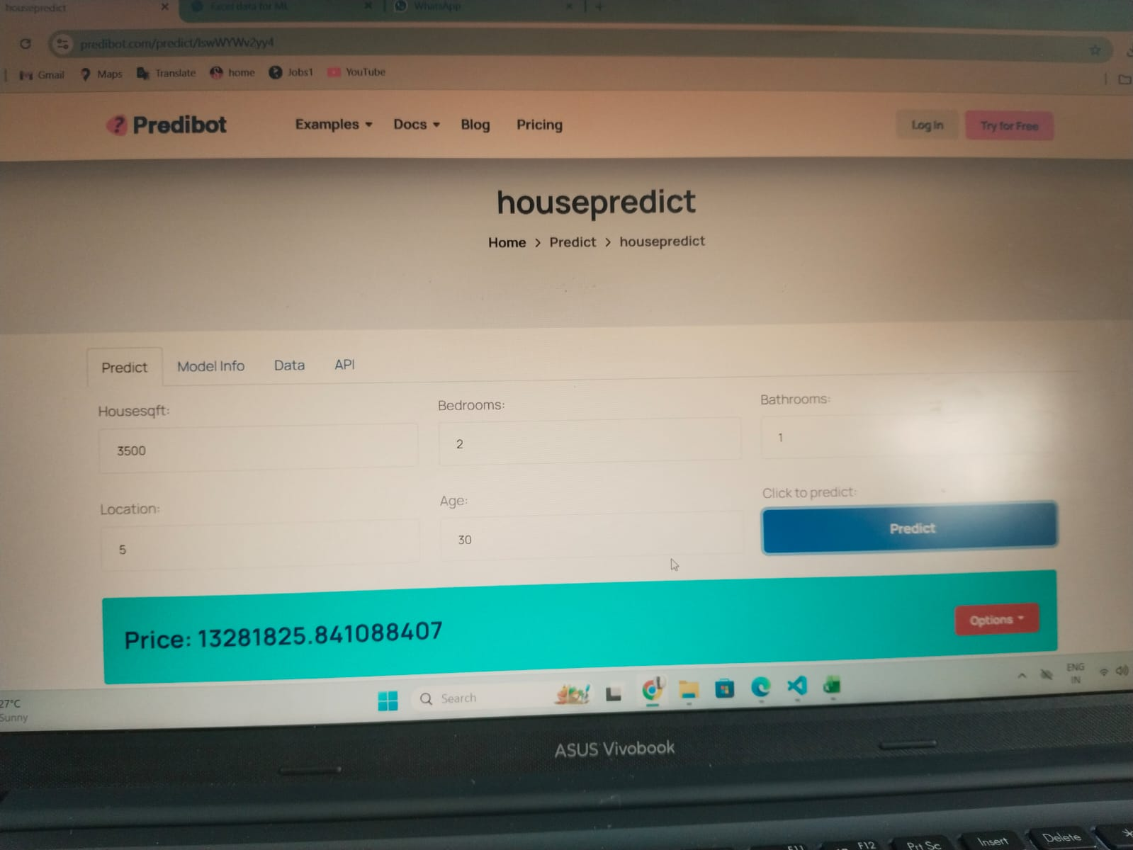

Conclusion

The model successfully predicts house prices using the specified features and PrediBot.

