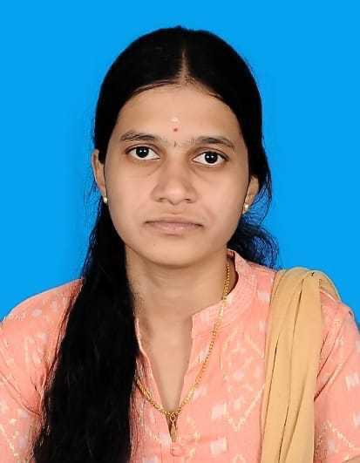
PRIYANKA R
priyankaiirt@gmail.com | 8778015851

PROFESSIONAL SUMMARY

Proficient Full Stack Developer familiar with a broad spectrum of programming utilities and languages. Effortlessly handles all aspects of the development process. Collaborative team member with strong technical abilities, providing around 4 + years of valuable experience.

EXPERIENCE

PROVILITY SOFTWARE SOLUTIONS - CHENNAI, TAMIL NADU October 2021 - Present
Software Engineer

• Proficient in developing robust and scalable web applications utilizing a combination of frontend (JavaScript, TypeScript, RxJS, Redux) and backend (Java, Spring Boot, Spring ,Groovy,.Net) technologies.
• Familiarity with Angular and Ionic framework for rapid application development.
• Hands-on experience with project management tools such as Jira, GitHub, and Bitbucket for collaborative development and issue tracking.
• Proficient in using integrated development environments like IntelliJ IDEA and Visual Studio for efficient coding and debugging workflows.

ACADEMICS

Degree/ Certificate | Board/University | School/college | Year of passing | Percentage (%)
B.Tech Information Technology | Anna University | Institute of Road and Transport Technology-Erode | 2020 | 77.1
12 | State Board | SRV Girls Higher  Secondary School- Namakkal | 2016 | 85.3
10 | State Board | SRV Girls Higher  Secondary School- Namakkal | 2014 | 94.4

SKILLS

● Frontend : JavaScript, Typescript, RxJS , Redux, HTML, CSS, Bootstrap,kendo.
● Backend : Java, Spring Boot, Spring, Groovy,ASP .Net Core,Spring reactive.
● Database : MySQL, Postgres, Neo4J,Azure.
● Framework : Angular, Ionic
● Libraries : NgRX, Angular-Formly, React, Formik.
● Project Management Tools : Jira, Github, Bitbucket.
● Integrated development Environment : IntelliJ Idea, Visual Studio.

PROJECTS

1.ROBOGEBRA

OCT 2024 – PRESENT

Summary:
- RoboGebra is an AI-driven digital learning ecosystem designed to deliver highly interactive mathematics education for school students. The platform combines a scalable Backoffice system for content and operations management with a mobile-first User App that provides real-time AI explanations, personalized study timelines, quiz workflows, and progress intelligence. My role involves end-to-end feature development and testing.

Contributions:
- Architected and delivered a personalized learning dashboard, integrating progress analytics, learning timelines, and solution with both detailed and short Answers
- Built a scalable Study Reminder system with flexible scheduling, notification delivery, and robust REST APIs (GET, POST, PUT, DELETE), improving user consistency and retention.
- Designed and implemented the Study List module, enabling students to create, organize, and track academic goals with real-time data sync across the app
- Developed an advanced AI-powered math explanation engine, generating step-by-step reasoning, formula breakdowns, and bilingual (Tamil/English) explanations.
- Engineered the interactive Quiz Module, supporting dynamic questions, instant evaluation, solution walkthroughs, and seamless integration with AI explanation services.
- Implemented real-time mathematical computation and visualization, allowing users to modify values and instantly view updated results, graphs, and AI-driven insights.
- Integrated rich multimedia learning assets, including bilingual video explainers, animated visuals, and interactive 3D graphs, significantly enhancing conceptual clarity.

Technology:

● Angular,Ionic,Java,Mysql

2.SUBSEA

APRIL 2024 – SEP 2024

Summary:

- The Subsea Project is a specialized software solution designed to manageand optimize subsea operations,including tools,pipeline connections,and quipments related to ships and marineactivities.The project focuses on efficiently handlingcategories.subcategories,andvarious types of equipment,streamlines processes for improved productivity and operational management.

Contributions:

- Fixed production functionality bugs, ensuring smooth operation and reliability.
- Implemented a new module called Schedule-Manager for managing subsea schedules.
- Developed APIs for the Schedule-Manager module using .NET, enabling seamless backend integration.
- Utilized Kendo UI Grid to implement complex UI functionality, enhancing user experience and data management.
- Designed and developed dynamic category and subcategory management features, allowing for flexible configuration of subsea equipment and tools.
- Assisted in refining the overall architecture, focusing on modularity and reusability to support futureexpansions.
Technology:

● Angular, .NET, Docker, Azure Database

3.BACKOFFICE UI ANGULAR VERSION MIGARTION

FEB 2024–MAR 2024

Summary:

• The Backoffice UI underwent a migration to the latest Angular version, aiming to modernize and improve performance. Meticulous testing ensured a seamless transition while minimizing disruptions to existing features. This upgrade not only aligned the UI with current Angular advancements but also set the stage for future enhancements and scalability.

Contributions:

• Migrated four repositories to version 16.

• Migrated the Ticketing web application from version 2 to 16.

• Migrated the ssg web plugin app repository from version 9 to 16.

• Migrated the ssg web plugin app gopass repository from version 4 to 16.

• Migrated the ssg web plugin app version admin repository from version 4 to 16.

4.EASYVISA

Nov 2021 – JAN 2024

Summary:

• The Visa Management System is a comprehensive software application designed specifically for attorneys to efficiently manage their clients, records, forms, and organizational visa processes. This project streamlines the visa application and documentation process, providing attorneys with a centralized platform to effectively handle their caseload and enhance their productivity.

Contributions:

• Implemented the full document portal module, featuring multiple accordion panels for uploading documents.
• Developed custom components using Angular Formly.

• Utilized Angular reactive forms extensively to construct nested forms.

• Customized the image cropper library for profile image usage.

• Migrated to a newer version of Angular, resulting in improved performance and stability.

• Created reusable components employed across multiple modules.

• Wrote unit test cases for all UI components and services.

• Assisted in documenting software specifications and user manuals.

Technology:

● Angular, Grails, Groovy, Postgres, Neo4

Date:

Place
Name & Signature

