Temiskaming Redesigning Hospital Project

Get well soon Card & Login System Entity Relationship Diagram

* 1. Get well Soon Card
  2. Entity Relationship Diagram

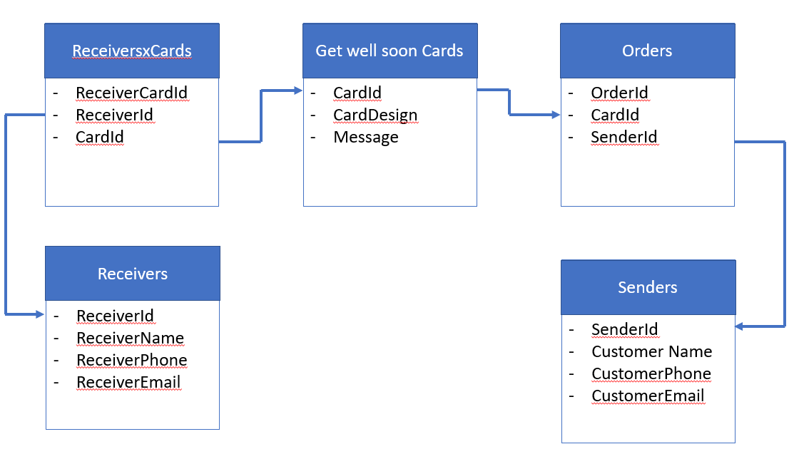

* 1. Narrative story + Justification

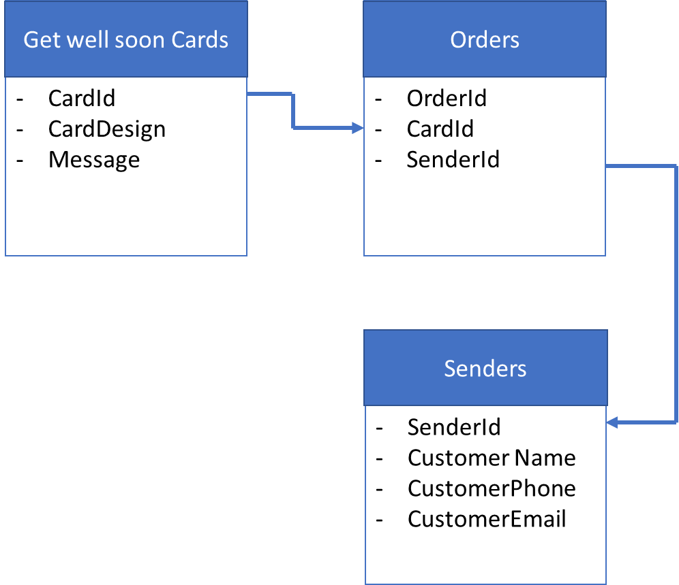

To illustrate the Many-to-Many Relationship between Get Well Soon Card and the Senders, let’s take a look at the story of Jack. Jack has a friend, John who has just recently an accident. He wants to send John a get well soon card. At the same time, he also receives the news that his sister is about to give birth at Temiskaming hospital and also wants to send a congratulation card to her.

Meanwhile, the same card Jack orders could have been in other’s people’s choice too. In other words, Jack could order many cards and the same card could be ordered by many people like Jack. A many-to-many relationship will facilitate this situation.

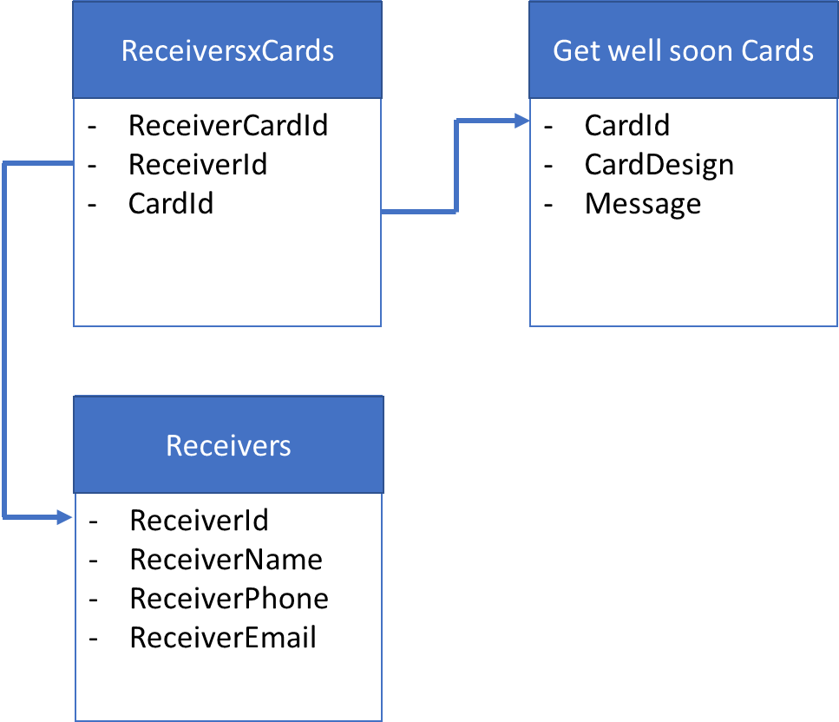

John is a patient at the hospital. Besides Jack, he has many friends who cares about him; therefore, it will be likely that he will receive many get well soon cards. Likewise, a card can be chosen by more than one of John’s friends to send to him. In this case, a many-to-many relationship is appropriate to implement.

* 1. Log in system

2.1) ERD Diagram

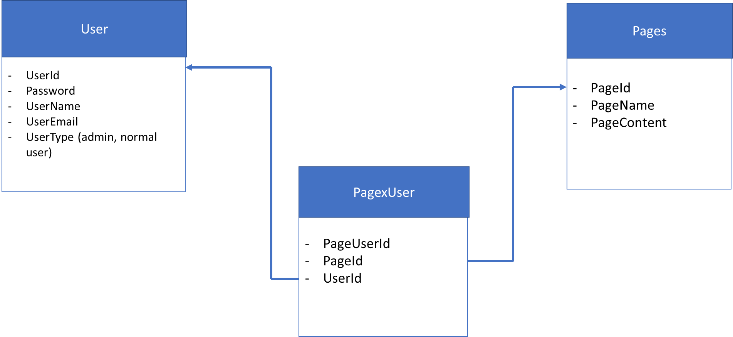

* 1. Narrative story + Justification

John has a brother, Jim who is always by his side caring for him since he got in the hospital. As John needs to stay in the hospital for a long time, Jim needs to book a long term stay for his brother. He also needs to reserve a parking spot for him too. A log in system will help him do that. Once log in, he can access the long-term room he registers for his brother as well as create and edit his parking information page.

The administrator of the hospital should be able to access Jim’s or any other patient’s pages as well. For example, if someone’s parking registration is overdue, he can delete their registrations to give space for someone else.

In short, logging in system allows users to create and access multiple pages like: longterm stay, parking registration. This page can also be accessed by the administrator team of the hospital.