**Temiskaming Redesigning Hospital Project**

**Get well soon Card & Login System Entity Relationship Diagram**

* 1. **Get well Soon Card**
  2. **Entity Relationship Diagram**

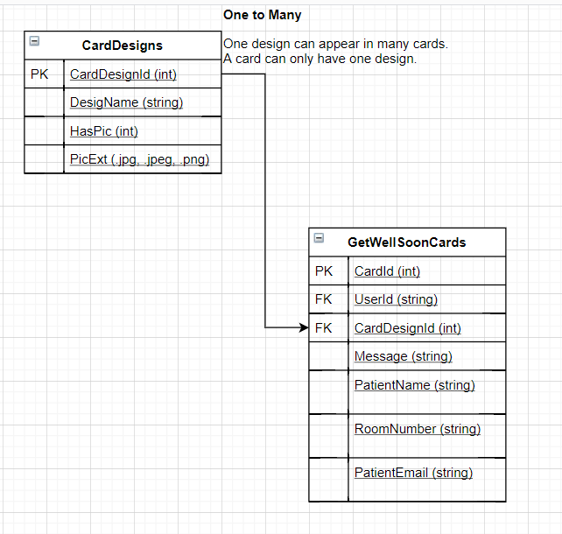

* 1. **Narrative story + Justification**

A user can send many cards as he likes. For example, Harry’s grandparents are in hospital because of the COVID-19 pandemic and he could not visit them because of the quarantine policy. Therefore, he should be able to create 2 (many) cards and send to them. This card will only belong to Harry.

A design can be applied in many cards. For example, Harry like the card with Lily flowers and so does Ron. Therefore, they should be able to both choose the card. A card will only have one design, otherwise, it will be the same card.

* 1. **User story and access right**

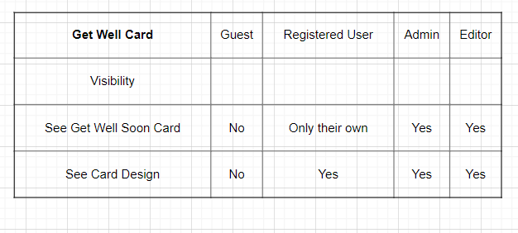

**Admin & Editors Story:** Admins and editors can see all the get well soon cards from other users so they can process them

**Registered Users & Guest**: They can only the cards they create by themselves. Guest can not see the card; they have to log in to use this online service.

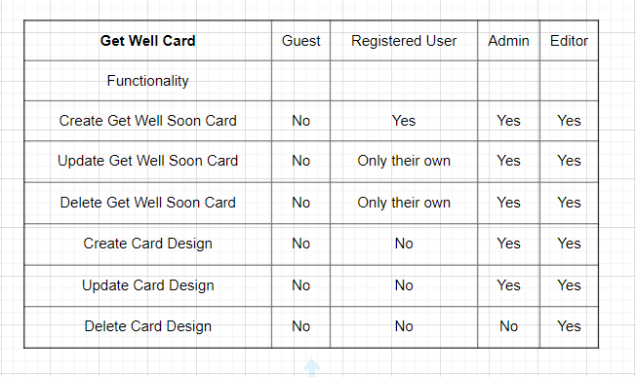

**Admin’s story:** Hermione is an administrator of the Temiskaming hospital website. Upon logging in to the system, she could see all the get well soon cards sent to the patient at the hospital. She could also create the cards and send out to some old patients who live alone in the area to cheer them up.

**Editor’s story:** Ron is the editor of the Temiskaming hospital website. After the COVID-19 pandemic, as there are so many people recovering from the disease, he helps Hermione send out the card to all the patients. He could help edit, update cards from the hospital as well as from the families of the patient if they request. However, to delete a card, he needs permission from Hermione – an administrator to avoid mistakes. Upon clicking delete, he will encounter a line that says You are not authorized to perform the action.

**Register users**: Harry ‘s grandfather, Mr. Dumbledoor is in the hospital. He needs to create a card to say to show that he is rooting for his grandpa. When he accesses the Get well soon Card page, the system will require him to log in or register to create a card.

Later on, he found out that he made a typo on the card and his grandfather – a teacher hates typo. He could log in again to see all the cards he has just created so far for different people like his dad: James, his uncle Lupin and Sirius in Temiskaming hospital. He found the card for Mr. Dumbledoor and edited it. Upon editing, he found out his grandfather has returned to England and thus, he deletes the card.

**Card Design Functionality**

**Admins and Editors:** Only admins and editors can create card designs. User can only choose from the existing one. For example, Hermione once saw a beautiful design at a shop and wants to sell the design in the hospital online store. After buying from the shop, she can go to website and update the card design list to attract people.

**Registered users:** For users like Harry, he could not buy and create a card design that the hospital doesn’t have so he can only choose from the existing one

* 1. **Log in system**

**2.1) ERD Diagram**

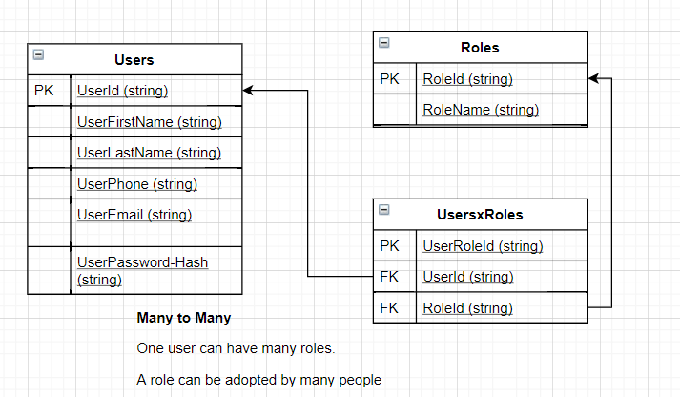

* 1. **Narrative story + Justification**

Our login system will help to classify our website visitor into 3 types: administrator, editor and register user. All people who registered will be registered users. Editors and administrators can only be assigned by an administrator. Each will have different access and authorization to different contents on the website. The administrator will have full right to see, create, update, delete everything in the website while for editors, register users, that right will be restricted in some contents.

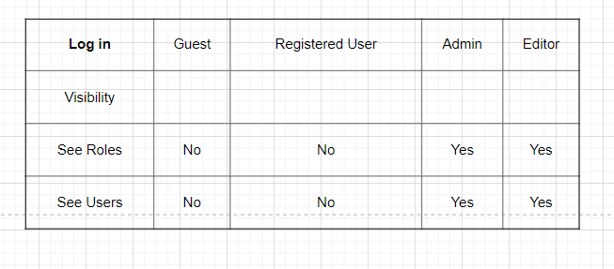

**Admin & Editor Story:** After logging in, Admin can see all the roles and he can also see users who use the services of the hospital to process their requests.

**Register User:** The register cannot see the admin information and other users for security reason. For example, Neville should not see Hermione as an admin of the website. He could contact the hospital for request and Hermione – the admin will answer him under hospital email but he could not see Hermione as an admin.

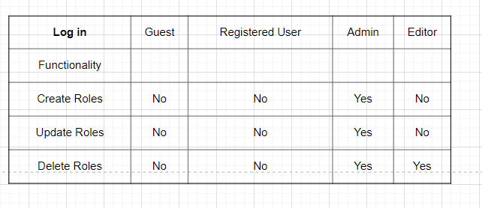

**Admin story:** Hermione is a nurse and also an administrator of the Temiskaming hospital website. As the COVID-19 pandemic gets serious, she needs to focus more on curing the patient rather than the website. Therefore, she recruits Harry as an administrator to help her.

**Editor story:** Harry takes on the job and quickly felt overwhelmed as there is so much to handle so he decides to recruit another newly-graduate to help him as an editor. After receiving the email and password from Harry, the newly-recruit can now work as an editor of the website. He cannot create a new account and assign roles to other people like Harry – the admin.

**Register user:** Neville has registered and logged in to the Temiskaming hospital website so he becomes a registered user. He can now enjoy many online services offered by the hospital such as parking registration, online appointment, send a get well soon card or job listing. However, he could not create a new account for others or himself when he logged in.