Temiskaming Redesigning Hospital Project

Event Calendar and Online Appointment

# Event Calendar

## Entity Relationship Diagram

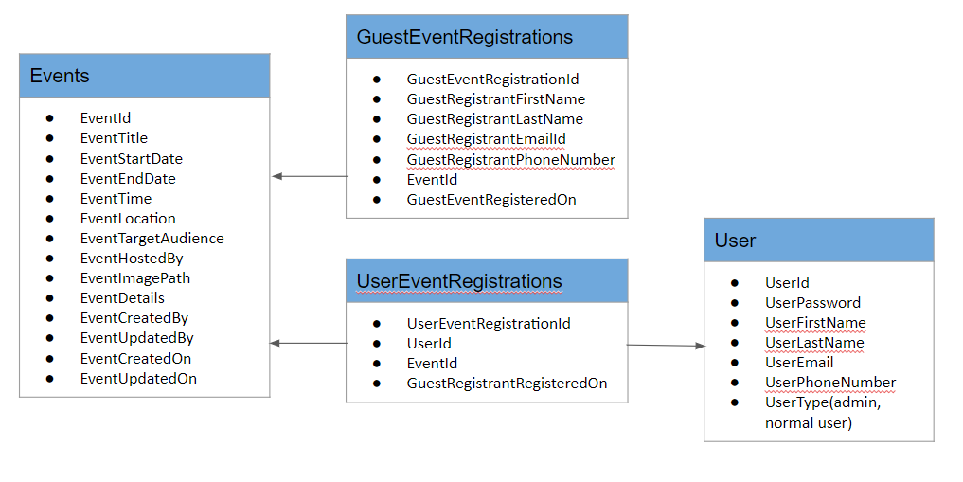

## Narrative story + Justification

To illustrate the Many to many relationships between Users and Events, Let’s have a look into the story of Siddhant and Priyanka. Siddhant logged into the system and click on the Events calendar. He wants to register for “**Neurosurgery Education Workshop**” and “**Blood Donation Camp**” events. Priyanka also wants to register for both events.

If Siddhant wants to see the list of the events he registered for in past and view the detail of the same. Then he can login into system and access all the list of registered events.

If a guest user Prijay wants to register for events without login into system then he can also register for an event with clicking on the Event Calendar and pick any of the Event and register for it. Prijay can register for an event once per an email. However, he can register for multiple events.

Admin user have all access to events and Registered user’s detail.

# Online Appointment

## Entity Relationship Diagram

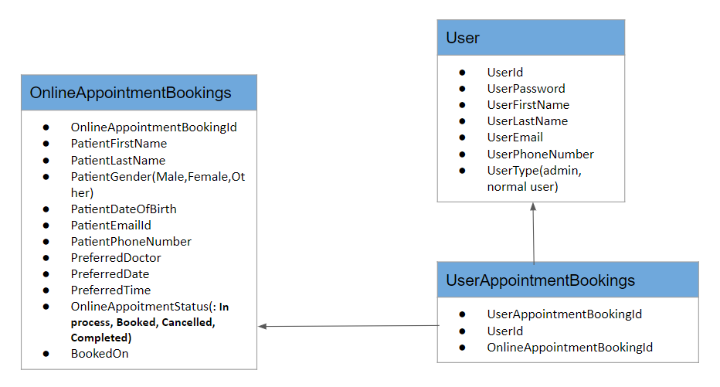

## Narrative story + Justification

To illustrate, many to many to relationship between User and Appointment Bookings let’s have a look into the story of the Jack. Jack’s mother is not well so she wants to see doctor so jack logged in into the hospital system and book an appointment. Also, Jack has pain in knee he also wants to see doctor so he books a separate appointment.

After a day Jack is feeling good and wants to cancel appointment so he logged into system go to the list of booked appointment and cancel the appointment.

A guest User Ryan wants to book an appointment for his office friend so he does not have an account or he does not want to register for an account so he also can fill all the information and book an appointment. He cannot track or change the Booked appointment.

Admin User have all access to the booked appointment and can change the status of the Appointment. For an example if patient have already seen doctor then he can change the status of the Appointment to “Completed”.