**ERD and Wireframes**

**Feature name: Long Term Stay (room booking)**

**Narrative Description**

Some of the hospital visits last from several minutes to a couple of hours such as emergency, doctor appointments, procedures, or consultations. However, some are long-term, such as surgery, chronic disease treatments, palliative care, etc. As the patients navigate to this page, they will be able to see information about all available long-term stay rooms. This varies from one day/overnight stay, to several weeks or even months. There are private (single bed), semi-private (2 beds), and rooms with 3 or more beds. Since not all accommodations are covered by OHIP, this page will include prices and the ability to reserve rooms.

Patients will be able to register for the room of their choice using the registration form. As well as pay using third-party payment processing platforms. When the form is submitted, the user will get a confirmation message, if the room was successfully booked, and email with all necessary details, including check-in/check-out, what to bring with them and which facilities are available. Patient information will be stored in a database and associated with that room.

Administrators of this page will be able to see all room occupancy and patients currently occupying them, with the contact information. If the room is not occupied it will display that information as well. Administrators are able to update all information associated with the patient and the room, also delete rooms from the list if it becomes permanently unavailable, or temporarily hide rooms from the available list, if it is occupied.

**ERD Justification:**

Since each room might have more than one bed in it, which means there might be several patients(users in the database) occupying one room. Also, a patient might have booked different rooms for different times. This means user and room are related as many to many, with booking table as a bridge between them

* Users have multiple bookings (different time)
* Room might have multiple bookings(many beds in a room)

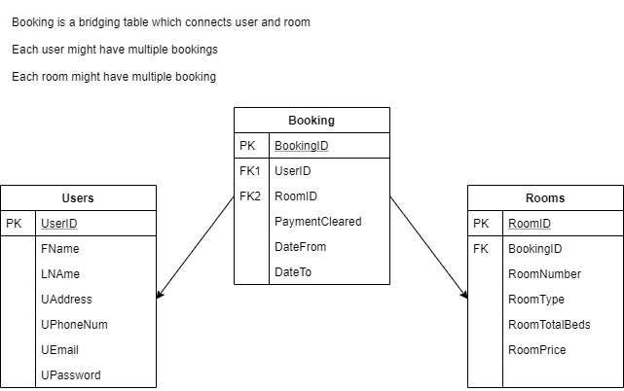

Wireframes

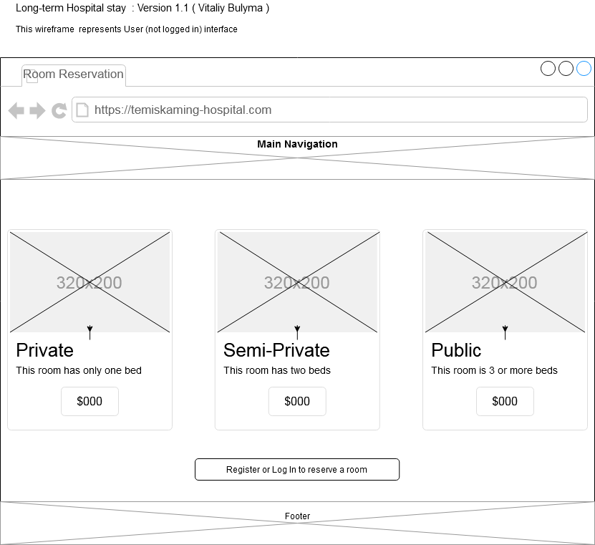

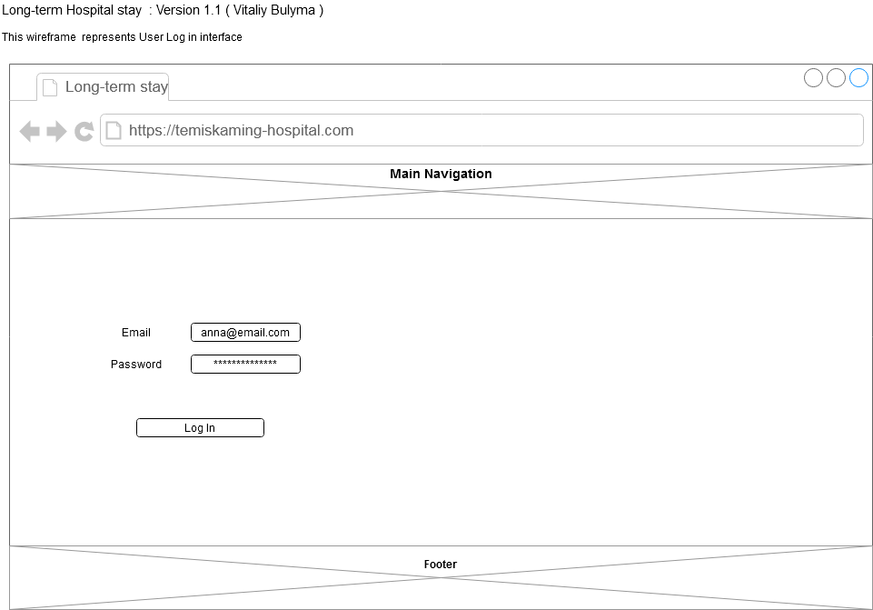

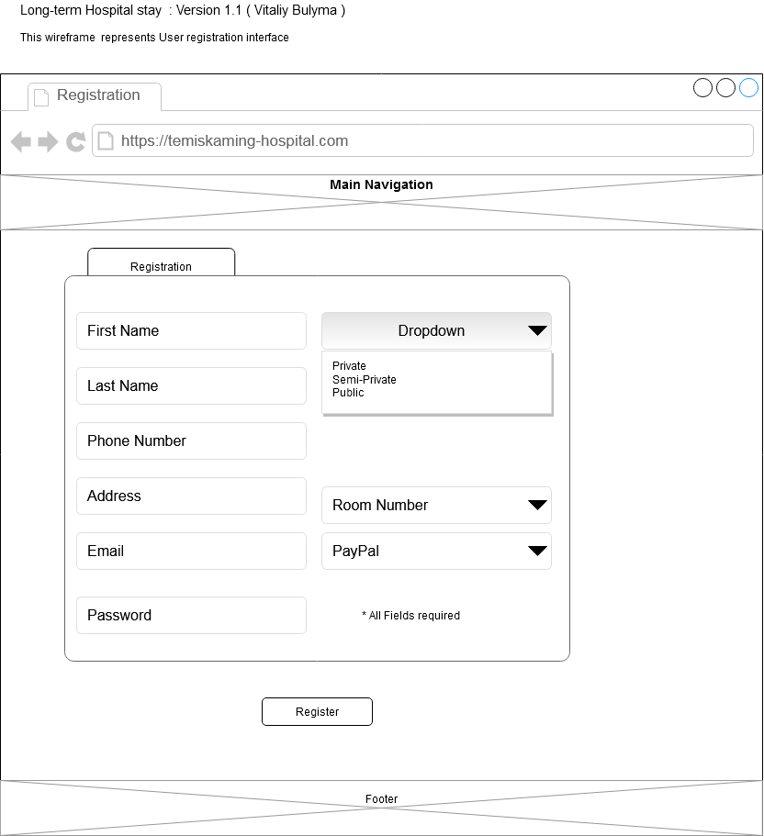

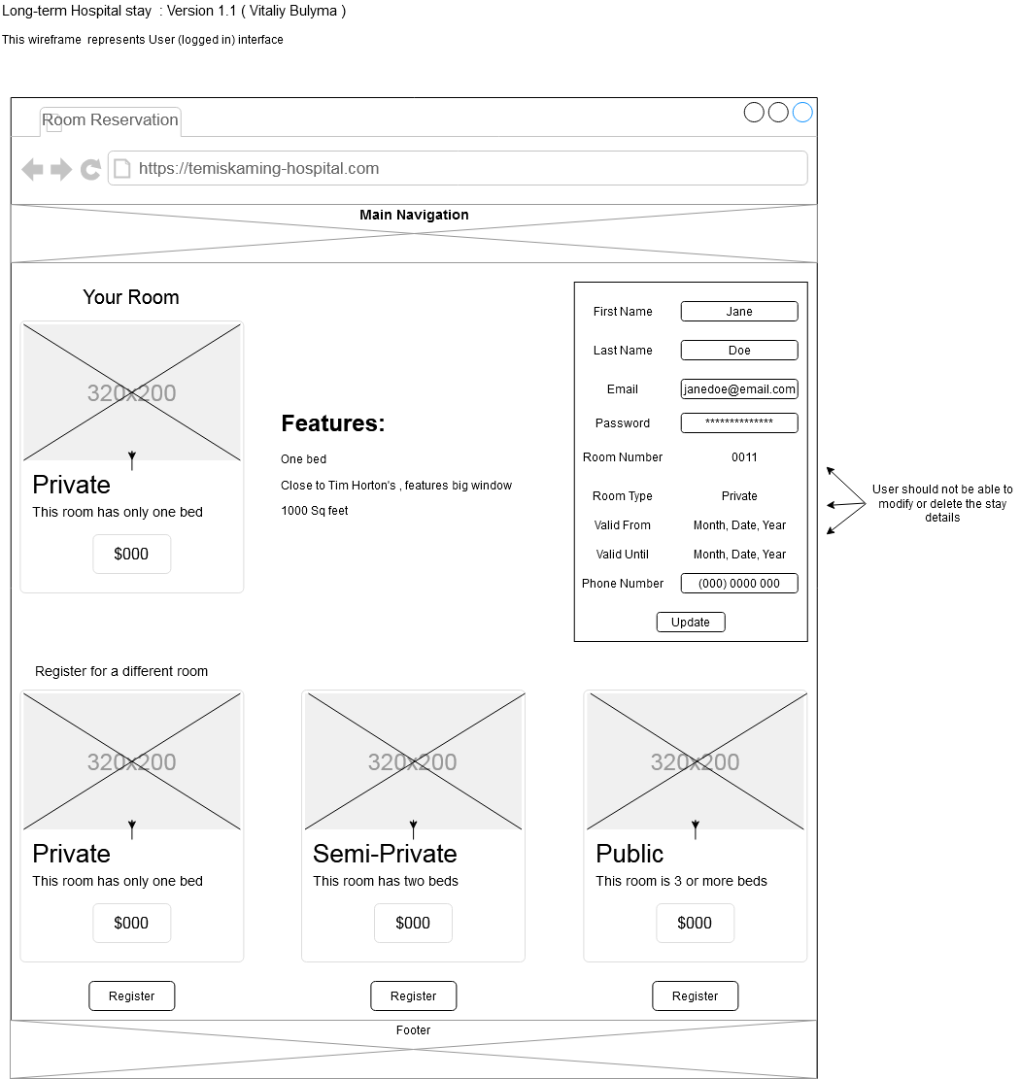

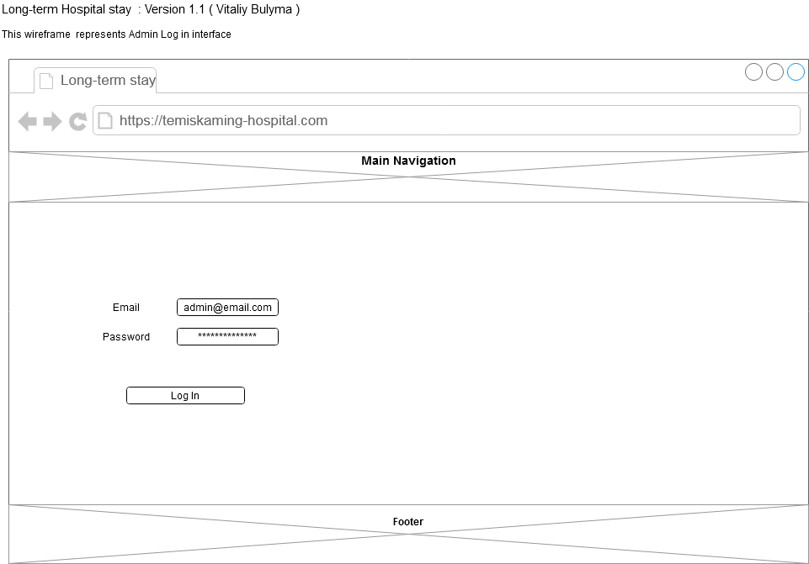

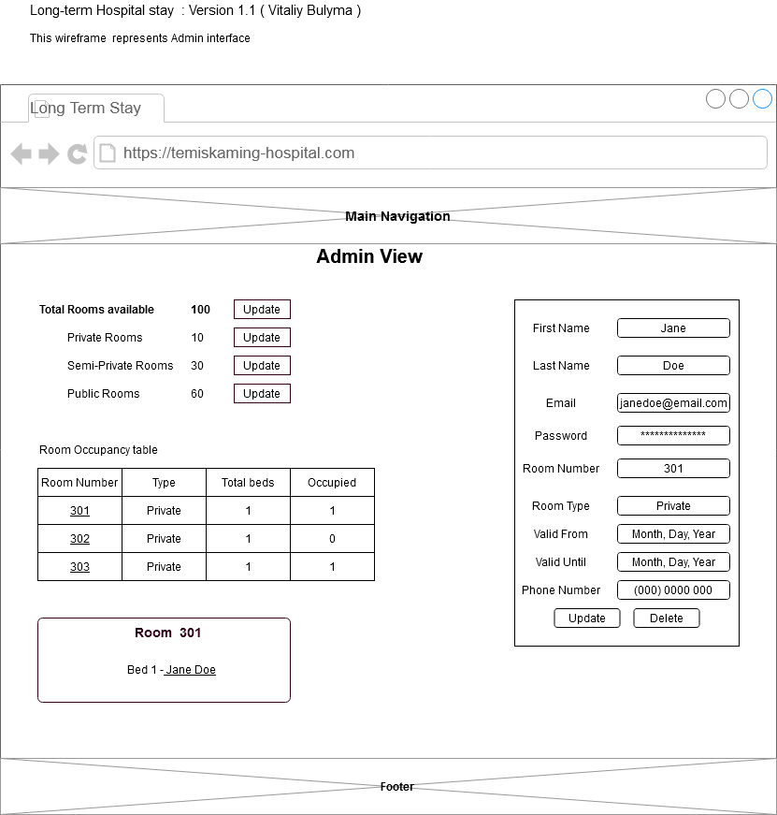

**Feature name: Public Health Crisis Information**

**Narrative Description:**

The purpose of this page is to bring forward all available information about the current public health crisis to a general public and especially to immediate and potential visitors of the hospital. As the crisis arises, there are a lot of people who refer to a local hospital for information regarding the current situation, updates and the virus/disease information at the root of the issue. This is not surprising, since hospitals are seen as an expert in health related issues, especially in small communities. Hospitals have the highest concentration of doctors, epidemiologists and other healthcare professionals. This page, in addition to providing valuable information, will increase the credibility of the hospital.

At the time of crisis many hospitals are overwhelmed with the high influx of patients visiting the hospital, as well as calling-in for information, updates, advice, etc . This page will reduce the strain on telephone lines, by providing answers to most frequently asked questions, and will have a section of “Tips and Advices”. The page will utilize the website's existing database of general health related Tips and Advices and link to a full Tips and Advices page. This will promote patients to follow good habits and potentially decrease a risk of spreading the infections and reduce hospital visits. In addition , the page will display a list of previous public health crises. The data for the feed will be rendered from the database.

The link to the Public Health Crisis Information will be available at the main page, highlighted red, and will only be activated when the crisis arises by the admin of the page. In addition to activating the page, the admin of the page will be able to view all articles posted, edit them, and delete in case that information posted was inaccurate or inappropriate for any reason. Also admin is able to create a new “Crisis Section” as needed.

**ERD Justification:**

There might be many articles related to one crisis

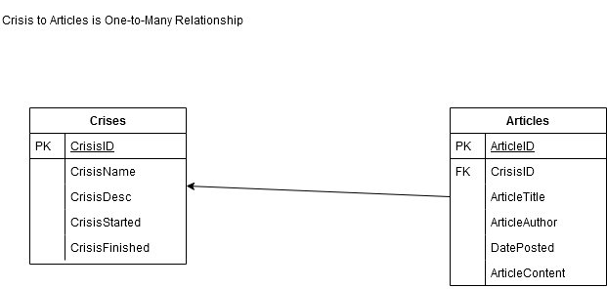

**Wireframes**

