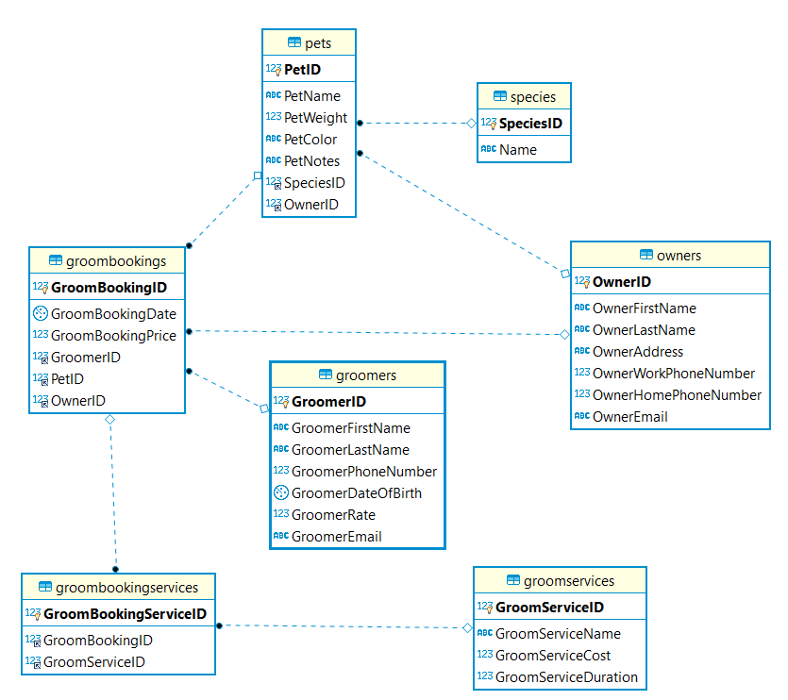

1. Pet:
   * Pet reference the **species** table because, Pet can be a dog, cat or other type of species.
   * It will also reference to the owner table to describe who is the owner of particular pet.
2. Species:
   * Species hold all the types of species of pets. For an instance, Cat, dog or sparrow
3. Owners:
   * This holds all the necessary information of the owner like first name, last name, address, work and home phone number and email.
4. Groomers:
   * This holds all the information of groomer like first name, last name, phone number, Date of Birth, groomer’s rate and email.
5. GroomServices:
   * This holds all information related to the different types of groom services like hair cut, nails, bath and etc.
6. GroomBookings:
   * This holds all the information related to a booking for the groom services of pets.so Owner Can book multiple groom services at a time. And Owner can also book multiple bookings for different days. This will reference to Owner.
   * It will reference to Pet to know for whom this booking is being done.
   * It will reference to Groomer to record who is going to do serve the groom services for particular booking.
7. GroomBookingsServices:
   * Let’s say an owner of a pet let’s say Priyanka booked two groom services for a booking then one booking would have two groom services. And Priyanka can book multiple bookings for a groom service. So, this would be many to many relationships. So, for this GroomBookingsServices would be bridging table.
   * It will refer GroomBooking and GroomService.