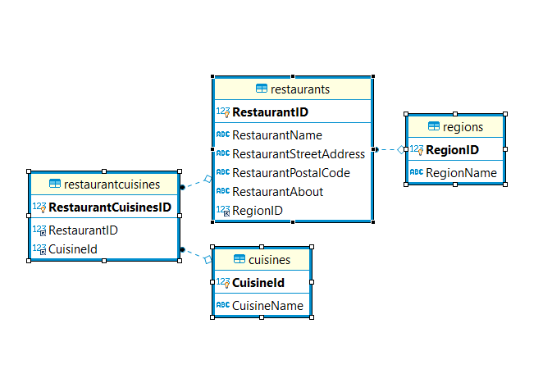

**One-to-Many**: In one region there would be multiple restaurants. For example, there are two hotels in downtown region of Toronto.

**Many-to-Many:** One Restaurant could serve multiple cuisines. For example, there are four hotels in different region serving different types of cuisines.

**Future Plan:**

* Future plan is to add login system for admin and restaurant finders, Restaurants owners.
* Also Review system so users can give reviews and share pictures. That would help others before visiting the restaurant.