## A PROJECT REPORT **ON**

**Vehicle Parking Management System**

Submitted To The



Rajgad Dnyanpeeth’s

Anantrao Thopte College Bhor

# SUBMITTED BY

## Sarthak AshokNavale Dnyanraj Bharat Dhondge

To

### SAVITRIBAI PHULE PUNE UNIVERSITY FOR THE ACADEMIC YEAR 2023-24

PROJECT GUIDE: Venupure Sir

Introduction

Project Introduction: EasyCode

EasyCode is an innovative online platform designed to simplify coding education and provide an engaging, user-friendly learning experience. The website offers comprehensive online coding courses in various programming languages like MERN stack (MongoDB, Express, React, Node.js) and Python. Our mission is to make learning coding accessible, affordable, and fun for students of all levels.

Through EasyCode, users can buy interactive courses tailored to meet their learning needs. The platform provides detailed video tutorials, hands-on coding exercises, and practical projects to ensure that learners acquire real-world skills. We focus on delivering structured lessons with clarity and ease, helping learners progress from basic concepts to advanced coding techniques.

To enhance the learning experience, EasyCode features a user dashboard that includes:

* Assignments: Practical coding tasks designed to test and reinforce the lessons.
* Quizzes: Interactive assessments that allow users to gauge their understanding of the material.
* Scoreboard: A leaderboard to motivate users and track their progress compared to others in the community.

With EasyCode, you don’t just learn coding—you gain the tools and resources to apply your skills in real-world tech projects. Whether you're starting from scratch or aiming to enhance your coding abilities, EasyCode is the perfect platform for online coding education.

### Objective

1. Provide Accessible Coding Education: To offer a user-friendly platform

that makes learning coding accessible to people of all skill levels, from beginners to advanced programmers, through online courses in languages like MERN stack and Python.

1. Offer High-Quality, Interactive Courses: To deliver well-structured,

engaging, and interactive coding courses with video tutorials, hands-on exercises, and real-world projects to ensure practical learning and skill development.

1. Enhance Learning with Assignments and Quizzes: To incorporate

assignments and quizzes within the user dashboard, enabling learners to practice what they've learned and assess their progress in real-time.

1. Foster a Competitive Learning Environment: To introduce a

scoreboard system that encourages students to track their progress, compete with peers, and stay motivated to achieve their learning goals.

1. Provide Personalized Learning Experience: To create a personalized

dashboard for users that tracks their progress, offers recommendations based on their learning patterns, and allows them to review completed assignments and quizzes.

1. Build a Strong Online Community: To create a collaborative platform

where learners can share ideas, ask questions, and support each other in their coding journey, fostering a sense of community and peer-to-peer learning.

1. Enable Skill Development for Real-World Applications: To ensure

that all courses are designed to help learners build skills that are directly applicable to real-world coding tasks, preparing them for careers in tech industries.

1. Support Continuous Learning and Improvement: To provide

continuous updates to courses, new content, and new learning tools that help users stay up-to-date with the latest trends in technology and coding.

1. Ensure a Seamless User Experience: To create a smooth and intuitive

user interface that enhances the learning experience and encourages students to engage with the platform regularly.

## Purpose :

The purpose of EasyCode is to empower individuals by providing an accessible, effective, and engaging platform for learning coding. Our goal is to break down the barriers to quality education in programming and technology, making it easier for anyone, regardless of background, to learn and master coding skills.

EasyCode is designed to:

1. Simplify Coding Education: Make learning complex programming languages like MERN stack and Python simple, interactive, and engaging for learners of all skill levels.
2. Provide Practical Knowledge: Equip learners with the hands-on experience and real-world skills necessary to succeed in the tech industry through assignments,

quizzes, and projects.

1. Support Lifelong Learning: Foster continuous growth and learning in coding, allowing users to continuously build and refine their skills through new courses,

resources, and challenges.

1. Promote Self-paced Learning: Offer a flexible learning environment where users can learn at their own pace, allowing them to balance education with other

commitments.

1. Encourage Motivation and Progress Tracking: Motivate users by providing tools like a personalized dashboard, quizzes, assignments, and a scoreboard to track their

progress and achievements.

1. Create a Community of Learners: Build a supportive, collaborative community where learners can share experiences, solve problems together, and grow in their

coding journey.

At its core, EasyCode aims to make coding education more accessible, effective, and enjoyable, empowering people to develop the technical skills needed for career advancement or personal growth in the ever-evolving tech world.

# System Requirements

#### Hardware Requirement :

Client Side:-

RAM 512 MB or above Hard disk 10 GB or above Processor 1.0 GHz or above

Sever side:-

RAM 16 GB or above Hard disk 20 GB or above Processor 2.0 GHz or

above Software

#### Requirement :

Client Side:-

Web Browser Google Chrome or any compatible browser Operating System Windows or any equivalent OS

Sever side:-

* Web Server APACHE
* Server side LanguagePHP5.6 or above version Database Server MYSQL
* Web Browser Google Chrome or any

compatible browser

* Operating System Windows or any equivalent OS

**ER Diagram**

VPMS

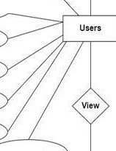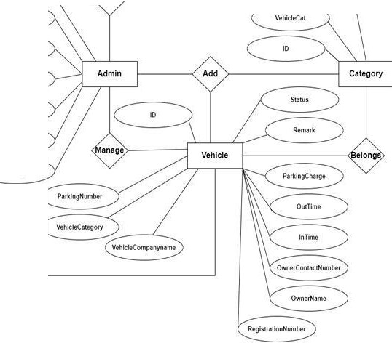

10

**Fir-**

ID

-tul.N-1mt

C,eatk>l10.tt

* **:tshMtn¢**

-·

Putwo,d

Use,rNomt

11:HU

**Rt9Dt1t**

Emall

**Use Case Diagram**

s111n In

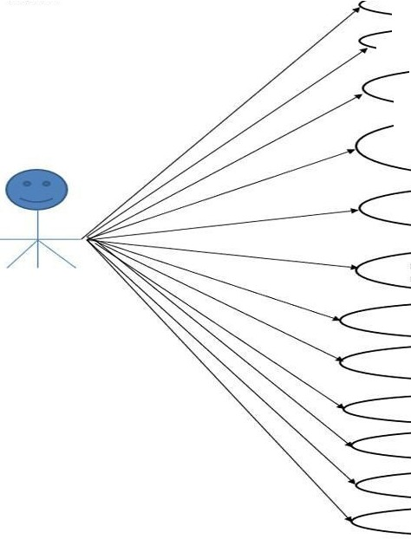

,

Dashboard ---....

Add Vehlde Category --------

-===========-_./

**Manage Vehlcle Cate**■**orv**

(Update Details)

Add Vehicle

**Manas• Vehlde(Update**

**(")p-,.,.ild**

View Reausers

Generate Reports

Update Profile

**Chance Pa.s.sword**

**Password Recovery**

**sea,c.h**

**Continue...**

Users



Signup

Sign in

-.

Dashboard

*I*

View Vehicle

Update Profile

Change Password

Password Recovery

**Class Diagram**

, !!

ID INT(l0)

* VehideCat VARO-IAR( 120) OCreiitionOate TIMESTAMP

►

,:J **tbk:ategory**

|  |  |  |
| --- | --- | --- |
| **:J tblvehide** | | |
| ID INT(l0)   * ParkingNumbe<*VAR*CHAR(120) * VehideCaiegory VARCHAR(120) * VehideCompanyname VARCHAR(120) * ReoistraoonNumber VAROiAR(120) * OwnerName VARCHAR(120) * OwnerContactNumber BIGINT(l0) * InTlme TIMESTAMP * OutTime TIMESTAMP * ParkingCharge VAROiAR(l20) ORemark MEOIUMTEXT * Status VARO-IAR(S) | | |
|  |  | ► |

I I I I

- !!

|  |  |
| --- | --- |
| **:Jtblregusers** • | |
| ID INT(S)   * FirstName VARCHAR(2SO) * lastName VARCHAR(250) * MobileNumber BIGINT(l0) * Email VAROiAR(250) * Password VARCHAR(250) * RegDate TIMESTAMP | |
|  | ► |

|  |  |
| --- | --- |
| **:J tbladniin**  ID INT(l0)   * AdminName VARCHAR(120) * UserName VARCHAR(120) * MobieNumber BIGINT(lO) * Email VAROiAR(200) * Password VARCHAR(l20) * AdminRegdate TIMESTAMP | |
|  | ► |

Data Flow Diagram

* A data flow diagram is graphical tool used to describe and analyse movement of data through a system. These are the central tool and the basis from which the other

components are developed. The transformation of data from input to output, through processed, may be described logically and independently of physical

components associated with the system. These are known as the logical data flow diagrams. The physical data flow diagrams show the actual implements and

movement of data between people, departments and workstations.

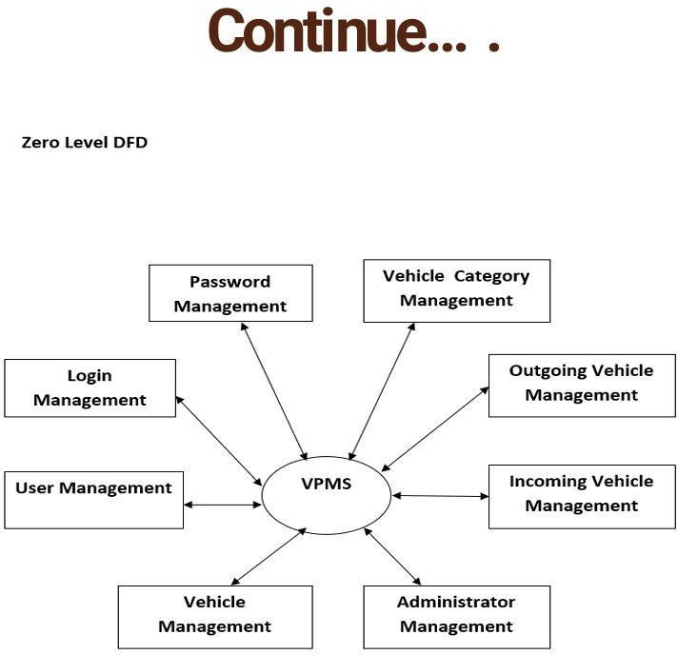

**Continue...** •

First Level DFD

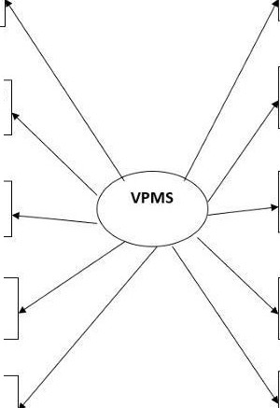

Outgoing Vehicle

Management

Password Recovery Management

Generate Vehicle Report

Vehicle Category Management

Password Management

Vehicle Management

User Management

Administrator Management

Login Management

Incoming Vehicle Management

**Continue...** •

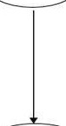**Second Level DFD**

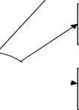

Login

to

Check

Roles of

Forgot

**Passwor**

Check

credentia

Manage

Modules

Admin

search vehicle

View Registered

**Users**

UpdateProfile

Change Password

**Generate vehicle**

report

Manage outgoing

**vehicle**

**Manage incoming**

vehicle

AddVehicle

Manage vehicle

category

**Continue...** •

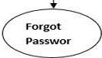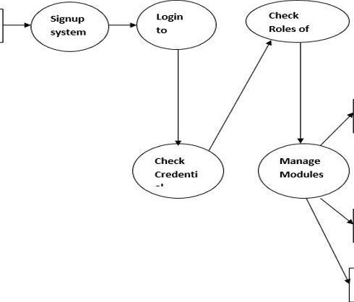

**User.s**

**View Vehicle**

Parking Details

Update Profile

Change Password

**Project Screens**

VEHICLE PARKINC MANACEMENT SYSTEM ADMIN USER'S



-

**Admin**

,:: O.w,boord

iiii Vc!IOCIC(olf$<l<Y

8 A.dd\'cl' f'

0 0 7

l, Jd,1,V·I

7

fo I/ hie [n111

!!! MJnJgt-Vehde

m Repo,1> ®  3

Q S.¥chVehicle

A R<gUS..'f>



-**Ad**-**min** **e**

.,..,.,,...,.. , OMhbOOtd

--

" -'d,t\>f'Ndo,

·-·

•

Q .-...·,,....-

**m**

*8.*

Admlnf>f"Of!M'

A.CSmon N•mo

UW-rN;)me,

Com.,«Numbor

,,.,...

touc-rl

**mm!**



**Admin** "' e

.-.

-

.. .......

V (.,C:q,:'.WV

Nfd .. 't'flid9,

()aShbodrd

*U Yc'Nd(,* Ch.rig• PMSWOl'd

cunc-nt P.,,nword

0. S..,chv...,_k NewPbSSWO<d

a .,.u....

C:Of'lfkm P.,UWOfd



**Ad**-**min** • **e.**

...

• -.• c-.,,y

-

>< ,.._

-

O.,,shboord

'-............ AddCM «y

* c.t N Vchck-(..,tt'&'()f'y

0. .....-th'- **m**

A

_,



-

O,wiboarit (),W **d** Mgtl1'lC01111 **Vthitlt**

*hldVH*

Jli■n *i'* lncom n Yrh[c



llJ -'llO'b S,N'O PIU:li'\ Nilmbtr 0/ti'M m• Vtll I **l!tfi** umliir Action



---

|  |  |  |  |  |  |
| --- | --- | --- | --- | --- | --- |
| 0. ;c,,c' | Jl300i8'9J | | Df1.-m7i; | | I Pt r |
| **\lil'r}** | *z*  .! | s,mm  917725 7 | rie  *MK* | OIL  CL1c nm | I "11nl |









iii 











**Admin** "' a

.... d

.. ..W• , r.._"""'""

.. Jl(ittV'°'.'li-0.

.. u-.,op. ,..,i.,

m -..

0

....,,,1g.,,



iL".Of'klnSNuntlMu'

V"tuccl♦ C.t♦.O,Y

" l<IQC'.-.-S

Vehl<I♦ <om nyN•m•



sr,nus



01.tCTY2322

TrstVSott'

123<&Sfi7890

.l0u1'.0J'.O l7:<IJ::(IJ

2019-07 o, '7:02:42

Vd'Jlt. Out

••



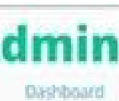**A**

..

c

_,,,.,

!lot_, D ll- llrporl



A,jlCSt

Q ... *a,* **'ttwde**

- Ihm

ilq>Dft from *2011* Ol DI to 2W2-0 11'.l

•••:kla1 Ym!!tr •Q **•N•mt** V lil lt R,tll tl!IMb. **r**

i;.,k<tl,/> c1111nc1,., OEL-613737

521 '}

46'}\l P•n>;.,t ll l ,.

7 5,4)23 ,1_,,,...ih Ol:L-56.'m

d]21 n,51) c:,n,c1 \l:lo6

J2iOD!WJ4 **Abhi** 0HM776

SlB7E;lll ""'"""' □H.s9Mu3

'll777 1Q7 **118'** Ot 1,l{TW

Yl<!w

v...,.

B ]'l,11836 T UWr OL *1cm 11 v,*



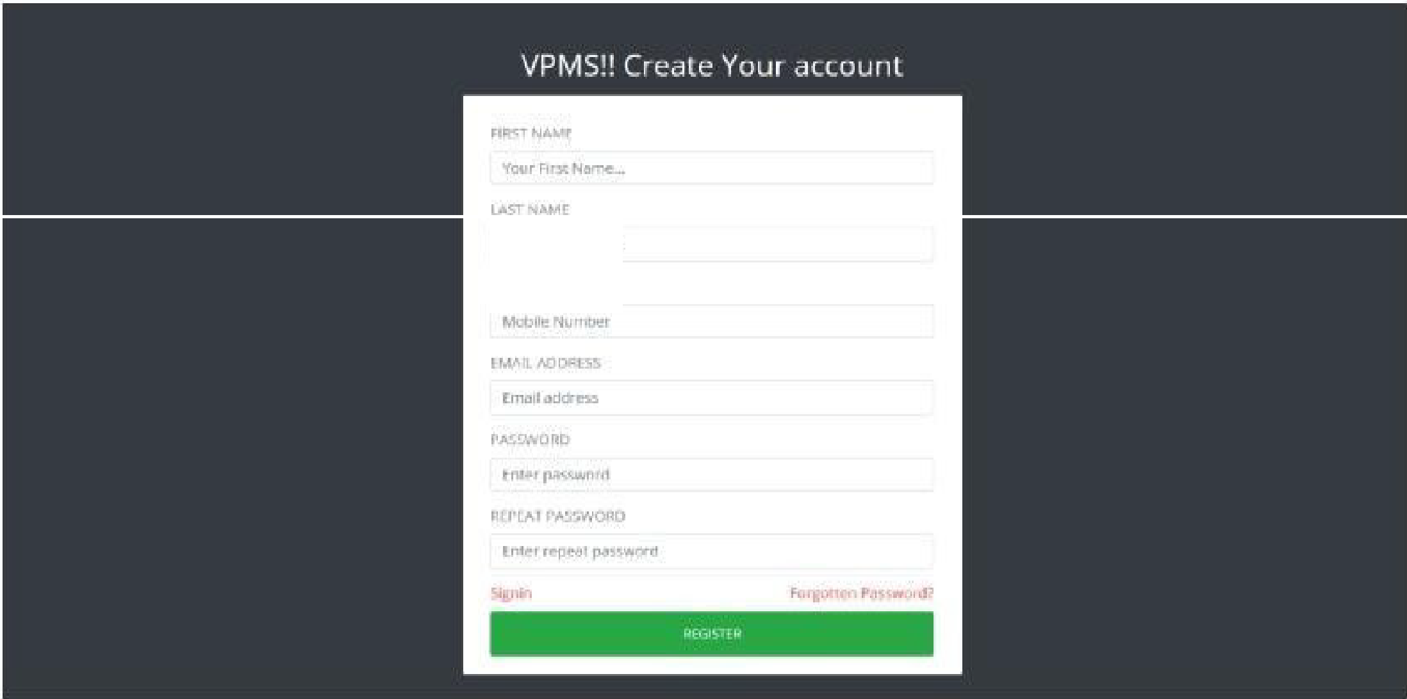

**'faurl..o5'!N'illme...**

'-"' It **r,n.,1r.1tstM**



ftEGISlEP.lOt AIL ORCONTACT N\J UlR

Reg..,,u•iC'd [IT\4lo1or Conr.1aNumbot"

PASSWORD

fnter pa.SSW(Jt'"'

VPMSUffn 0

##### Welcome to panel "Test Test

f>Mo. "11J

0

0.,shboord

ContAKt Nurnbc!t



*,*....

7987987987





l!:a



0

Oolshboard

Ch.ting•P4 won:I

Cuoent P'11s.sVlo'Ofd



m:I



VPMSUsen 0

Da$.hb00fd



p,.rldng Number Vt,hldeCHc-go,y

V hlc1• CompartyN•m•

Reg:l:stratlonNu-mbe<



s.}1'196069

1'Wowtk'-C'fM C.,t

-··

OH-618,-81

RakHhCNnck,> 79$79879$7

2022-0S.@ l l.2$:.)8:

Status Ve-hldot'out

NA

50Rs



Pil-f'ki"9 Nurnbe-t

v.hkt.GQmp,o..y N•m•

N.-me

tn nm.

.,,,,....

e,hCh,,,ndt.-

-

202l·OH)9 U,2$.*U*

2022-0 ,09 *11:oe,04*

NA

Vehicle Parking receipt

V.hic:le C•1ejek)'

l'lt,-•tion Numb<t,, ()w,-Cont N1,unti. St.-t\1:11



lwo CMitg,OCy Ofl-678781

79879'87987

OUl-90' \• i<le

,,,,,.

Data Dictionary :-

Admin Table

|  |  |
| --- | --- |
| Name | Type |
| ID | Int(20) |
| Admin name | Varchar(120  ) |
| User name | Varchar(120  ) |
| Mobile  Number | BigInt(10) |
| Email | Varchar(200  ) |
| Password | Varchar(120  ) |
| AdminRegDat  e | TimesTamp |

Vehicle Category Table

|  |  |
| --- | --- |
| ID | Int(20) |
| VehicleCat | Varchar(120  ) |

|  |  |
| --- | --- |
| CreationDat  e | TimesTamp |

Vehicle Details Table

|  |  |
| --- | --- |
| Name | Type |
| ID | Int(10) |
| Parking  Number | Varchar (120) |
| Vehicle  Category | Varchar (120) |
| Vehicle company  name | Varchar (120) |
| Registration  number | Varchar (120) |
| Owner name | Varchar (120) |
| Owner Contact  number | BigInt(10) |
| In Time | TimesTamp |
| Out Time | TimesTamp |
| Parking  charges | Varchar (120) |
| Remark | Mediumtext |
| Status | Varchar (5) |

Implementation and System Testing

* After all phase have been perfectly done, the system will be implemented to the server and the system can be used.

System Testing

* + The goal of the system testing process was to determine all faults in our project .The program was

subjected to a set of test inputs and many explanations were made and based on these explanations it will be decided whether the program behaves as expected or not. Our Project went through two levels of testing

1. Unit testing
2. Integration testing

# FUTURE WORK

Our System Vehicle Parking Management System is mainly used in big cities where now finding parking space can cause a lot of traffic

problems to Other vehicle and can take much time. so, this version Of computerized program Will now help in those fields. It can only be

managed by one people efficiently.

Although we have achieved many Of thoughts this project but there are still some which we need to work. In future we would now like to

improve financial transaction in computerized method according to time.

We Will be thankful fey your honest review or this software so we can make it even more efficient and With new feature,

Bibliography

### For PHP

➢ https://[www.w3schools.com/php/default.asp](http://www.w3schools.com/php/default.asp)

➢ https://[www.sitepoint.com/php/](http://www.sitepoint.com/php/)

➢ https://[www.php.net/](http://www.php.net/)

### For MySQL

➢ https://[www.mysql.com/](http://www.mysql.com/)

➢ [http://www.mysqltutorial.org](http://www.mysqltutorial.org/)

### For XAMPP

➢ https://[www.apachefriends.org/download.ml](http://www.apachefriends.org/download.ml)