Data Analytics (DA)
Module -1 - Excel
Excel Assignment 1 – Data Exploration
Dataset: Product Dataset
Attributes: Product ID, Product Name, Brand Name, Quantity, Category, Price
Basic Data Exploration
1. Sum, Count, and Average
Perform the following calculations using Excel functions:
● Calculate the total price of all products in the dataset.
Formula : =SUM(D2:D35)
Result : Rs.10100
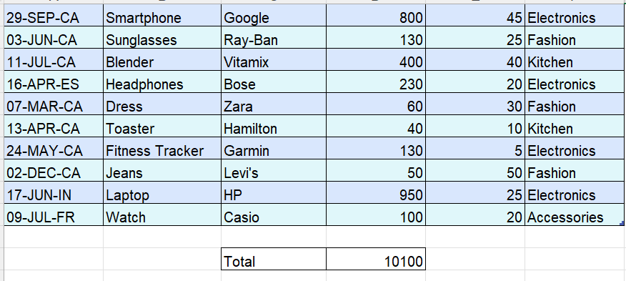
● Determine how many products exist in the dataset.
Formula: =COUNTA(UNIQUE(Table1[Product Name]))
Result: 21
● Calculate the average price of the products.
Formula: =AVERAGE(D2:D35)
Result: 297.06
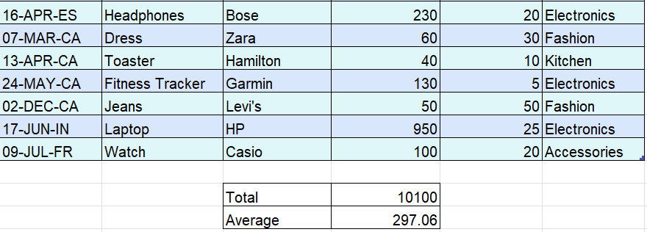

2. Minimum and Maximum Values
Using Excel functions:
● Identify the minimum price among all products.
Formula: =MIN(D2:D35)
Result: 30
● Identify the maximum price among all products.
Formula: =MAX(D2:D35)
Result: 1000
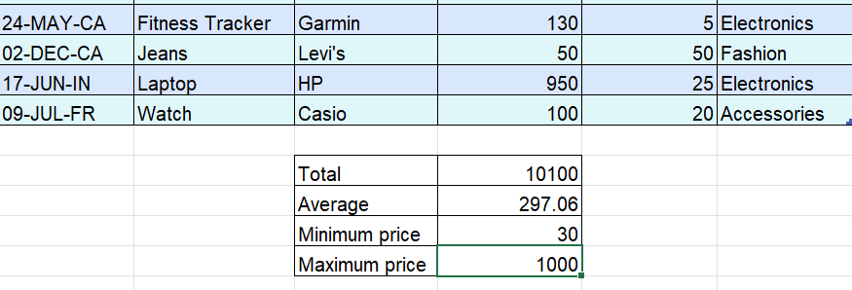

Logical Function – IF
● Create a new column named Price Range.
● Use the IF function to categorize products based on their price:
○ If Price ≥ $500 → classify as High Price
○ If Price < $500 → classify as Standard Price
Formula : =IF([@[Price ($)]] >=500,"High Price","Standard Price")
=IF(D2 >=500,"High Price","Standard Price")

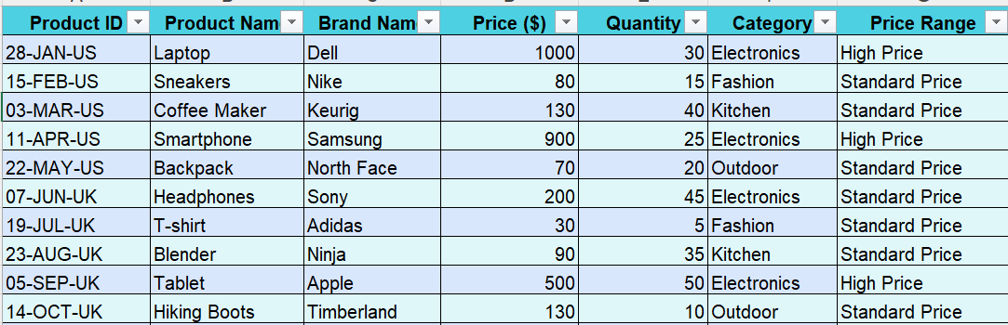

4.Conditional Functions – SUMIF and COUNTIF
Perform the following conditional calculations:
● Use the SUMIF function to calculate the total price of products in the
Electronics category.
Formula: =SUMIF(Table1[Category],"Electronics",Table1[Price ($)])
Result: 8050
● Use the COUNTIF function to determine the number of products with a price
less than $100.
Formula: =COUNTIF(Table1[Price ($)],"<=100")
Result: 12
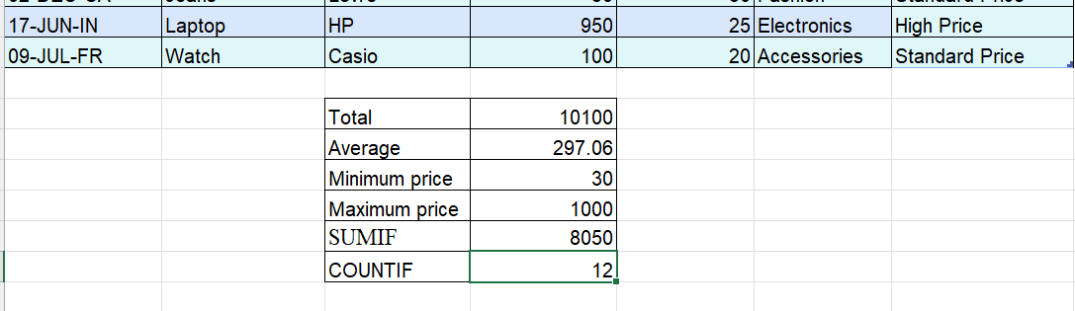

5. Text Formatting – LEFT, RIGHT, MID
● Use text functions to extract information from the Product ID column.
● Create the following new columns:
○ Create a new column named Day with the first 2 characters of each
'Product ID' using the LEFT function.
Formula: = =LEFT([@[Product ID]],2)
○ Create a new column named Country Code by extracting the last 2
characters from the 'Product ID' column using the RIGHT function.
Formula: =RIGHT([@[Product ID]],2)
○ Create a new column named Month by extracting the 4th to 6th
characters from the 'Product ID' column using the MID function.
Formula: =MID([@[Product ID]],4,3)
