Data Analytics (DA)
Module -2
Power BI Assignment 1 – Data Transformation & Data Modelling

Dataset Description:
You will work with the following three datasets:
● List of orders
Attributes: Order ID, Order Date, Customer Name, City, State, Category, Amount, Profit ● Order Details
Attributes: Order ID, Category, Sub-Category, Quantity, Amount, Profit
● Sales Target
Attributes: Category, Month of Order Date, Target

Tasks
Data Import & Transformation
1. Data Import:
○ Import List of Orders.csv into Power BI.
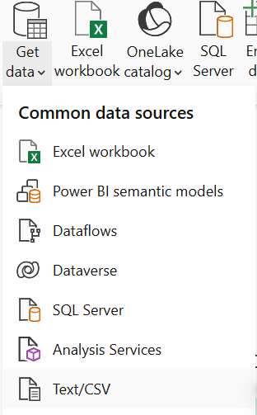
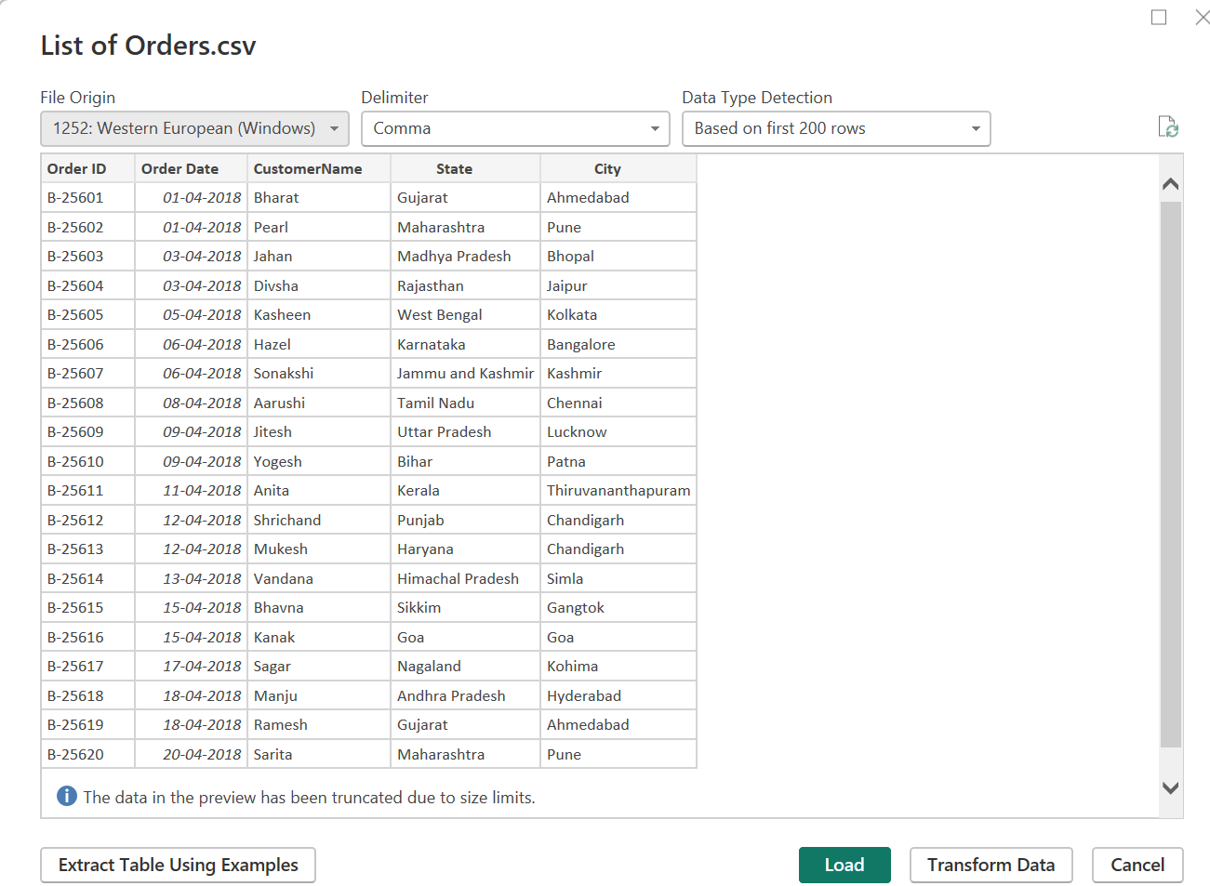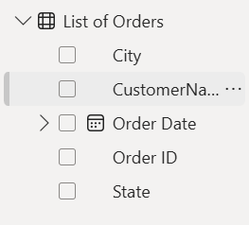
○ Open the list of orders in the Power Query Editor using the Transform Data option.
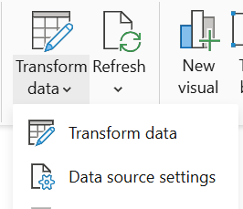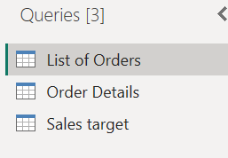
○ Import Order Details.csv and Sales Target.csv into Power Query Editor.
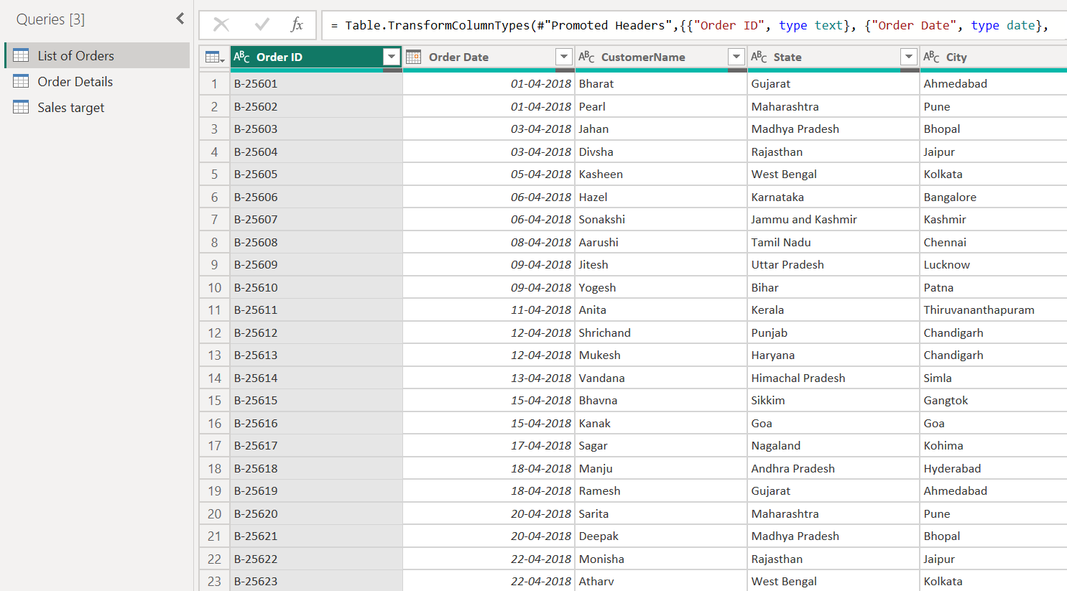

2. Row Limiting & Data Types:
○ Restrict the List of Orders table to the first 500 rows.
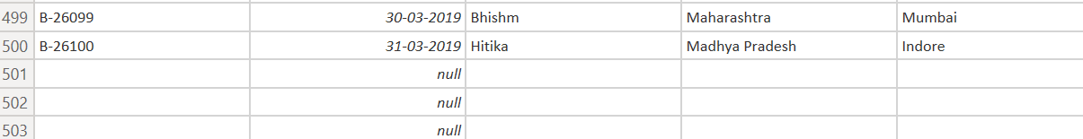
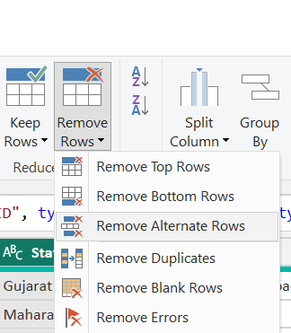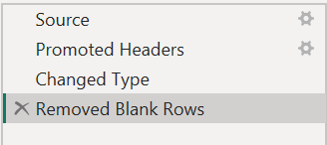
○ Set the Order Date column to the Date data type.
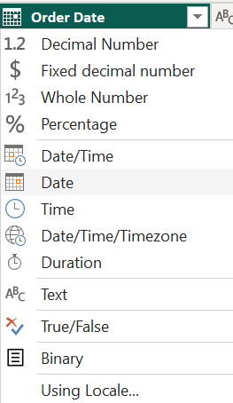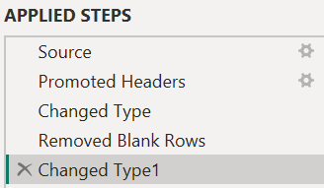
○ Change the Amount and Target columns to fixed decimal numbers.
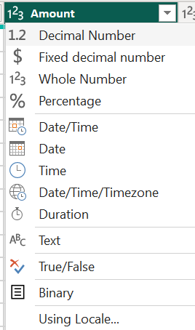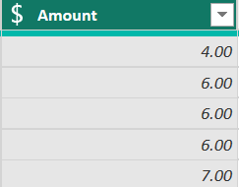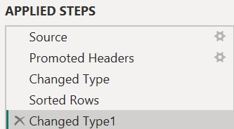

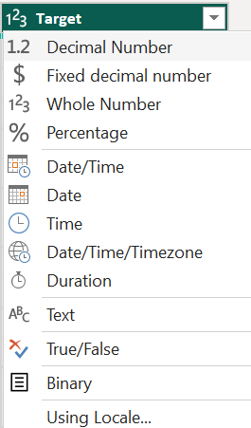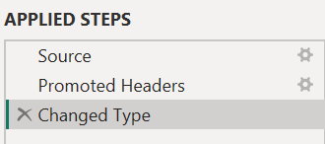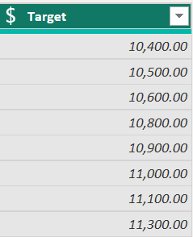
3. Text Formatting:
○ Format the CustomerName column to proper case to ensure consistent capitalization.

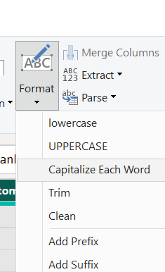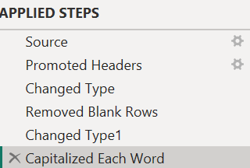

4. Column Creation:
○ Merge the City and State columns to create a new column named Location in the format: City, State
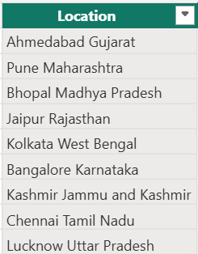
○ Create a custom column named Profit Margin calculated as: Profit / Amount (expressed as a percentage)
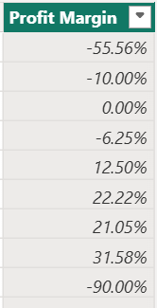

5. Conditional Column:
○ Add a conditional column named Profit Status based on:
■ Profit < 0 → Loss
■ Profit = 0 → Break-Even
■ Profit > 0 → Profit
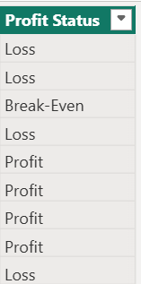

6. Merging Data (Joins)
○ Merge the List of Orders and Order Details tables using Order ID.
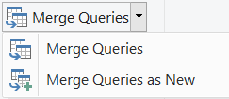
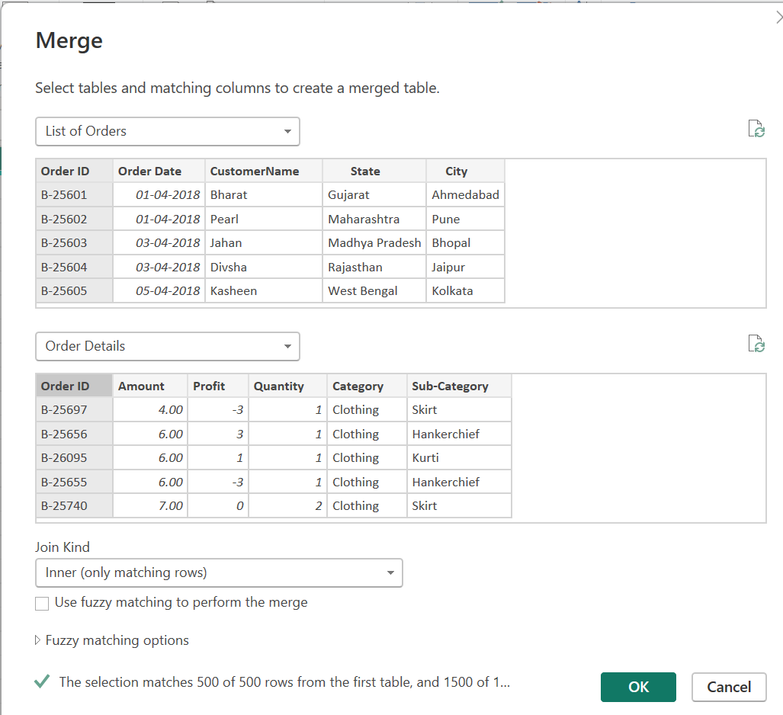
○ Name the merged output table as Orders Data.
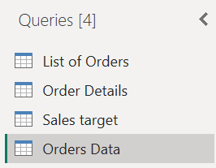

7. Handling Missing Data & Duplicate Data
● Identify missing values across all tables.
No Missing values are found.
Define and apply appropriate strategies such as:
○ Replacing missing values
Mean, Median, Mode can be used for replacing missing values.
○ Removing records

○ Retaining nulls with justification
Retaining nulls means keeping missing values in the dataset instead of replacing or removing them when the missing information itself is meaningful or when filling/removing the data could distort the analysis.
● Identify duplicate rows and define a suitable handling strategy based on business logic.
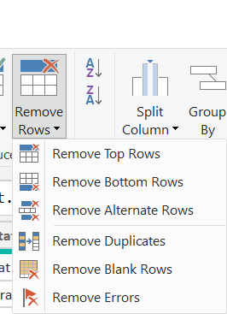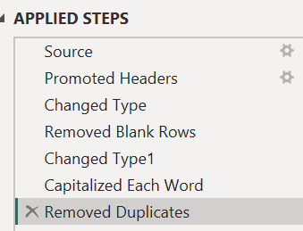
8. Sorting and Filtering Data
● Sort records in the Orders Data table by Order Date in descending order.
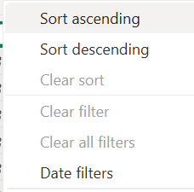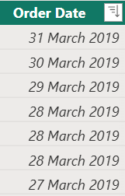
● Apply filters to analyze orders from a specific state (e.g., Tamil Nadu).
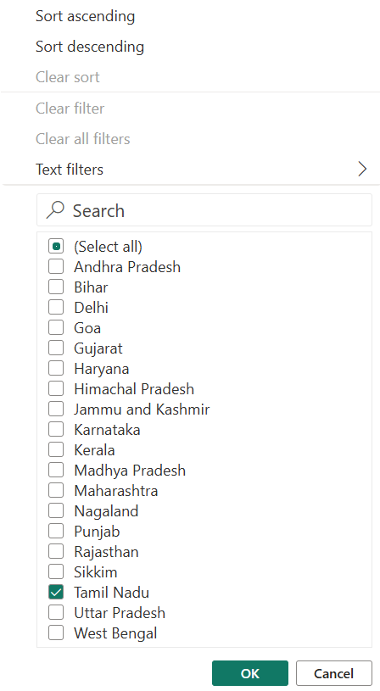
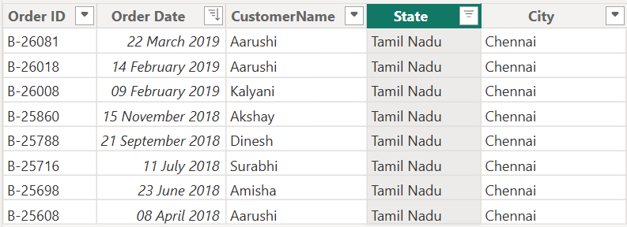

9. Grouping and Aggregating Data
● Duplicate the Order Details table and perform the following:
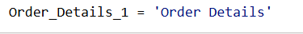
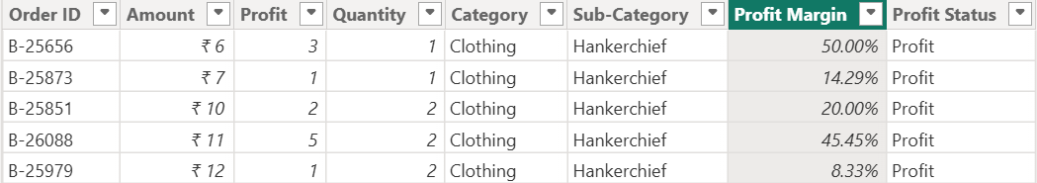

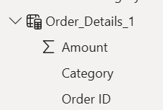
○ Count of Order ID
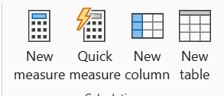
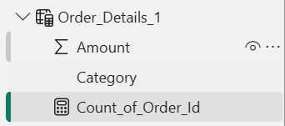
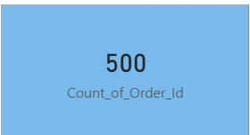
○ Average Profit by Category
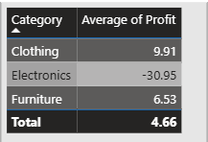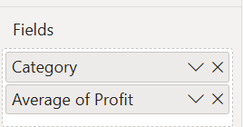

○ Total Amount by Sub-Category
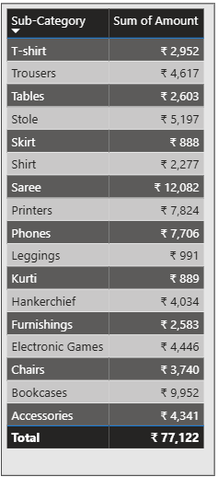
● Duplicate the Sales Target table and aggregate the total Target by Month of order date.
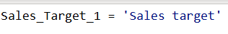

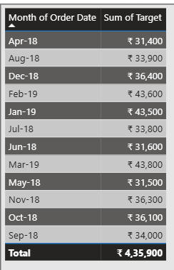
10. Data Modelling:
● Establish a relationship between:
○ List of Orders and Order Details using Order ID
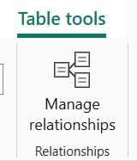
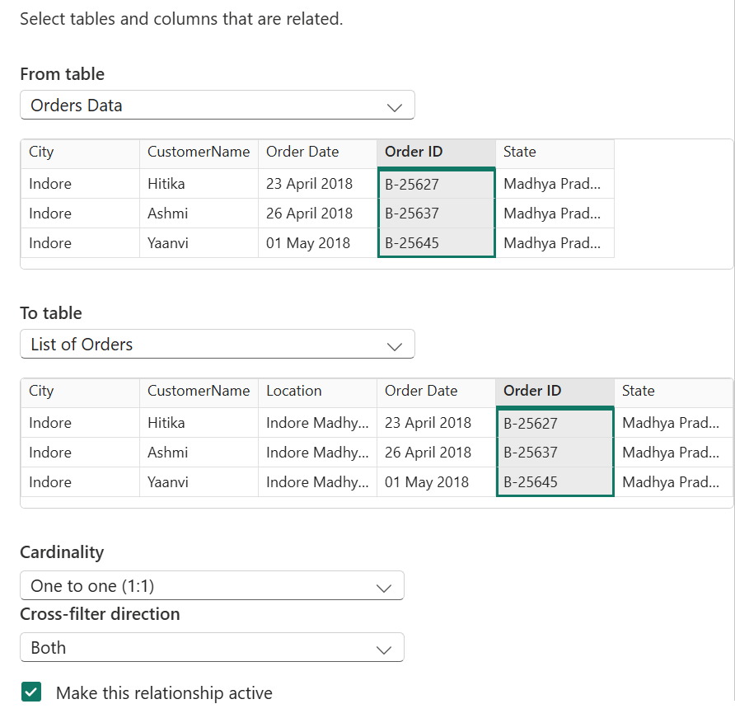
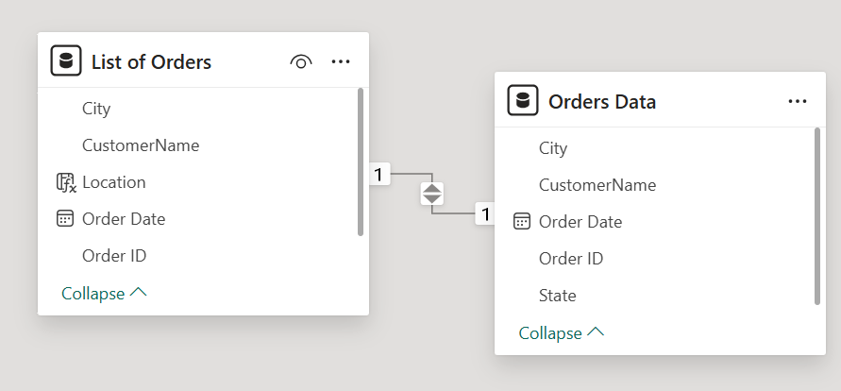
● Establish a relationship between:
○ Order Details and Sales Target using Category
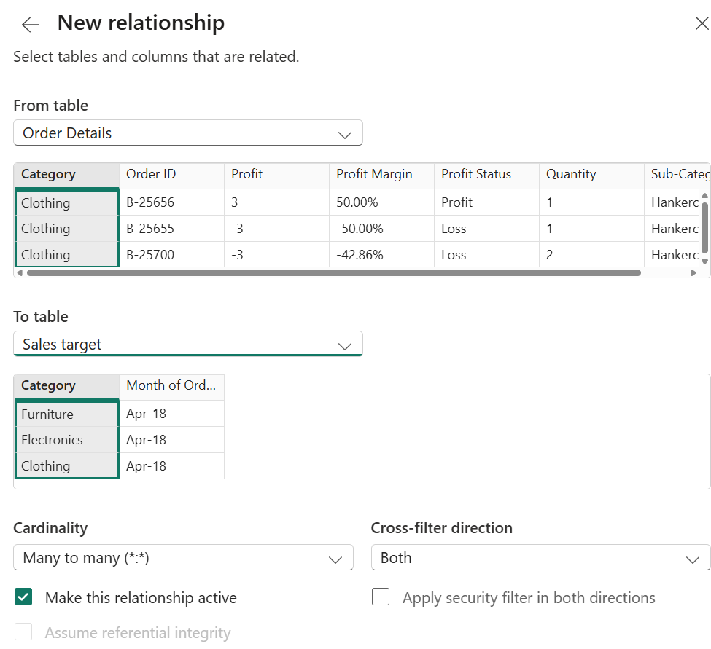
2. Use Manage Relationships to ensure relationships are active and correctly defined.
