Assignment ML

ANS 1 :

**Neural network**

Neural networks are computational models that work like neural networks in the human brain process information. They consist of layers of neurons that transform the input data into meaningful outputs .

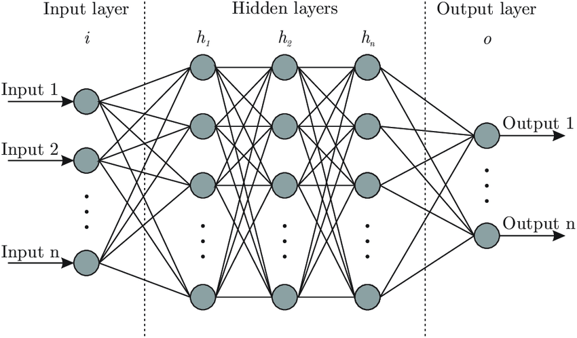

Types of neural networks :

1. **ANN ( Artificial Neural Network ):**

Used for regression and classification

It is a type of computational model that is inspired by the structure and function of the human brain, composed of interconnected nodes or "neurons" that process and transmit information .

They are used for solving complex machine learning problems such as image classification, recommendation systems, and language-to-language translation.

They are now using in various applications , including image recognition , speech recognition , and natural language processing .

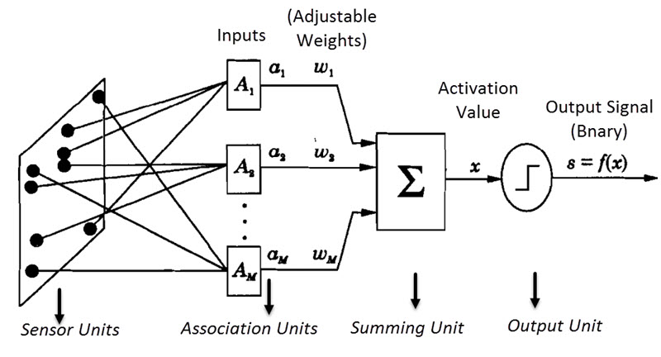

1. **CNN ( Convolutional Neural Networks ):**

Used for image classification

It is a type of neural network architecture that is particularly well-suited for image and video processing tasks. They are inspired by the structure and function

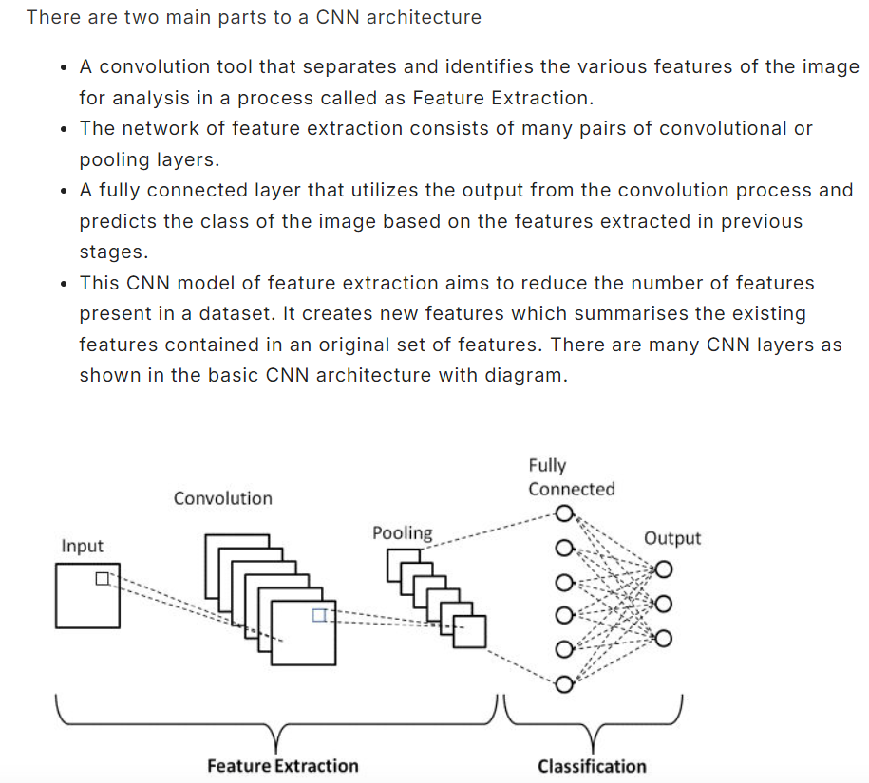

They are needed for image classification , object detection , and image segmentation tasks .

They are now used in applications like self-driving cars , facial recognition , and medical image analysis .

1. **GAN ( Generative adversarial networks):**

It is a type of deep learning algorithm that consists of two neural networks: a **Generator** and a **Discriminator**. The generator creates new data samples that are similar to a given dataset, while the discriminator evaluates the generated samples and tells the generator whether they are realistic or not.

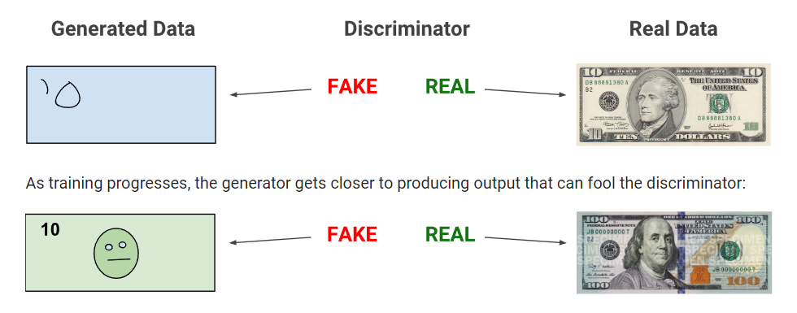

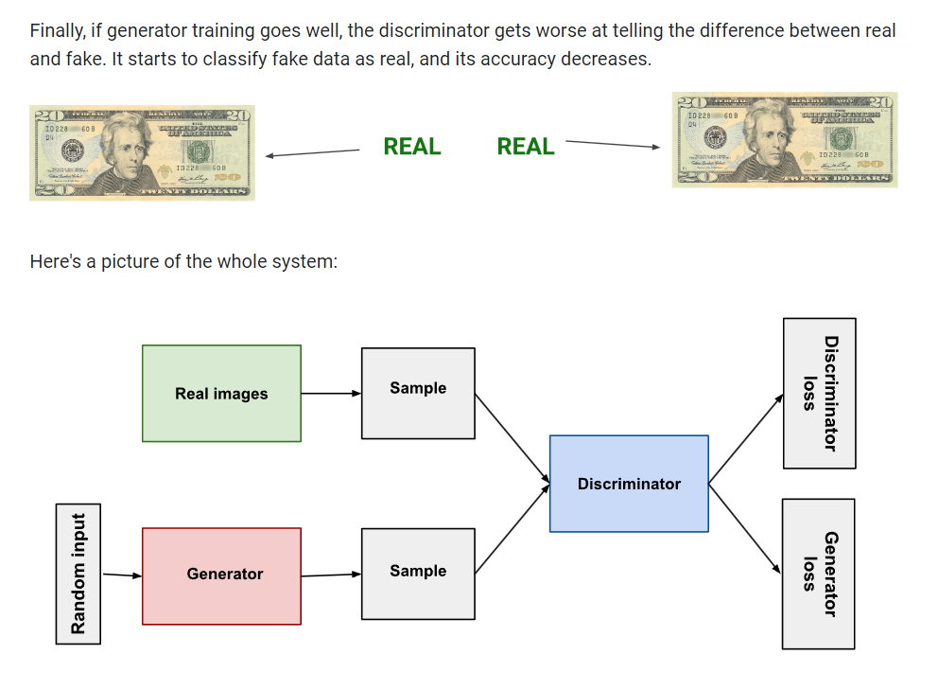

Through training , the generator improves at creating realistic samples, and the discriminator become better at distinguishing between real and fake samples and it can be used for image generation , data augmentation .

1. **Transformers**

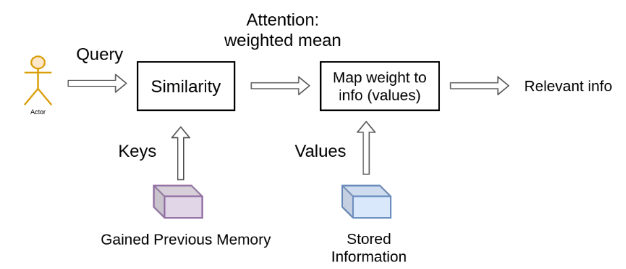

It is also a type of neural network architecture introduced in 2017 by Vaswani et al. in the paper "Attention is All You Need". They revolutionized the field of Natural Language Processing (NLP) and have since been widely adopted in many areas of machine learning.

Features of transformers :

1. **Parallelization** : they can be parallelized more easily than recurrent neural networks (RNNs), making them faster to train and deploy.
2. **Scalability** : they can handle longer input sequences and larger models than RNNs.
3. **Performance** : they have achieved state-of-the-art results in many NLP tasks, such as machine translation, text classification, and language modeling.

These transformers can be used in various applications

like Machine translation , language modelling , text classification , chatbots and conversational AI .

1. **Encoders :**

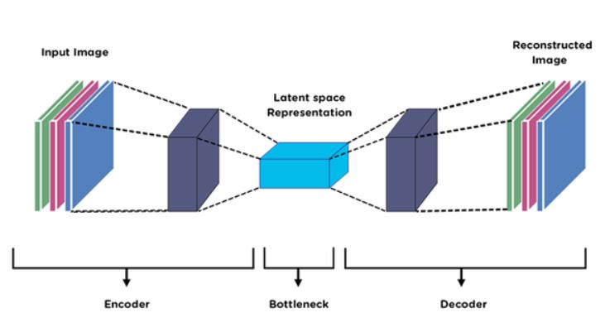

In machine learning, an encoder is a component of a neural network architecture that processes input data and transforms it into a lower-dimensional representation, called a latent representation or encoding. The encoder is typically used in conjunction with a decoder, which generates the output data from the latent representation.

It is needed for tasks like dimensionality reduction , anamoly detection , generative modelling , language modelling .

It often used as part of a large model , such as transformer or autoencoder.

1. **Large Language Models (LLMs):**

Local Linear Models (LLMs) are a type of machine learning model that combines the simplicity of linear models with the flexibility of non-linear models. It can assume that the relationship between the input features and the target variable is locally linear, meaning that the relationship can be approximated by a linear function within a small region of the input space.

It is used in many applications like regression tasks , classification tasks , time series forecasting and recommendation systems .

Here are some popular algorithms that are used in LLMs:

1. Local Linear Regression (LLR)
2. Piecewise Linear Regression( PLR)
3. Generalized Additive Models ( GAMs)
4. Tree -based Models ( e.g., CART , Random Forest )

**ANS 2: Super-resolution using GANs**

Super-resolution using GANs aims to enhance the resolution of images, making them clearer and more detailed. GANs can be used to generate high-resolution images from low-resolution inputs by learning the underlying distribution of high-resolution images, in the medical science as we now that sometime the input we want is not clear due to which is not possible give to accurate results that’s why its better is use this neural network with super resolution .

**Generative Adversarial Network (GAN)**: it’s a type of neural network which Consists of two main components, the Generator and the Discriminator.

* **Generator**: it creates high-resolution images from low-resolution inputs.
* **Discriminator**: it evaluates the quality of the generated images, distinguishing between real high-resolution images and generated ones.

**Implementation Steps**

**1. Data Preparation**

* **Collecting High-Resolution and Low-Resolution Image Pairs**:
* First we gather a dataset of high-resolution images and down sample them to create corresponding low-resolution images. Remember the dataset is large and diverse for better performance.

**2. Network Architecture**

* **Encoder Network**: Use a convolutional neural network (CNN) to extract features from the low-resolution images. This network will compress the input image into a latent space representation.
* **Generator Network**: Design a deep network (e.g., U-Net or ResNet) to upsample the feature representation from the encoder and reconstruct the high-resolution image. Incorporate techniques like residual connections and dilated convolutions to improve quality.
* **Discriminator Network**: Implement a CNN-based network that classifies images as either real (from the high-resolution dataset) or fake (generated by the Generator). This helps the Generator improve its output quality over time

**3. Training**

* **Loss Functions**: it use a combination of loss functions:
* **Adversarial Loss**: it measures how well the Generator can fool the Discriminator.
* **Content Loss**: it ensure the generated image is similar to the ground truth high-resolution image. Often implemented as Mean Squared Error (MSE) or L1 loss.
* **Perceptual Loss**: it measures the difference between high-level features of the generated and ground truth images, often using pre-trained networks like VGG.
* **Training Procedure**:
* There is alternate between training the Generator and the Discriminator.
* It uses a batch of low-resolution images to generate high-resolution images and compare them to the actual high-resolution images.
* Optimize the networks using gradient descent methods like Adam or RMSprop.

**4. Evaluation**

* **Quantitative Metrics**: it evaluate the performance using metrics such as Peak Signal-to-Noise Ratio (PSNR) and Structural Similarity Index (SSIM) to assess image quality.
* **Qualitative Assessment**: Inspect the generated images to ensure they are visually appealing and free from artifacts.

**5. Deployment**

* **Medical Field**: In medical imaging, implement the trained GAN model to enhance the resolution of diagnostic images such as MRI or CT scans. This can help in detecting finer details and improving diagnostic accuracy.
* **Camera Surveillance**: it apply the GAN model to enhance surveillance footage, making it easier to identify objects or individuals in low-resolution video feeds.

Ans 3 . Research problems involving Generative Adversarial Networks (GANs) for image super-resolution are broad and multifaceted. Below are some significant research problems that address current limitations and explore new frontiers in this area:

**1. Improving Image Quality and Realism**

**Problem**: GANs is used for generating high-resolution images with artifacts or unnatural textures, which can lower the perceived quality and orginality of the images.

* **Research Questions**:
  + How can the architecture of GANs be improved to minimize artifacts in super-resolved images?
  + What novel loss functions or regularization techniques can be introduced to enhance the visual quality and fidelity of the generated images?
* **Potential Approaches**:
  + Explore advanced GAN architectures, such as those incorporating self-attention mechanisms or novel residual connections.
  + Develop new perceptual or adversarial loss functions that better capture high-level visual features.

**2. Data Requirements and Generalization**

**Problem**: Training GANs for super-resolution often requires large amounts of high-quality paired data (high-resolution and low-resolution image pairs). In practice, such datasets may not be readily available.

* **Research Questions**:
  + How can GANs be trained effectively with limited or unpaired datasets?
  + Can techniques like transfer learning or domain adaptation improve performance when high-resolution data is scarce?
* **Potential Approaches**:
  + Investigate methods for semi-supervised or unsupervised learning using unpaired datasets.

Implementation of Encoders for super-resolution GANs (SRGANs) in the medical field and camera surveillance

Autoencoders are neural network-based data compression algorithms that are data-specific lossy and learn from examples. They consist of three key components:

1. **Encoding Function:** Compresses input data into a lower-dimensional representation.
2. **Decoding Function:** Reconstructs the original data from the compressed representation.
3. **Loss Function:** Measures the difference between the original and reconstructed data to minimize information loss during training.

Autoencoders are tailored to specific data types (e.g., faces) and may not generalise well to unrelated data (e.g., trees). They are lossy, meaning the decompressed data is slightly degraded. However, they are easy to train for specialised tasks with the right data.

* **Encoder**: The encoder is responsible for extracting key features from the low-resolution image. It typically consists of several convolutional layers that progressively reduce the spatial dimensions while increasing the depth of feature maps.
* **Decoder**: The decoder reconstructs the high-resolution image from the compressed feature representation. It uses techniques like deconvolution (transposed convolution) to increase the spatial dimensions back to the original resolution.

**Autoencoders are great for:**

1. **Data Denoising:** They clean up noisy data, making it clearer.
2. **Dimensionality Reduction:** They shrink data to fewer dimensions, which helps in visualizing it better. Autoencoders can find patterns that basic methods like PCA might miss.

### 

### **1. Problem Definition**

* **Medical Field**: Enhance the resolution of medical images like MRI, CT scans, or X-rays to improve diagnostic accuracy by revealing finer details that may not be visible in low-resolution images.
* **Camera Surveillance**: Upscale low-resolution footage to better identify individuals, objects, or events, aiding in security and forensic investigations

### **2. Data Collection and Preprocessing**

* **Medical Field**:
  + Collect a dataset of high-resolution medical images and their corresponding low-resolution counterparts. This can involve downsampling high-resolution images to create training pairs.
* **Camera Surveillance**:
  + Gather surveillance footage or images in both high and low resolution. Downsample high-resolution frames to create pairs.

### **3. Encoder-Decoder Architecture**

* **Encoder**: The encoder is responsible for extracting key features from the low-resolution image. It typically consists of several convolutional layers that progressively reduce the spatial dimensions while increasing the depth of feature maps.
* **Decoder**: The decoder reconstructs the high-resolution image from the compressed feature representation. It uses techniques like deconvolution (transposed convolution) to increase the spatial dimensions back to the original resolution.

### **4. GAN Integration**

* **Generator**: The encoder-decoder acts as the generator in the GAN framework, attempting to generate high-resolution images from low-resolution inputs.
* **Discriminator**: The discriminator is trained to differentiate between real high-resolution images and the generated ones.
* **Loss Functions**:
  + **Content Loss**: Usually based on the difference between the generated high-resolution image and the ground truth, measured using pixel-wise loss (e.g., MSE or L1 loss).

**5. Training Strategy**

* **Dataset Splitting**: Divide the dataset into training, validation, and test sets. Ensure that the model is not overfitting by using a diverse set of images.
* **Training Process**:
  + Alternate between training the generator and the discriminator.
  + Use a learning rate scheduler and early stopping to prevent overfitting.
  + Fine-tune the model by using techniques like transfer learning, especially in the medical field where annotated data is often scarce.

### **6. Post-processing**

* **Image Enhancement**: After generating the high-resolution images, apply further enhancement techniques like sharpening, denoising, and contrast adjustment to improve visual quality.

### **7. Evaluation Metrics**

* **PSNR (Peak Signal-to-Noise Ratio)**: Measures the quality of the reconstructed image compared to the original high-resolution image.
* **SSIM (Structural Similarity Index)**: Assesses the similarity between the generated and real images, focusing on structural information.
* **Qualitative Assessment**: In medical applications, have experts (e.g., radiologists) evaluate the quality and diagnostic utility of the enhanced images.

**8. Deployment**

* **Medical Field**: Integrate the model into medical imaging software, ensuring that it can process images in real-time or near-real-time.
* **Camera Surveillance**: Deploy the model in surveillance systems, where it can enhance images on the fly or process stored footage for analysis.

.

**Implementation**

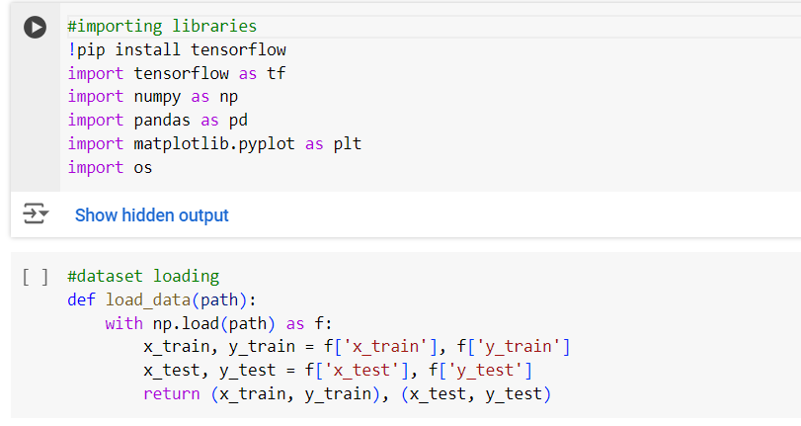

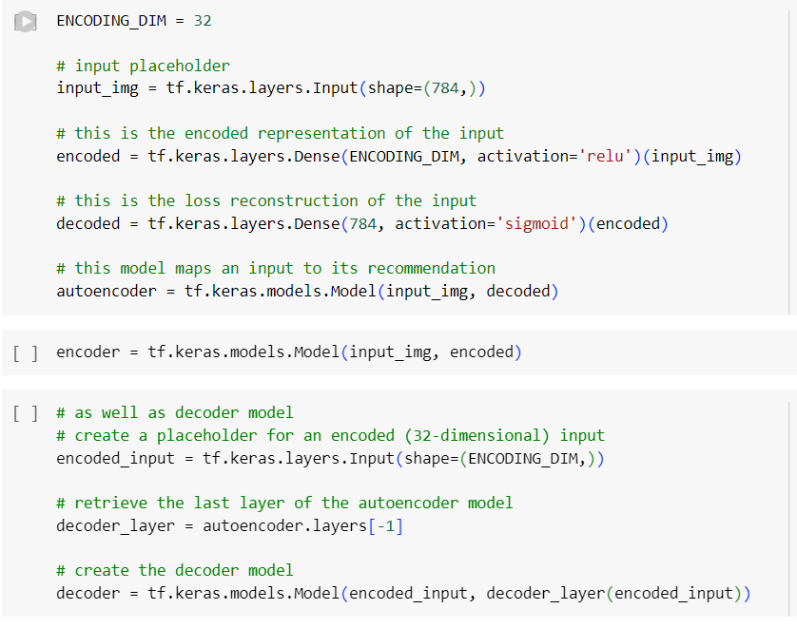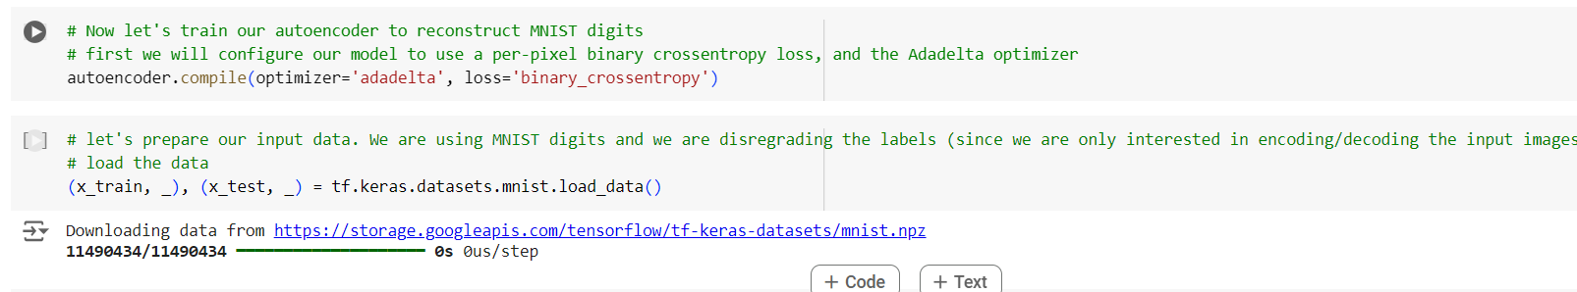

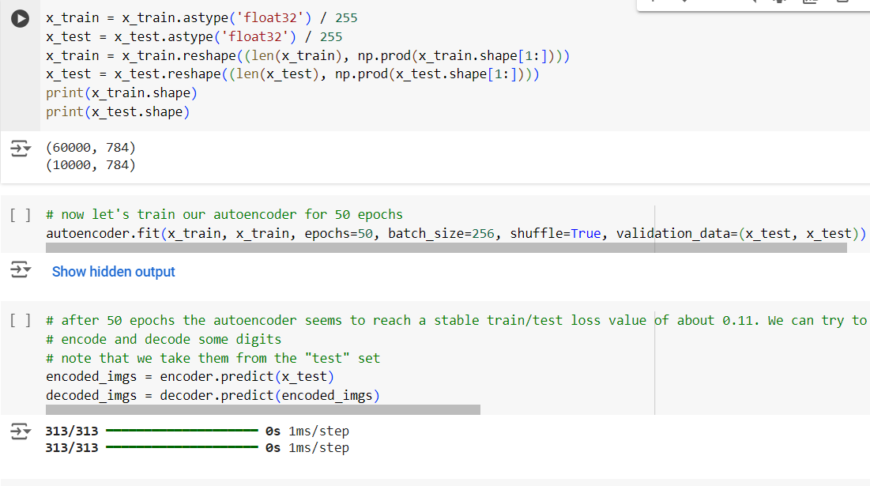

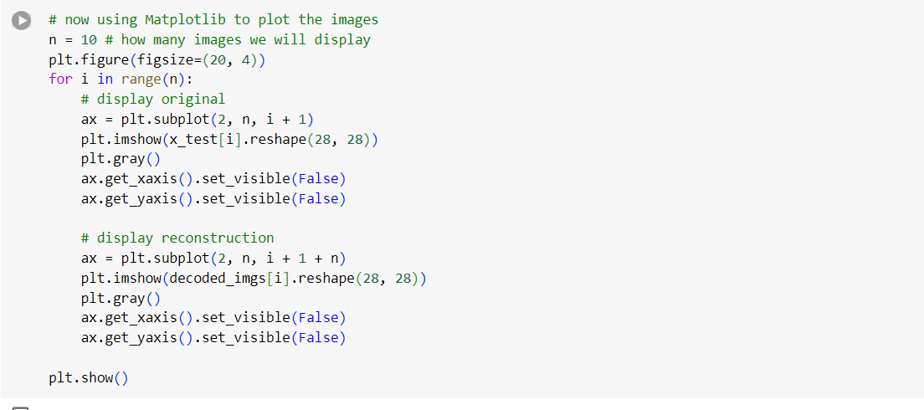

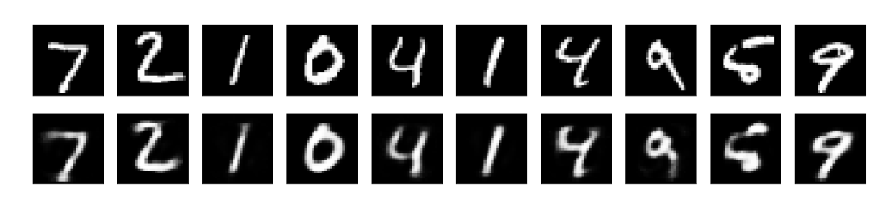

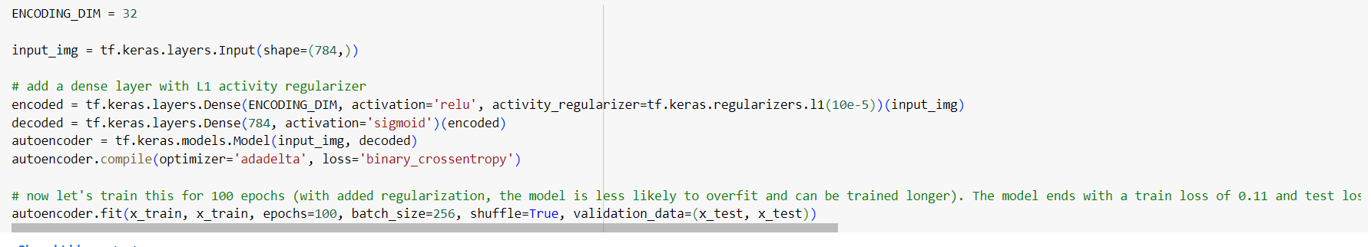

**Q. Why we use GAN for super resolution of images?**

**A.** Generative Adversarial Networks (GANs) are used for super-resolution of images because they excel at generating high-quality, realistic images, which makes them well-suited for enhancing the resolution of low-resolution images.

**High-Quality Image Generation**: GANs consist of two networks, a generator and a discriminator. The generator creates high-resolution images from low-resolution inputs, while the discriminator evaluates whether these images are realistic or not. This adversarial process helps the generator produce images that look more natural and detailed.

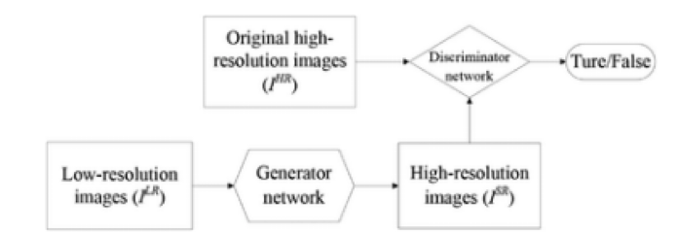

**Perceptual Loss**: In traditional methods, super-resolution focuses on minimizing pixel-wise differences (e.g., mean squared error) between the high-resolution and low-resolution images, which often leads to blurry results. GANs, however, can use a perceptual loss function that focuses on high-level features (e.g., edges, textures) extracted from a pre-trained network, leading to sharper and more visually pleasing images.

Perpetual loss function (LSR), which is used by the SRGAN, is the weighted sum of two types of loss: content loss and adversarial loss. For the generator architecture's performance, this loss is crucial.



**Learning Fine Details**: GANs are particularly good at learning and recreating fine textures and details in images, which are crucial for high-quality super-resolution. This makes the output images look more realistic compared to outputs from other methods.

**Adaptive Upscaling**: GANs can learn complex mappings from low-resolution to high-resolution images, adapting to different image types and content. This adaptability allows GANs to produce better results across a wide range of images, including faces, landscapes, and text.

**SRGAN**

