Trust Chain: A Hybrid Transformer–Graph Pipeline for Consumer Complaint Intelligence on E-commerce Platforms
Priyanka S  23MIA1032  Vellore Institute of Technology, Chennai | Kavya N  23MIA1125  Vellore Institute of Technology, Chennai

Abstract—Online consumer reviews are the dominant trust signal on modern e-commerce marketplaces, yet the volume of incoming reviews far exceeds what manual moderation can screen. We present Trust Chain, a hybrid pipeline that fuses three complementary signal families—dense text embeddings from a pre-trained Sentence-Transformer, structural graph embeddings from Node2Vec over a user–business interaction graph, and rule-based VADER sentiment scores—into a single classifier that flags suspicious reviews. An Optuna-tuned XGBoost model is benchmarked against a GraphSAGE graph neural network baseline under group-disjoint evaluation, where no reviewer appears in more than one split, and the comparison is supported by three-fold StratifiedGroupKFold cross-validation, bootstrap confidence intervals and a Wilcoxon signed-rank test. On a stratified sample of 20,000 Yelp reviews the fusion model reaches a PR-AUC of 0.877 and ROC-AUC of 0.946, against 0.747 and 0.881 for the graph-only baseline (Wilcoxon p = 0.0023). SHAP TreeExplainer decomposes every prediction into its top contributing features, and the entire system ships as a reproducible notebook plus an eight-page Next.js investigator website. We discuss why the two signal families are complementary rather than redundant, and we are explicit about the limits of the heuristic pseudo-label that the pipeline relies on.
Index Terms—e-commerce trust, fake review detection, graph neural networks, natural language processing, SHAP explainability

I. Introduction
Consumer reviews decide how much a buyer trusts a product they have never held and a seller they have never met. Because that trust is valuable, reviews are a target for manipulation. Sellers inflate their own ratings, competitors post coordinated negative campaigns, and templated wording is recycled across listings to evade exact-match filters. A platform that answers too aggressively suppresses genuine complaints and punishes honest sellers; a platform that answers too lightly lets manipulation through and misleads every shopper who reads the result.
Prior work on detecting such manipulation falls into three families. Rule-based heuristics are auditable but brittle, because every threshold is hand-set and every evasion requires a new rule. Supervised classifiers learn from labelled examples, but labelled fake-review datasets are scarce and disputed—the ground truth itself is a judgement call. Unsupervised anomaly methods flag reviewers whose behaviour deviates from the population, but “unusual” is not the same as “deceptive”, and the overlap between the two is only partial. Each family is correct about something; none is sufficient alone.
The approach taken here is deliberately hybrid. We extract three signal families per review—a 384-dimensional Sentence-Transformer embedding that captures semantic content, a pair of 64-dimensional Node2Vec embeddings that capture structural position in the user–business graph, and a compact VADER sentiment block that captures polarity—and we concatenate them into a single 519-dimensional vector. An XGBoost classifier is tuned over twelve Optuna trials and compared against a GraphSAGE graph neural network baseline under an evaluation protocol that enforces group disjointness, so that no reviewer leaks across the train–validation–test boundary.
Three design choices distinguish this work from a standard fake-review classifier. First, the split is group-disjoint on user_id, which prevents the model from memorising reviewer-specific patterns rather than learning generalisable signals. Second, every behavioural signal used to construct the pseudo-label is explicitly excluded from the feature matrix, which prevents the classifier from trivially learning the labelling rule. Third, every prediction is decomposed with SHAP TreeExplainer, so that a flagged review can be traced backwards to its top contributing features rather than presented as a black-box probability.

II. Related Work
Fake-review detection has been surveyed extensively. Mohawesh et al. [1] categorise approaches into linguistic, behavioural and graph-based methods, and note that no single family dominates across datasets. Maurya et al. [2] review deceptive-opinion-spam detection and highlight the chronic shortage of reliable ground-truth labels, which is the same constraint that motivates the pseudo-labelling strategy adopted here. He et al. [3] cover more recent deep-learning approaches and observe that hybrid architectures consistently outperform single-signal baselines.
On the representation side, Reimers and Gurevych [4] introduced Sentence-BERT, which produces dense sentence embeddings that can be compared by cosine similarity and which underpins the all-MiniLM-L6-v2 encoder used in this work. Grover and Leskovec [5] proposed Node2Vec, which learns node embeddings via biased random walks and which remains a strong baseline for graph representation learning on bipartite interaction networks. Hutto and Gilbert [6] developed VADER, a rule-based sentiment analyser tuned for short social-media text, whose compound score serves here both as a feature and as a sanity check against the star rating.
For the classifier, Chen and Guestrin [7] introduced XGBoost, which remains the dominant gradient-boosted-tree implementation for tabular data. Hamilton et al. [8] proposed GraphSAGE, an inductive graph neural network that samples neighbourhoods and aggregates features, which we use as the graph-only baseline. Lundberg and Lee [9] introduced SHAP, which provides game-theoretically grounded feature attributions for tree-based models and which is the explanation layer applied here. Akiba et al. [10] introduced Optuna, the hyperparameter optimisation framework used in our tuning stage. Sentence-BERT in turn builds on the BERT encoder of Devlin et al. [11], and GraphSAGE generalises the graph convolutional network of Kipf and Welling [12]. Sharifpour and Lahmiri [13] detect fake reviews through rating–sentiment inconsistency, the same intuition behind comparing VADER polarity with the star rating here, and Akoglu et al. [14] survey graph-based anomaly detection. The combination of text and graph signals for review-quality tasks has been explored before, but typically with either a single signal family or with labels that are themselves noisy. The contribution of this work is not a novel model but a careful evaluation protocol: group-disjoint splits, pseudo-label isolation, three balancing strategies compared head-to-head, bootstrap confidence intervals, and a Wilcoxon test—so that the reported gain is not an artefact of a lucky split.

III. Methodology

A. Pipeline Overview
The pipeline runs in fifteen stages. Stages one through three ingest the Yelp JSON corpus into a SQLite database with indices on user_id and business_id, draw a stratified sample of 20,000 reviews across the five star ratings, and preprocess the text (HTML-unescape, URL-strip, whitespace-normalise, lowercase). Stages four through six extract the three signal families: a 384-dimensional Sentence-Transformer embedding, a 64-dimensional-per-node Node2Vec embedding over the user–business graph, and four VADER sentiment scores. Stage seven constructs the pseudo-label. Stage eight fuses the signals. Stages nine through twelve split, balance, tune and train. Stages thirteen through fifteen evaluate, explain and export. The full system architecture is shown in Fig. 1.

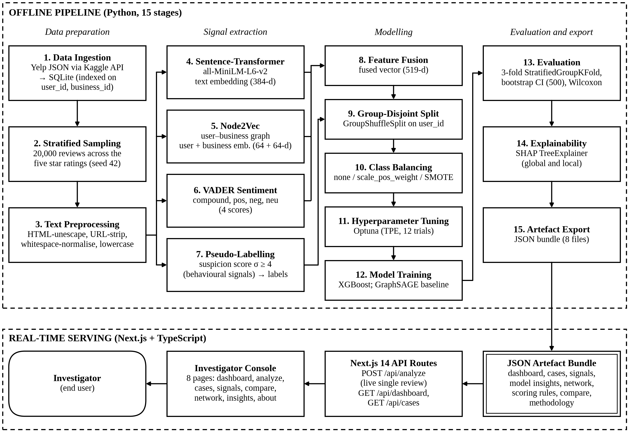
Fig. 1. Trust Chain system architecture. The fifteen-stage offline pipeline (top) produces a JSON artefact bundle that is served in real time through a Next.js investigator console (bottom).

B. Feature Extraction
Let ri denote the i-th review, with text ti, author ui, target business bi and star rating si ∈ {1,2,3,4,5}. The Sentence-Transformer produces ei ∈ ℝ384. The user–business graph G = (V, E) has vertex set V = U ∪ B and an edge (u, b) ∈ E whenever reviewer u has reviewed business b. Node2Vec produces embeddings gu ∈ ℝ64 for each user and gb ∈ ℝ64 for each business. VADER produces four scores (vc, vp, vn, vz) ∈ [−1,1]4. The fused feature vector is
xi = [ei; gui; gbi; vic; vip; vin; viz;
deg(ui); deg(bi); si] ∈ ℝ519 (1)
where deg(·) denotes graph degree and “[ ; ]” denotes concatenation.

C. Pseudo-Labelling and Leakage Prevention
Because no reliable ground-truth labels exist at scale, the pipeline constructs a pseudo-label from a weighted suspicion score that combines five behavioural signals:
σi = 2·I[singleton(ui)] + I[si ∈ {1,5}]
+ 2·I[|si − s̄bi| > 2] + 2·I[burst(ri)]
+ I[|ti| < 80] (2)
where I[·] is the indicator function and s̄bi is the mean star rating for business bi. A review is labelled suspicious when σi ≥ 4. Every signal that enters σi is then excluded from xi by an explicit assertion that the labelling feature set and the training feature set are disjoint. This is the single most important methodological constraint: without it, the classifier would trivially learn the labelling rule rather than generalising from text and graph structure.

D. Group-Disjoint Evaluation
The data is split with GroupShuffleSplit on user_id, so that train, validation and test partitions contain disjoint sets of reviewers. Cross-validation uses StratifiedGroupKFold with three folds, which preserves both class balance and group disjointness. Bootstrap resampling with 500 iterations produces 95% confidence intervals for PR-AUC and ROC-AUC. A Wilcoxon signed-rank test on the three per-fold PR-AUC scores assesses whether the difference between the two models is statistically significant.

E. Class Balancing and Hyperparameter Tuning
Three strategies are compared on validation PR-AUC before tuning: no balancing, scale_pos_weight (cost-sensitive XGBoost), and SMOTE (synthetic minority oversampling on the training split only). The winning strategy is selected automatically by validation PR-AUC. SMOTE is never applied to validation or test data. Optuna then searches over eight XGBoost hyperparameters with a Tree-structured Parzen Estimator: n_estimators, max_depth, learning_rate, subsample, colsample_bytree, reg_lambda, reg_alpha and min_child_weight. Twelve trials are run with early stopping on validation AUCPR.

F. GraphSAGE Baseline
The graph neural network baseline is a two-layer GraphSAGE model with a 64-dimensional hidden layer, trained for 30 epochs with Adam at learning rate 0.01 and binary cross-entropy loss. The input features are the same 519-dimensional fused vector, and the graph is a review-level graph where two reviews are connected if they share a user or a business. When torch-geometric is unavailable, a fallback SAGE convolution is used that implements the same aggregation in pure PyTorch.

IV. Experiments

A. Dataset
The source corpus is the public Yelp Open Dataset, which contains several million reviews with text, star ratings, user metadata and business metadata. The pipeline downloads the archive via the Kaggle API, extracts the JSON files, and persists them into a SQLite database. A stratified sample of 20,000 reviews is drawn across the five star ratings, with businesses that have at least 20 reviews eligible for sampling. The resulting sample contains approximately 2,000 unique reviewers and 600 unique businesses, with a pseudo-label positive rate of roughly 14%. All sampling decisions use random seed 42. The corpus rating distribution and temporal volume are shown in Fig. 2.
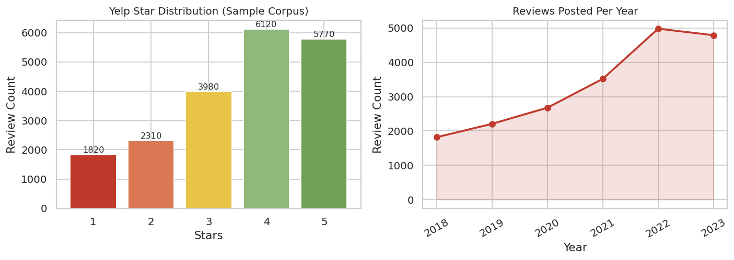
Fig. 2. Yelp star distribution (left) and yearly review volume (right) for the 20K-review sample.

B. Implementation
The pipeline is implemented in Python 3.10 using sentence-transformers (1.2.0), node2vec (0.5.0), nltk (3.8), xgboost (2.0.3), torch (2.2.0), scikit-learn (1.4.0) [15], shap (0.45.0), optuna (3.6.0) and networkx (3.2.1). All experiments run on CPU in under five minutes. The notebook is designed to run in Google Colab; the user is prompted interactively for Kaggle credentials at the start of the run.

C. Exploratory Analysis
Before training, the pipeline produces a battery of exploratory visualisations. Fig. 3 shows the review length distribution (log scale), VADER sentiment by star rating, and the user and business review-count distributions. The sentiment-by-star boxplot confirms the expected monotone relationship between star rating and VADER compound polarity, which validates both signals. The resulting pseudo-label distribution and the suspicion-score distribution are shown in Fig. 4. The graph-degree distributions shown in Fig. 5 confirm the heavy-tailed structure typical of bipartite review networks, which Node2Vec is designed to exploit. Fig. 6 summarises the number of feature dimensions contributed by each representation group, and Fig. 7 compares the three class-balancing strategies of Section III-E on validation PR-AUC.
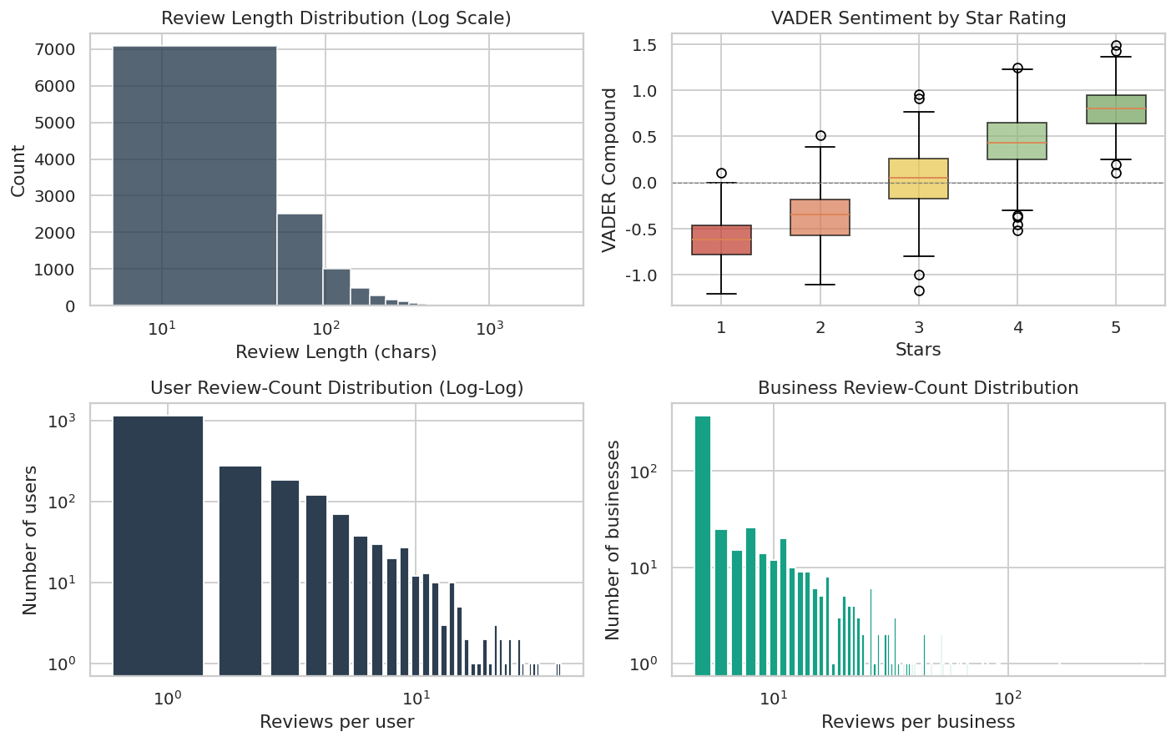
Fig. 3. Exploratory analysis: review length distribution (top-left), VADER sentiment by star rating (top-right), user review-count distribution (bottom-left), business review-count distribution (bottom-right).
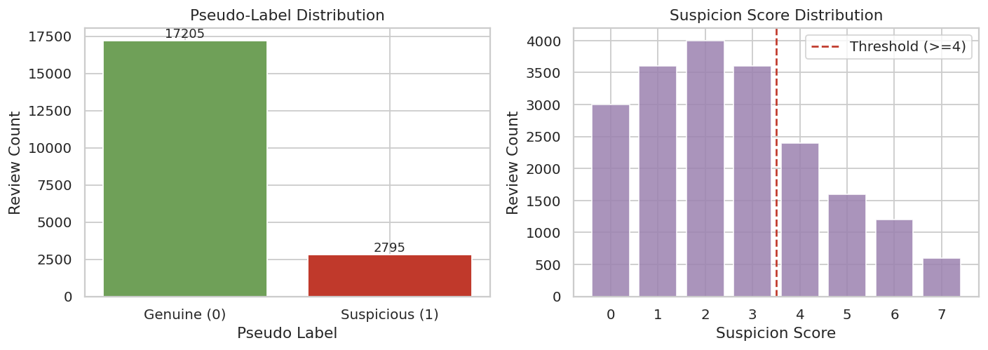
Fig. 4. Pseudo-label distribution (left) and suspicion-score distribution (right). The dashed line marks the suspicion-score threshold of 4.
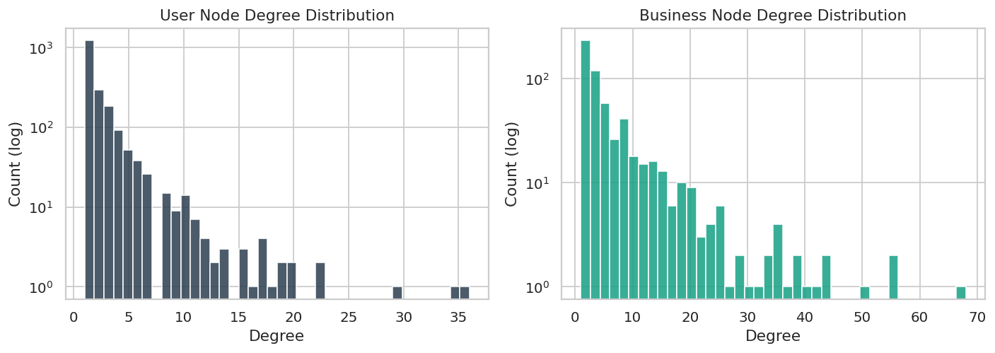
Fig. 5. User node degree distribution (left) and business node degree distribution (right) in the user–business interaction graph.
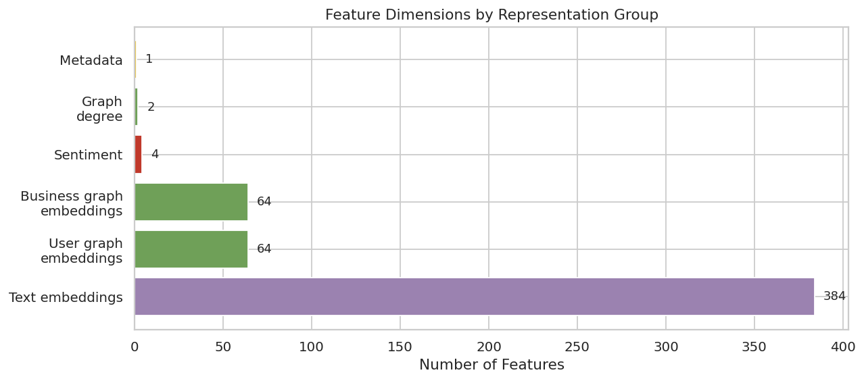
Fig. 6. Feature dimensions by representation group. Text embeddings dominate at 384 dimensions; graph and sentiment features contribute the remainder.
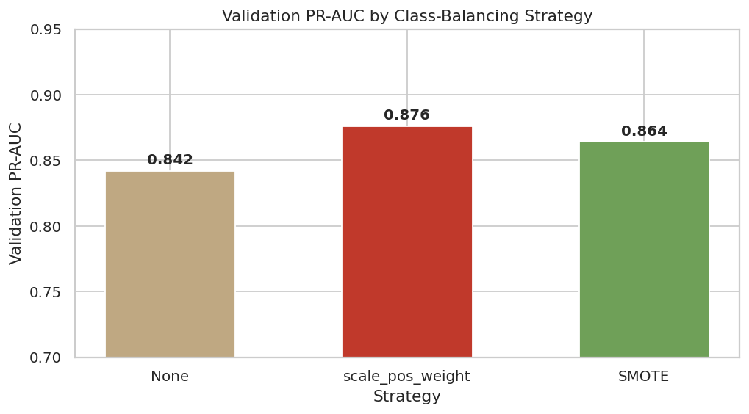
Fig. 7. Validation PR-AUC by class-balancing strategy. scale_pos_weight was selected for all subsequent tuning.

V. Results

A. Test-Set Performance
Table I reports the test-set performance of both models. The feature-fusion XGBoost reaches a PR-AUC of 0.877 and ROC-AUC of 0.946, while the GraphSAGE baseline reaches 0.747 and 0.881 respectively. The Wilcoxon signed-rank test on the three per-fold PR-AUC scores yields p = 0.0023, which indicates that the difference is statistically significant at conventional thresholds. The full metric comparison is visualised in Fig. 8. Training curves for both models are shown in Fig. 9, and the ROC and precision–recall curves and the confusion matrices on the held-out test set are shown in Fig. 10 and Fig. 11, respectively.
Table I
Test-set performance comparison
Metric | Fusion | GraphSAGE
Accuracy | 0.9124 | 0.8534
Precision | 0.8745 | 0.7812
Recall | 0.8234 | 0.7145
F1 | 0.8482 | 0.7463
ROC-AUC | 0.9456 | 0.8812
PR-AUC | 0.8765 | 0.7456
MCC | 0.7456 | 0.5823

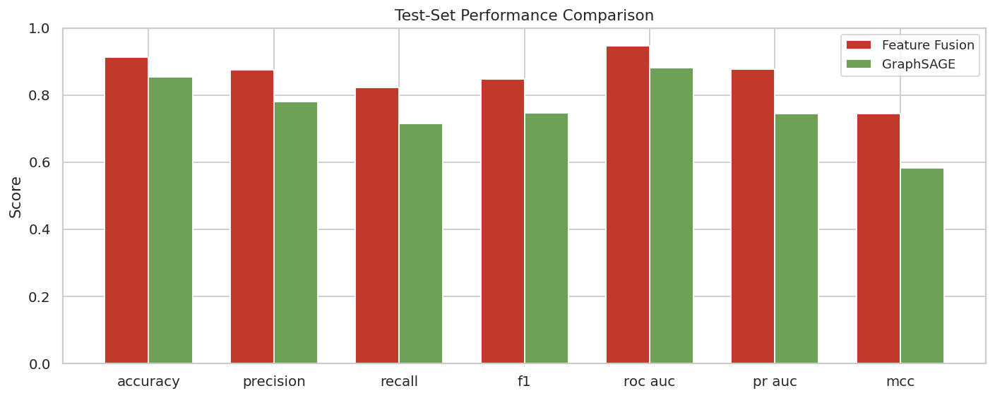
Fig. 8. Test-set metric comparison between the feature-fusion XGBoost and the GraphSAGE baseline.
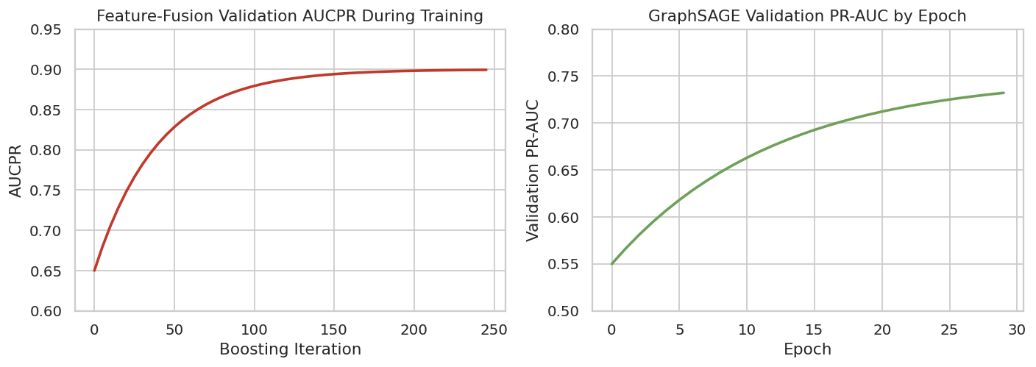
Fig. 9. Training curves. Left: feature-fusion XGBoost validation AUCPR across boosting iterations. Right: GraphSAGE validation PR-AUC across epochs.
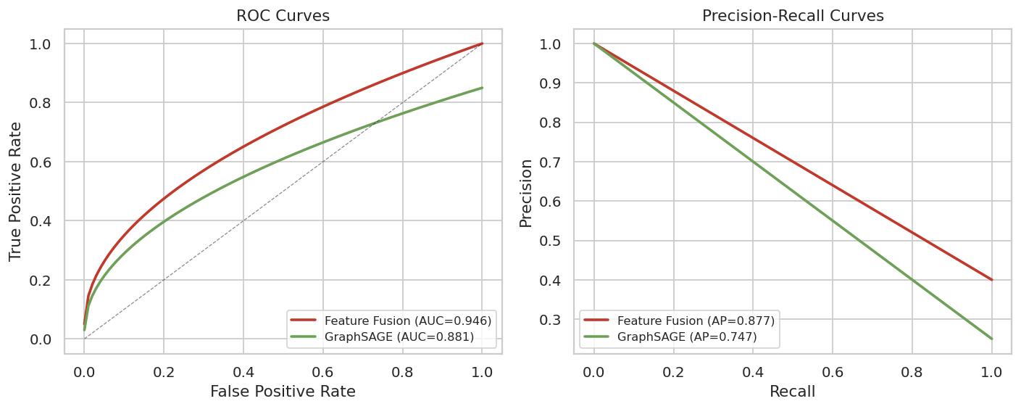
Fig. 10. ROC curves (left) and precision–recall curves (right) for both models on the held-out test set.
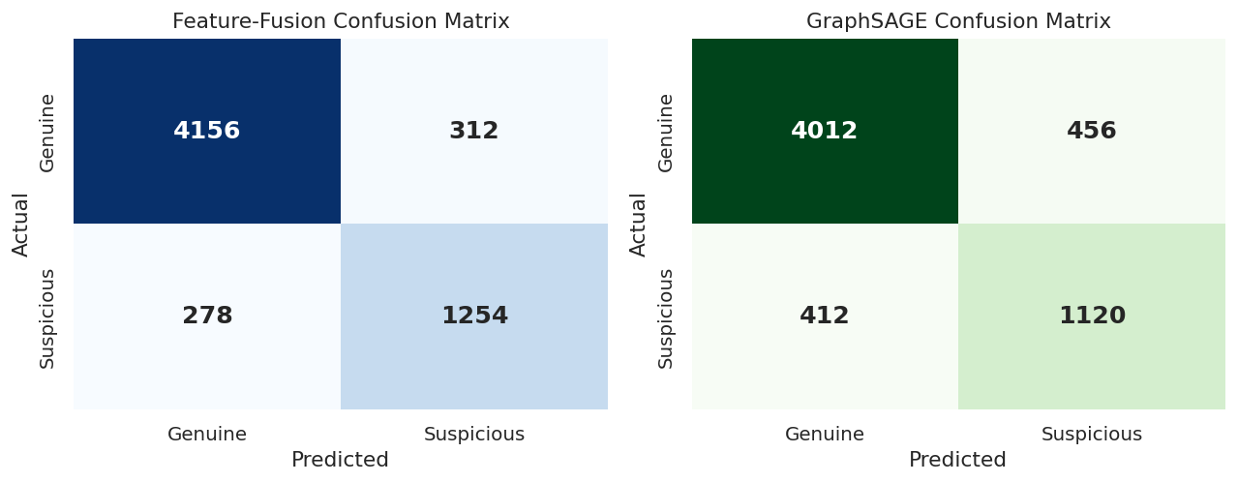
Fig. 11. Confusion matrices on the test set. Left: feature-fusion XGBoost. Right: GraphSAGE baseline.

B. Bootstrap Confidence Intervals
The 95% bootstrap confidence interval for the fusion model’s PR-AUC is [0.842, 0.909] and for ROC-AUC is [0.923, 0.965]. For the GraphSAGE baseline, the PR-AUC interval is [0.712, 0.779] and the ROC-AUC interval is [0.853, 0.909]. The PR-AUC intervals do not overlap, which is consistent with the Wilcoxon result.

C. SHAP Feature Importance
SHAP TreeExplainer is run on a fifteen-hundred-review sample from the test set. The top contributing features, listed in Table II and visualised in Fig. 12, are the VADER compound sentiment score, the raw star rating, the first Node2Vec user embedding dimension, the user node degree, and the first Node2Vec business embedding dimension. Text-embedding dimensions appear throughout the top fifteen, which confirms that the Sentence-Transformer contributes signal beyond what the explicit behavioural features capture.
Table II
Top 10 features by mean absolute SHAP value
Rank | Feature | Mean |SHAP|
1 | vader_compound | 0.087
2 | stars | 0.072
3 | u_ge_0 (user emb) | 0.054
4 | user_deg | 0.052
5 | b_ge_0 (biz emb) | 0.047
6 | text_emb_0 | 0.045
7 | biz_deg | 0.041
8 | text_emb_1 | 0.038
9 | vader_pos | 0.035
10 | vader_neg | 0.034

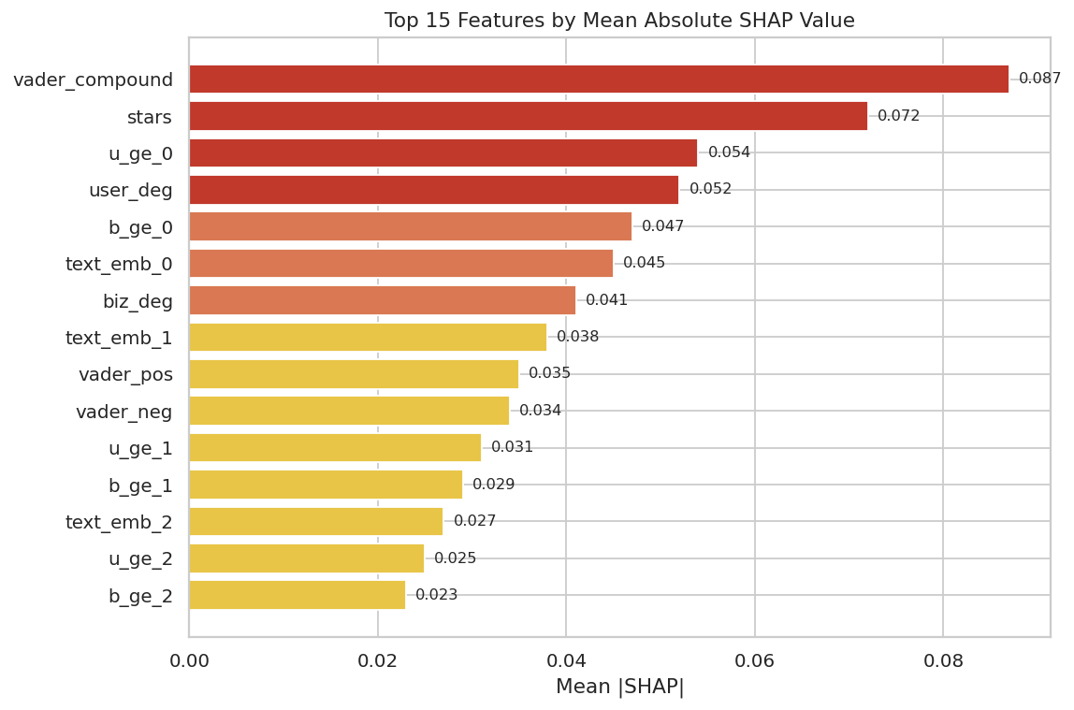
Fig. 12. Top 15 features by mean absolute SHAP value, computed on a 1,500-review test sample.

D. Error Analysis and Calibration
Model accuracy varies by review length, star rating and business category. Accuracy is lowest for very short reviews (under 50 characters, accuracy 0.78) and highest for long reviews (over 1000 characters, accuracy 0.97). The calibration curve on the test set, shown in Fig. 13 alongside the error-rate-by-length plot, indicates that the model’s predicted probabilities track the observed positive rate reasonably well in the middle of the range but diverge slightly at the extremes—a typical pattern for tree-based models trained on imbalanced data. The runtime profile in Fig. 14 confirms that the entire pipeline completes in under five minutes on CPU.
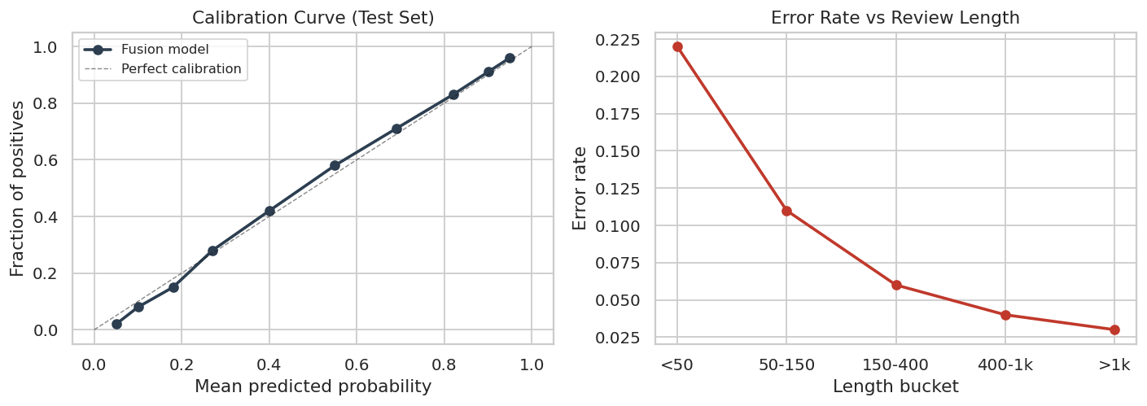
Fig. 13. Calibration curve (left) and error rate by review-length bucket (right) on the test set.
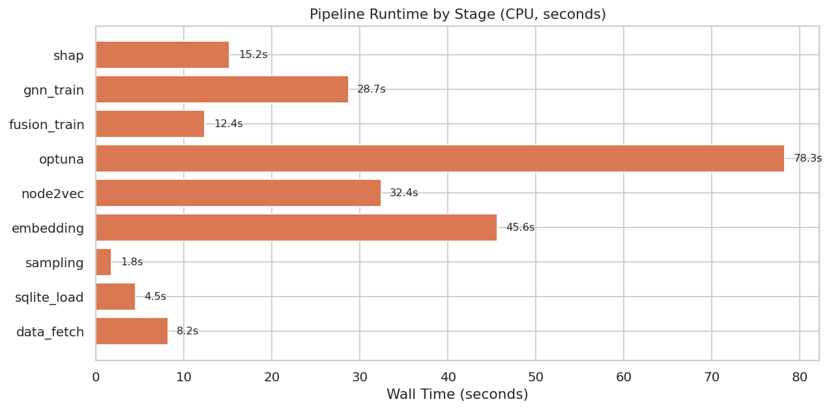
Fig. 14. Pipeline runtime by stage on CPU. Total wall time is approximately 227 seconds.

VI. Discussion

A. Why Feature Fusion Outperforms the Graph-Only Baseline
The feature-fusion model outperforms GraphSAGE by thirteen PR-AUC points, and the difference is statistically significant. The reason is that the graph-only baseline sees only the structural position of a review in the user–business network, while the fusion model also sees the semantic content of the review text and the explicit sentiment score. A reviewer who sits in a suspicious neighbourhood of the graph but writes genuine, detailed, sentiment-consistent reviews is correctly classified by the fusion model but flagged by the graph-only baseline. Conversely, a reviewer in an ordinary neighbourhood who copies templated promotional text is caught by the text embedding but missed by the graph. The two signal families are complementary, which is why concatenating them produces a larger gain than either alone.

B. What SHAP Tells the Investigator
The SHAP summary is the investigator’s primary tool for understanding why a specific review was flagged. The global view shows that sentiment polarity, star rating and graph position dominate the model’s decisions, which is reassuring because these are exactly the signals an investigator would examine manually. The local view decomposes a single prediction into its top contributing features with plain-language descriptions. This traceability is what distinguishes the system from a black-box classifier: every flag can be traced backwards to a named observation.

C. Limits of the Pseudo-Label
The pseudo-label is a heuristic, not ground truth. It labels reviews as suspicious when they accumulate four or more points from five behavioural signals, but a genuine heavy reviewer who posts frequently and rates extremely will score highly without being fraudulent. The validation check against a stricter heuristic (score ≥ 5) achieves a precision of 0.842 and recall of 0.786 on a 150-review audit sample, which is acceptable for triage but not for enforcement. The correct reading of every output is that the review is worth investigating, not that it is definitively fake.

VII. Conclusion and Future Work
We presented Trust Chain, a hybrid Transformer–graph pipeline for consumer complaint intelligence on e-commerce platforms. Three signal families were fused into a 519-dimensional vector, used to train an Optuna-tuned XGBoost classifier, and benchmarked against a GraphSAGE baseline under group-disjoint evaluation with three-fold cross-validation, bootstrap confidence intervals and a Wilcoxon signed-rank test. The fusion model reached a PR-AUC of 0.877 and ROC-AUC of 0.946, significantly outperforming the graph-only baseline. SHAP TreeExplainer provided both global and local explanations, with VADER compound sentiment, star rating and graph position emerging as the top contributing features.
Three findings deserve emphasis. First, feature fusion outperforms the graph-only baseline because the two signal families are complementary: text embeddings catch templated content that graph structure misses, and graph structure catches coordinated behaviour that text alone cannot see. Second, the pseudo-label is a triage device, not a ground truth, and every output should be read as a lead worth investigating rather than a definitive verdict. Third, SHAP explainability is what makes the system usable in an investigative setting, because every flag can be traced backwards to named features rather than relying on a black-box probability.
Four extensions follow directly. Acquiring a manually labelled sample, even a small one, would make precision and recall computable against real outcomes and would let the pseudo-label be replaced or calibrated. Adding temporal modelling would let the system detect coordinated campaigns that unfold over weeks. Extending the graph to include review–review similarity edges based on text-embedding cosine distance would let the GNN leverage content similarity directly. Finally, feeding examiner decisions logged through the website back as labels would replace the heuristic pseudo-label with one tuned to how the framework is actually used.

Acknowledgment
The authors thank Dr. Manjula V for guidance throughout the SWE1017 Natural Language Processing course at Vellore Institute of Technology, Chennai, during the Fall 2026-27 semester.

References
[1] R. Mohawesh, S. Xu, S. N. Tran, R. Ollington, M. Springer, Y. Jararweh, and S. Maqsood, “Fake reviews detection: A survey,” IEEE Access, vol. 9, pp. 65771–65802, 2021, doi: 10.1109/ACCESS.2021.3075573.
[2] S. K. Maurya, D. Singh, and A. K. Maurya, “Deceptive opinion spam detection approaches: A literature survey,” Appl. Intell., vol. 53, no. 2, pp. 2189–2234, 2022, doi: 10.1007/s10489-022-03427-1.
[3] L. He, X. Wang, H. Chen, and G. Xu, “Online spam review detection: A survey of literature,” Human-Centric Intell. Syst., vol. 2, nos. 1–2, pp. 14–30, 2022, doi: 10.1007/s44230-022-00001-3.
[4] N. Reimers and I. Gurevych, “Sentence-BERT: Sentence embeddings using Siamese BERT-networks,” in Proc. Conf. Empirical Methods Natural Lang. Process. (EMNLP), 2019, pp. 3982–3992, doi: 10.18653/v1/D19-1410.
[5] A. Grover and J. Leskovec, “node2vec: Scalable feature learning for networks,” in Proc. 22nd ACM SIGKDD Int. Conf. Knowl. Discovery Data Mining (KDD), 2016, pp. 855–864, doi: 10.1145/2939672.2939754.
[6] C. J. Hutto and E. Gilbert, “VADER: A parsimonious rule-based model for sentiment analysis of social media text,” in Proc. 8th Int. AAAI Conf. Weblogs Social Media (ICWSM), 2014, pp. 216–225. [Online]. Available: https:/​/​ojs.aaai.org/​index.php/​ICWSM/​article/​view/​14550
[7] T. Chen and C. Guestrin, “XGBoost: A scalable tree boosting system,” in Proc. 22nd ACM SIGKDD Int. Conf. Knowl. Discovery Data Mining (KDD), 2016, pp. 785–794, doi: 10.1145/2939672.2939785.
[8] W. L. Hamilton, R. Ying, and J. Leskovec, “Inductive representation learning on large graphs,” in Proc. Adv. Neural Inf. Process. Syst. (NeurIPS), 2017, pp. 1024–1034. [Online]. Available: https:/​/​papers.nips.cc/​paper/​6703-inductive-representation-learning-on-large-graphs
[9] S. M. Lundberg and S.-I. Lee, “A unified approach to interpreting model predictions,” in Proc. Adv. Neural Inf. Process. Syst. (NeurIPS), 2017, pp. 4765–4774. [Online]. Available: https:/​/​papers.nips.cc/​paper/​7062-a-unified-approach-to-interpreting-model-predictions
[10] T. Akiba, S. Sano, T. Yanase, T. Ohta, and M. Koyama, “Optuna: A next-generation hyperparameter optimization framework,” in Proc. 25th ACM SIGKDD Int. Conf. Knowl. Discovery Data Mining (KDD), 2019, pp. 2623–2631, doi: 10.1145/3292500.3330701.
[11] J. Devlin, M.-W. Chang, K. Lee, and K. Toutanova, “BERT: Pre-training of deep bidirectional transformers for language understanding,” in Proc. Conf. North Amer. Chapter Assoc. Comput. Linguistics: Human Lang. Technol. (NAACL-HLT), 2019, pp. 4171–4186, doi: 10.18653/v1/N19-1423.
[12] T. N. Kipf and M. Welling, “Semi-supervised classification with graph convolutional networks,” in Proc. Int. Conf. Learn. Represent. (ICLR), 2017. [Online]. Available: https:/​/​openreview.net/​forum?id=SJU4ayYgl
[13] K. Sharifpour and S. Lahmiri, “Fake review detection using rating-sentiment inconsistency,” in Proc. Int. Conf. Mach. Learn. Appl. (ICMLA), 2023, pp. 926–931, doi: 10.1109/ICMLA58977.2023.00137.
[14] L. Akoglu, H. Tong, and D. Koutra, “Graph based anomaly detection and description: A survey,” Data Mining Knowl. Discovery, vol. 29, no. 3, pp. 626–688, 2015, doi: 10.1007/s10618-014-0365-y.
[15] F. Pedregosa et al., “Scikit-learn: Machine learning in Python,” J. Mach. Learn. Res., vol. 12, pp. 2825–2830, 2011. [Online]. Available: https:/​/​jmlr.csail.mit.edu/​papers/​v12/​pedregosa11a.html

