

XDOS Ground Station — Software Architecture and Design

03 September 2026

XDLINX Space Labs Pvt. Ltd
Address:
Plot No. 19/2 Sector III,
HMDA Techno Enclave,Near Raidurg Metro Station
Madhapur, Hyderabad – 500 081, India.

DOCUMENT CONTROL
Classification/Distribution | Internal — Proprietary & Confidential
Report type | Internal Technical Review
Version and Revision | 1.0 / Revision 00
Title of the Report/ Document | XDOS Ground Station — Software Architecture and Design
Pages | 26
Author(s) | XDLINX Space Labs — Ground Software Team
Collaboration Partner/Agency | XDLINX Space Labs Pvt., Ltd.
Approved by
Date of Release | 03 September 2026
Project | XDOS
Form of circulation | Online
Abstract | This document describes the architecture and design of the XDOS ground station: a C++17 codebase comprising an operator telecommanding CLI, an on-board-computer bridge with an autonomous rate-group telemetry engine, a master-frame telemetry viewer, and six subsystem simulators. It specifies the network interfaces and port allocation, the CCSDS telecommand and telemetry frame formats, and the binary rate-group look-up table that lets the flight computer poll and downlink housekeeping telemetry without carrying any subsystem database. It closes with the verification status measured on the current working tree and a set of proposed next steps.

Table of Contents
1 Introduction 7
1.1 Overview of XDLINX Space Labs 7
1.2 Purpose and scope 7
1.3 Intended audience 8
1.4 Definitions, acronyms and abbreviations 8
1.5 Reference documents 9
2 System overview 9
2.1 Operational concept 9
2.2 Processes and responsibilities 10
2.3 Network interfaces and port allocation 11
2.4 Subsystem identity and APID map 11
3 Software architecture 12
3.1 The layered stack 12
3.2 Build targets and dependencies 12
3.3 Data-driven design 13
4 Telecommand path 13
4.1 End-to-end flow 13
4.2 Command selection and parameter entry 14
4.3 Subsystem commanding flows 14
4.4 Response decoding and presentation 15
5 CCSDS framing 15
5.1 Telecommand frame 16
5.2 Telemetry frame 16
5.3 Frame validation 17
6 Rate-group telemetry and the binary LUT 17
6.1 Design rationale 17
6.2 Data flow 18
6.3 Authoring 18
6.4 File format 19
6.5 Uplink, verification and hot-swap 20
6.6 On-board execution and cadence 21
6.7 Subframe and master-frame layout 21
6.8 Ground decoding 22
7 Simulation environment and flight power model 22
7.1 Subsystem simulators 22
7.2 Flight power model 22
8 Verification 23
8.1 Test suite composition 23
8.2 Results 24
8.3 Coverage gaps 24
9 Build, run and operations 24
9.1 Building 24
9.2 Running the stack 24
9.3 Operating notes 25
10 Status and proposed next steps 25
10.1 Delivered and verified 25
10.2 Decisions closed 25
10.3 Proposed next steps 26

Table of Figures
Figure 1 XDOS ground station — system block diagram 10
Figure 2 Telecommand flow, from operator input to decoded response 14
Figure 3 CCSDS telecommand and telemetry frame layouts 16
Figure 4 Binary rate-group LUT — end-to-end data flow 18
Figure 5 Subframe partition and master-frame block structure 21

List of Tables
Table 1 Definitions, acronyms and abbreviations 8
Table 2 Reference documents 9
Table 3 Processes and their responsibilities 10
Table 4 Port allocation 11
Table 5 Subsystem identity, ports and native framing 11
Table 6 Layers of the codebase 12
Table 7 Build targets 12
Table 8 Operator main menu 14
Table 9 Telecommand frame fields 16
Table 10 Telemetry frame fields 17
Table 11 CSV master-list columns 18
Table 12 Binary LUT header (50 bytes) 19
Table 13 Binary LUT entry (variable length, repeated per segment) 20
Table 14 Pick triplet (6 bytes) 20
Table 15 Tier budgets per master frame 22
Table 16 Battery thresholds and load shedding 23
Table 17 Test coverage by area 23
Table 18 Helper scripts 25
Table 19 Closed design decisions 26

Introduction

Overview of XDOS GROUND STATION
The XDOS ground station is the Level-1/Level-2 ground software for the XDOS satellite. It gives an operator a single console from which every subsystem can be commanded, models the spacecraft closely enough that the whole command-and-telemetry path can be exercised on a desk, and decodes the housekeeping telemetry the on-board computer sends down on its own schedule.
This document records what has been built, how the pieces fit together, and what the wire contracts are. It is written for an internal technical review: it assumes familiarity with spacecraft telecommanding but not with this codebase, and every figure in it is quoted from the working tree rather than from a plan.

Purpose and scope
The purpose of this document is to describe the ground-segment software as it stands, at a level of detail sufficient for design review, for a new engineer joining the work, and for anyone integrating against its interfaces. It covers:
• the process architecture and the network interfaces between the ground station, the on-board computer and the subsystem simulators;
• the layered structure of the C++17 codebase and its build targets;
• the telecommand path, from operator input to a decoded response;
• the CCSDS telecommand and telemetry frame formats used on the flight link;
• the binary rate-group look-up table — its rationale, data flow, file format and on-board execution;
• the simulation environment and the flight power model;
• the verification status and the gaps that remain.
Out of scope: the radio-frequency layer, the flight software running on the real on-board computer, and the spacecraft platform itself. Where this document refers to the on-board computer, it means the bench model implemented in this repository, which presents the same interfaces as the flight article.

Definitions, acronyms and abbreviations
Table 1 Definitions, acronyms and abbreviations
Term | Meaning
ADCS | Attitude Determination and Control Subsystem
APID | Application Process Identifier — the CCSDS field that identifies the source or destination subsystem
CCSDS | Consultative Committee for Space Data Systems — the standards body whose packet and frame formats are used here
CRC | Cyclic Redundancy Check; CRC-16-CCITT throughout this system (polynomial 0x1021, initial value 0xFFFF)
EGSE | Electrical Ground Support Equipment — here, the umbilical path that reports the on-board computer's power state
EPS | Electrical Power Subsystem
FECF | Frame Error Control Field — the CRC that terminates a telemetry frame
GS | Ground Station
LUT | Look-Up Table; specifically the binary rate-group table described in section 6
Master frame | Sixteen consecutive subframes — the period over which every tier refreshes at least once
MIB | Message Information Base — the JSON files that define every telecommand, telemetry message, parameter and enumeration
OBC | On-Board Computer
PDU | Power Distribution Unit — the EPS board that switches subsystem channels
Pick | A byte range selected from a telemetry response for inclusion in the downlink
SFC | Sub-Frame Count — the per-APID counter in the telemetry primary header
SOF | Start Of Frame marker
SPP | Space Packet Protocol
Subframe | One 1280-byte block of rate-group telemetry, transmitted once per second
TC / TM | Telecommand / Telemetry
Tier | One of the four rate classes: Very High, High, Medium, Low
UHF | Ultra High Frequency
XLINK-S | The S-band transceiver subsystem

Reference documents
Table 2 Reference documents
Ref | Document | Location
R1 | Binary Rate-Group LUT — Format and How-To | docs/LUT_FORMAT_README.md
R2 | XDOS Binary Rate-Group LUT — Design (Master Frame rev. 2026-08-03) | docs/binary_lut_design.md
R3 | xdos_gs Internals | docs/xdos_gs_internals.html
R4 | XDOS Ground Segment overview | docs/xdos_ground_segment.html / .drawio
R5 | CCSDS telecommand frame profile (sheet v2) | mib/ccsds_tc.json
R6 | CCSDS telemetry frame profile | mib/ccsds_tm.json
R7 | Subsystem databases (ADCS, EPS, GPS, Payload, UHF, XLINK-S) | mib/*.json
R8 | Flight power-sequence configuration | config/flight.json
R9 | Repository overview and build instructions | README.md, BUILD_WINDOWS.md

System overview

Operational concept
The ground station runs as five cooperating processes on a single host, connected by plain TCP sockets. An operator works in the telecommanding CLI; that CLI talks to the on-board computer, which routes each command to the subsystem that owns it. In parallel, and without being asked, the on-board computer polls a set of housekeeping telecommands on a fixed cadence and pushes the results to a separate telemetry terminal.
Because every link is an ordinary TCP socket carrying the real wire format, any node in the diagram can be replaced by hardware without changing the software on either side of it. Substituting the real on-board computer for the bench model is a matter of pointing the CLI at a different address and port.
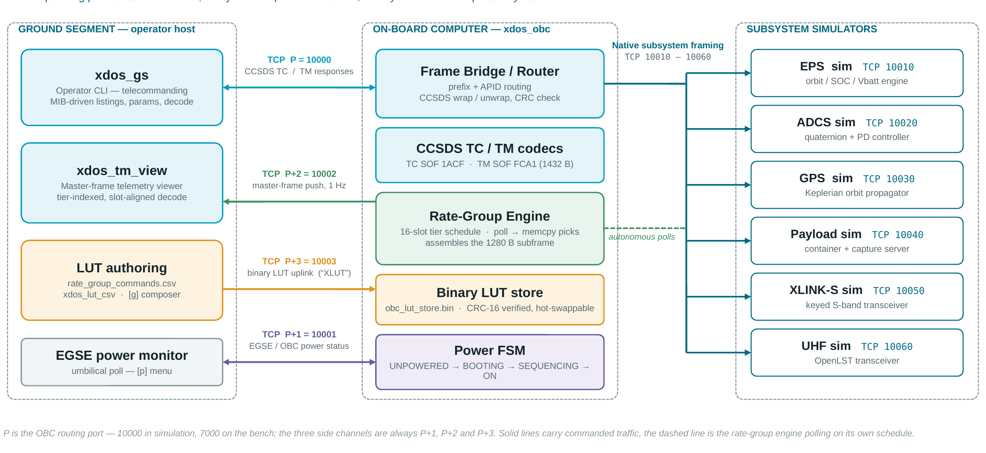
Figure 1 XDOS ground station — system block diagram
Three characteristics of the layout are worth drawing out before the detail:
• Side channels are physically separate. Telemetry pushed once per second, EGSE power status and look-up-table uplinks each get their own port, so an unprompted stream can never contend with a command reply on the routing port.
• Routing is by identity, not by content. The bridge selects a subsystem from the APID inside the CCSDS frame; it never parses the subsystem payload.
• The on-board computer is database-free. It carries no command definitions at all. What it polls, and which response bytes it keeps, are uplinked to it as an opaque binary table.

Processes and responsibilities
Table 3 Processes and their responsibilities
Process | Role | Key responsibilities
xdos_gs | Operator CLI | Lists and sends telecommands from the MIB, prompts for parameters, wraps frames in CCSDS, decodes and renders responses, hosts the power-control menu and the binary LUT composer
xdos_obc | On-board computer (bench model) | Routes frames between the ground and the subsystems, wraps and unwraps CCSDS, runs the rate-group engine, holds the binary LUT, and models the power-up sequence
xdos_tm_view | Master-frame telemetry viewer | Receives the pushed telemetry stream, positions each subframe by its slot, reassembles tier blocks and decodes them using the ground-only JSON twin
xdos_lut_csv | LUT compiler | Compiles the CSV master command list into the binary LUT and its JSON twin, enforcing every budget
xdos_*_sim | Subsystem simulators (six) | One process per subsystem, answering on its own port in the subsystem's native framing
xdos_tests | Test executable | The Catch2 v3 suite covering framing, codecs, the LUT, the engine, the power model and one end-to-end path

Network interfaces and port allocation
Ports are allocated relative to a single routing port, written P below. P is 10000 in simulation and 7000 on the bench; the three side channels always sit at P+1, P+2 and P+3, so moving between the two environments changes one number.
Table 4 Port allocation
Port | Link | Direction | Carries
P = 10000 | TC / TM routing | GS ⇄ OBC | CCSDS telecommand frames and their responses — the flight link
P+1 = 10001 | EGSE umbilical status | GS → OBC | The on-board computer's power state during boot and load-shed recovery. Kept off the routing port because sharing it caused reply contention.
P+2 = 10002 | Rate-group stream | OBC → GS | 1280-byte subframes wrapped in 1432-byte telemetry frames, pushed once per second to every connected viewer
P+3 = 10003 | Binary LUT uplink | GS → OBC | The literal bytes “XLUT”, a 32-bit big-endian length and the file; the listener replies OK or ERR
10010 – 10060 | Subsystem buses | OBC ⇄ Sim | Native subsystem framing, one TCP port per subsystem

Subsystem identity and APID map
Spacecraft identity and the APID map are defined once, in the telecommand profile, and the telemetry profile references that same file. Uplink and downlink therefore cannot drift apart: there is only one place where the spacecraft ID (625, 0x271) and the subsystem APIDs are written down.
Table 5 Subsystem identity, ports and native framing
Subsystem | APID | Sim port | Native framing prefix | MIB definitions
ADCS | 1 (0x001) | 10020 | 1F 7F <id> … 1F FF | 220 messages, 79 enumerations
UHF | 2 (0x002) | 10060 | OpenLST framing | 41 messages
EPS | 3 (0x003) | 10010 | 00 <base64 telegram> 01 | 82 messages, 16 PDU channels, 8 nodes
GPS | 4 (0x004) | 10030 | AA 44 12 … | 19 messages
Payload | 5 (0x005) | 10040 | [type | cmd | len] + data | 10 messages
XLINK-S | 6 (0x006) | 10050 | product key + event frame | 46 messages
Rate group | 600 (0x258) | — | telemetry only — master-frame push | not applicable — position-indexed

Note. The on-board computer originally identified subsystems by sniffing the first one to three bytes of each frame — the native framing prefix in the table above. With CCSDS framing in place, routing uses the inner packet's APID instead; the prefixes remain the wire format on the subsystem buses.

Software architecture

The layered stack
Every layer lives in one static library, xdos_core; the executables are thin shells over it. Dependencies point downward only, and the layers are:
Table 6 Layers of the codebase
Layer | Source | Contents
Applications | src/cli, obc, simulator | xdos_gs, xdos_tm_view, xdos_obc, xdos_lut_csv, six subsystem simulators, xdos_tests
Session and subsystems | src/session, src/subsystems | Connection sessions with shared-link slots, the subsystem plugin registry, the XLINK-S keyed codec
Codec | src/codec | The CCSDS telecommand codec, the CCSDS telemetry codec, and the earlier non-CCSDS codec kept for the direct-to-simulator mode
Framing | src/framing | One module per subsystem wire format: adcs, eps, gps, payload, uhf, xlink
Data model | src/mib, src/lut | The MIB loader; the binary LUT builder, its CSV grammar and the on-disk format definition
Common and transport | src/common, src/transport | CRC-16-CCITT, hex and colour helpers, the EGSE model, shared types, the POSIX/WinSock compatibility shim, and the TCP client and server

Build targets and dependencies
The build is CMake-driven and produces one library and eleven executables. Third-party code is limited to a vendored nlohmann/json header and Catch2 v3 for the test target; everything else is C++17 standard library plus the platform socket API, which keeps the port to Windows to a single compatibility header.
Table 7 Build targets
Target | Kind | Purpose
xdos_core | static library | Every layer below the applications
xdos_gs | executable | Operator telecommanding CLI
xdos_obc | executable | On-board computer bridge, rate-group engine and power FSM
xdos_tm_view | executable | Master-frame telemetry viewer
xdos_lut_csv | executable | CSV to binary LUT compiler
xdos_eps_sim, xdos_adcs_sim, xdos_gps_sim | executables | Simulators driven by physical engines
xdos_payload_sim, xdos_xlink_sim, xdos_uhf_sim | executables | Protocol-level simulators
xdos_tests | executable | Catch2 v3 test suite (built when Catch2 is available)

Toolchain: C++17, gcc 11 or newer, CMake 3.20 or newer.

Data-driven design
Almost nothing about a subsystem is compiled in. Command listings, field offsets and sizes, enumerations, units, PDU channel labels and the CCSDS frame layout are all read from JSON at start-up. A database revision therefore changes the software's behaviour without a rebuild, and the same profile drives encoding and decoding, so the two directions cannot disagree.
The configuration files are:
• mib/*.json — one file per subsystem, defining every telecommand and telemetry message with its parameters, offsets, sizes, types, units and enumerations; 418 messages in total.
• mib/ccsds_tc.json, mib/ccsds_tm.json — the frame profiles: spacecraft identity, APID map, field layout and the rate-group APID.
• config/flight.json — the power sequence: boot time, stagger, default switch-on order, battery thresholds, load-shed sets and the orbit period.
• config/rate_group_commands.csv — the master list of housekeeping commands from which the binary LUT is compiled.

Telecommand path

End-to-end flow
A telecommand traverses ten steps between an operator keystroke and a rendered response. Steps 3 and 9 are the only places where subsystem-specific knowledge is applied; everything between them is subsystem-agnostic.
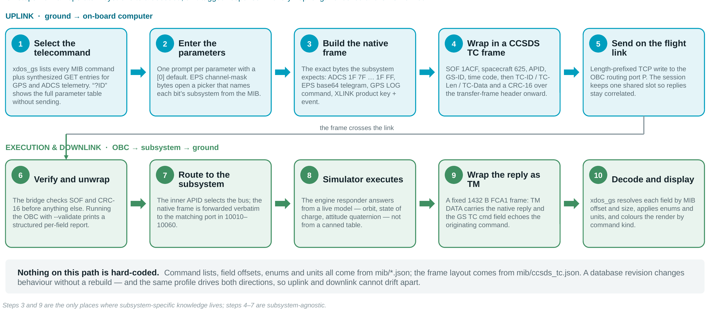
Figure 2 Telecommand flow, from operator input to decoded response

Command selection and parameter entry
The listing the operator sees is built from the MIB, with two synthesised additions so that telemetry reads look like ordinary commands: every GPS telemetry message appears as a LOG-wrapped GET, and every ADCS telemetry message appears as an empty-payload request. Entering an identifier prefixed with a question mark shows the command's kind, wire identifier, length, board, documentation reference and full parameter table without sending anything.
Identifier resolution is deliberately forgiving but never ambiguous. It tries, in order, an exact specification-ID match with alphanumeric normalisation (so ep19 resolves EP-019), then a numeric-tail match, and finally a plain numeric message identifier. Where a numeric tail could match more than one specification ID, the resolver lists the collisions instead of guessing.
Parameters are prompted one at a time with a zero default. EPS channel-mask bytes are recognised and divert to a picker that names each bit's subsystem from the MIB and accepts a comma-separated channel list, a hexadecimal value, all, or none — out-of-range channels are ignored with a warning rather than silently dropped.

Subsystem commanding flows
Four flows sit behind the main menu. The generic one serves ADCS, EPS, GPS and UHF; Payload and XLINK-S have their own because their command sets are shaped differently.
Table 8 Operator main menu
Key | Action
1 / 2 / 3 | Send a telecommand to ADCS / EPS / GPS
4 / 5 / 6 | Send a telecommand to Payload / XLINK-S / UHF
p | Power control — kill switch, per-subsystem ON/OFF, orbit state
g | Binary rate-group LUT: CSV import, pick editor, build and uplink
c | Toggle CCSDS framing on the flight link
! | Repeat a recent command
h / r / q | Help / reconnect the buses / quit

Within a listing, Enter pages forward, b steps back one level and q quits. ADCS offers a kind filter first — set, get, act or all — because its listing runs to over 150 entries.

Response decoding and presentation
A response is decoded against the same MIB entry that produced the command: each parameter is read at its declared offset and size, converted according to its type, and rendered with its unit and, where one applies, its enumeration label. Output is coloured by command kind — yellow for set, green for get, cyan for act, red for errors — and the colouring can be stripped with a flag when piping to a file.
The Payload flow is the exception: the payload server returns no telemetry, only a single-character acknowledgement. The flow prints the sent frame's type, command and length breakdown, the CCSDS summary and both hex dumps, then validates the declared length and the echoed command identifier before rendering the acknowledgement.

CCSDS framing
Both frame layouts are loaded from JSON profiles rather than compiled in. The telemetry profile references the telecommand profile, so spacecraft identity and the APID map are shared.
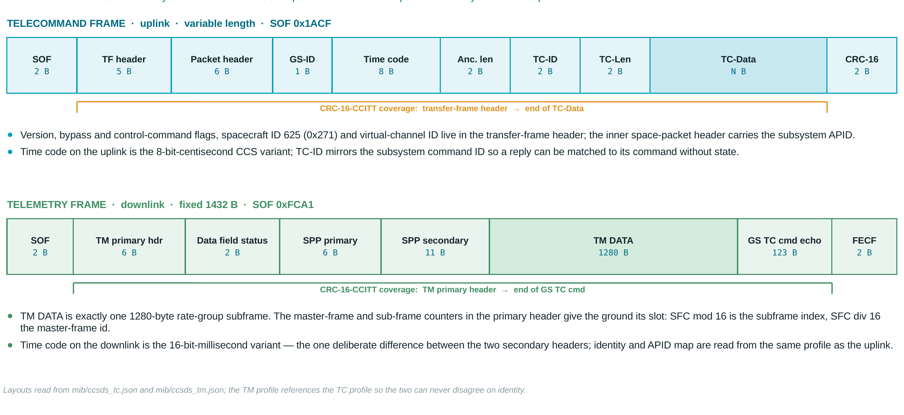
Figure 3 CCSDS telecommand and telemetry frame layouts

Telecommand frame
The uplink frame is variable length and starts with the two-byte marker 0x1ACF. There is no end-of-frame marker; framing on the wire is length-prefixed.
Table 9 Telecommand frame fields
Field | Size | Contents
SOF | 2 B | 0x1ACF
Transfer-frame header | 5 B | Version, bypass and control-command flags, spacecraft ID 625 (0x271), virtual-channel ID, frame length and frame sequence number
Packet header | 6 B | Space-packet version, type, secondary-header flag, APID, sequence flags and count, packet data length
GS-ID | 1 B | Ground-station identifier
Time code | 8 B | CCS time code, 8-bit centisecond variant
Ancillary length | 2 B | Length of the ancillary section
TC-ID | 2 B | The subsystem command identifier, mirrored so a reply can be matched without keeping state
TC-Len | 2 B | Length of the command data that follows
TC-Data | N B | The complete native subsystem frame
CRC | 2 B | CRC-16-CCITT over the transfer-frame header through the end of TC-Data

Telemetry frame
The downlink frame is fixed at 1432 bytes and starts with the marker 0xFCA1. Its data field carries exactly one 1280-byte rate-group subframe, and the originating telecommand is echoed alongside it.
Table 10 Telemetry frame fields
Field | Size | Contents
SOF | 2 B | 0xFCA1
TM primary header | 6 B | Transfer-frame version, spacecraft ID, radio-module ID, master-frame count and sub-frame count
Data field status | 2 B | Secondary-header flag, synchronisation flag, packet-order flag, segment length ID and first-header pointer
SPP primary header | 6 B | Packet version, type (0 for telemetry), secondary-header flag, APID, sequence flag and count, data length
SPP secondary header | 11 B | Ground-station ID, time code (16-bit millisecond variant) and a reserved field
TM DATA | 1280 B | One rate-group subframe
GS TC cmd echo | 123 B | The originating telecommand
FECF | 2 B | CRC-16-CCITT over the TM primary header through the end of the command echo

Note. The sub-frame count is the ground's clock. SFC modulo 16 gives the subframe's slot within the master frame and SFC divided by 16 gives the master-frame identifier, so a lost frame leaves a visible gap in the display rather than shifting every subsequent subframe out of alignment.

Frame validation
Running the on-board computer with the validate flag installs a frame observer that fires on every frame arriving from the ground, before any CCSDS processing, and prints a structured per-field report. The bridge separately counts frames in and out, frames routed per subsystem, unrecognised frames, and CCSDS frames that arrived, were sent, or failed to decode.

Rate-group telemetry and the binary LUT

Design rationale
Housekeeping telemetry has to be polled continuously and downlinked on a fixed cadence. The obvious way to do that — teach the flight computer the subsystem databases — was rejected for three reasons. It would mean carrying a parser for six different protocols on board. It would mean re-flashing the on-board computer every time a subsystem database was revised. And it would not, by itself, solve the real constraint: the downlink budget is fixed and small, so what is sent has to be selected byte by byte.
The design that was adopted instead puts one binary file on board that tells the on-board computer three things: which telecommands to replay, which bytes of each response to keep, and where those bytes go in the downlink block. The on-board computer's entire runtime job per selection is a single memory copy. There are no names and no identifiers anywhere in the file; all meaning stays on the ground, in the database and in a JSON twin that is never transmitted.
Four consequences follow, and they are the reason the design is worth the indirection:
• No on-board database. The on-board computer boots with no table at all and transmits nothing — no polls, no subframes, no master frame — until a binary LUT is uplinked or a previously stored one passes its CRC check at boot. This is a deliberate fail-silent default.
• Change without re-flashing. Edit the CSV, rebuild, uplink. The engine hot-swaps the running table and keeps its slot phase, so the ground's alignment survives the swap.
• Deterministic and quotable. An identical table always produces a byte-identical file, so its CRC-16 signature can be cited in a review and compared between the two sides.
• Failures land on the ground. Unknown command or parameter names, picks that fall outside the declared response length, and tiers whose selected bytes exceed the budget are all rejected at build time, with the tier and the offending entry named. None of these conditions can arise at runtime.

Data flow
The path from a line in a CSV file to a named value on the operator's screen has three stages: authoring and build on the ground, uplink and execution on board, and downlink and decoding back on the ground.
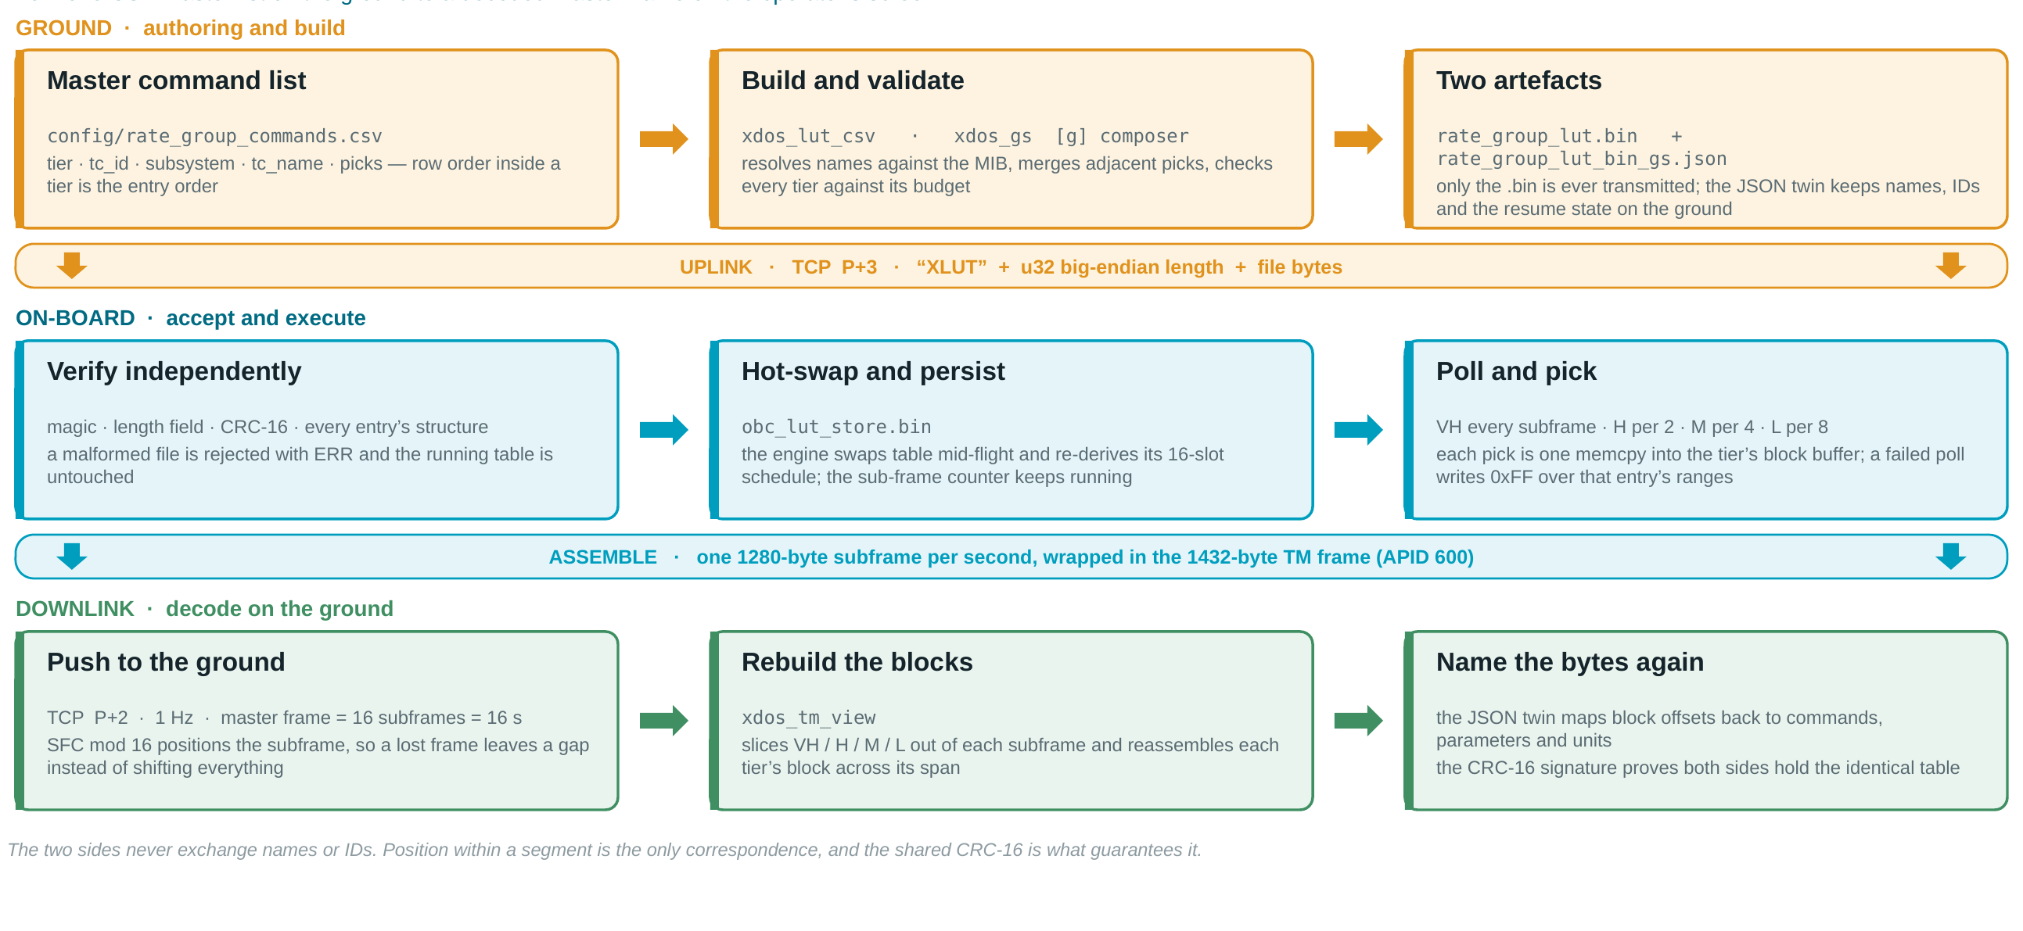
Figure 4 Binary rate-group LUT — end-to-end data flow

Authoring
The intended route is a single master list, config/rate_group_commands.csv, with one row per rate-group command and five columns:
Table 11 CSV master-list columns
Column | Meaning
tier | VH, H, M or L. Row order within a tier is the entry order, and the entry order is the link between the two sides — reordering rows changes the downlink layout.
tc_id | A label for the row. For GPS the trailing number is the log identifier (GPS-42 is BESTPOS).
subsystem | ADCS, EPS, GPS, Payload, XLINK or UHF.
tc_name | For EPS and XLINK-S, the telecommand name, with the response derived as <name>_RSP. For ADCS, the telemetry name or numeric identifier, because an ADCS poll is itself a telemetry request. For GPS, LOG.
picks | Semicolon-separated parameter names, one-based parameter numbers, or explicit byte ranges written as bytes OFFSET:SIZE. An empty cell selects the full payload.

The file is compiled by xdos_lut_csv, which reports each tier's command count and byte usage against its budget and refuses to write a file if any tier is over. Errors carry CSV row numbers.
The same table can be edited interactively in the operator CLI under the g key, which offers add, import CSV, edit picks, change tier, delete, list, build and send. When a previous table exists the composer offers to resume it or start empty. Selections may be given by parameter number, by exact parameter name, or as a raw byte range; note that the range syntax is offset and size, not a start and end offset. Selections are sorted, and adjacent or overlapping ranges merge automatically — so eight flags packed into one byte cost exactly one byte.
A build always writes two artefacts. Only the first is ever transmitted:
• config/rate_group_lut.bin — the on-board binary.
• config/rate_group_lut_bin_gs.json — the ground-only twin, holding names, identifiers, pick labels for decoding, and the resume state for later edits.

File format
All multi-byte values are little-endian. The file is a 50-byte header followed by four segments — Very High, High, Medium and Low — of variable-length entries packed back to back.
Table 12 Binary LUT header (50 bytes)
Offset | Size | Field | Value and meaning
0 | 4 B | magic | “XLUT” — file identifier
4 | 1 B | version | 1 — format revision
5 | 1 B | flags | 0 — reserved
6 | 2 B | subframe_size | 1280 — fixed; the 1362-byte variant is ruled out
8 | 2 B | seg VH | 400 B
10 | 2 B | seg H | 400 B
12 | 2 B | seg M | 300 B
14 | 2 B | seg L | 175 B
16 | 1 B | reserved | 5 — bytes 1275 to 1279, transmitted as zero
17 | 1 B | pad | 0 — alignment
18 | 2 B | T_sf | 1000 ms — the subframe period; a legacy value of 0 is read as 1000
20 | 8 B | entry counts | Four 16-bit counts: entries in VH, H, M and L
28 | 16 B | segment offsets | Four 32-bit absolute file offsets — a direct seek, with no walking
44 | 4 B | file length | Total bytes; an integrity check paired with the CRC
48 | 2 B | CRC-16-CCITT | Polynomial 0x1021, initial value 0xFFFF, computed over the whole file with this field zeroed

The CRC is the shared signature. Because entries carry no identifiers, position within a segment is the only link between what the on-board computer transmits and what the ground decodes; the CRC is what guarantees both sides hold the identical table.
Table 13 Binary LUT entry (variable length, repeated per segment)
Field | Size | Meaning
sync | 2 B | 0xA55A — entry boundary marker
apid | 1 B | Hardware APID: ADCS 1, EPS 3, GPS 4, Payload 5, XLINK-S 6
flags | 1 B | Reserved, zero
tc_len | 2 B | Length of the telecommand bytes that follow
tc bytes | variable | The complete native frame, replayed verbatim on the bus — an ADCS telemetry request 1F 7F <id> 1F FF, an EPS base64 telegram, a GPS LOG command, or an XLINK-S key and event frame
tm_raw_len | 2 B | The raw response payload length according to the database
pick_count | 1 B | Number of pick triplets that follow
picks | 6 B × n | The triplets defined below

Table 14 Pick triplet (6 bytes)
Field | Size | Meaning
src | 2 B | Byte offset within the raw response payload
size | 2 B | Number of bytes to copy
block | 2 B | Destination offset inside the tier's block, assigned by the generator and packed back to back

The runtime operation per pick is therefore memcpy(block + block_off, payload + src, size) — no interpretation of any kind. Picks address the raw payload, that is the database byte space with all native framing excluded.

Uplink, verification and hot-swap
The binary is sent to the on-board computer's LUT listener on port P+3 — 10003 in simulation, 7003 on the bench — framed as the literal bytes “XLUT”, a 32-bit big-endian length and the file itself.
The on-board computer checks the file independently of whatever the ground believes about it: the magic bytes, the length field, the CRC-16 and the structure of every entry. A file that fails any check is rejected with an error reply and the running table is left untouched. A file that passes is hot-swapped into the running engine, persisted as obc_lut_store.bin for automatic reload after a restart, and acknowledged with the entry count and the CRC. JSON tables are no longer accepted; that uplink path is retired and replies with an error.

On-board execution and cadence
The engine derives a sixteen-position schedule when a table is loaded. Entry i of tier t is polled in the slots where the slot number modulo the tier's span equals i modulo that span — so Very High entries are polled every subframe, High every second, Medium every fourth and Low every eighth. Polls are spread evenly across each one-second window with a 50 ms link-pacing floor between them. A window that overruns finishes late and is counted, but never skips a slot, so block phase is preserved.
Poll results land in per-tier block buffers of 400, 800, 1200 and 1400 bytes. A failed poll writes 0xFF over that entry's pick ranges — the ground's subsystem-down marker — and block bytes that no pick claims stay zero. Once per subframe period the engine assembles one 1280-byte subframe from the Very High block plus the High, Medium and Low slices selected by the current slot, wraps it in the 1432-byte telemetry frame under APID 600, and pushes it to every connected viewer.

Subframe and master-frame layout
Every subframe carries all four tiers at fixed offsets. The tiers differ only in how many subframes a block spans, and therefore in how much unique data each block holds.
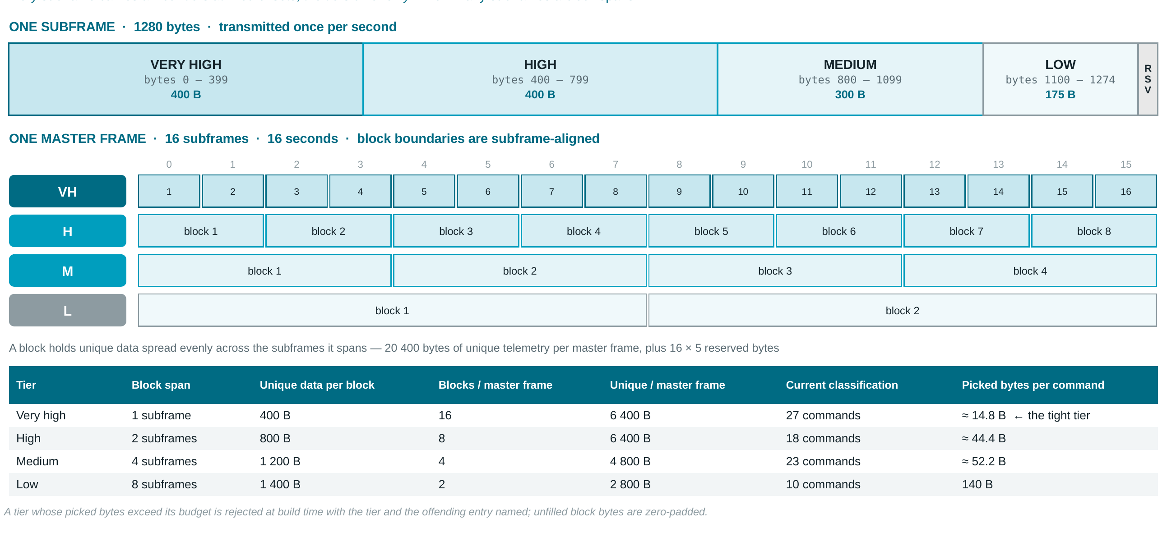
Figure 5 Subframe partition and master-frame block structure
Table 15 Tier budgets per master frame
Tier | Block span | Unique data per block | Blocks per master frame | Unique per master frame | Current classification | Picked bytes per command
Very high | 1 subframe | 400 B | 16 | 6 400 B | 27 commands | ≈ 14.8 B
High | 2 subframes | 800 B | 8 | 6 400 B | 18 commands | ≈ 44.4 B
Medium | 4 subframes | 1 200 B | 4 | 4 800 B | 23 commands | ≈ 52.2 B
Low | 8 subframes | 1 400 B | 2 | 2 800 B | 10 commands | 140 B

Total unique telemetry per master frame is 20 400 bytes, plus sixteen five-byte reserved fields transmitted as zero. Block boundaries are subframe-aligned: High blocks begin at subframes 1, 3, 5 and so on; Medium at 1, 5, 9 and 13; Low at 1 and 9. With the present 78-command classification, Very High is the tight tier at roughly 14.8 bytes of picked data per command, and it is where the generator's budget check will bite first.

Ground decoding
The viewer positions each arriving subframe by the sub-frame count in its header, slices the four tier segments out of it, and reassembles each tier's block across the subframes it spans. The ground-only JSON twin then maps block offsets back to commands, parameters and units. Because the correspondence is positional, the CRC-16 signature carried in the header is what proves the twin in use matches the table the on-board computer is executing.

Simulation environment and flight power model

Subsystem simulators
Three of the six simulators answer from a live physical model rather than a fixed table, so the ground station is exercised against values that change between polls:
• EPS. State of charge and battery voltage are propagated against the orbit — 3300 seconds sunlit, 2100 seconds in eclipse — with the PDU channel mask determining the load.
• ADCS. An attitude quaternion is propagated under a proportional-derivative controller; set, get and act commands move the modelled body and the telemetry follows it.
• GPS. A Keplerian orbit propagator sits behind the native message set, so LOG commands return position, velocity and time as the receiver would.
Payload, XLINK-S and UHF are protocol-level: they return structurally correct replies — acknowledgement bytes, keyed S-band events and OpenLST transceiver responses — without modelling physics.

Flight power model
The on-board computer's power behaviour is modelled by a finite-state machine that runs UNPOWERED to BOOTING to SEQUENCING to ON, and returns to UNPOWERED whenever the kill switch is turned off. While the machine is not in the ON state the bridge drops every frame from the ground, with one exception: EGSE umbilical frames are always answered, so the ground can see the power state at any point during boot.
Once ON, the machine watches the EPS. If load shedding has switched a default subsystem off and the battery has recovered to Normal, it re-enables that subsystem, staggered and rate-limited. All timing honours a time-scale factor, so a boot-and-sequence run that takes real seconds on the bench compresses into milliseconds under test.
Table 16 Battery thresholds and load shedding
Battery mode | Threshold | Channels shed
Full | ≥ 12.0 V | None
Normal | ≥ 11.1 V | None — the default switch-on sequence is restored, staggered and rate-limited
Safe | ≥ 9.9 V | Payload (channel O10)
Critical | ≥ 9.0 V | Payload, ADCS and the avionics bus (O10, O4, O3)
Below critical | < 9.0 V | Everything except the two on-board-computer channels (O1, O2)

A hysteresis of 0.15 V keeps a battery sitting on a threshold from oscillating between modes. Channel bindings are by EPS PDU channel identifier; the labels come from the EPS database and the sequence from config/flight.json, where the boot time is 10 seconds and the stagger 2 seconds.

Verification

Test suite composition
The suite is written against Catch2 v3 and lives in 21 translation units. It exercises the real socket stack rather than mocks wherever a socket is part of the behavior under test.
Table 17 Test coverage by area
Area | Translation units | What is proven
Utilities | test_crc, test_hex | CRC-16-CCITT against known vectors; hexadecimal encode and decode round-trips
Subsystem framing | test_adcs_framing, test_eps_framing, test_gps_framing, test_payload, test_uhf, test_xlink_codec, test_xlink_keys | Native encode and decode round-trips per subsystem, and rejection of malformed or truncated frames
CCSDS codecs | test_ccsds_codec, test_ccsds_tm_codec, test_ccsds_validator | Frame layout, shared identity, both time-code variants, CRC coverage and the structured validator report
Data model | test_mib_load | Every database file loads, and messages, parameters, enumerations and channel maps resolve as declared
Binary LUT | test_binary_lut, test_binary_rate_lut, test_rate_group_csv | Header and entry encoding, the deterministic CRC signature, pick merging, over-budget rejection, and the CSV grammar with row-numbered errors
Rate-group engine | test_rate_group | The sixteen-slot tier schedule, block assembly, the 0xFF down marker on a failed poll, and hot-swap while running
Flight behaviour | test_power_sequence, test_flight_realism | Boot and staggered switch-on, load-shed thresholds with hysteresis, and staggered restore on recovery
End to end | test_e2e | Ground station to on-board computer to simulator and back, across the real socket stack

Results
Measured on the current working tree by running ./build/xdos_tests: all tests pass — 1 672 assertions in 110 test cases.

Coverage gaps
Three things this suite does not and cannot establish, and which need bench time rather than more unit tests:
• Behaviour against real flight hardware, including the actual on-board computer and the real subsystem boards.
• The radio-frequency layer — everything here runs over TCP on a single host.
• Behaviour under sustained link congestion, where the engine's overrun handling and the 50 ms pacing floor would be exercised in earnest.

Build, run and operations

Building
From the repository root: cmake -B build -DCMAKE_BUILD_TYPE=Release then cmake --build build -j. The test target is built when Catch2 v3 is available; a Windows build is described separately in BUILD_WINDOWS.md.

Running the stack
The helper scripts under scripts/ launch and tear down the whole stack. Logs are written per user into logs/ in the project root, and leftover processes from a previous run are cleaned up before new ones start, so ports are always free.
Table 18 Helper scripts
Script | Purpose
scripts/run_all.sh | Launch the simulators and the on-board computer in the background and the operator CLI in the foreground; Ctrl-C cleans everything up. Pass --no-obc to talk directly to the simulators.
scripts/run_sim.sh | Launch the subsystem simulators only
scripts/run_cli.sh | Launch the operator CLI only
scripts/run_tm_view.sh | Launch the master-frame telemetry viewer
scripts/run_tests.sh | Build and run the test suite
scripts/kill_all.sh | Stop every XDOS process

Operating notes
• Launch the operator CLI from the repository root so that config/ and mib/ are visible; the LUT composer reads and writes files there.
• The on-board computer transmits no telemetry at all until a binary LUT has been uplinked, or a previously stored one has passed its CRC check at boot. Silence on the telemetry port is the expected state before the first uplink, not a fault.
• Rate-group telemetry is displayed by the standalone viewer, not by the operator CLI. The CLI keeps the LUT uplink flow, because that is telecommanding.
• Passing the no-colour flag strips the ANSI escapes, which makes the output suitable for piping to a file.

Status and proposed next steps

Delivered and verified
• Telecommanding of all six subsystems, driven by the MIB, over CCSDS telecommand frames.
• CCSDS telemetry downlink in the fixed 1432-byte frame, decoded and rendered on the ground.
• The full binary LUT path: CSV compilation, uplink, independent on-board verification, hot-swap and persistence across restarts.
• Tier-scheduled polling with a sixteen-position schedule and slot-aligned master frames.
• A flight-realistic power sequence with load shedding, hysteresis and staggered restore.
• 110 test cases covering framing, codecs, the LUT, the engine, the power model and one end-to-end path.

Decisions closed
The following were open questions in the frame design and are now settled and implemented. They are recorded here because they constrain anything built on top of this layer.
Table 19 Closed design decisions
Decision | Resolution
Subframe size and partition | 1280 bytes, partitioned 400 / 400 / 300 / 175 with 5 reserved. The 1362-byte variant is ruled out.
Subframe period | T_sf = 1000 ms — one subframe per second, one master frame every 16 seconds. Written into the LUT header; a legacy zero is read as 1000.
Cadence | Tier-scheduled on a sixteen-position schedule computed by the on-board computer when the table is loaded.
Execution source | The binary LUT only. The on-board computer boots with no table and transmits nothing until one is uplinked; the JSON LUT uplink path is retired.
Authoring | One CSV master list, compiled by xdos_lut_csv or imported into the composer.
Slot alignment on the wire | The per-APID sub-frame count increments once per push; SFC modulo 16 is the slot and SFC divided by 16 the master-frame identifier.

Proposed next steps
These are proposals for the review to accept, reject or reprioritise; none of them is committed work.
• Exercise the bench port map — the 7000 series — against the real on-board computer, including the LUT listener on port 7003.
• Bring Payload, XLINK-S and UHF commands into the rate-group classification. The present 78-command list is dominated by ADCS, EPS and GPS.
• Watch the Very High tier. At 27 commands it allows roughly 14.8 picked bytes each, and it is the tier the budget check will reject first as the classification grows.
• Extend the structured validation reporting to the operator CLI's downlink path, so a malformed telemetry frame is diagnosed as clearly as a malformed telecommand.
• Housekeeping: refresh README.md, which still describes CCSDS wrapping on the ground-to-OBC link as deferred to Level 2 although it is implemented, and retire the superseded CLI kept at src/cli/main.cpp.old.

