1. **Introduction**
   1. **Purpose**

The purpose of this Design Document is to provide a detailed description of the system design fully such that it gives a better understanding for developing the software. It focuses mainly on what is to be built and how it is expected to be built. In the RASD document we have described the requirements for Safe Streets.

In this document we are going to explain especially about the following things in detail.

* Architecture chosen.
* Components involved in this system and their respective process.
* Interaction among the components.
* The design patterns selected.
* User interface design.
* Mapping the requirements to the components.

**1.2 Scope**

The following presents a rehash of the scope of Safe Streets that is stated in the RASD document.

Safe Streets is aimed in reducing the traffic violations especially parking violations. The users registered with this application will be able to send the details of the violation by filling out some details to proceed with reporting the violation. The application after receiving the information validates, process and store the data. These information will be sent to the authorities who are registered with Safe Streets. Both the users and the authorities can access the data stored in Safe streets. The authorities can access all the data like the areas where the number of violations is high and the vehicles committing a greater number of violations whereas the users will have only limited access.

Safe Streets will be able to access the data from the municipality services. Using these data the safe streets will identify the unsafe areas. It will also provide some suggestions for reducing the violations which when implemented by the authorities will reduce the number of violations. It will create a vigilance among the citizens about traffic and parking violation. It will help the authorities to get know about almost all the violations occurring in the city with the help of the public people who acts as the source in providing these information that they come across in their day-to-day life. This will also help the user to know about the incidents in the city by accessing the services provided by the municipality to retrieve the accidents in the selected area. This will make the users stay alert in the areas that are marked unsafe. On the whole Safe Streets acts as an intermediator between the user and authorities by facilitating some useful services.

Some of the machine phenomena that needs to be considered are as follows:

* The system will not highlight an area where the violations are more if no user reports the incidents in that area.
* The authority will not be able to find the vehicle violating the rules if the user did not take a picture covering the license plate or if the image quality is too low or shaky.
* The device that the user using should have a GPS with high accuracy.

## 1.3 Definitions, Acronyms, and Abbreviations.

**1.3.1 Definitions**

**User:** The customer of the application who provides information about the traffic violations, retrieve information from Safe Streets about the accidents occurring in the unsafe areas.

**Authorities:** Traffic officials who has the power or right to give orders, make decisions, and enforce obedience.

**Violation:** A violation is any act that fails to abide by the existing law.

**Meta-data:** Data that provides information about other data.

**Algorithm:** A process or set of rules to be followed in calculations or other problem-solving operations, especially by a computer.

**Unsafe areas:** The areas where large number of accidents occur and the area where the number of violations reported is high.

**1.3.2 Acronyms**

**API:** Application Programming Interface.

**GPS:** Global Positioning System.

**UI:** User Interface.

**SS:** Safe Streets.

**ID:** Identification number.

**GDPR:** General Data Protection Regulation.

**ELB:** Elastic Load Balancer.

**SSL:** Secure Socket Layer.

**1.3.3 Abbreviations**

no. –number

**1.4 Revision History**

## Version 1.0: First release.

**1.5 Reference documents**

1. **Specification document:** “Safe Streets Mandatory Project Assignment A.Y. 2019-2020”.
2. **Requirement Analysis and Specification Document:**
3. IEEE standard for Information Technology- Systems Design- Software Design Decriptions.
4. **UML diagrams:**

<https://www.uml-diagrams.org/>

1. **Traffic rules:**

<http://www.poliziamunicipale-online.it/?l=eng#/Legislation>

1. http://www.cloudcomputingpatterns.org/

**1.6 Document Structure**

**Chapter 1:** This chapter contains the purpose of the design document and a rehash of what is written in the RASD document with some more information being added.

**Chapter 2:** This chapter gives the overall description of the architecture of the system and the design patterns chosen. It introduces all the components of the system and their interactions. It also contains sequence diagrams to provide the run time picture of the components and a diagram to describe the interfaces.

**Chapter 3:** This chapter provides a better understanding of the application design through user interface mockups. It picturizes almost all the important features of the application.

**Chapter 4:** This chapter describes the mapping between the requirements and the design components identified and how these components help in achieving all the requirements that are formulated in the RASD.

**Chapter 5:** This chapter contains the integration plan for the components that is the order in which it is going to be implemented.

**Chapter 6:** This chapter shows the effort spent by each member of the group spent on working on this design document.

1. **Architectural Design**

**2.1 Overview: High-­‐level components and their interaction**

Safe Streets will be a crowdsourced application where all the data is maintained in the Microsoft Azure Cloud. It is supposed to have a layered architecture where components are separated in layers. Also it inherits some of the concepts from cloud and distributed computing. Presentation layer (P) that contains all the user interface elements, the Application layer (A) that contains all the business or domain logic of the application and finally the Data access (D) that contains all the components to access the database. Basically it is a three tier architecture where it can be extended into n- number of layers based on the requirement. Layered architecture is very flexible to add or remove components and is the most successful model used to implement many applications.

Web Server

Safe Streets Application

DBaaS

Presentation / UI layer

Data access/ Persistence Layer

Application/ Business logic Layer

**Figure 1**: High Level System Architecture of Safe Streets.

By adopting a layered architecture there is a lot of advantages and some of them are listed below.

1. This architecture will provide elastic scalability and flexibility.
2. It will give the ability to update the technology stack of one tier, without impacting other areas of the application.
3. It will allow different development teams to work independently on their own areas of expertise.
4. It adds reliability and more independence of the underlying servers or services.
5. It provides an ease of maintenance of the code base, managing presentation code and business logic separately, so that a change to business logic, for example, does not impact the presentation layer.

A Layered architecture provides the ability to utilize new technologies as they become available. It also ensures the product is ready to adapt; ready for the future and will provide the opportunity to redesign the product or application and actually look not only to today’s needs but into the future. It stays ahead of the game and maintains a competitive advantage.

The main intent of choosing a cloud based data storage is to reduce the cost, offer a strategic edge, high speed, backup and restoration of data, automatic software integration, reliability, mobility, unlimited storage capacity, collaboration, quick deployment and offers resilient computing.

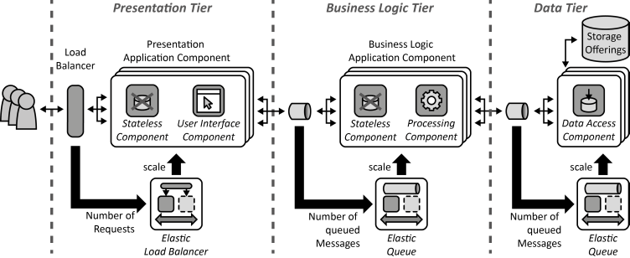

**Figure 2:** Layered architecture with high level components in each tier.

The Presentation tier contains the load balancer that distributes the workload across multiple computing resources and a user interface component. This tier contains all the UI components necessary for the user to interact with the system. The user reports the violation and the authorities can view the same using these UI components. It also contains a caching layer that is distributed. A distributed data cache, also called a distributed data grid, is a storage layer that sits between a database server and the in-memory of an application. It is believed that it will speed up an application’s performance. It contains all the data so that it can be accessed very quickly, much more quickly than if it were kept just in the database server.

The internal state of the components are not maintained in the component itself instead it is stored in an external storage to ensure fault tolerance and recovery. Hence each component is represented to contain a Stateless component. Load balancers will be explained in the deployment diagram section along with router.

[MapReduce](https://searchcloudcomputing.techtarget.com/definition/MapReduce), a method of analysis that divides a computation among several servers and then combines the results, can be more easily deployed through the use of distributed data grids. The primary use of distributed data caches is to store fast changing data that is accessed by multiple servers and the distributed data caches will grow over time. It will continue to provide a platform for performing parallel data analysis. Map reduce technique is used everywhere in the architecture where there is a need to scale up the components for distributed computing.

The Business logic layer contains all the processing components. This is the layer where all the business logic is implemented like finding the license number from the picture provided, analyze the data for identifying the unsafe areas, highlighting the areas with large number of violations and the vehicles committing more violations, finding the most common type of violations in a given areas, identifying no. of accidents in each area. It generates dynamic content based on the user request.

This component splits the processes into separate function blocks and assigns it to independent processing components. Since each processing component will be scaled out independently and will be implemented in a stateless fashion as described in the [Stateless Component](http://www.cloudcomputingpatterns.org/stateless_component/) pattern the Scaling will be handled by an [Elastic Queue](http://www.cloudcomputingpatterns.org/elastic_queue/). The data required for processing will be provided with requests or by [Storage Offerings](http://www.cloudcomputingpatterns.org/cloud_offerings/#storage_offerings).

The Data access layer will contain the components to access the data from the Storage offering. This component will be responsible for maintaining all the data manipulation. This layer maintains all the data regarding the violation. In case of replacing a storage offering interface or a storage offering, only the data access component need to be modified. This layer will also have the Elastic Queue which scales to assign process to independent components.

**2.2 Component diagram:**

Component diagram describes the organisation and the interaction between the physical components of the system. In this diagram the business logic is described in detail since it is the core element of the system. Even though some of the components in the other layers are also shown in the component diagram in order to show their interaction with the application layer. The components and their interactions are described below.

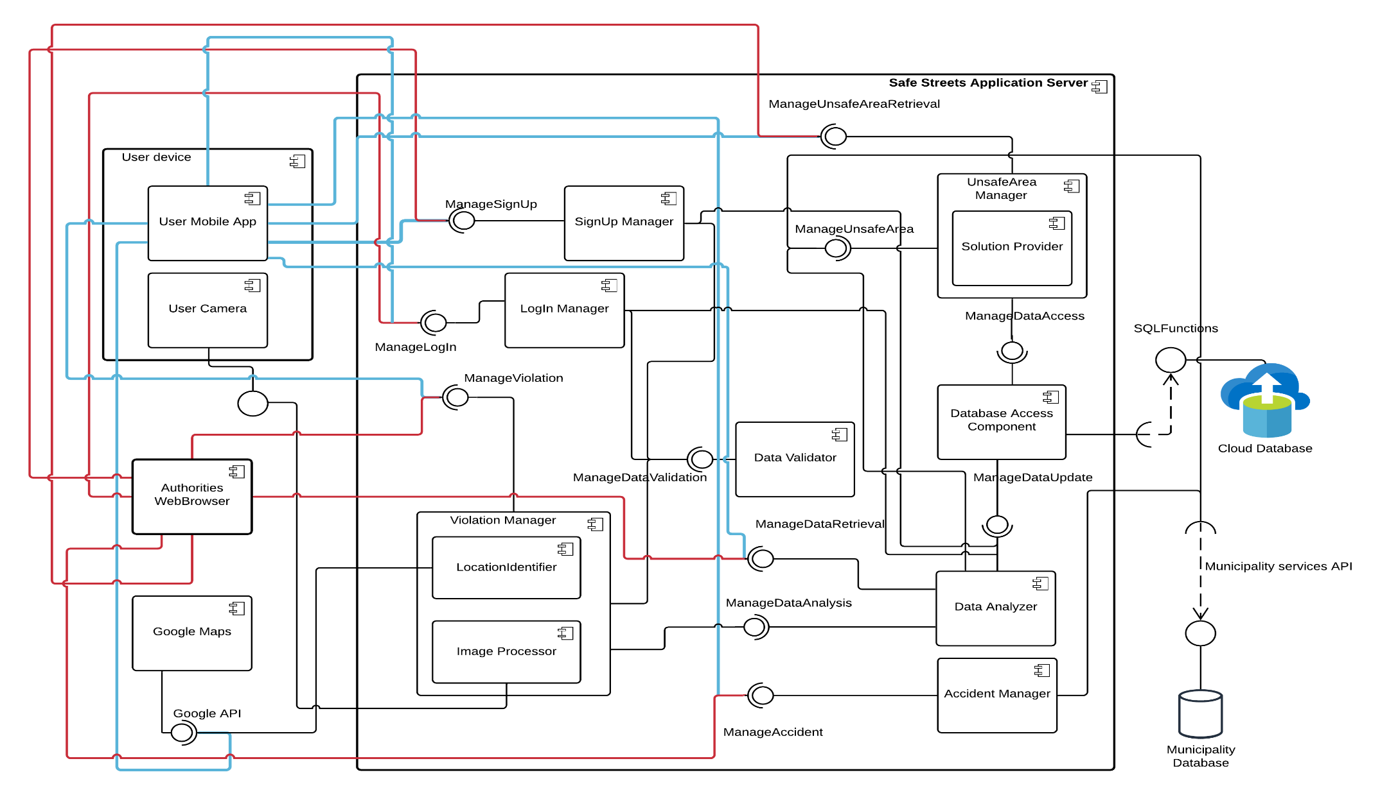

**Figure 3:** Component Diagram

The client side contains mobile app and authorities web browser where the user’s mobile device also contains a camera.

* **User Mobile App:** This component contains all the user interface elements for the user to access the application server.
* **Authorities Web Browser:** This component contains all the user interface elements for the authorities to access the application server.

The server side contains all the domain logic and the components that are required to accomplish all the functionalities of the system. Cryptographic techniques like MD5 hash can be used to check the integrity while sending and receiving data across the Internet.

* + - **SignUp Manager:** This component contains all the procedures to allow the customers to register to Safe Streets. It is connected to the database component to store and retrieve data from the cloud database. It is also connected to the Data Validator component which verifies and validates all the data entered in the SignUp page before storing the data in the cloud.
    - **LogIn Manager:** This component contains all the routines to allow the customers to login to the SafeStreets. It is connected to the database component and Data Validator component to check the username and password entered to ensure authentication.
    - **Data Validator:** This component is used to validate login, signup and violation data. It checks whether all the constraints and requirements specified for each field is met. In violation data it mainly checks the mandatory field type of violation is specified or not and also checks for the image of the violation.
    - **Violation Manager:** It handles all the data regarding the violation like type of violation, its description, image, date and time and the location where the violation is identified. It automatically retrieves the date and time from the user’s mobile device. It is also connected to a data validator to check the data. It is responsible for all the actions that are performed on the violation data. This component contains another two sub components called Location Identifier and Image processor.
      * **Location Identifier:** It uses the Google API to find the location of the user. Using which it finds and returns the area where the violation has taken place.
      * **Image Processor:** It runs Image processing algorithm over the image provided by the user to find the license number of the vehicle that is violating the rules.
    - **Accident Manager:** This component retrieves all the information regarding the accidents in a particular area specified by the customer from the municipality database through municipality services API.
    - **Data Analyzer:** This component performs operations over the data by accessing the violation manager component and stores the results in the cloud database through the database access component. It has routines that identifies the area where the number of violations are higher comparatively and the vehicle committing the highest number of violations. It also identifies the most common type of violation in each area. It is used by the User Mobile App and the Authorities Web Browser components to retrieve analysed data where the authorities are allowed to access all the analysed data and the user is allowed to access only the data regarding the highlighted areas. It is another main component containing the business logic.
    - **Unsafe Area Manager:** This component identifies the potentially unsafe areas in the city by comparing the accident data from the municipality database and the violation data from the Safe Streets database that is stored in the cloud. It also provides some solutions using its inbuilt Solution Manager to the authorities to curtail the violations and the accidents happening in the city. It provides the list of the unsafe areas to the user and with solutions to the authorities.
    - **Database Access Component:** This component acts a middleware between the application layer and the data layer. All the actions either read or write passes through the database component to the cloud database.
  1. **Deployment View:**

A deployment diagram, models the run-time architecture of a system. It shows the components that is deployed in each layer. It shows the configuration of the hardware elements and shows how software elements and artifacts are mapped onto those nodes.

Generally, a node has two stereotypes as follows:

**<< device >>:** It is a node that represents a physical machine capable of performing computations. A device can be a router or a server PC. It is represented using a node with stereotype <<device>>.

**<< execution environment >>:**It is a node that represents an environment in which software is going to execute.

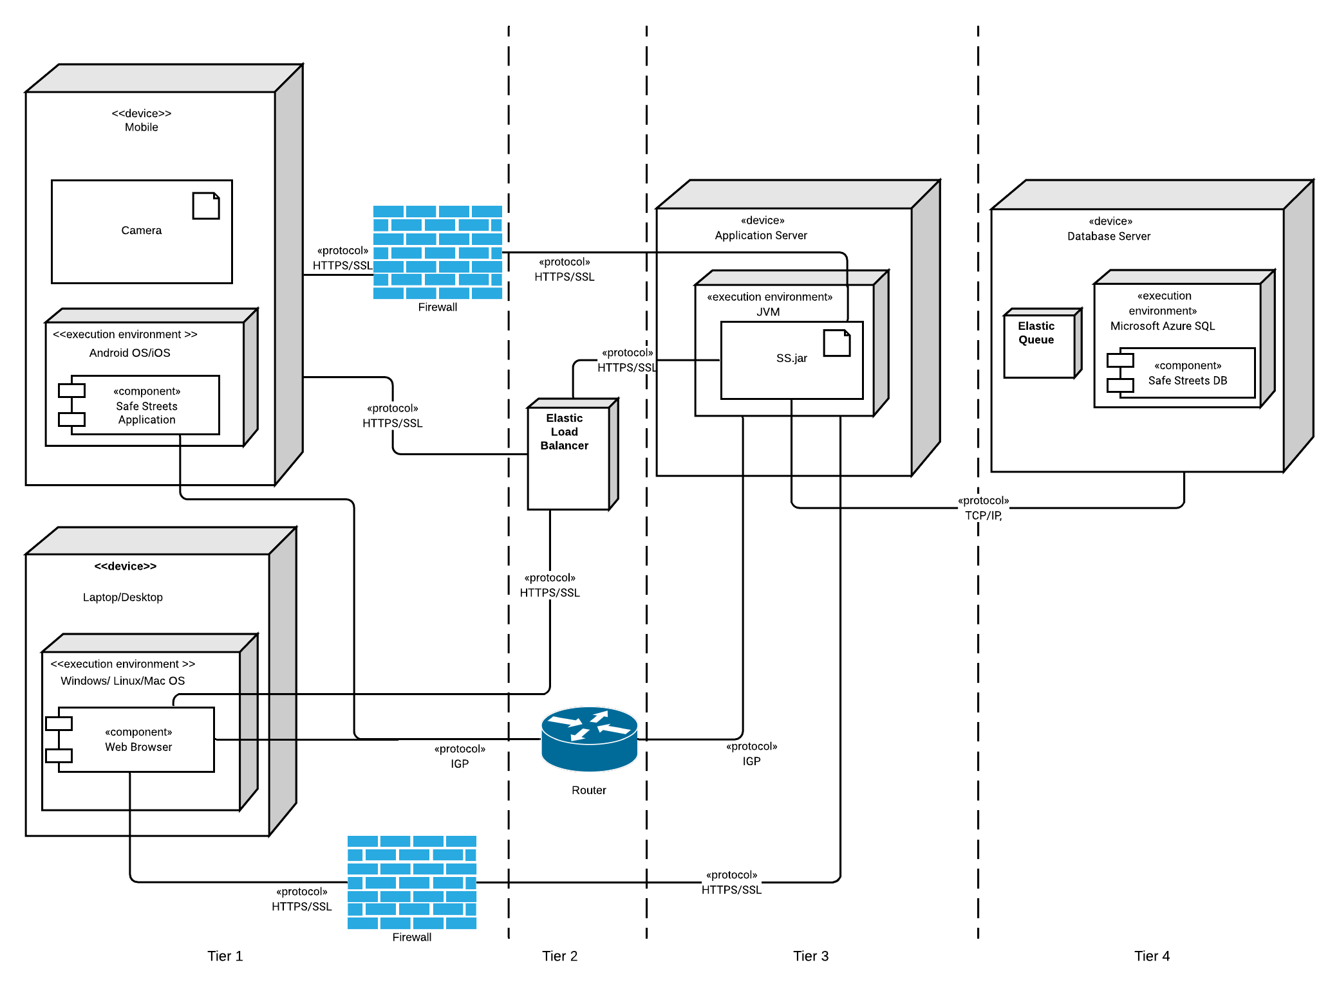

**Figure 4:** Deployment diagram

**Tier 1:** This tier has presentation logic. It has the user devices through which the customers can access the SS. The user is provided with a mobile phone with a camera. The user can have a mobile phone with either an android OS or with an iOS. This device should be installed with SS mobile app in order to interact with the system. On the other hand authorities are provided with a web application that runs on any web browser. They can simply access the system by hitting the URL. The desktop that the authorities are using can have either a Windows OS or Linux OS or Mac OS. This layer also has a firewall which restricts the unauthorized access and also monitoring the network traffic.

**Tier 2:** This tier has the components required for transporting data across the network. It is provided with an Elastic Load Balancer and a router. The ELB automatically distributes incoming application traffic and scales resources to meet traffic demands. It also detects the unhealthy Elastic Compute Cloud instances and spreads the instances only through healthy channels. It offers a flexible cipher support and manages the SSL certificates. It supports both IPv4 and IPv6. Router is another main component in an architecture of the system since it is the component that connects devices and favors a better transmission of data. A router is a physical or virtual appliance that passes information between two or more packet-switched computer networks. A router inspects a given data packet's destination Internet Protocol address (IP address), calculates the best way for it to reach its destination and then forwards it accordingly. A router is a common type of gateway. It is positioned where two or more networks meet at each point of presence on the internet.

**Tier 3:** This tier contains the application server which is the core element of the system. This tier contains all the components required to run the system. It handles all the request from the client and provides the desired responses in return. All the components are implemented using Java. So, it contains the jar file being deployed in it. It executes all the commands using Java Virtual Machine which acts as the execution environment for the Java classes.

**Tier 4:** This tier contains the database which acts as the store for all the data. It has a Microsoft Azure Database which is a cloud storage offering provided by Microsoft. It manages all the storage requirements. It has an Elastic Queue that is used to distribute asynchronous requests among multiple application components instances. Based on the number of enqueued messages the Elastic Queue adjusts the number of application component instances for handling these requests.

* 1. **Runtime View:**

**2.4.1 Reporting a Violation:**

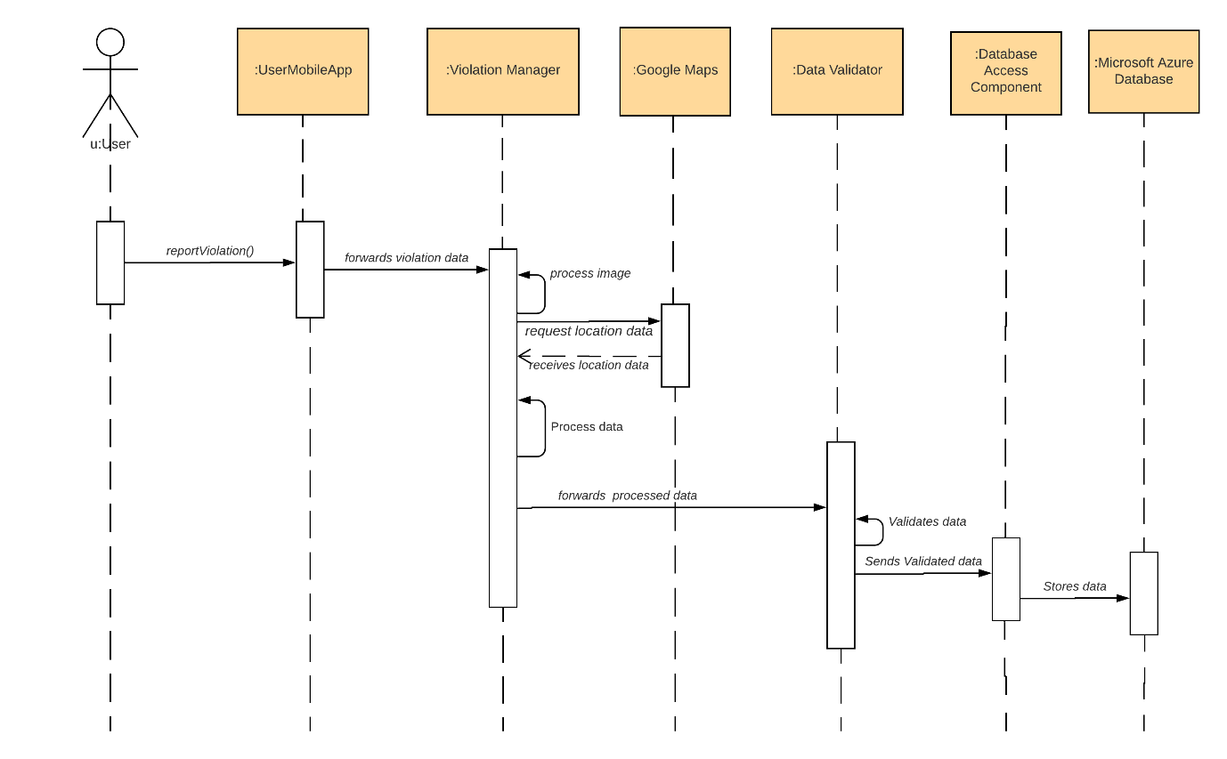

**Figure 5:** Reporting a violation

In this sequence diagram, the flow of the messages from the user to the database for reporting a violation is presented. The user with the mobile app installed in his/her mobile phone log in and take a picture of the violation and provides some more details regarding the violation and then submits it. This data is transferred from the UserMobileApp to Violation Manager which process the image for getting the license number of the violated vehicle. It also finds the area in which the violation has taken place using the Google Maps. It also receives the date and time of the user’s mobile and then send all the data that is received and processed to the data validator. This again checks the data and forwards to the database access component. This then stores the violation data in the Microsoft Azure database.

**2.4.2 View Violation:**

In this sequence diagram, the process through which the authorities are able to view the violation data is presented. The authorities after logging into the SS application then clicks on the View Violation button which triggers the following actions. The web browser interacts with the Violation Manager by forwarding the request. This in turn request the data from the database component which retrieves the requested data from the cloud database and then sends it to the Violation Manager. This is forwarded to the web browser that displays the authorities with the list of violations and its details.

The authorities will be provided with the image of the violation, type of the violation, description if it is provided by the user, date and time of the violation and the area where the violation took place.

The authorities after viewing the violation details takes the required action and then closes the violation by providing the comments. The violation has to be closed after taking action since other authorities can know that action has been taken on the particular violation. This update is progressively passed to the database through the same set of components that are previously used by the application to retrieve violation data. This data update is done each time after closing or entering comments by the authorities.

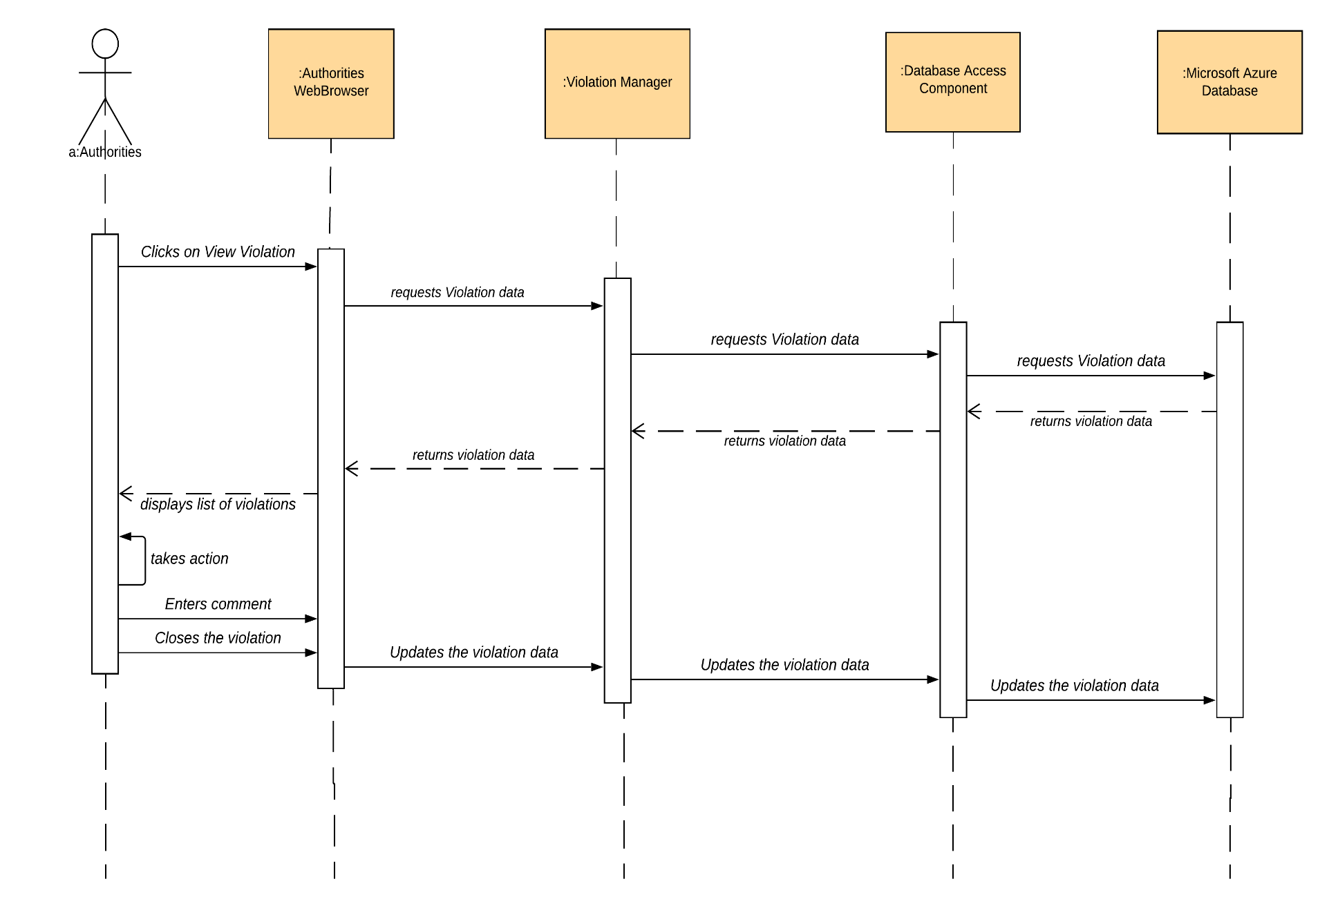

**Figure 5**: View Violation

**2.4.3 Retrieving Analyzed Data:**

In this sequence diagram, the process in the retrieval of the information from SS. 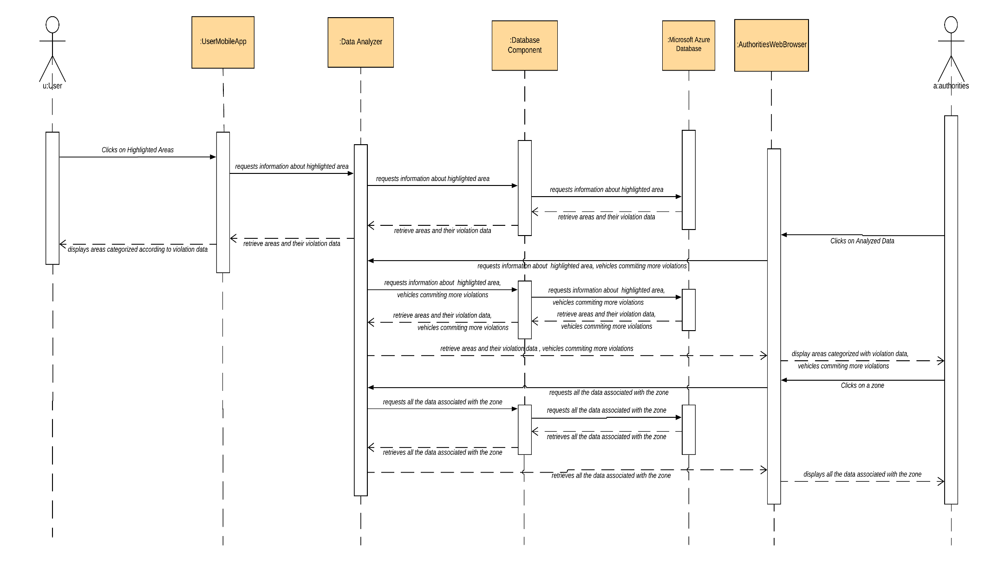

**Figure 6:** Retrieve Analyzed Data

The user clicks on Highlighted Data. This request is passed through the User Mobile App to the Data Analyzer which fetches the analyzed data from the database through database access component.

The authorities clicks on Analyzed Data and this request is passed through the web browser then to the data analyzer and then this component fetches the data from database thorough database access component. The web browser displays a pie chart with all the zones categorized as highly violated areas and less violated areas. It also displays the license number associated with the vehicle committing more violations.

The authorities clicks on any of the zone and the web browser fetches the information regarding that zone from again through the same set of components and provides the authorities with all the data associated with that zone including the most common type of violation in that zone.

**2.4.4 View Accident Information:**

The user through the Mobile app clicks on Accident Information and enters the area then clicks on search. The request is transferred to the Accident Manager which fetches the information from the Municipality database through Municipality services. The requested information is passed again through the same set of components to the User mobile app which displays the retrieved information to the user.

The authorities through the web browser clicks on Accident Information and enters the area then clicks on search. The request is transferred to the Accident Manager which fetches the information from the Municipality database through Municipality services. The requested information is passed again through the same set of components to the web browser which displays the retrieved information to the authorities.

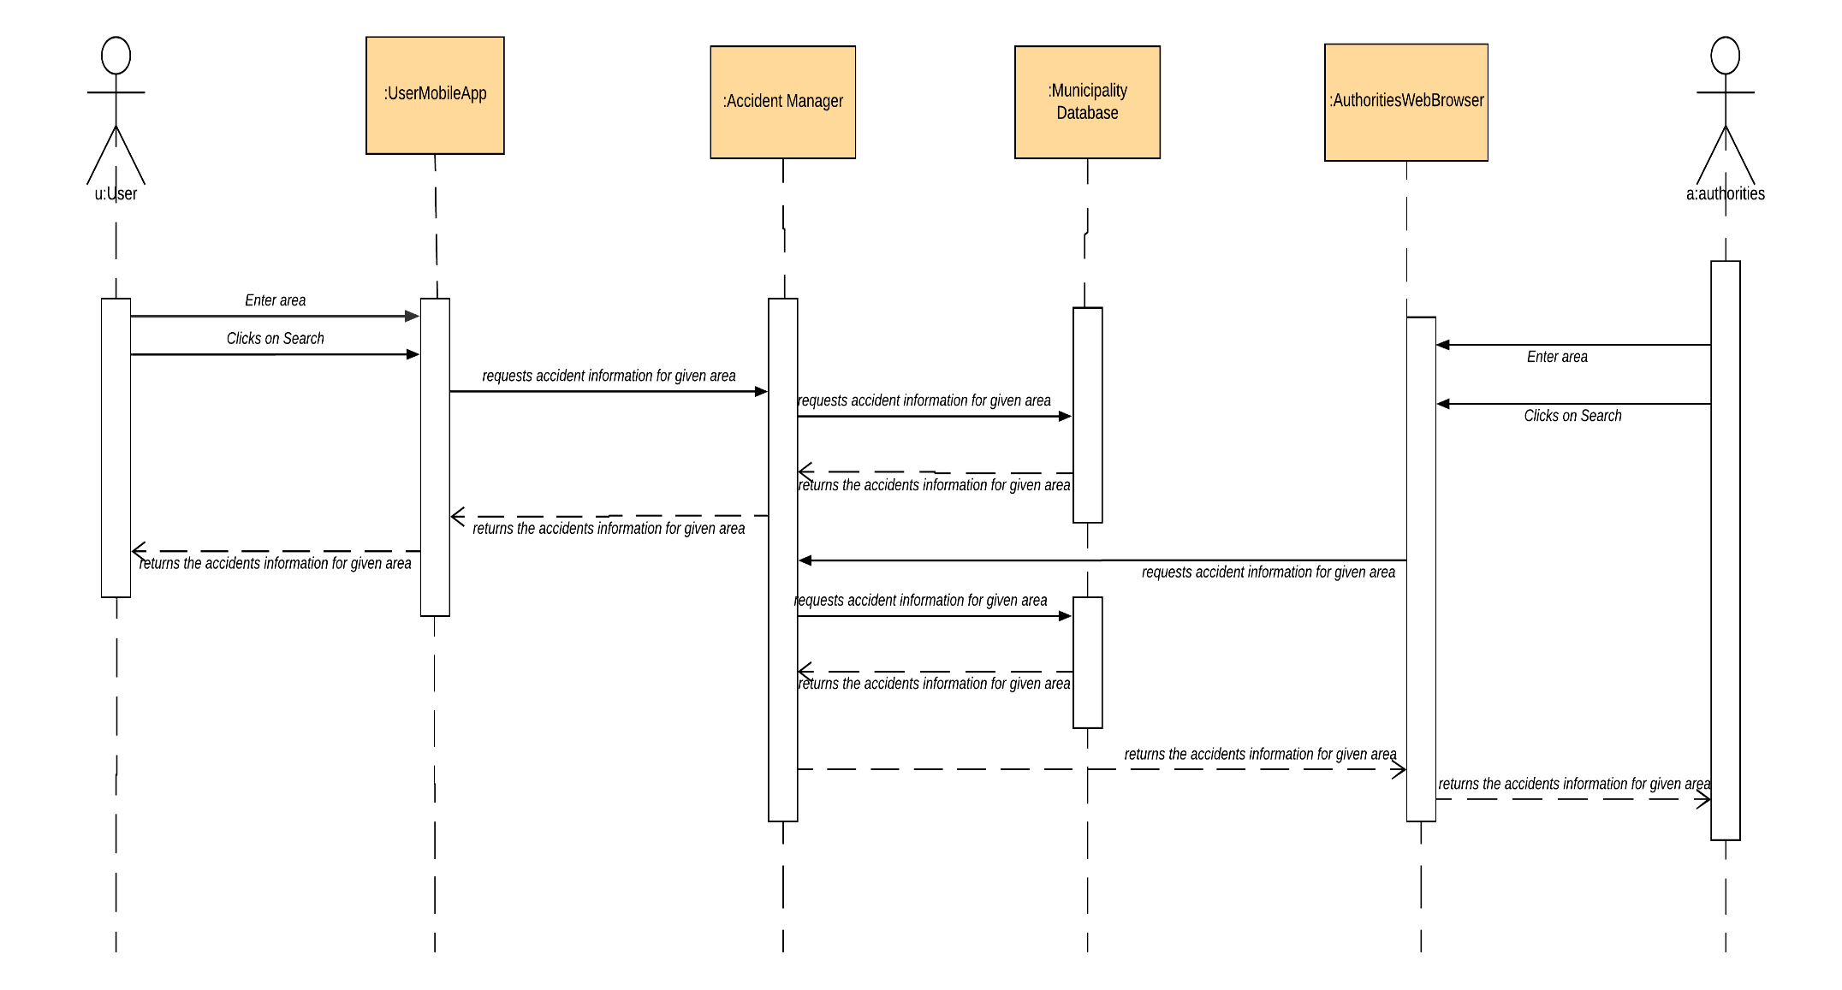

**Figure 7:** Accident Information

**2.2.5 View Unsafe Areas:**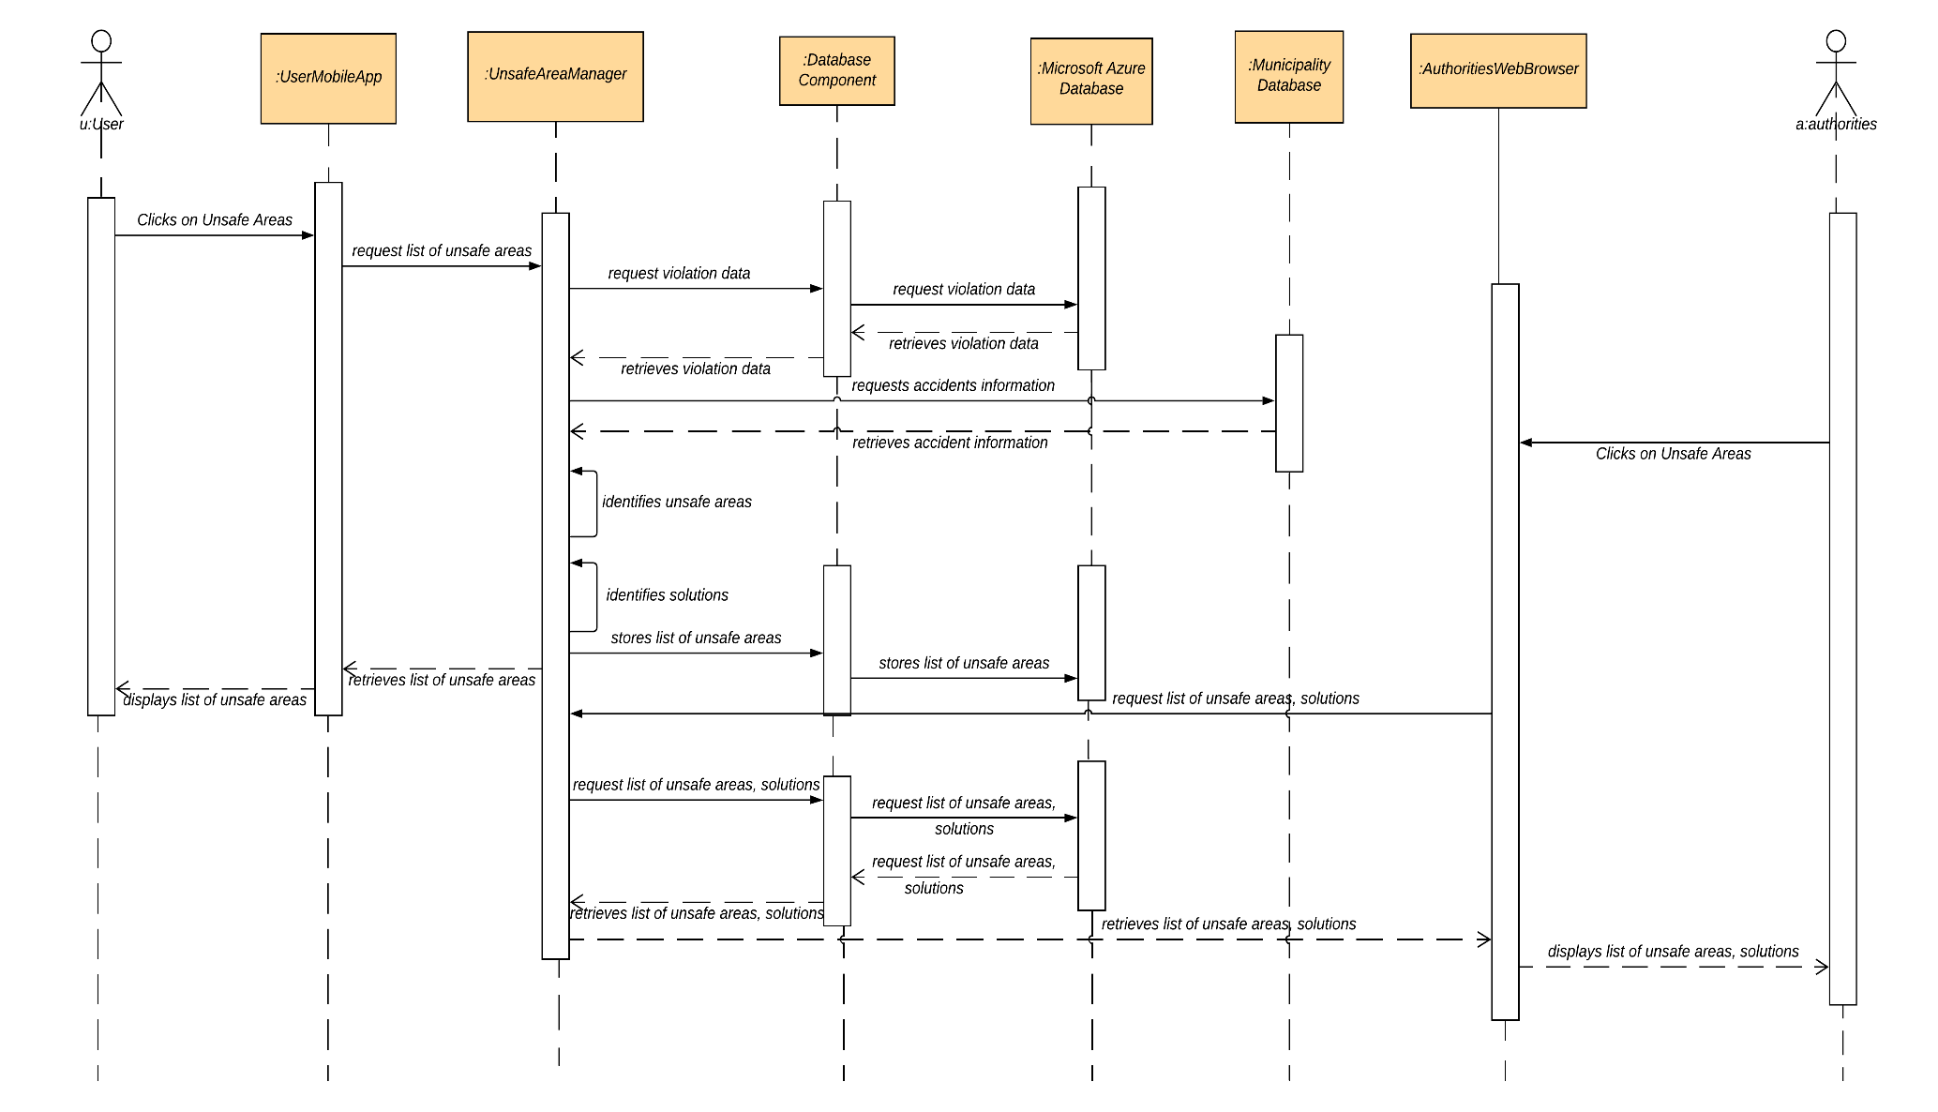

**Figure 8:** Unsafe Area

In this sequence diagram, the process involved in finding and retrieving the unsafe areas is illustrated. The user clicks on the unsafe area in the Mobile app, this request is redirected to the unsafe area manager which request the accident information from the municipality database and the violation data from the database through database access component. It then uses the information retrieved to identify potentially unsafe areas. It also uses the data to identify the solutions in order to reduce the number of violation and accidents in the specified unsafe areas thus by converting it into a Safe Street. The list of unsafe areas are then passed to the mobile app by the Unsafe Area Manager and displayed to the user. Solutions will not be displayed to the users.

The authorities clicks on the unsafe area in the web browser, this request is redirected to the unsafe area manager which request the accident information from the municipality database and the violation data from the database through database access component. It then uses the information retrieved to identify potentially unsafe areas. It also uses the data to identify the solutions in order to reduce the number of violation and accidents in the specified unsafe areas thus by converting it into a Safe Street. The list of unsafe areas and the identified solutions are then passed to the web browser by the Unsafe Area Manager. These details are displayed to the authorities by the web browser.

* 1. **Component Interfaces:**

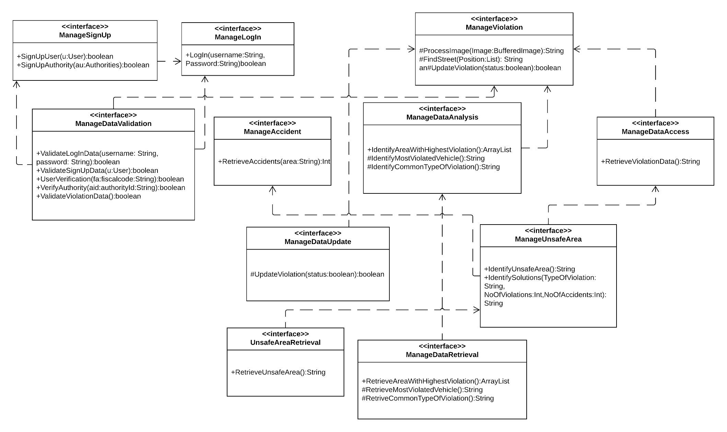

**Figure 9:** Component Interfaces