Janani
A caregiving companion for anyone managing pregnancy, elder care, and infant care — one role, two, or all three at once

The Problem
Most caregiving apps are built for someone who doesn't really exist — someone with just one thing to manage, and enough spare attention to track it. Janani is built for anyone managing a mix of pregnancy, elder care, and infant care — whether that's one of these, two, or all three at once, like the working woman handling every role together, on top of a job.
The hard part was never the caregiving itself. It's the fear of the one thing you forgot — the dose skipped between meetings, the BP reading that crept up while you were at work, the home-visit day that slipped by unnoticed. Janani exists so none of that depends on her memory.

Safety Is Architectural, Not AI-Guessed
Readings come in from simulated IoT devices for testing. The moment one arrives, every safety-critical judgment runs through deterministic, unit-tested logic — never an LLM. A dangerous BP reading, a postpartum red flag, an EPDS depression-screening cutoff, a stalled infant growth trend — each is caught by a plain threshold checker instantly, whether or not she's watching. Gemini only steps in after something's flagged, to turn it into calm, correctly-worded guidance. The noticing was never her job to begin with.
When a Critical alert fires, she's not the single point of failure:
- Every caregiver sharing the profile is notified
- The family's doctor is emailed automatically
- Janani drafts an SOS message from the exact clinical finding, one tap to send, with 108 (ambulance) or 112 (all-India emergency services) already built in
The same discipline runs through the quieter parts of the day too: medication reminders that fire on schedule instead of on memory, and a postpartum recovery plan plus HBNC (Home Based Newborn Care — India's official government newborn home-visit protocol, run through ASHA workers) home-visit schedule, computed automatically from the real delivery date rather than tracked by hand.

Beyond Safety: A Daily Companion
Fourteen Gemini agents power the day-to-day experience:
- Companion — open-ended pregnancy questions, grounded in a curated knowledge base
- Mood-based meal suggestions
- A guided birth-plan wizard that streams its output as it writes
- A medicine-lookup agent grounded in live Google Search results, not the model's own recall
- Daily-plan generators for both elder care and infant care
- Recipes — ask a question in plain language the way you'd ask a friend, filtered by First Foods, Finger Foods, Postpartum Recovery, or Lactation Support, answers drawn from a real curated dataset rather than invented
- Family Care — one cross-profile question spanning whichever roles apply to her, including government entitlement lookups
- Elder Mode — a simplified, large-type interface meant for the elder to use directly, not the caregiver, with its own in-page language switch
AI-generated responses go out in 15 languages. The app itself — core navigation and page UI — is fully localized in English, Hindi, and Telugu today, with the rest falling back to English.

System Architecture
Two independently deployed Cloud Run services share one Postgres-backed caregiver graph. janani-app (public, .NET 8 / Blazor Server) handles all caregiver-facing modules and owns the database connection. janani-agents (private, FastAPI) hosts the 14 Gemini agents behind Google's Agent Development Kit, and is reachable only from janani-app via a Google ID token — no agent is ever exposed directly to a browser.
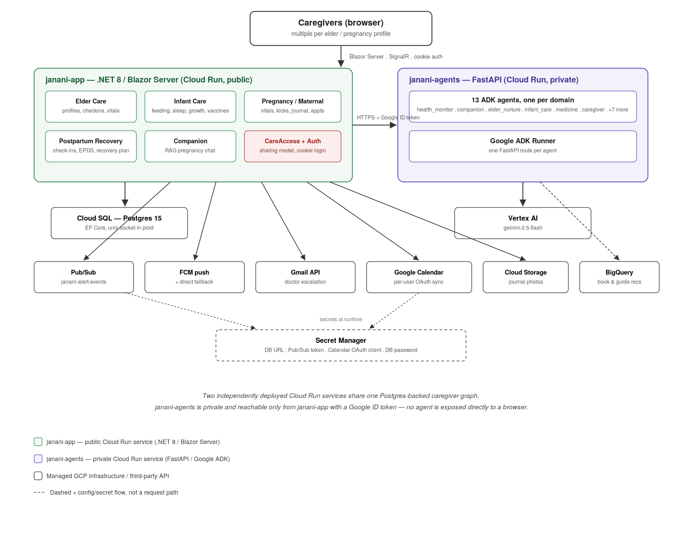

Built End-to-End on Google Cloud
Rather than bolting AI onto a generic backend, every layer of Janani runs on Google Cloud:
Google Cloud Service | How Janani Uses It
Cloud Run | Two services: a public Blazor Server app (the user-facing product), and a private FastAPI agent service reachable only by service-account identity
Cloud SQL (Postgres) | Stores every profile and every reading across pregnancy, elder, and infant care
Cloud Build + Artifact Registry | Builds and deploys every release
Agent Development Kit + Gemini 2.5 Flash (Vertex AI) | Powers the entire AI agent layer — all 14 agents
Pub/Sub + Firebase Cloud Messaging | Routes every alert to the right caregiver, in real time
Cloud Storage | Holds journal photos behind private signed URLs
BigQuery | Ranks care-guide recommendations from a real ratings dataset, not an AI guess
Secret Manager | Holds every credential
IAM | Scopes each service account to exactly the roles it needs, and nothing more

Summary: Janani pairs a deterministic, clinically-grounded safety layer with a warm, multilingual AI companion — built entirely on Google Cloud, from Cloud Run and Postgres up through Vertex AI and BigQuery — so that safety never depends on an LLM's judgment, and care never depends on one person's memory.

