**CODING CONTEST**

**727721EUIT118**

**PRIYANKA J**

1)

package CC;

import org.openqa.selenium.By;

import org.openqa.selenium.WebDriver;

import org.openqa.selenium.WebElement;

import org.openqa.selenium.chrome.ChromeDriver;

import org.openqa.selenium.chrome.ChromeOptions;

import io.github.bonigarcia.wdm.WebDriverManager;

public class Question1 {

public static void main(String args[]) throws InterruptedException {

WebDriverManager.*chromedriver*().setup();

WebDriver driver;

ChromeOptions co = new ChromeOptions();

co.addArguments("--remote-allow-origins=*");

driver = new ChromeDriver(co);

driver.manage().window().maximize();

driver.navigate().to("https://www.saucedemo.com/");

WebElement username= driver.findElement(By.*id*("user-name"));

username.sendKeys("standard_user");

WebElement password= driver.findElement(By.*id*("password"));

password.sendKeys("secret_sauce");

WebElement login= driver.findElement(By.*id*("login-button"));

login.click();

Thread.*sleep*(3000);

WebElement add= driver.findElement(By.*xpath*("//*[@id=\"add-to-cart-sauce-labs-backpack\"]"));

add.click();

WebElement view = driver.findElement(By.*xpath*("//*[@id=\"shopping_cart_container\"]/a"));

view.click();

WebElement check = driver.findElement(By.*id*("checkout"));

check.click();

WebElement fname = driver.findElement(By.*id*("first-name"));

fname.sendKeys("Priyanka");

WebElement lname = driver.findElement(By.*id*("last-name"));

lname.sendKeys("J");

WebElement code = driver.findElement(By.*id*("postal-code"));

code.sendKeys("638452");

WebElement con = driver.findElement(By.*id*("continue"));

con.click();

WebElement product = driver.findElement(By.*xpath*("//*[@id=\"item_4_title_link\"]/div"));

System.***out***.println("Product name "+product.getText());

WebElement price = driver.findElement(By.*xpath*("//*[@id=\"checkout_summary_container\"]/div/div[2]/div[8]"));

System.***out***.println(price.getText());

String Exceptedtitle = "Swag Labs";

String Actualtitle = driver.getTitle();

if(Exceptedtitle.equals(Actualtitle))

{

System.***out***.println("Title is valid");

}

else

{

System.***out***.println("Title is not valid");

}

String Exceptedurl = "https://www.saucedemo.com/checkout-step-two.html";

String Actualurl = driver.getCurrentUrl();

if(Exceptedurl.equals(Actualurl))

{

System.***out***.println("Url is valid");

}

else

{

System.***out***.println("Url is not valid");

}

}

}

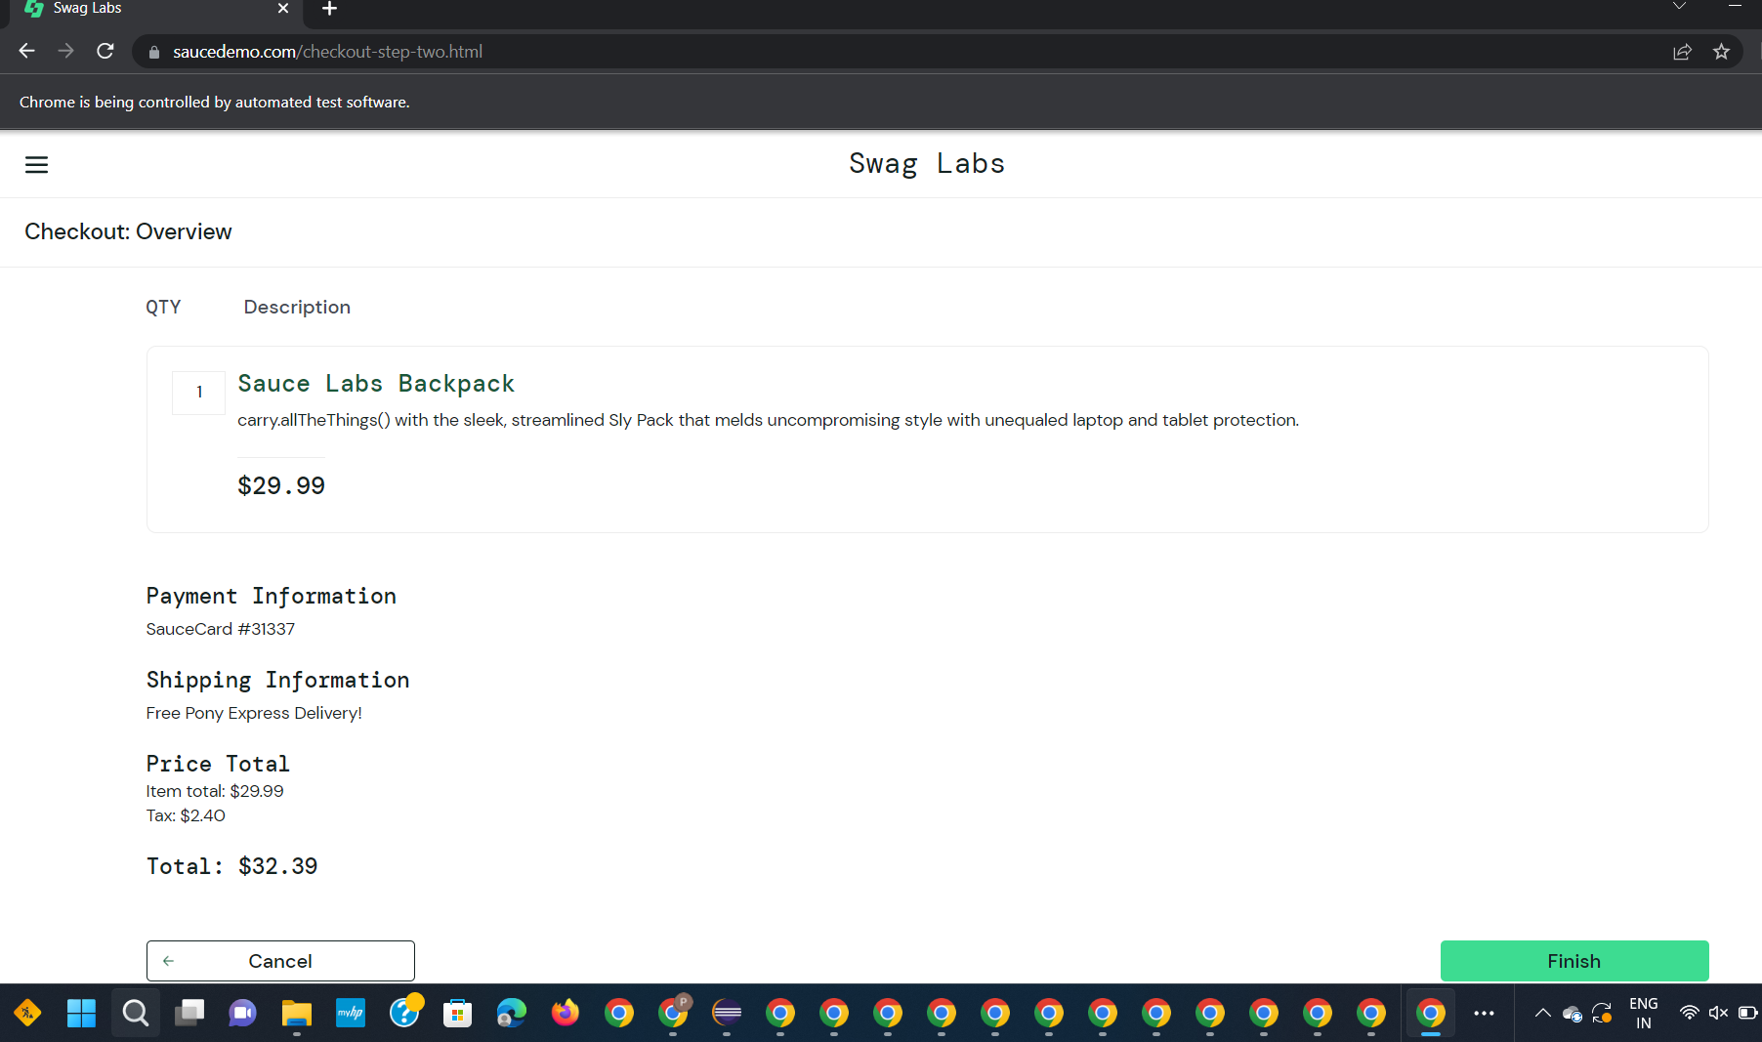

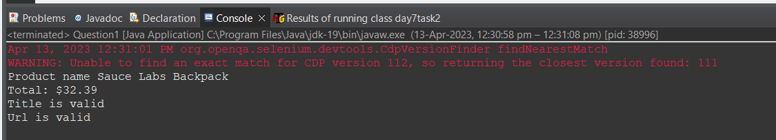

2)

package CC;

import org.openqa.selenium.By;

import org.openqa.selenium.WebDriver;

import org.openqa.selenium.WebElement;

import org.openqa.selenium.chrome.ChromeDriver;

import org.openqa.selenium.chrome.ChromeOptions;

import org.openqa.selenium.support.ui.Select;

import io.github.bonigarcia.wdm.WebDriverManager;

public class Question2 {

public static void main(String args[]) throws InterruptedException {

WebDriverManager.*chromedriver*().setup();

WebDriver driver;

ChromeOptions co = new ChromeOptions();

co.addArguments("--remote-allow-origins=*");

driver = new ChromeDriver(co);

driver.manage().window().maximize();

driver.manage().window().maximize();

driver.navigate().to("https://www.saucedemo.com/");

WebElement username= driver.findElement(By.*id*("user-name"));

username.sendKeys("standard_user");

WebElement password= driver.findElement(By.*id*("password"));

password.sendKeys("secret_sauce");

WebElement login= driver.findElement(By.*id*("login-button"));

login.click();

WebElement drop = driver.findElement(By.*xpath*("//*[@id=\"header_container\"]/div[2]/div/span/select"));

drop.click();

Select sel = new Select(drop);

sel.selectByIndex(0);

WebElement product1 = driver.findElement(By.*xpath*("//*[@id=\"item_4_title_link\"]/div"));

System.***out***.println("Product1 name "+product1.getText());

WebElement drop1 = driver.findElement(By.*xpath*("//*[@id=\"header_container\"]/div[2]/div/span/select"));

drop.click();

Select sel1 = new Select(drop);

sel1.selectByIndex(1);

WebElement product2 = driver.findElement(By.*xpath*("//*[@id=\"item_3_title_link\"]/div"));

System.***out***.println("Product2 name "+product2.getText());

WebElement drop2 = driver.findElement(By.*xpath*("//*[@id=\"header_container\"]/div[2]/div/span/select"));

drop2.click();

Select sel2 = new Select(drop);

sel2.selectByIndex(2);

WebElement product3 = driver.findElement(By.*xpath*("//*[@id=\"item_2_title_link\"]/div"));

System.***out***.println("Product3 name "+product3.getText());

WebElement drop3 = driver.findElement(By.*xpath*("//*[@id=\"header_container\"]/div[2]/div/span/select"));

drop3.click();

Select sel3 = new Select(drop);

sel3.selectByIndex(3);

WebElement product4 = driver.findElement(By.*xpath*("//*[@id=\"item_5_title_link\"]/div"));

System.***out***.println("Product4 name "+product4.getText());

}

}

