**CA 1**

**Software Testing using Selenium**

**727721EUIT118**

**PRIYANKA J**

1.

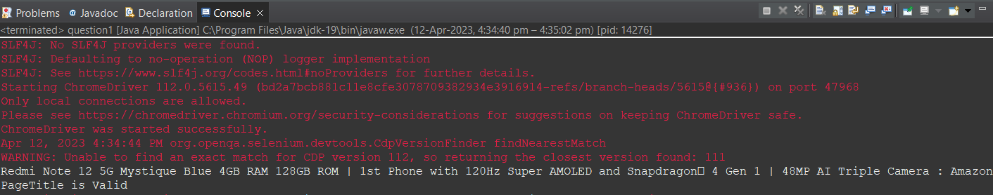

package com.selenium.test.NewTest2.SelTest;

package QUESTIONS;

import org.apache.commons.lang3.builder.EqualsBuilder;

import org.openqa.selenium.By;

import org.openqa.selenium.WebDriver;

import org.openqa.selenium.WebElement;

import org.openqa.selenium.chrome.ChromeDriver;

import org.openqa.selenium.chrome.ChromeOptions;

import io.github.bonigarcia.wdm.WebDriverManager;

public class question1 {

public static void main(String args[])

{

WebDriverManager.*chromedriver*().setup();

WebDriver driver;

ChromeOptions co = new ChromeOptions();

co.addArguments("==remote=allow=origins=*");

driver = new ChromeDriver(co);

driver.get("https://www.amazon.in/Redmi-Mystique-AMOLED-Snapdragon%C2%AE-Triple/dp/B0BQ3PJJDQ/ref=sr_1_2_sspa?crid=2E978AD8MM31G&keywords=mobile&qid=1681289215&sprefix=mobile%2Caps%2C518&sr=8-2-spons&sp_csd=d2lkZ2V0TmFtZT1zcF9hdGY&th=1");

driver.manage().window().maximize();

System.***out***.println(driver.getTitle());

String txt = driver.getTitle();

if(txt.equals(driver.getTitle()))

{

System.***out***.println("PageTitle is Valid");

}

else

{

System.***out***.println("PageTitle is Invalid");

}

WebElement addcart = driver.findElement(By.*id*("add-to-cart-button"));

addcart.click();

WebElement cart = driver.findElement(By.*className*("a-button-input"));

cart.click();

driver.navigate().to("https://https://www.amazon.in/gp/cart/view.html/ref=dp_atch_dss_cart?");

WebElement delete = driver.findElement(By.*xpath*("//*[@id=\"sc-active-a36a6b26-ab9f-49a3-af9b-4a5ac4a80377\"]/div[4]/div/div[2]/div[1]/span[2]/span/input"));

delete.click();

}

}

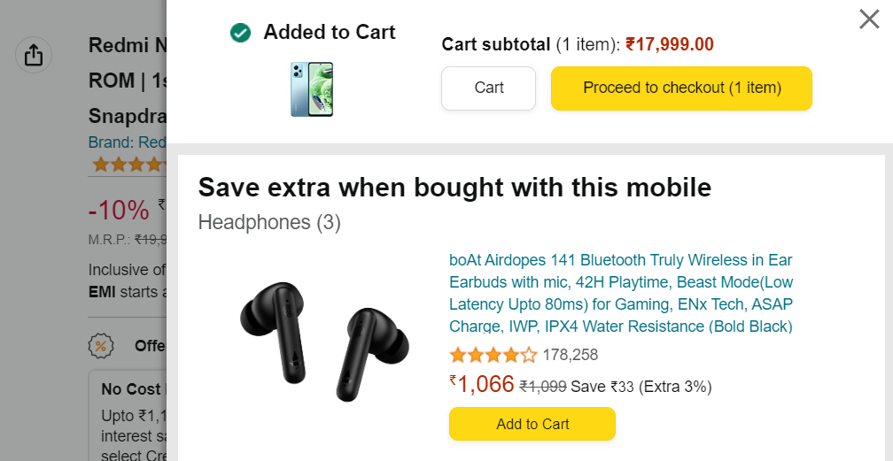

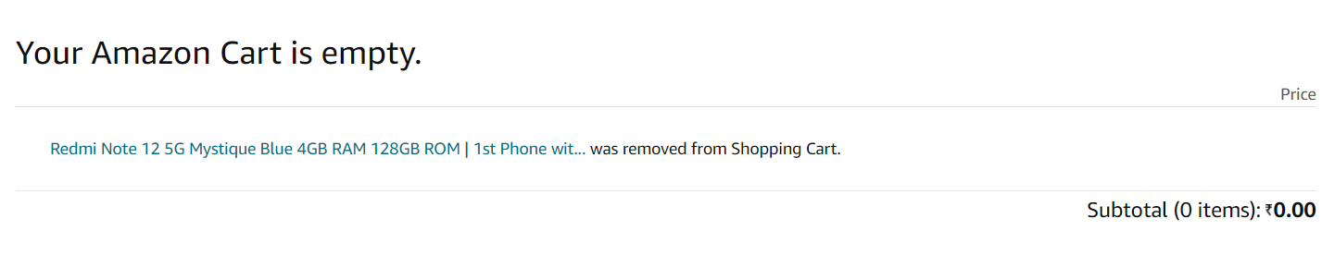

2. 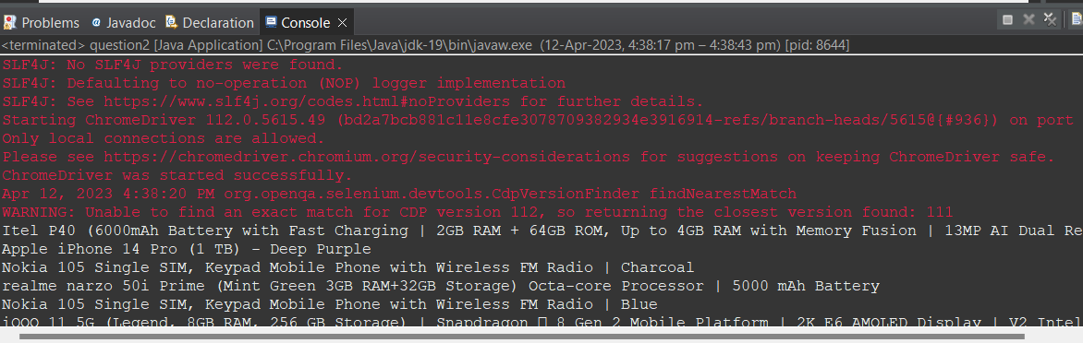

package QUESTIONS;

import java.util.List;

import org.openqa.selenium.By;

import org.openqa.selenium.Keys;

import org.openqa.selenium.WebDriver;

import org.openqa.selenium.WebElement;

import org.openqa.selenium.chrome.ChromeDriver;

import org.openqa.selenium.chrome.ChromeOptions;

import io.github.bonigarcia.wdm.WebDriverManager;

public class question2 {

public static void main(String args[])

{

WebDriverManager.*chromedriver*().setup();

WebDriver driver;

ChromeOptions co=new ChromeOptions();

co.addArguments("--remote-allow-origin=*");

driver=new ChromeDriver(co);

driver.get("https://www.amazon.in/");

driver.manage().window().maximize();

WebElement phone= driver.findElement(By.*id*("twotabsearchtextbox"));

phone.sendKeys("phone");

WebElement search= driver.findElement(By.*id*("nav-search-submit-button"));

search.click();

List<WebElement> li = driver.findElements(By.*xpath*("//*[@class=\"a-size-medium a-color-base a-text-normal\"]"));

for(WebElement l:li)

System.***out***.println(l.getText()+" ");

}

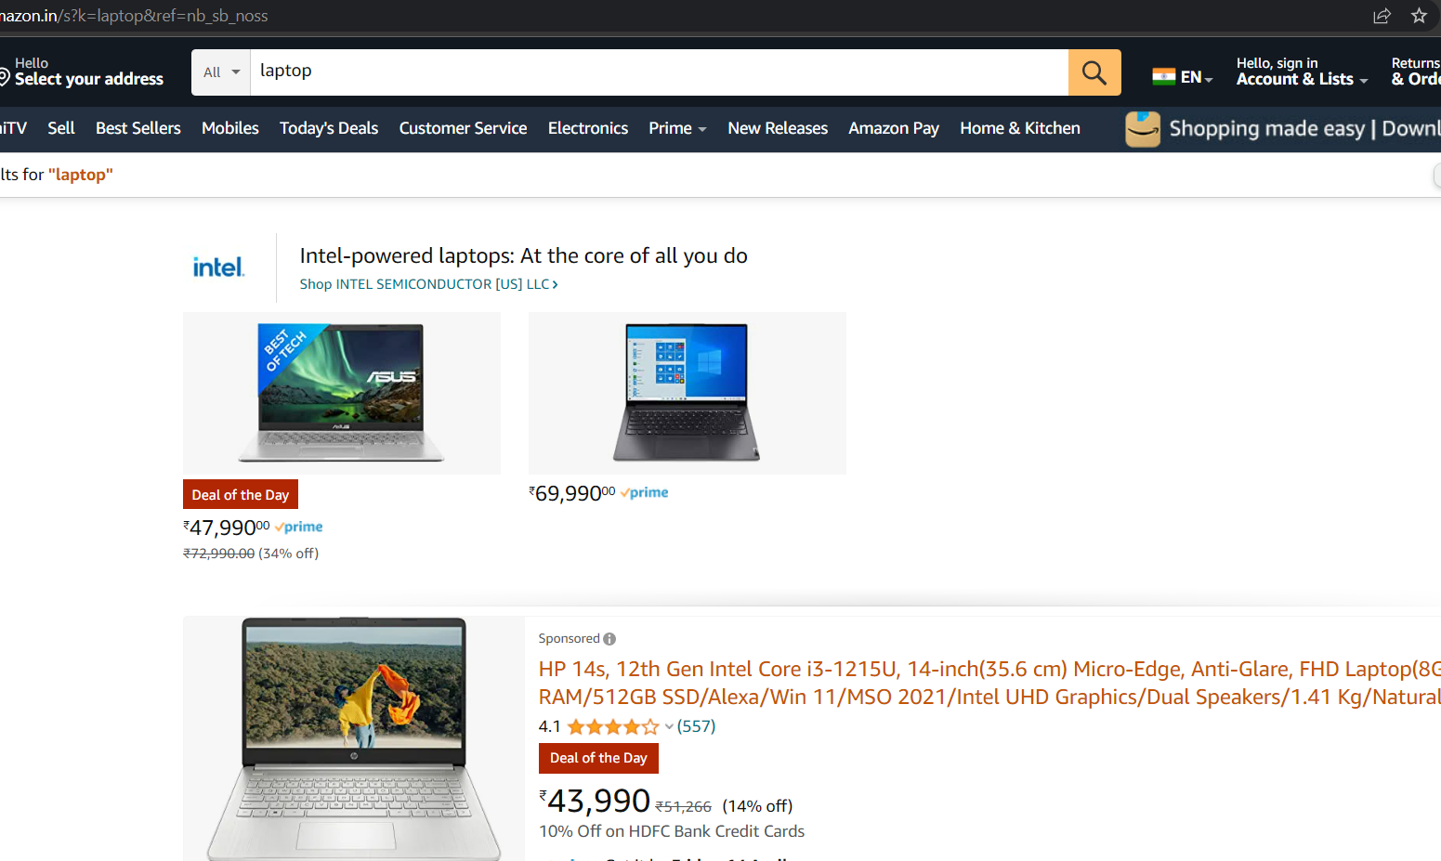

}

3. 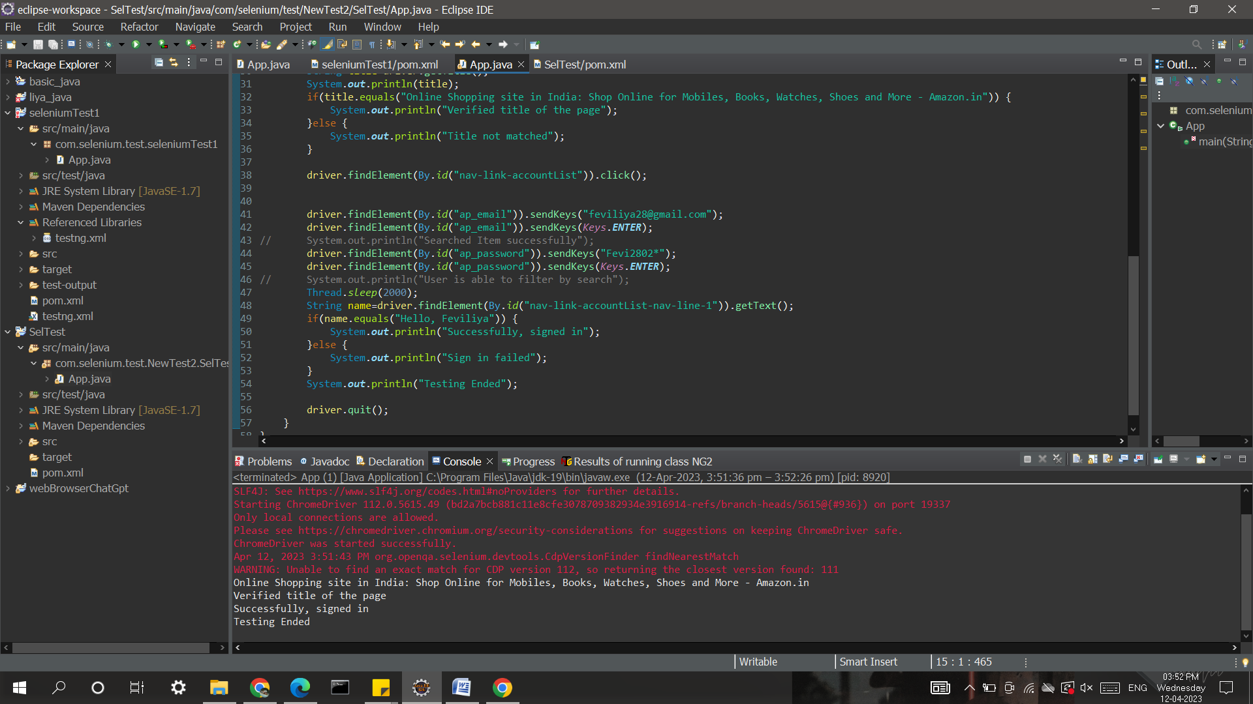

package com.selenium.test.NewTest2.SelTest;

import java.util.List;

import org.openqa.selenium.By;

import org.openqa.selenium.JavascriptExecutor;

import org.openqa.selenium.Keys;

import org.openqa.selenium.WebDriver;

import org.openqa.selenium.WebElement;

import org.openqa.selenium.chrome.ChromeDriver;

import org.openqa.selenium.chrome.ChromeOptions;

import org.openqa.selenium.support.ui.Select;

import io.github.bonigarcia.wdm.WebDriverManager;

public class App

{

public static void main( String[] args ) throws InterruptedException

{

WebDriverManager.chromedriver().setup();

ChromeOptions co = new ChromeOptions();

co.addArguments("--remote-allow-origins=*");

WebDriver driver=new ChromeDriver(co);

driver.get("https://www.amazon.in/ref=nav_logo");

driver.manage().window().maximize();

String title=driver.getTitle();

System.out.println(title);

if(title.equals("Online Shopping site in India: Shop Online for Mobiles, Books, Watches, Shoes and More - Amazon.in")) {

System.out.println("Verified title of the page");

}else {

System.out.println("Title not matched");

}

driver.findElement(By.id("nav-link-accountList")).click();

driver.findElement(By.id("ap_email")).sendKeys("priyanka2003@gmail.com");

driver.findElement(By.id("ap_email")).sendKeys(Keys.ENTER);

driver.findElement(By.id("ap_password")).sendKeys("Priya2003*");

driver.findElement(By.id("ap_password")).sendKeys(Keys.ENTER);

Thread.sleep(2000);

String name=driver.findElement(By.id("nav-link-accountList-nav-line-1")).getText();

if(name.equals("Hello, Priyanka")) {

System.out.println("Successfully, signed in");

}else {

System.out.println("Sign in failed");

}

System.out.println("Testing Ended");

driver.quit();

}

}