**Venues Data Analysis of Pune City**

**Introduction: Business Problem**

**This is the era of industrual revolution 4.0 where world has come together due to Globalisation. IT sector is one of the pillars of globalisation.**

**Pune city in Maharashtra is one of the most importent IT hub in India. Many IT based, e-commarce companies had set up their offices here.**

**To manage the business, client’s travel to India. While visiting to entire different country and culture, they face problem to find the hotels to stay and the restaurants to have a food.**

**Using** Foursquare location data the best nearby places can be easily found which will make client’s experince better.

**Data Section:**

Using Foursquare location data, any place can be explored.

From the longitute and lattitue, Pune city will be located in Foursquare data.

Then, best places will be searched using query feature and the place with maximun rating will be selected.

Then, using the same data, based on the choice of cuisine, the best restraunts around the Hotel will be sselected.

**Methodology:**

I utilized the Foursquare API to explore the hotels around Pune. I designed the limit the radius **500 meter** from given latitude and longitude informations. Here is a head of the list Venues name, category, latitude and longitude informations from Forsquare API.

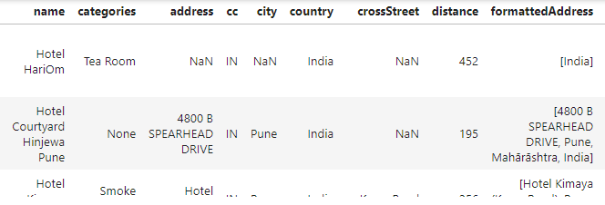

I used python **folium** library to visualize geographic details of Pune and its hotels and I created a map of Pune with hotels superimposed on top:

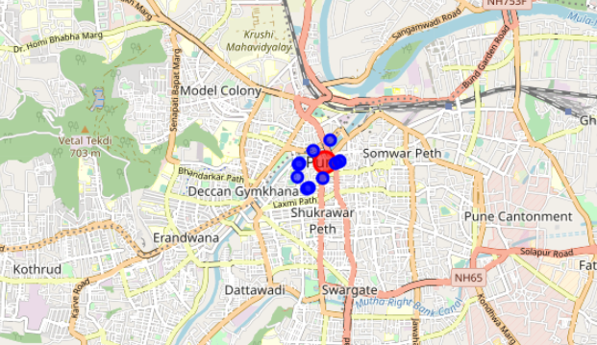

Then, I explored the nearest hotels and picked the one which has the best rating. hotel Courtyard is the one which has good rating as well as closer to the given location. So this could be the best place for client to stay.

Then, I searched for the best restraunts around hotel Courtyard. As Punjabi is the most famous cuisine in India, I looked for the Punjabi restraunts using Foursquare Data. I got below restraunts:

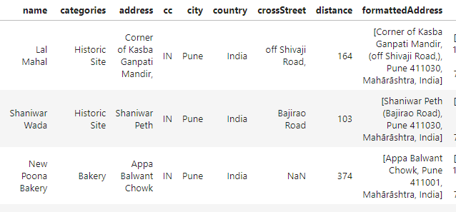

I selected 10 restaurants based on distance and visualized as below:

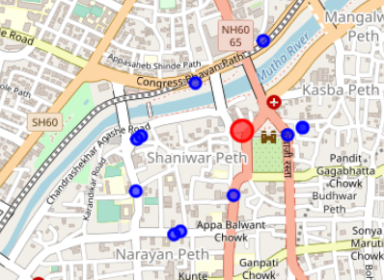

**Conclusion:**

Pune is one of the major IT hubs in India. Using Foursquare data, the best hotels and restaurants were located. This Project can be made more dynamic by giving an option for choosing the city and integrated with some Booking websites like makeMyTrip or OYO rooms to make the entire visit smooth for visitors.