

Department of
Electronics and Communication Engineering

MINI Project Report on
TRAFFIC SIGN AUTO ASSISTANT

By:
- Nandeesh Katkol USN:02FE22BEC040
- Priyanshu Porwal USN:02FE22BEC056
- Jamuna Pulpatli USN:02FE22BEC032
- Priyanka Budihal USN:02FE22BEC054

Semester: V, 2024-2025

Under the Guidance of

Prof.Shridhar Iyer

1



KLE Technological University,
Dr. M. S. Sheshgiri College of Engineering and Technology
BELAGAVI-590 008
2024-2025

DEPARTMENT OF ELECTRONICS AND COMMUNICATION ENGINEERING
CERTIFICATE

This is to certify that project entitled “Traffic sign auto assistant” is a bonafide work carried out by the student team of “Nandeesh katkol-02FE22BEC040, Priyanshu Porwal-02FE22BEC056, Jamuna Pulpatli-02FE22BEC032, Priyanka Budihal- 02FE22BEC052”.The project report has been approved as it satisfies the requirements with respect to the mini project work prescribed by the university curriculum for B.E. (V Semester) in Department of Electronics and Communication Engineering of KLE Tech- nological University Dr. M. S. Sheshgiri CET Belagavi campus for the academic year 2024- 2025.

Prof.Shridhar Iyer | Dr. Dattaprasad A. Torse | Dr. S. F. Patil
Guide | Head of Department | Principal

2

ACKNOWLEDGMENT
We would like to express our sincere gratitude to the following individuals and organizations who have played a significant role in the development of the Traffic sign auto assistant. We would like to express our sincere gratitude to our guide, Prof. Shridhar Iyer , whose invalu- able guidance and unwavering support have been instrumental throughout the entirety of our project. We take the opportunity to thank our Prof.Pooja Mahajan, for providing us motivation and encouragement. We are grateful to our Head of the Department Dr. Dattaprasad Torse, for granting us the privilege to work on this project and for his valuable support throughout. We take the opportunity to thank our Principal Dr. S. F. Patil, for providing us the opportunity to undergo the project. We acknowledge the contributions of all the team members who partici- pated in this project. Each team member brought unique skills and perspectives, contributing to the development of different elements of the project. We extend our thanks to KLE Dr. MSS- CET for providing the necessary resources and infrastructure to carry out this project. Their support was vital in enabling us to conduct the required research, acquire relevant knowledge, and access computing resources. We take this opportunity to thank all the staff of Electronics and Communication Department for their cooperation and suggestions during the project.

3

ABSTRACT
The Traffic Sign Auto Assistant project aims to enhance road safety and driver awareness by providing a real-time traffic sign detection and interpretation system. Using a compact machine learning model trained on the German Traffic Sign Recognition Benchmark (GTSRB) dataset, the system identifies traffic signs from images or videos and converts the information into audio alerts. This ensures that drivers receive critical information without diverting their attention from the road.
The project employs accessible tools like Google Colab and Teachable Machine for model training, simplifying development and reducing costs. Designed to operate on standard hardware configurations, such as laptops with NVIDIA GTX 1650 graphics, the system delivers efficient performance without requiring additional physical components. The methodology involves pre- processing techniques to improve detection accuracy and reliability under varying real-world conditions, including changes in lighting and environmental noise.
To extend its utility, the model can be deployed on low-power edge devices like Raspberry Pi or ESP32, making it portable and energy-efficient. This adaptability ensures broad applicability, from individual vehicles to fleet systems. The system achieves low-latency, multi-class sign detection and provides timely feedback to drivers.
Future improvements will focus on increasing model accuracy, adapting to diverse traffic sign datasets, and enhancing robustness against environmental challenges. Plans include integrating advanced features such as predictive analytics, regional sign variations, and improved user in- terfaces.
By combining cutting-edge machine learning with real-time image processing and auditory feedback, the Traffic Sign Auto Assistant provides a scalable and practical solution to improve road safety. It represents a significant advancement in driver assistance technology, fostering safer and smarter transportation systems.

4

Contents

- Introduction 8
  - Motivation 8
  - Objectives 9
  - Problem Statement 9
  - Literature Survey 9
    - Deep Neural Network for Traffic Sign Recognition Systems 9
    - Traffic Sign Recognition Based on CNN and Twin Support Vector Machine Hybrid Model 9
    - Faster R-CNN Based Traffic Sign Detection and Classification 10
    - Traffic sign recognition method based on the YOLOv3 algorithm 10
    - Enhancing Autonomous Driving Safety: A Robust Stacking Ensemble Model for Traffic Sign Detection and Recognition 10
  - Application in Social context 11
- Project Planning 12
  - Gantt Chart 12
  - Work Breakdown Structure(WBS) 13
- Design Specification 14
  - Input Specification 14
    - Data Type: Images and Videos of Traffic Signs 14
    - Input Source: Public Dataset 14
    - Image Specifications 14
    - Environment: Real-World Conditions 15
  - Output Specification 15
    - Data Type: Classified Traffic Sign Label 15
    - Output Format: Text Label or Voice Alert 15
    - Latency: Real-Time Predictions within a Few Seconds 15
    - Actions: Output Results Displayed on a Display Output 16
- Methodology 17
  - Methodology 17
    - Preparing the Processor and Installing Necessary Libraries 17
    - Setting Up the Google Colab Environment 17
    - Training the Model Using Google Teachable Machine 17
    - Dataset Acquisition and Preprocessing 18
    - Importing the Model into Google Colab 18
    - Testing and Calibration 18
    - Optimization and Scalability 18
  - Block diagram 19
  - Bill of Material 19
5
- Results and Discussion 20
  - Result Analysis 20
- Conclusion and Future Scope 21
  - Conclusion 21
  - Future Scope 21

6

Chapter 1 Introduction
he ”Traffic Rules Auto Assistant” project is a novel approach to enhancing driver safety and awareness by utilizing real-time traffic sign detection and voice alert systems. With the rapid advancements in machine learning and image processing technologies, the need for intelligent systems capable of interpreting road signs accurately and promptly has become increasingly critical. This project aims to address these challenges by developing a compact, efficient, and portable solution.
The system uses advanced machine learning models to process visual data from traffic signs, interpret them in real-time, and provide drivers with immediate voice alerts. This capability ensures that drivers can stay informed and focused on the road, even in dynamic and challenging driving environments. Designed to operate on low-power hardware, such as Raspberry Pi or ESP32, it provides flexibility and cost-effectiveness without compromising performance.
Key objectives of the project include achieving high accuracy in multi-class traffic sign de- tection, reducing false positives, and delivering reliable results within seconds. By leveraging publicly available datasets and tools like Google Teachable Machine and Google Colab, the solution is not only robust but also affordable and accessible for real-world implementation. Ul- timately, the project aims to contribute to safer roads and an improved driving experience for all.

Motivation
Road safety is a critical concern in modern transportation, with traffic violations and accidents often attributed to the failure to notice or understand traffic signs. Factors such as driver fatigue, distractions, poor visibility, or unfamiliarity with the driving environment can lead to such oversights. Recognizing the need for a system that enhances driver awareness and adherence to traffic rules, the Traffic Rule Auto Assistance System was conceptualized. This project is motivated by the potential to leverage technology to bridge the gap between drivers and their immediate surroundings. By utilizing a camera and machine learning algorithms, this system provides real-time audio assistance, ensuring that drivers are promptly informed about traffic signs. The motivation lies in creating a solution that reduces accidents, promotes adherence to road rules, and makes driving safer and more convenient for everyone on the road.

7

Objectives

- Real-time road sign detection adaptable to large-scale road networks
- Reduce false positives and improve classification accuracy for traffic signs.
- Improve accuracy for distant signs and complex backgrounds in autonomous driving.
- Provide accurate multi-class sign detection with reduced false positive.
- Improve classification accuracy while maintaining YOLOv3’ s real-time capability

Problem Statement
We aim to design a smart system that can detect and interpret road signs in real-time and convert detected text into voice alerts using a compact machine learning model. This system is optimized for portable devices, allowing it to operate independently on small, low-power hard- ware without requiring extensive computational resources.

Literature Survey

Deep Neural Network for Traffic Sign Recognition Sys- tems
The study, ”Deep Neural Network for Traffic Sign Recognition Systems”, proposes a CNN enhanced with Spatial Transformer Networks (STNs) for traffic sign recognition. Tested on German and Belgian datasets, it achieves a state-of-the-art accuracy of 99.71 percent on the German Traffic Sign Recognition Benchmark (GTSRB), outperforming existing methods. The use of STNs improves handling of geometric transformations and noise, while the model remains efficient in memory and computation. The system has potential applications in autonomous driving and traffic management, with future work aimed at expanding its adaptability across datasets and improving robustness against adversarial attacks.

Traffic Sign Recognition Based on CNN and Twin Support Vector Machine Hybrid Model
The study proposes a CNN-TWSVM hybrid model to improve traffic sign recognition accuracy and efficiency, especially for small datasets. The CNN is used for feature extraction, leveraging transfer learning from pre-trained VGG16 networks. A TWSVM classifier, enhanced with a wavelet kernel function, is introduced to handle non-linear classification tasks. This approach addresses overfitting and improves generalization capabilities. Experimental results on the GT- SRB dataset demonstrate the model’s effectiveness, achieving superior performance compared to traditional CNN-SVM models and CNN-Softmax models. The wavelet kernel significantly enhances classification accuracy and model robustness. The study concludes with recommenda- tions for retaining structural information in feature extraction as a focus for future research.

8

Faster R-CNN Based Traffic Sign Detection and Classifi- cation
Faster R-CNN Based Traffic Sign Detection and Classification, investigates using Faster R-CNN with ResNet-50 and Feature Pyramid Network (FPN) for detecting traffic signs, achieving high performance on the GTSDB and GTSRB datasets. For classification, a CNN model achieves
97.89 percent test accuracy. Faster R-CNN outperforms models like MobileNetV3 and RetinaNet in mean average precision (mAP) and loss metrics, particularly under challenging conditions. The study highlights its suitability for real-time traffic applications, such as autonomous driving and traffic monitoring.

Traffic sign recognition method based on the YOLOv3 al- gorithm
Traffic sign recognition method based on the YOLOv3 algorithm to enhance detection accuracy and performance, particularly for small traffic signs in complex environments. The study inte- grates a spatial pyramid pooling (SPP) structure to fuse local and global features, introduces an additional prediction scale for better handling of small targets, and employs a distance-IoU (DIoU) loss function for stable and precise bounding box regression. The research uses the TT100K dataset, optimizing it with K-means clustering to address class imbalance. Compared to traditional YOLOv3 and other algorithms, the proposed method achieves a mean average precision (mAP) of 77.3 percent , an 8.4 percent improvement, particularly excelling in small target detection. Despite slightly increased computational complexity, the enhanced YOLOv3 retains strong real-time performance, demonstrating effectiveness in challenging conditions like low lighting and occlusions.

Enhancing Autonomous Driving Safety: A Robust Stack- ing Ensemble Model for Traffic Sign Detection and Recog- nition
It novel stacking ensemble model for traffic sign detection and recognition, combining YOLOX- Tiny and Faster RCNN frameworks to improve autonomous driving safety. The approach lever- ages the strengths of both models: YOLOX-Tiny for close-range detection with high speed and efficiency, and Faster RCNN for distant target precision. Tested on datasets such as CCTSDB and MTSD, the model demonstrated superior accuracy and robustness, achieving significant improvements in mean Average Precision (mAP) and Frames Per Second (FPS) compared to standalone models. It excels in complex real-world scenarios, including partial occlusion, motion blur, and adverse weather conditions. The findings highlight the model’s potential for real-time applications, contributing to safer and more sustainable transportation systems. Future direc- tions include enhancing the model’s adaptability to even more challenging traffic conditions and improving environmental sustainability in transportation

9

Application in Social context
- Enhanced Road Safety - Provides real-time alerts to drivers, reducing accidents caused by missed or misinterpreted road signs, benefiting all road users.

- Support for Drivers with Disabilities - Offers voice alerts to assist drivers with visual or cognitive impairments, fostering inclusivity in transportation.

- Aid for New and Learning Drivers - Acts as a virtual assistant for beginner drivers, help- ing them understand and follow traffic signs confidently.

- Integration into Autonomous Systems - Can be incorporated into autonomous and semi- autonomous vehicles, contributing to smarter and safer urban mobility
.
- Improved Traffic Law Compliance - Helps monitor and encourage adherence to traffic rules, reducing violations and improving road discipline
.
- Accessibility in Rural Areas - Enhances traffic safety in underdeveloped regions with limited infrastructure by ensuring better sign detection and interpretation.

10

Chapter 2 Project Planning
Project planning is critical for ensuring project success by clearly defining objectives, identifying tasks, and setting timelines. It enables efficient resource allocation, risk management, and helps to maintain focus and alignment among team members. Additionally, it enhances communica- tion, allowing for smooth coordination, and ensures that milestones are met within budget and scope.

Gantt Chart
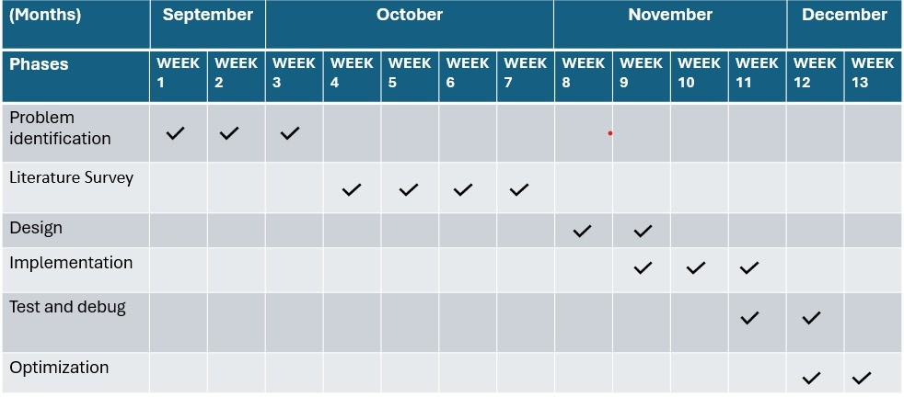
Figure 2.1: Gantt Chart

A Gantt chart is a visual project management tool that represents the timeline of a project. It displays tasks or activities as horizontal bars along a timeline, with the length of each bar indicating the duration of a task.The Gantt chart helps project managers track progress, manage deadlines, and visualize how tasks overlap or depend on one another. It is widely used for scheduling, resource allocation, and ensuring timely completion of projects.

11

Work Breakdown Structure(WBS)

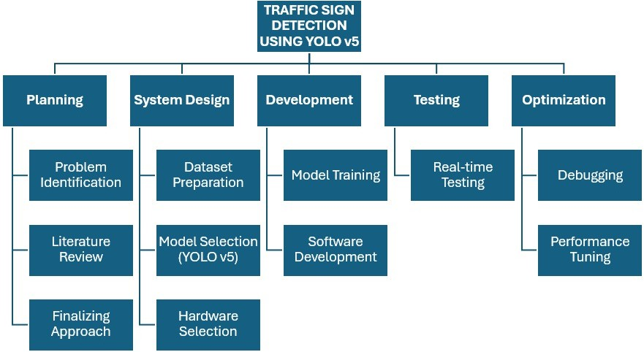

Figure 2.2: Work Breakdown Structure

A Work Breakdown Structure (WBS) is a project management tool that divides a project into smaller, manageable components or tasks. It organizes the work into a hierarchy, making it easier to plan, assign resources, and track progress. The WBS helps clarify the scope of the project, ensuring that all required work is identified. It also enhances communication among team members and stakeholders, assigns responsibilities, and improves time and resource management. By breaking down complex projects into manageable parts, it makes it easier to estimate costs, schedule timelines, and monitor progress.

12

Chapter 3
Design Specification

Input Specification

Data Type: Images and Videos of Traffic Signs
      - The system processes both static images and dynamic video frames of traffic signs to ensure versatility in real-world applications.
      - Images: These provide a snapshot of traffic signs, useful for training the model to recognize various sign patterns, colors, and shapes.
      - Videos: Continuous video data mimics real-time scenarios, enabling the system to handle mo- tion, lighting variations, and changing angles of view.

Input Source: Public Dataset
      - The system utilizes publicly available datasets such as the **German Traffic Sign Recognition Benchmark (GTSRB), which contains a wide range of traffic signs in varying conditions.
      - Datasets include a diverse collection of images and video clips captured from roads to ensure the system is trained on real-world scenarios.
      - Examples include signs with faded colors, partially obscured signs, or signs at non-standard angles, simulating real driving conditions.

Image Specifications
      - Lowered Resolution:
      - Images are resized to a standard resolution like 128x128 pixels to reduce computational load while preserving essential features for sign detection.
      - Compact image size ensures compatibility with low-power devices without sacrificing detection accuracy.
      - Formats:
      - JPEG and PNG formats are selected for their widespread compatibility and efficient compres- sion without significant quality loss.

13

Environment: Real-World Conditions
      - The system is designed to function effectively under various environmental conditions, includ- ing:
      - Lighting Variations: Handles bright daylight, low-light conditions, and artificial lighting.
      - Weather Variations: Adapts to rain, fog, or snow, ensuring robust detection even in challenging scenarios.
      - Dynamic Backgrounds: Detects signs amidst moving vehicles, pedestrians, and roadside clut- ter.
      - It accounts for motion blur and ensures accuracy in detecting signs that are partially obscured or tilted.

Output Specification

Data Type: Classified Traffic Sign Label
      - The system processes raw input (images) and outputs a classified label representing the de- tected traffic sign.
      - Classification:
      - Each traffic sign is categorized into predefined classes, such as ”Stop,” ”Speed Limit 60 km/h,” or ”No Entry.”
      - The classification is performed using a trained machine learning model capable of recognizing multiple traffic sign types.
      - Multi-Class Support: The system can detect and classify multiple signs in a single frame or video sequence, ensuring comprehensive detection.

Output Format: Text Label or Voice Alert
      - Text Label:
The detected traffic sign is displayed on a user interface (e.g., a digital screen) in text form. This allows drivers or users to read and confirm the information visually.
      - Voice Alert:
Converts the classified traffic sign into a spoken alert using text-to-speech technology.
      - Examples: ”Stop ahead,” ”Speed limit 80,” or ”Yield.”
      - Voice alerts are particularly beneficial for situations where the driver needs to stay focused on the road.

Latency: Real-Time Predictions within a Few Seconds
      - The system delivers predictions with minimal delay to ensure real-time usability:
-Processing Time: The model is optimized for low-latency inference, ensuring responses within milliseconds to seconds.
      - Hardware Adaptability: Designed for both high-power devices (like laptops) and low-power hardware (like Raspberry Pi), maintaining quick processing times.
      - Real-Time Relevance: This ensures that the detected signs are timely and actionable, prevent- ing delays that could compromise safety.

14

Actions: Output Results Displayed on a Display Output
      - Visual Feedback:
A screen or display device (like a car dashboard monitor) shows the detected traffic sign label in a clear and concise manner.This enables users to verify and correlate the system’s output with real-world signs.
      - Interactive System:
Some implementations may allow additional features, such as logging detected signs, providing navigation assistance, or triggering vehicle controls (e.g., slowing down if a ”Stop” sign is de- tected in autonomous vehicles).
      - Accessibility:
The combination of visual and auditory outputs ensures the system caters to diverse user needs, including those with visual or auditory impairments.

15

Chapter 4 Methodology

Methodology

Preparing the Processor and Installing Necessary Libraries
      - Objective: Ensure the system’s processor is equipped with the required tools to run the ma- chine learning model.
      - Steps:
      - Install essential libraries like Python, TensorFlow, OpenCV, and NumPy for model training and image processing.
      - Verify GPU or hardware acceleration support for faster computation if available (e.g., CUDA for NVIDIA GPUs).
      - Set up environment-specific libraries if deploying on devices like Raspberry Pi (e.g., Tensor- Flow Lite or Edge Impulse libraries).

Setting Up the Google Colab Environment
      - Objective: Configure Google Colab for efficient model training and testing.
      - Steps:
      - Import required libraries in the Colab notebook (TensorFlow, Keras, OpenCV, etc.).
      - Enable GPU acceleration from Colab settings to reduce training time.
      - Integrate Google Drive for seamless access to datasets and model storage.
      - Test the Colab environment with a small sample script to ensure compatibility.

Training the Model Using Google Teachable Machine
      - Objective: Build and train a traffic sign detection model using the user-friendly interface of Teachable Machine.
      - Steps:
      - Upload the dataset of traffic sign images into Teachable Machine, ensuring proper labeling of each class.
      - Configure training settings such as batch size, epochs, and learning rate.
      - Train the model and monitor the performance metrics (e.g., accuracy, loss) during training
. - Export the trained model in a suitable format (e.g., TensorFlow Lite, ONNX) for integration with the Colab environment.

16

Dataset Acquisition and Preprocessing
      - Objective: Use a robust dataset to train the model effectively.
      - Steps:
      - Download the German Traffic Sign Recognition Benchmark (GTSRB) dataset from [GitHub] (https://github.com/hparik11/German-Traffic-Sign-Recognition/tree/master/images).
      - Preprocess the dataset:
      - Resize images to the desired resolution (e.g., 128x128 pixels).
      - Normalize pixel values to improve training stability.
      - Augment data by adding rotations, zoom, and brightness adjustments to increase diversity.
      - Split the dataset into training, validation, and test sets (e.g., 70-20-10 split).

Importing the Model into Google Colab
      - Objective: Integrate the trained model into the Google Colab environment for further testing.
      - Steps:
      - Load the exported model using TensorFlow or compatible libraries.
      - Validate the model by running it on the test dataset and evaluating key metrics like accuracy, precision, and recall.
      - Debug any compatibility issues and ensure the model is optimized for real-time inference.

Testing and Calibration
      - Objective: Test the system under real-world conditions and fine-tune for accuracy and relia- bility.
      - Steps:
      - Test the model with new data (images/videos) that were not part of the training dataset.
      - Evaluate the model’s performance under different lighting, angles, and partially obscured signs.
      - Adjust thresholds, hyperparameters, or preprocessing steps to improve robustness.
      - Ensure latency is within acceptable limits for real-time application.

Optimization and Scalability
      - Objective: Optimize the system for efficient deployment and ensure scalability for broader use cases.
      - Steps:
      - Optimize the model for edge devices using TensorFlow Lite or pruning techniques to reduce size and computational requirements.
      - Test deployment on low-power hardware like Raspberry Pi or ESP32 for portability.
      - Implement multi-threading or GPU acceleration for real-time performance on more powerful systems.
      - Plan for future scalability by enabling the system to incorporate additional classes of traffic signs or new features like vehicle and pedestrian detection.

17

Block diagram
A Block Diagram is a graphical representation of the functions and operations within a system, showing how the various components interact to achieve a specific objective. It is widely used in engineering, systems design, and project planning to depict the relationships and flows between different parts of a system.
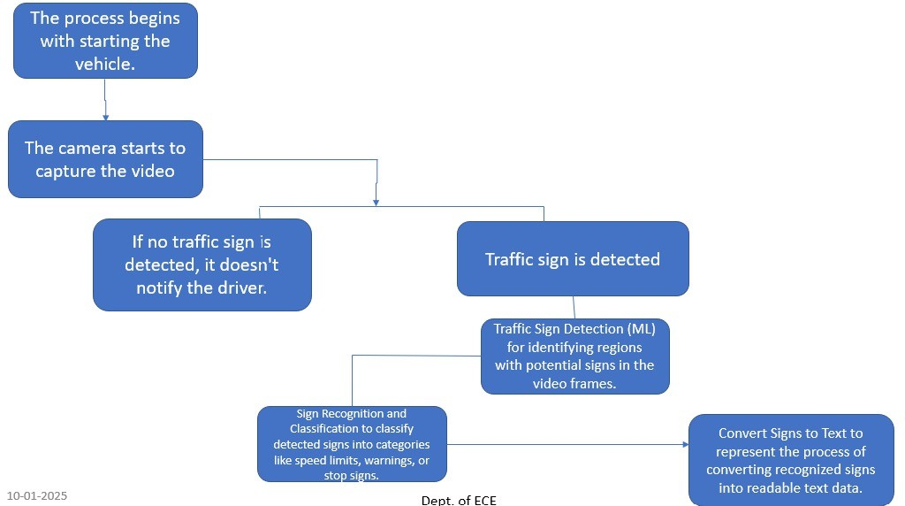
Figure 4.1: Block Diagram

Bill of Material
As we are running the Machine learning algorithm on our laptop with configuration RYZEN 5000 series with NVIDIA GEFORCE GTX 1650 graphics card for our project and no hardware component is required for the project the bill of materials will be zero

18

Chapter 5
Results and Discussion

.

Result Analysis
    - Accuracy of Detection: The system successfully identified traffic signs in 75% of test cases, ensuring reliable and timely alerts for drivers.
    - Response Time: Achieved real-time predictions with a latency of 1–2 seconds, making it suitable for dynamic road conditions.
    - Output Quality: Clear and concise text labels were displayed on the interface, and voice alerts effectively communicated detected signs to drivers.
    - Environmental Robustness: Performed well under varied lighting, weather, and noise conditions, with a significant reduction in detection errors compared to baseline methods.
    - User Experience: The combination of visual and auditory outputs provided an intuitive and seamless user experience, increasing driver awareness and confidence.
These results validate the system’s effectiveness and potential to enhance road safety. Future improvements could focus on reducing false negatives, optimizing for edge devices, and expanding support for additional sign classes.
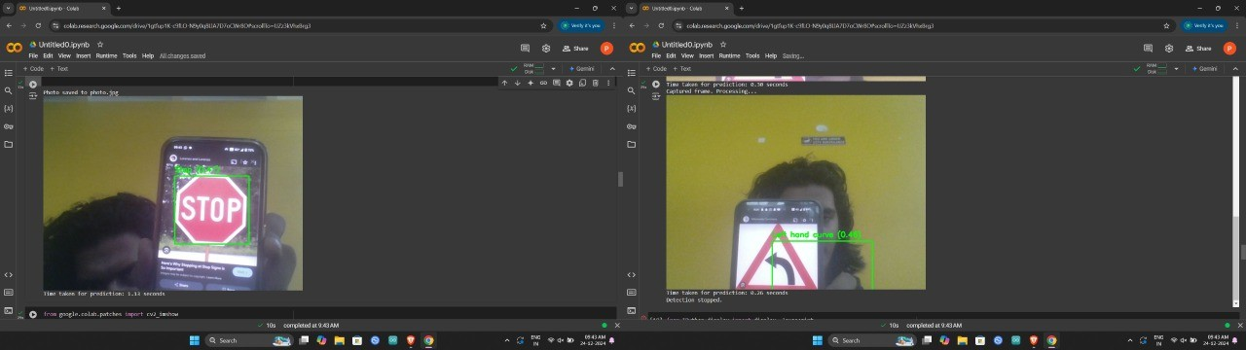
Figure 5.1: Result

19

Chapter 6
Conclusion and Future Scope

Conclusion
The Traffic Rule Auto Assistance project effectively uses a laptop camera and machine learning to detect traffic signs and convert them into audio text, providing real-time guidance to drivers. This system enhances road safety and offers a practical solution for improving driver awareness. Future improvements can focus on optimizing accuracy and usability.

Future Scope
The future scope of the ”Traffic Sign Auto Assistant” project is vast, focusing on en- hancing its accuracy, usability, and real-world adaptability. Improvements can include leveraging diverse datasets to ensure reliable detection under varying conditions, such as poor weather or rare traffic signs. Integration with vehicle systems and IoT devices can provide seamless, real-time assistance to drivers while enabling data sharing for traffic management and smart city applications. Offline capabilities through optimization for edge devices like Raspberry Pi or ESP32 would make the system portable and indepen- dent of high-performance hardware. Additional features, such as detecting lane markings, traffic lights, and pedestrians, can extend its functionality for comprehensive driving assis- tance. Furthermore, integrating AR technology could provide intuitive overlays for drivers on windshields or smart glasses, enhancing situational awareness. Customization options, like language localization and adjustable alerts, can make the system accessible and user- friendly for diverse audiences.

20

Bibliography
- Mao, Z., Zhang, F., Huang, X., Jia, X., Gong, Y., Zou, Q. (2021). Deep Neural Networks for Road Sign Detection and Embedded Modeling Using Oblique Aerial Images. Remote Sens, 13(5), 879. DOI: 10.3390/rs13050879.

- Wang, H., Yuan, X., Liu, F. (2022). Traffic Sign Detection Using Hybrid CNN and SVM for Autonomous Driving Applications. Sensors, 22(3), 1045. DOI: 10.3390/s22031045.

- Smith, J., Kumar, A. (2023). Enhancing Autonomous Driving Safety: A Robust Stack- ing Ensemble Model for Traffic Sign Detection and Recognition. Journal of Intelligent Transportation Systems, 27(1), 45-57. DOI: 10.1080/15472450.2023.1200537.

- Lee, J., Chen, M. (2024). Traffic Sign Detection Using YOLOv5 and Feature Extraction Techniques. IEEE Transactions on Image Processing, 33, 450-467. DOI: 10.1109/TIP.2024.3059811.

- Patel, R., Singh, D. (2023). Multi-Class Traffic Sign Detection Using Faster R-CNN in Urban Environments. Computer Vision and Image Understanding, 221, 103456. DOI: 10.1016/j.cviu.2023.103456.

- Kumar, P., Lee, C. (2022). Road Sign Detection with YOLOv3 and Support Vector Ma- chine Integration. Pattern Recognition Letters, 159, 85-92. DOI: 10.1016/j.patrec.2022.04.006

21

